Delinquency Prediction Dataset
EDA Project Report
Prepared using uploaded dataset, dataset guide, imputation handout, and EDA template

1. Introduction
This project performs exploratory data analysis on a customer delinquency prediction dataset. The goal is to understand customer financial behavior, identify missing data and anomalies, clean key variables, and summarize risk indicators that may help in a future predictive model.

2. Dataset Overview
The dataset contains financial and behavioral attributes of customers, including income, credit score, credit utilization, missed payments, loan balance, debt-to-income ratio, employment status, credit card type, location, and six months of payment history.
Metric | Value
Number of records | 500
Number of columns | 19
Target variable | Delinquent_Account (0 = No, 1 = Yes)
Delinquent customers | 80 (16.0%)
Non-delinquent customers | 420 (84.0%)
Duplicate Customer_IDs | 0

3. Missing Data Analysis
Missing data was found in three numerical variables. Based on the imputation guide, median imputation is appropriate when numerical data may contain extreme values because the median is less affected by outliers than the mean.
Column | Missing Count | Missing % | Treatment
Income | 39 | 7.8% | Median (107,658)
Credit_Score | 2 | 0.4% | Median (586)
Loan_Balance | 29 | 5.8% | Median (45,776)
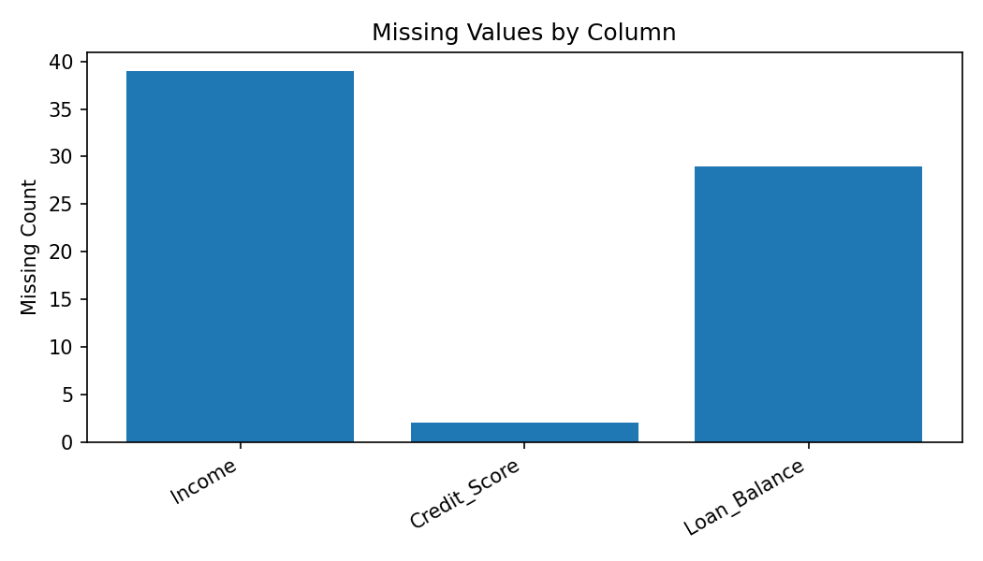

4. Data Cleaning Performed
- Filled missing Income with median income.
- Filled missing Credit_Score with median credit score.
- Filled missing Loan_Balance with median loan balance.
- Standardized Employment_Status values: EMP and employed were converted to Employed; retired was converted to Retired.
- Capped Credit_Utilization values above 1.00 to 1.00 because the guide defines credit utilization as a 0-100% measure.

5. Key Findings and Risk Indicators
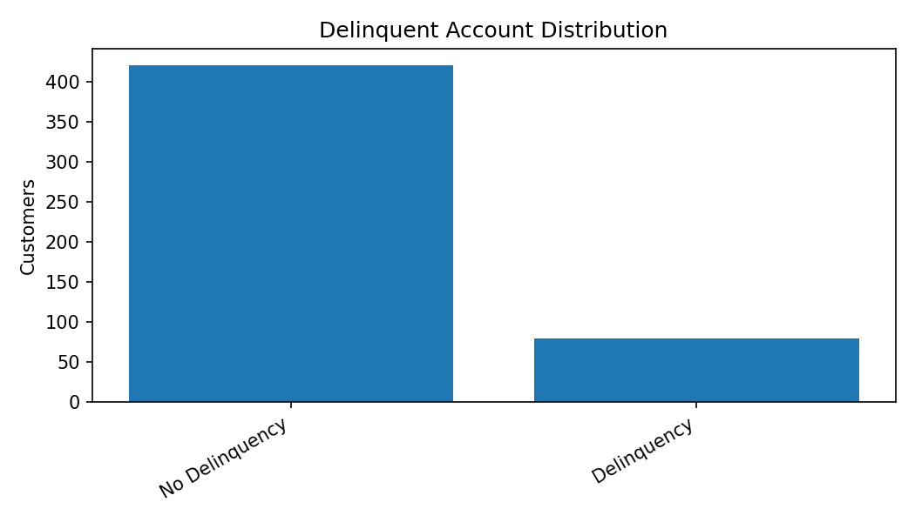
The dataset is imbalanced: 80 customers are marked delinquent and 420 are non-delinquent. This means a future classification model should use metrics such as precision, recall, F1 score, and AUC-ROC rather than accuracy alone.
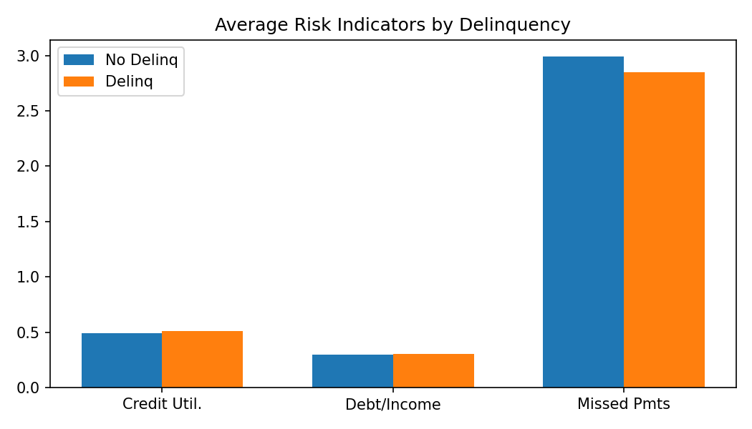
The strongest linear relationships with the target are weak in this sample. The highest absolute correlations are Income, Account_Tenure, Credit_Score, Debt_to_Income_Ratio, and Credit_Utilization, but all are close to zero. This suggests that feature interactions, categorical variables, or non-linear models may be needed for stronger predictive performance.
Feature | Correlation with Delinquent_Account | Interpretation
Income | 0.045 | Weak positive relationship
Account_Tenure | -0.040 | Weak negative relationship
Credit_Score | 0.035 | Weak positive relationship
Debt_to_Income_Ratio | 0.034 | Weak positive relationship
Credit_Utilization | 0.034 | Weak positive relationship
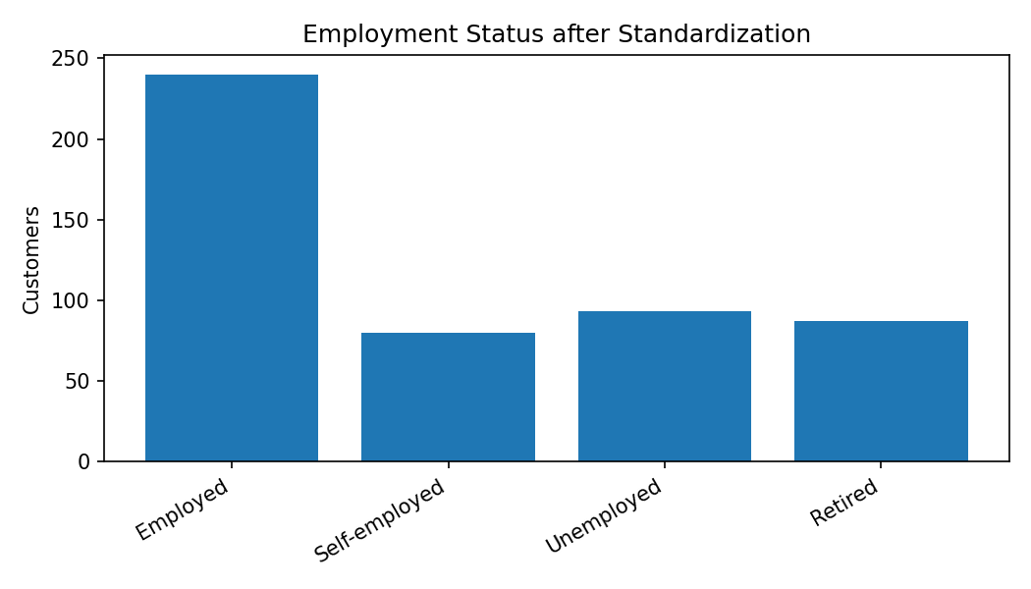
Employment status had inconsistent labels. After standardization, the main categories are Employed, Unemployed, Self-employed, and Retired.

6. AI & GenAI Usage
Generative AI was used to structure the EDA report, suggest imputation choices, summarize risk indicators, and create clean project deliverables.
- Summarize key patterns in the delinquency prediction dataset and identify anomalies.
- Suggest an imputation strategy for missing numerical credit-risk variables.
- Create an EDA summary report using the provided template.

7. Conclusion & Next Steps
The dataset is suitable for a credit-risk classification project after cleaning. The next steps are to encode categorical variables, split the dataset into training and testing sets, handle class imbalance, and build baseline models such as Logistic Regression and Decision Tree. Model evaluation should focus on recall, precision, F1 score, confusion matrix, and AUC-ROC.

References from Uploaded Files
- Dataset Description Guide: column meanings and target-variable context.
- Imputation Guide Handout: mean, median, and mode imputation rules.
- EDA Summary Report Template: structure for introduction, overview, missing data, findings, AI usage, and conclusion.
- Tata Data Analytics Glossary: definitions of EDA, imputation, delinquency, AUC-ROC, precision, recall, and F1 score.

