**Lab Assignment-4**

**Activity Recognition Web services:**

**This is an extension to our android app, with a new feature of saving the sensed data. Android application is included with a button of “save” for this purpose. Sensitive data from the sensor tag are been noticed from android device and are grasped accordingly. Once save is clicked the whole data will be stored into respective files as given in the code.**

**Mere aim of this lab is to include the necessary data of gestures “left to right”, “right to left” and “top to down”. All the data is taken into files so_lr, so_rl, so_td respectively. And are pushed onto the cloudera machine. I belong to group 8 so I pushed all my files into group-8 using Winscp.**

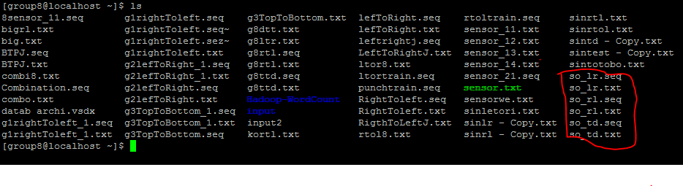

**These are the list of files on group 8, red bordered are the files generated by me.**

**1. Segment and convert to sequence file for Training file**

Input file :home/group8/so_lr.txt Output file : home/group8/so_lr.seq

Data below is the screen shot of how the sensor sensed the gestures as the movements from left-to-right is made. Repeated moments are done and the reading are taken automatically. So on running below url the data is converted from just the sequence of readings to readings established with the start and end bounds as shown below.

http://134.193.136.147:8080/HMMWS/jaxrs/generic/TrainFileOperation/-home-group8-so_lr.txt/-home-group8-so_lr.seq

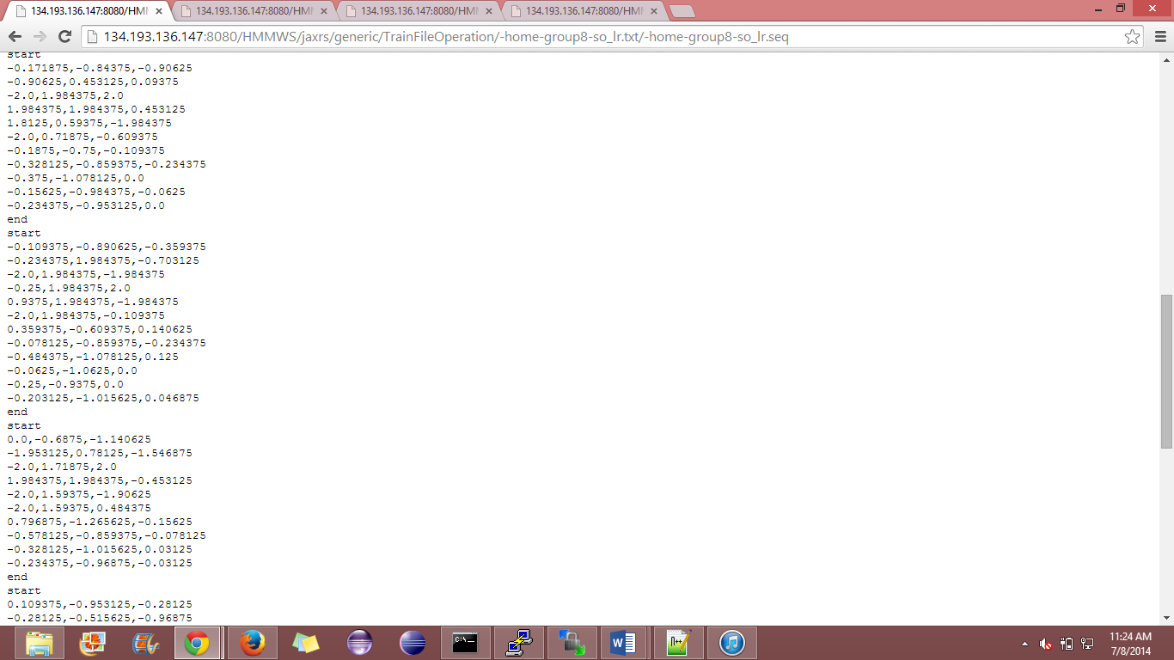

Input : home/group8/so_rl.txt output:home/group8/so_rl.seq

Same procedure is repeated for the capturing gestures dimensions as the sensor tag is moved from right to left. Data is collected saved and is converted into sequence file.

<http://134.193.136.147:8080/HMMWS/jaxrs/generic/TrainFileOperation/-home-group8-so_rl.txt/-home-group8-so_rl.seq>

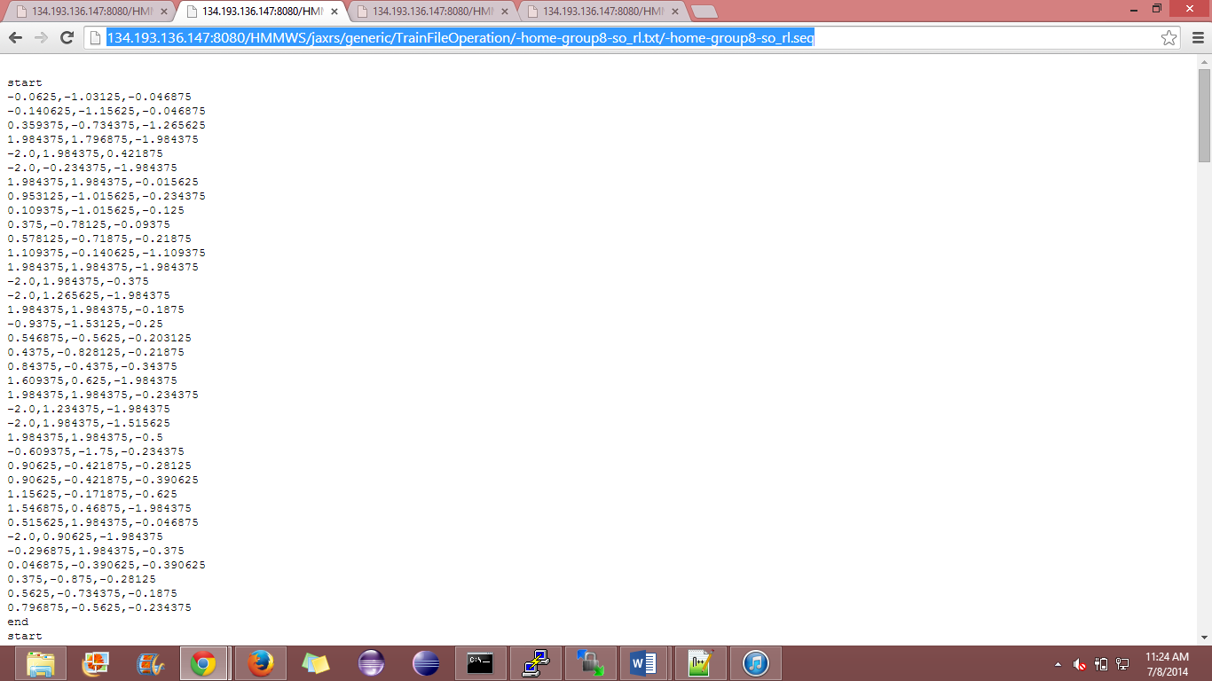

Input:home/group8/so_td.txt output: home/group8/so_td.seq

Now the motion is changes from horizontal movements to vertical movements and below is how data is visualized after text file is converted from txt to seq file.

<http://134.193.136.147:8080/HMMWS/jaxrs/generic/TrainFileOperation/-home-group8-so_td.txt/-home-group8-so_td.seq>

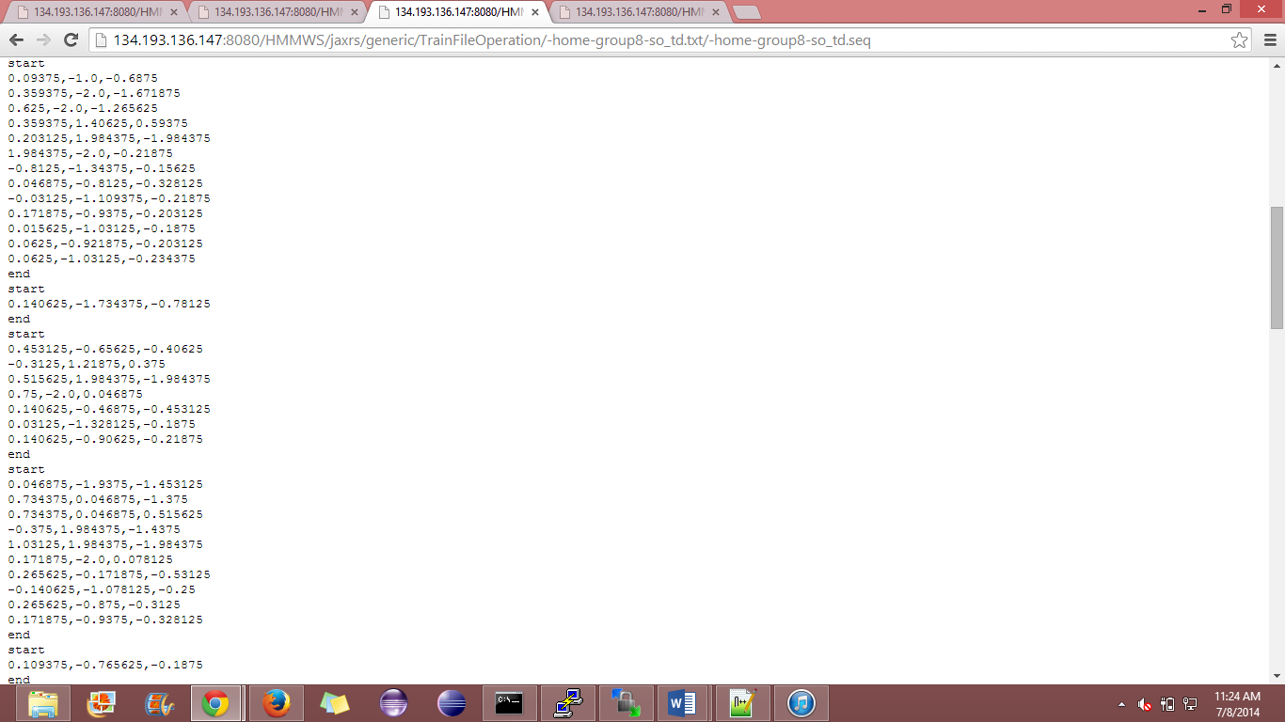

**2. Training and Testing for Activity Recognition (for three motions as training data):**

**In this step a combination file is to sense as all gesture motions are captured together into a single file. Combination left-to-right, right-to-left and top-bottom. Data thus collected is now converted from txt file to sequence file. Untill previous step it is all of the training of the data that is been done and now the critical step of test the exact activity is to be tested. As given the gesture measures are sensed and is passed to the cloud era. On running the url it converts the file from txt to seq file.**

**Input: homw/group 8/so_test.txt**

**Output:home/group8/so_test.seq**

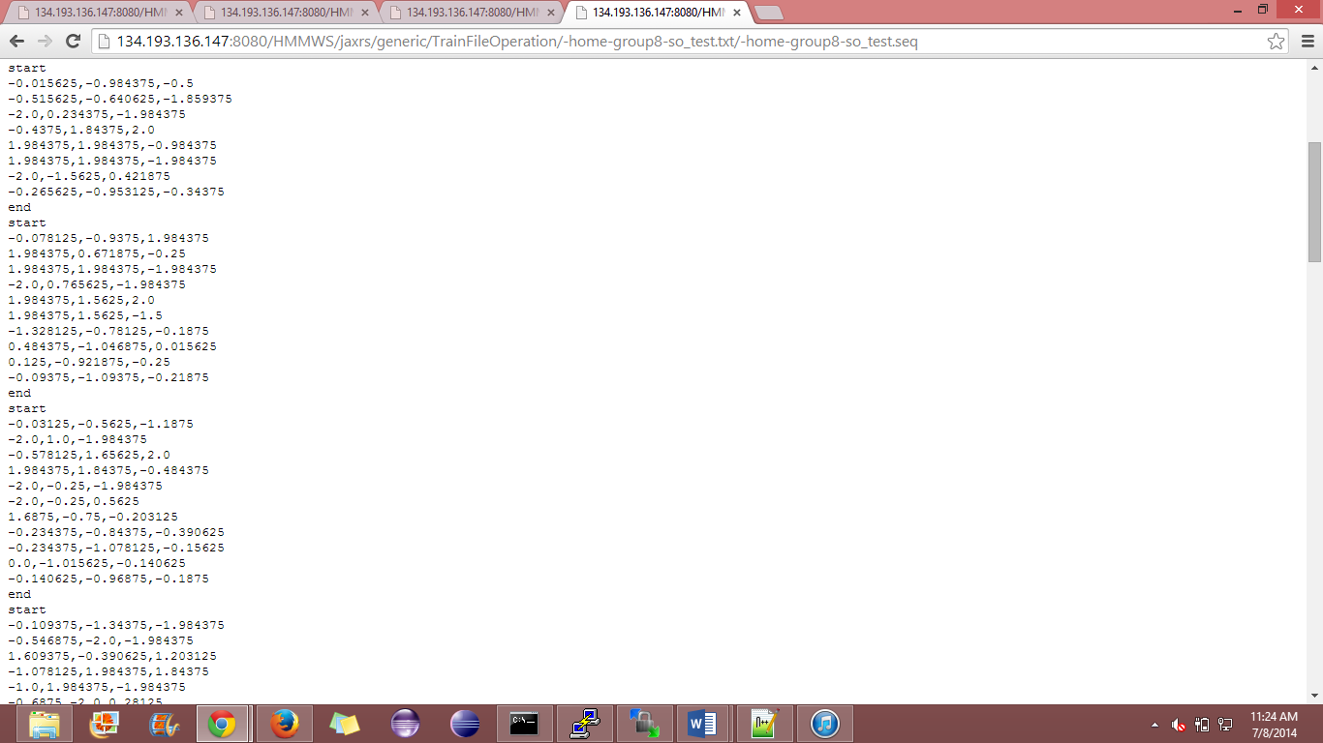

Below is how a generated sequence looks like

