Lab 2

Step1:

Initial step is to choose any four services out of Time, GPS, Acceleration, Temperature, Humidity, Signal Strength, Gyroscope, Pressure, etc. As taken from the blackboard app1-app3-SensorTag which is a mixed version of first and third apps, I used the same for current application and have chosen humidity as an extra added feature.

There after edit the code as needed looking into the <http://www.ti.com/> for more info of the Sensor Tag features. Collecting the necessary information into a text file by running the service in an android device(Nexsus-7).

Save the text file on to the system.

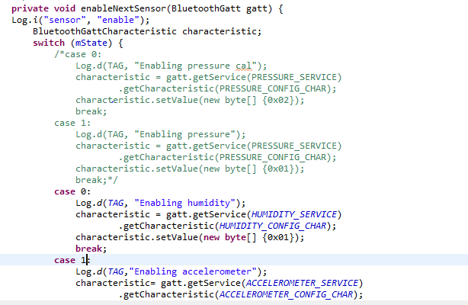

Above is obtained by uncommenting the needful lines of code.

Major functions for concentrating are

enableNextSensor --- for enabling the devices

readNextSensor—read the value

onConnectionStateChange—for appropriate values of changing

Step2:

Getting values of four considered features into the text file.

Below shows the name of the Sensor text file generated



Below is the view of the data

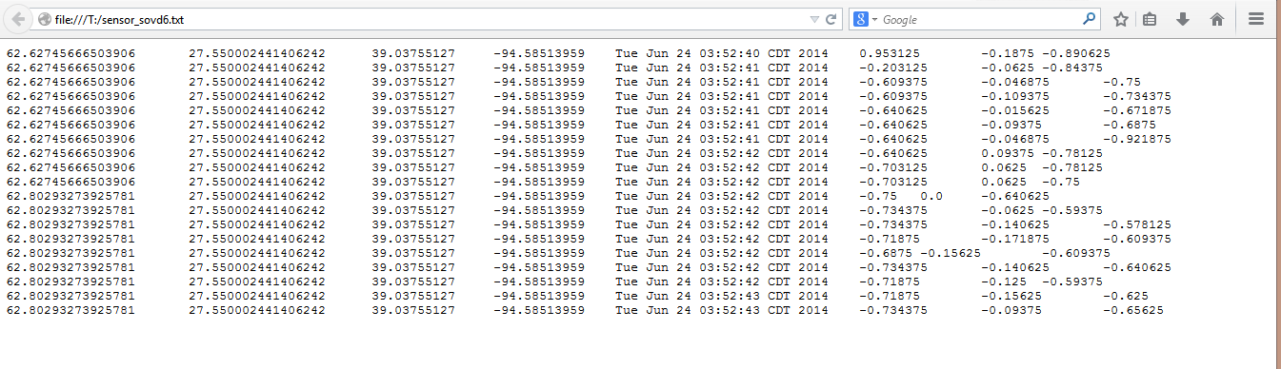

Step3:

This step involves the working of HbaseClient as downloaded from the blackboard. Following the instructions for appending the code so as to include the new variables for making relevant entries into the table.

Table is created with the name Sensorg8



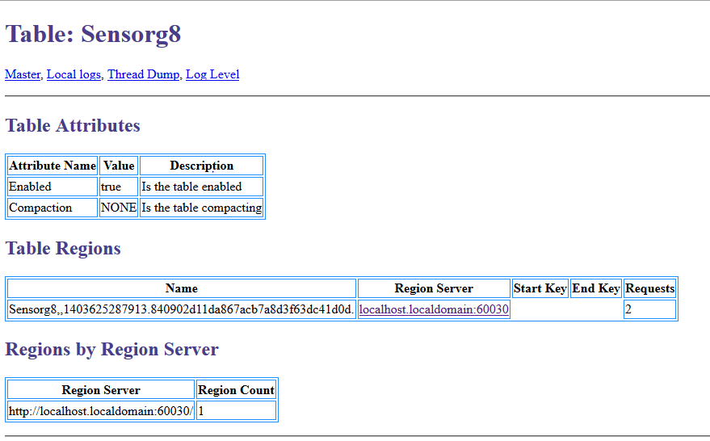

Important to note that the functions other than create are been comment for making them to remain inactive.

Below shows that code edited using the eclipse.

Before doing all these the local host has to be edited on hosts file.

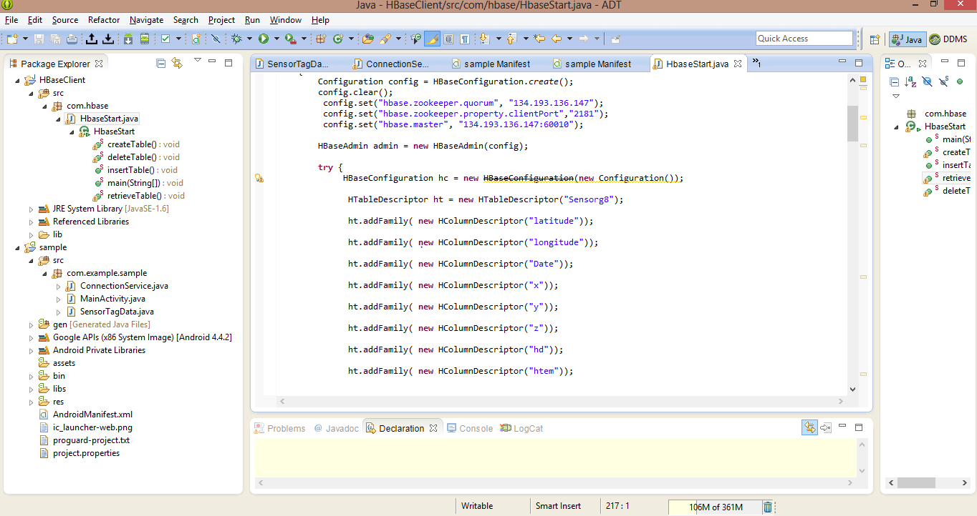

Next use the Insert function this uses the values of the text file generated and puts them into the column family of the table that is just created.

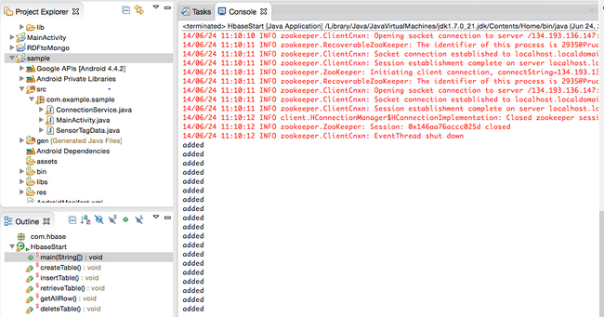

Retrieval function works for retrieving the info and screen shot looks as shown below

