Restful web service for designing a calculator.

1. Inorder to create a restful web service open visual studio and create new wcf service application.

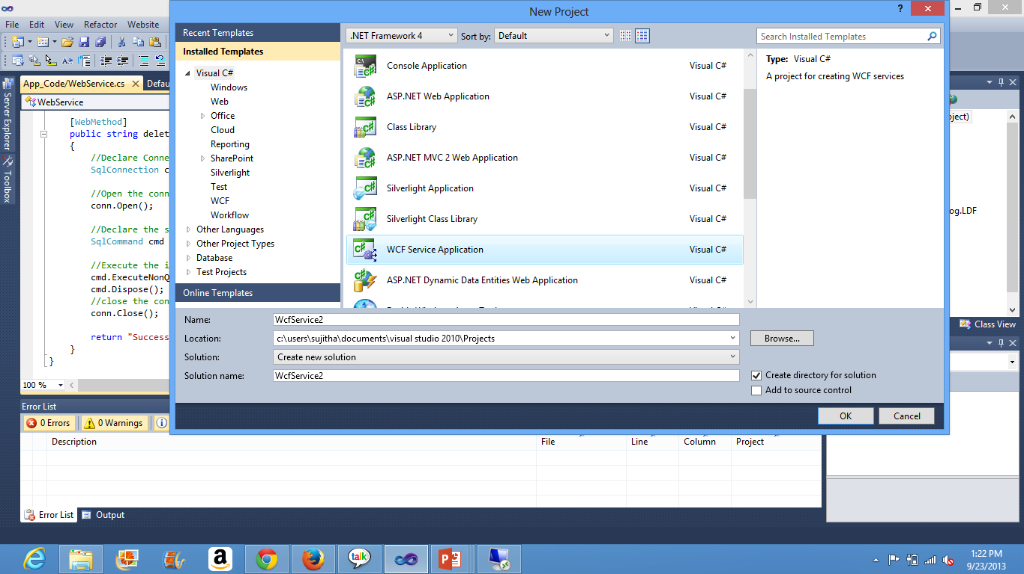

2. Declare the necessary interfaces under IService1.cs using the [OperationContract].

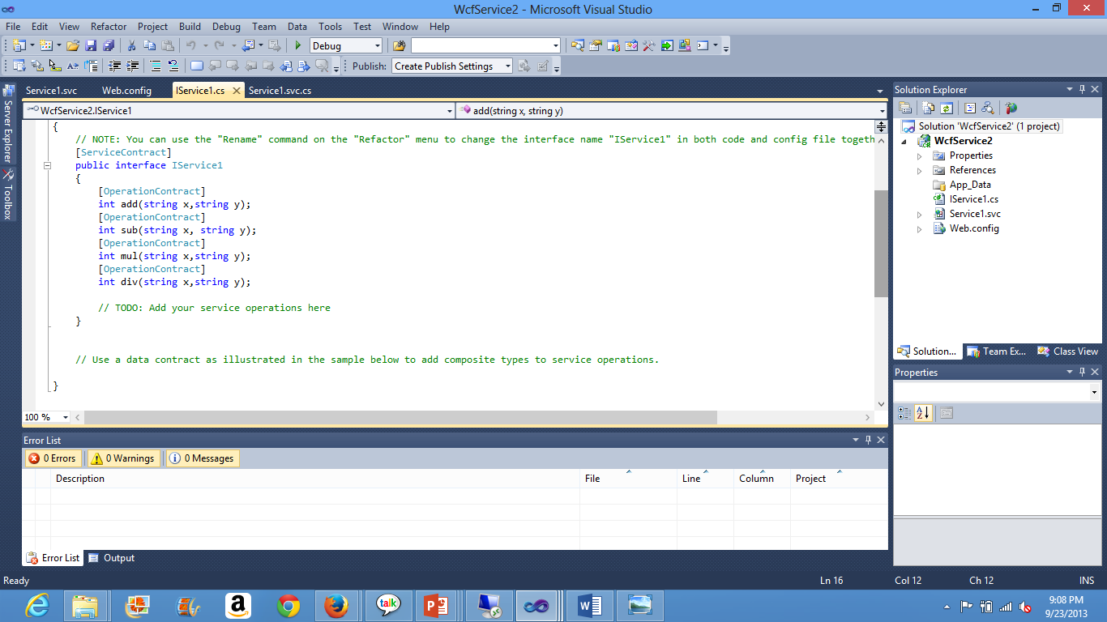

3. Now the declared methods in the interface are to be defined in the WcfService.svc file.

Important is to mention the necessary URL template i.e. the intended URL giving suppose addition of 9 and 8 this will be to the url as **url…/add/9/8.**

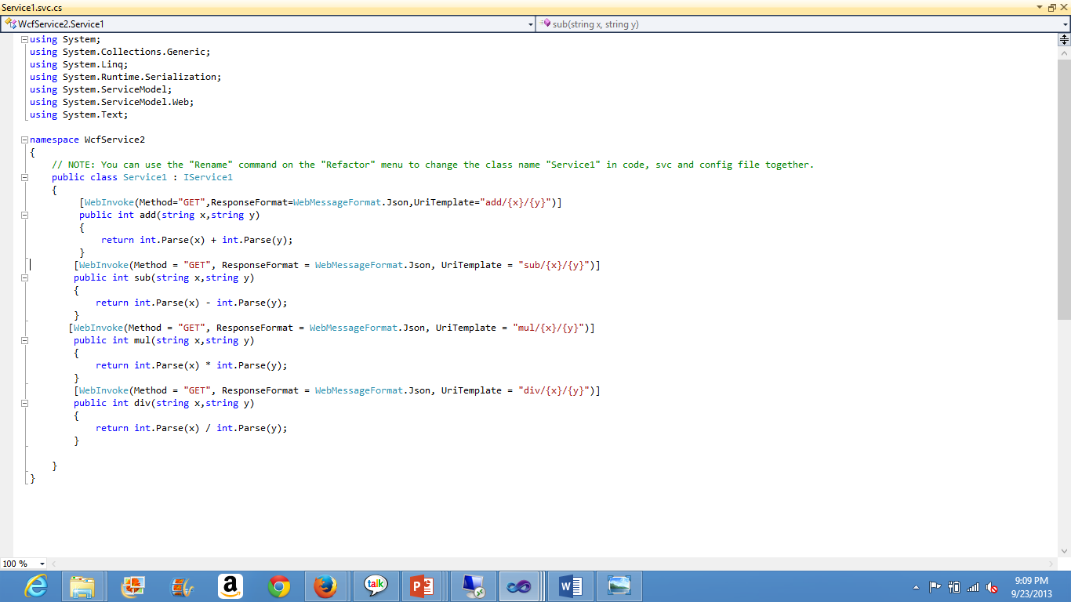

4. Right click on the Service.svc and for view markup. And append the Factory=”System.Service1.Activation.WebServiceHostFactory”.

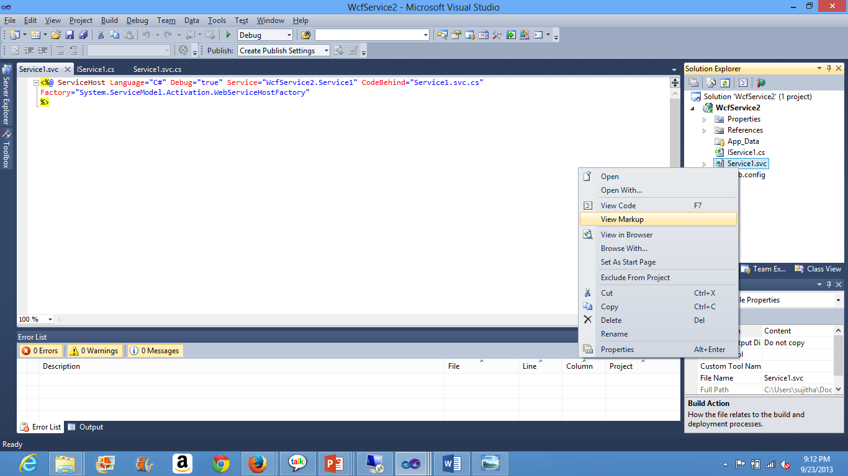

5. Right click on the Service1.csv and opt view in Browser for the display of the output.

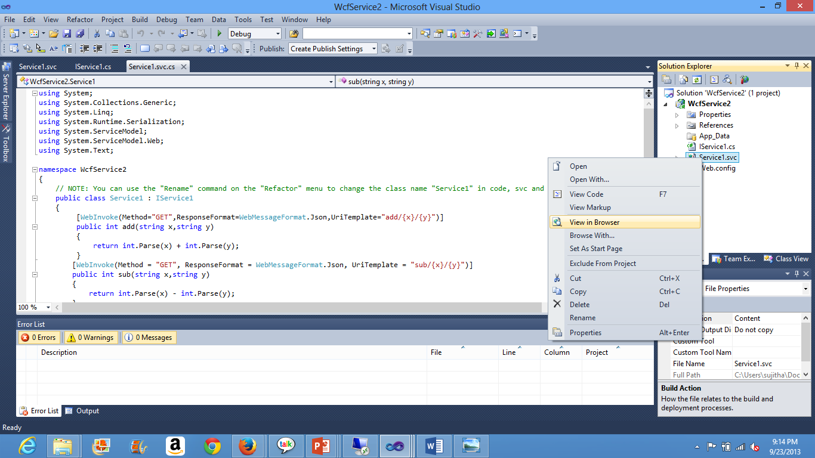

6. The following will be displayed. Endpoint not found this is shown as there is no corresponding function. Hence we append the URL with the intended inputs.

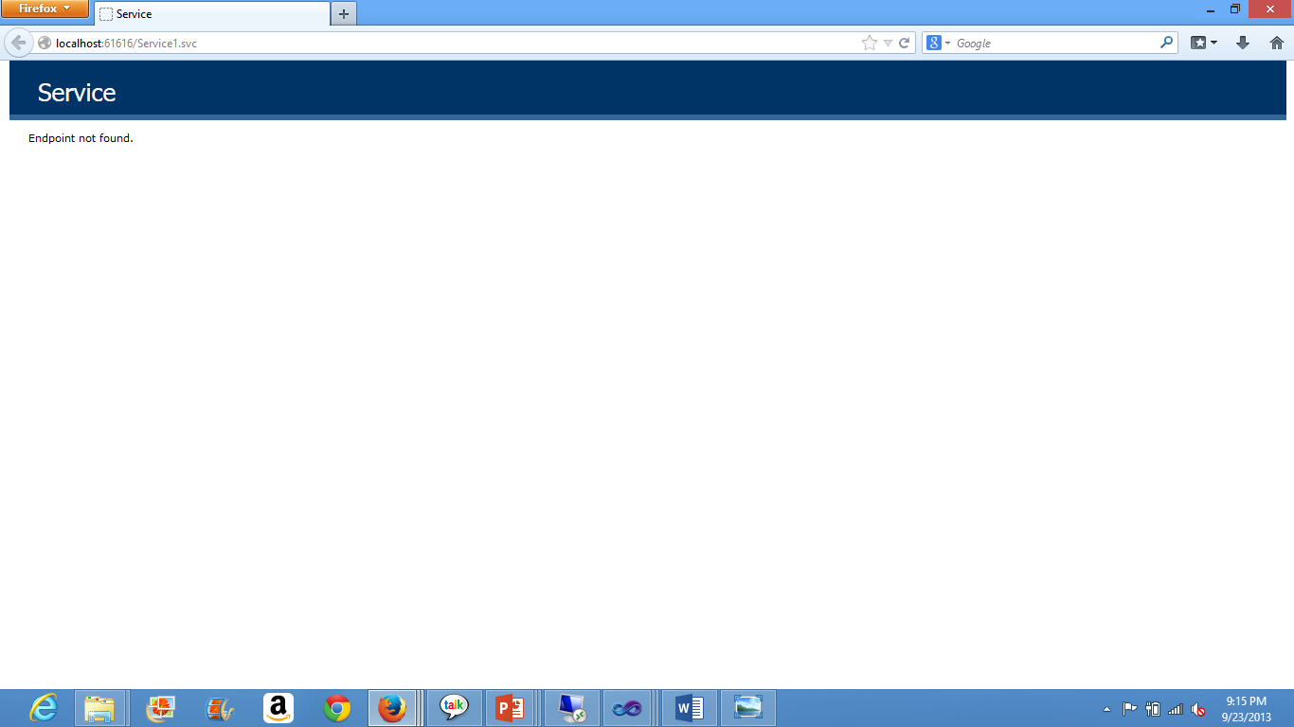

7. <http://localhost:61616/Service1.svc/add/1/2> if the URL is given this way. The system considers the appended and retrieves the necessary inputs directly without any user’s involvement.

Add means addition and the later /1/2 indicates the two input numerical. 1 as x and 2 as y. Finally addition operation is computed and the output is displayed as 1+2=3. 3 is displayed on the browser.

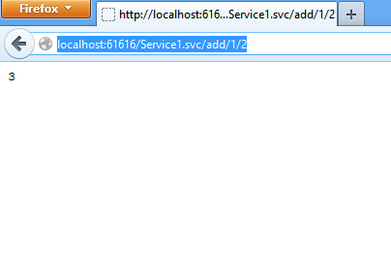

8. Now the Wcf Service is to be deployed at the cloud end using the IIS server. For this remote desktop connection is opened after logging in into the ibm cloud instance. Vhost name that is assigned for instance will be used to login the remote desktop connection. Wcf is copied into the server end under the asp-client under c drive. C:\inetpub\wwwroot\aspnet_client

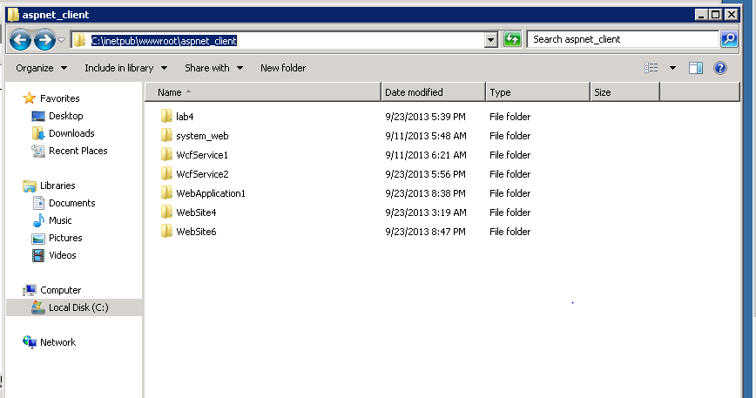

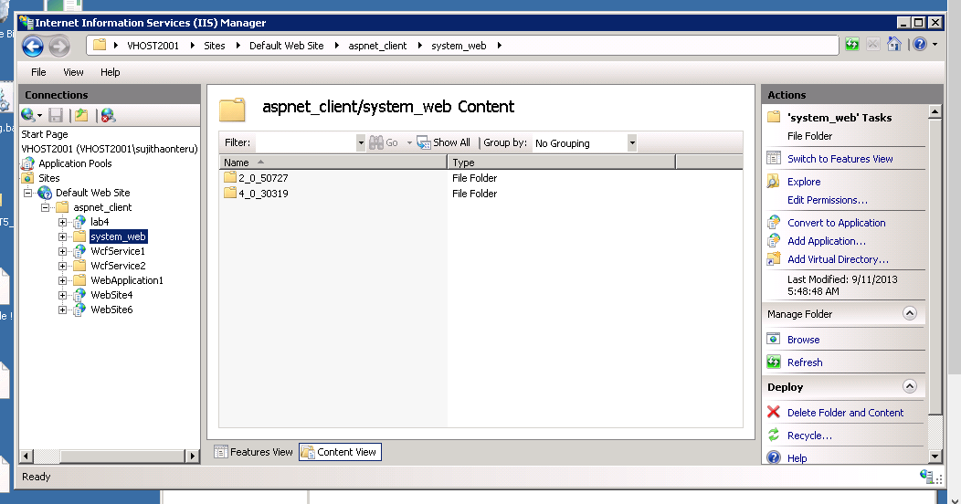

9. Now trace in the vhost until you reach the wcfservice.(WcfService2). Convert the Wcfservice into application. Now edit its permission add IIS_IUSRS allow full control click ok.

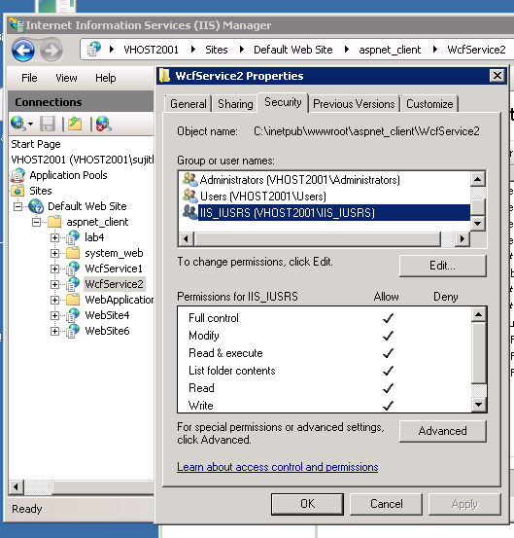

10. Under the Advanced Settings change the default application pool to ASP.NET 4.0. And click ok.

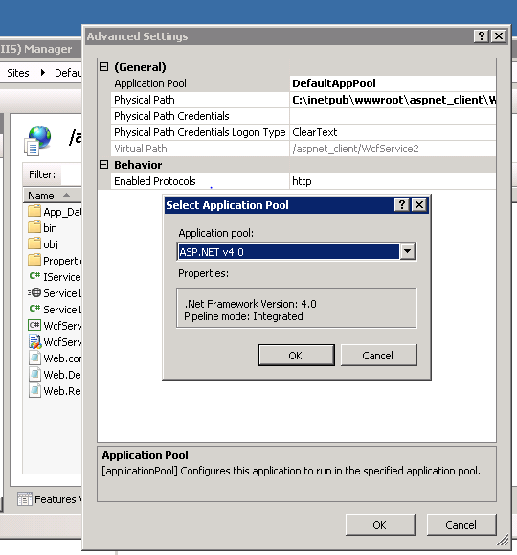

11. Under the content view right click on the Service1.svc and choose browse. It gets opened in the default web browser.

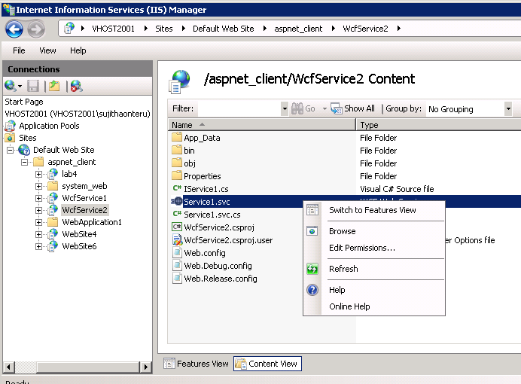

12. Opening it we a screen saying end point not found. Now append the string with add/2/6 it now displays to save a local host file.

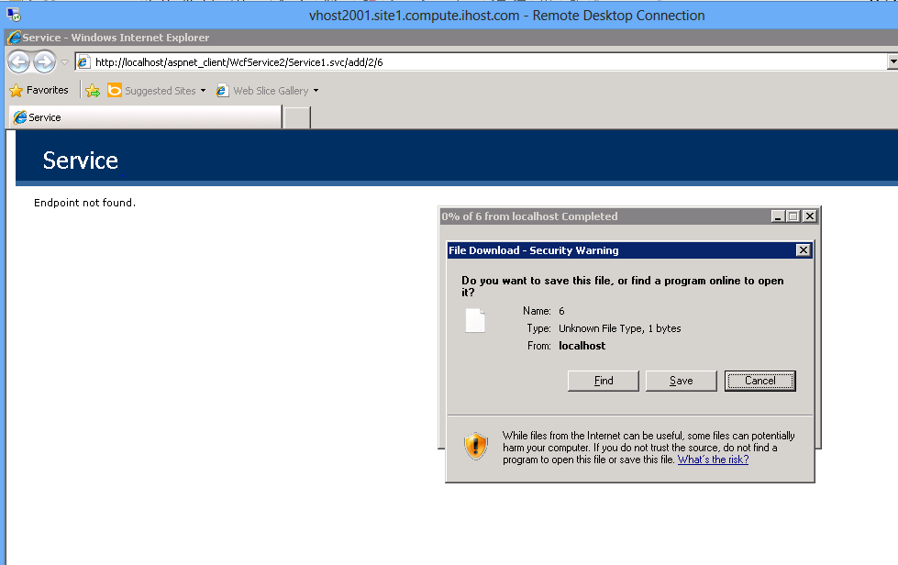

13. Now change the localhost to vhost name.

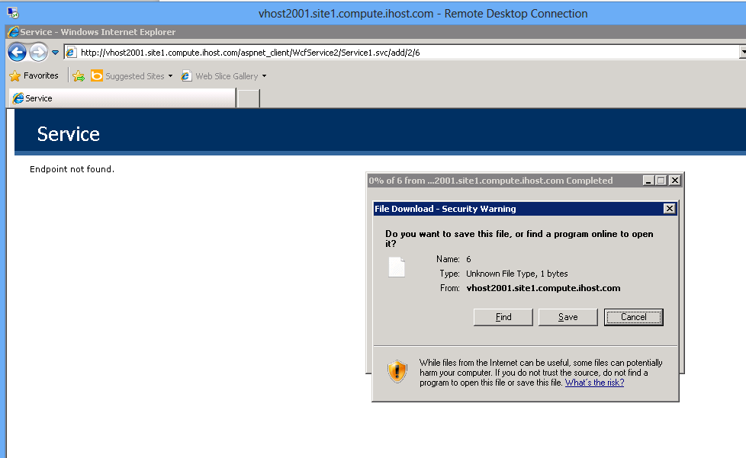

14. Opening it locally on the device shows the following.

