**WSDL application for designing a calculator with +,-,*,/ operations.**

Screen shots with necessary steps

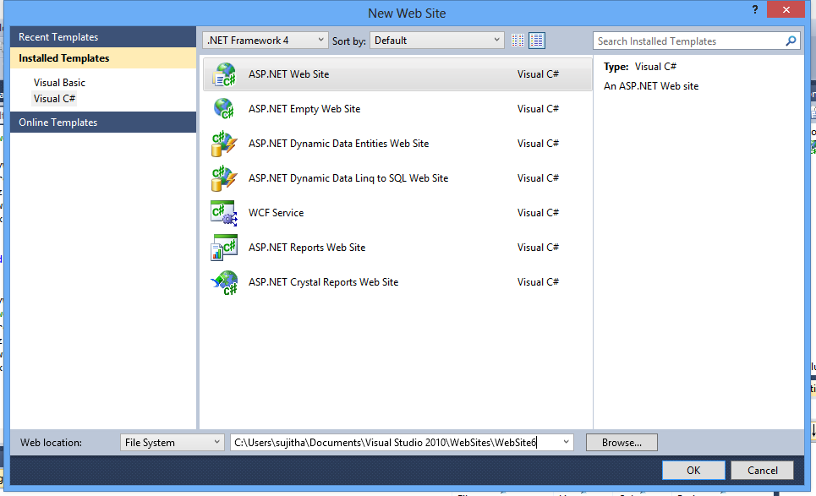

1. Creating a website inorder to create a webservice that can be used for web application further. Name it as ‘Website6’
2. Add a new instance to it. Under C# select Web Service and click add.

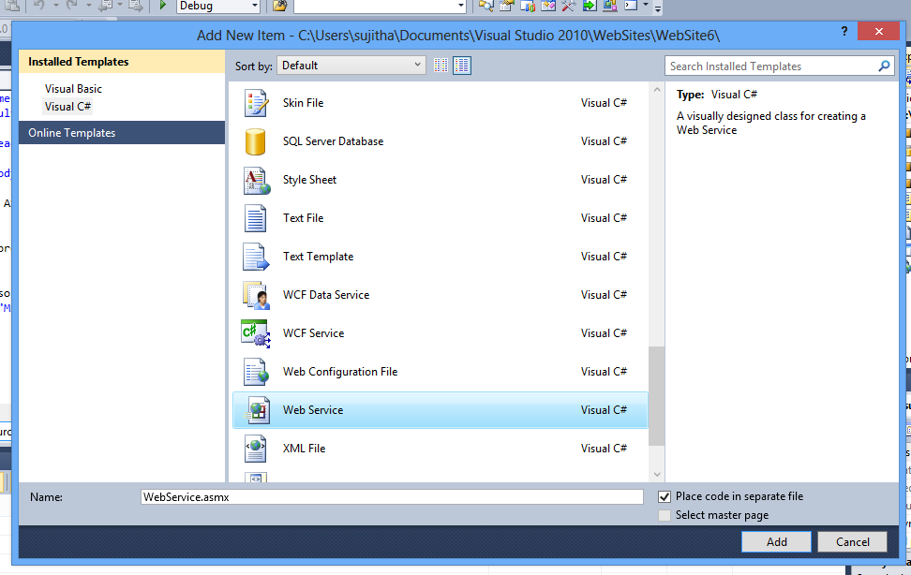

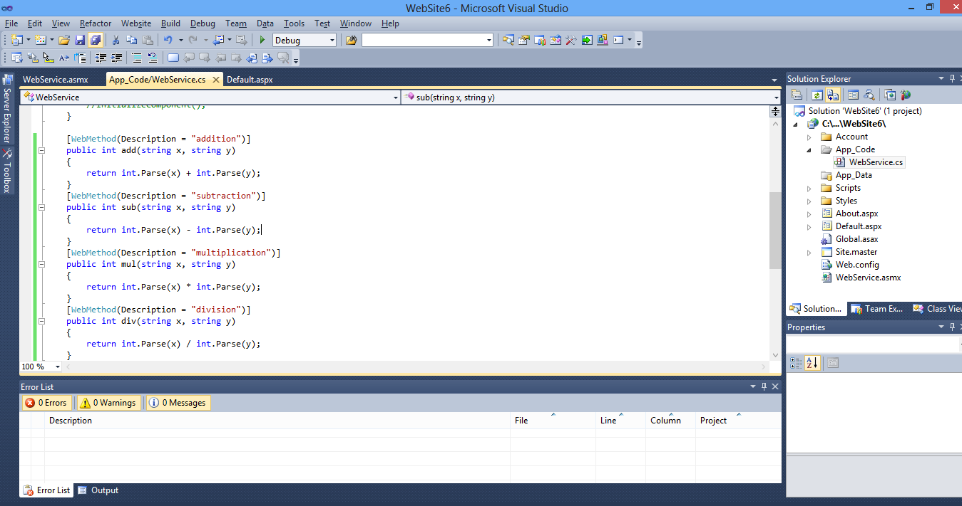

1. Now define methods for add,sub,mul and div for +,-,*,/ operations respectively under WebService.cs.

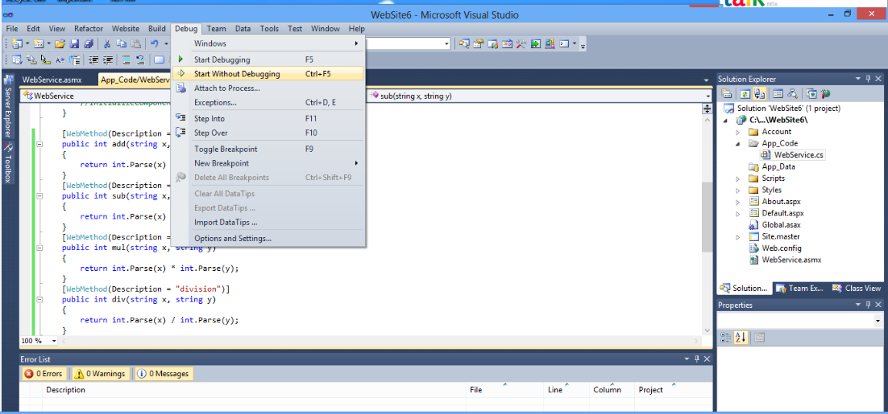

1. Now build the file once the file is successful in building, now debug it click start without debugging. Then the output will be displayed in the default as shown below.

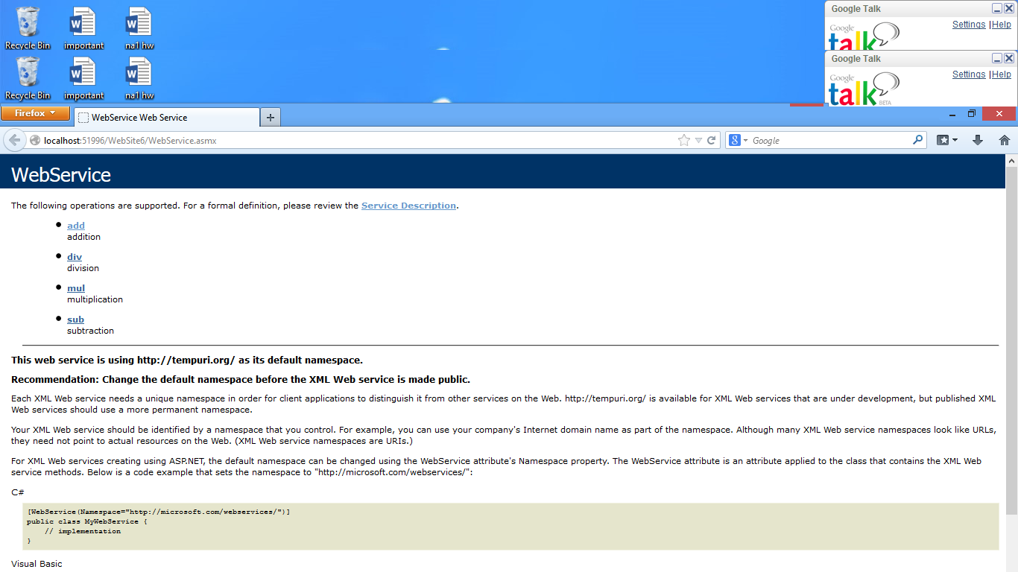

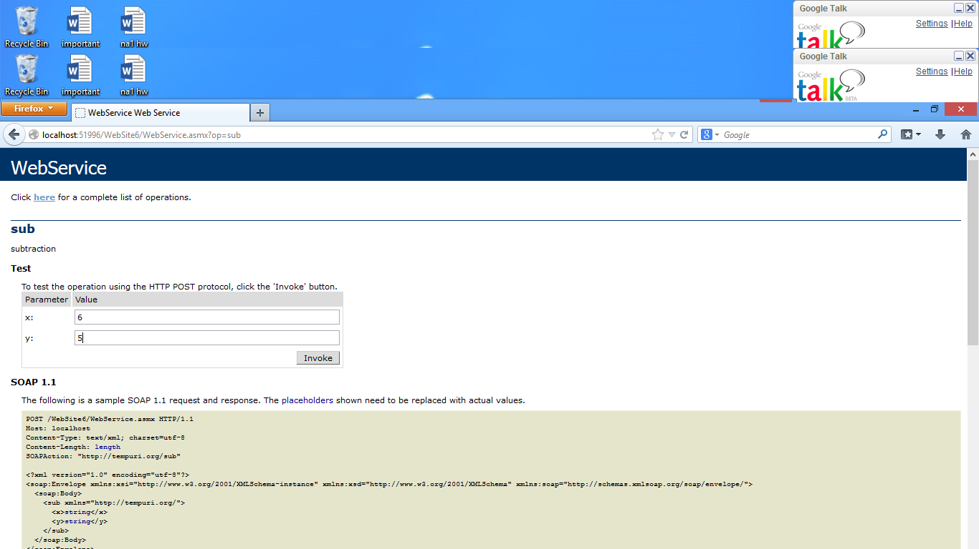

1. As a test example click on either of the hiper links of the functions, then give the two inputs as x and y. the result is computed and the output the Is displayed in xml format as shown below.

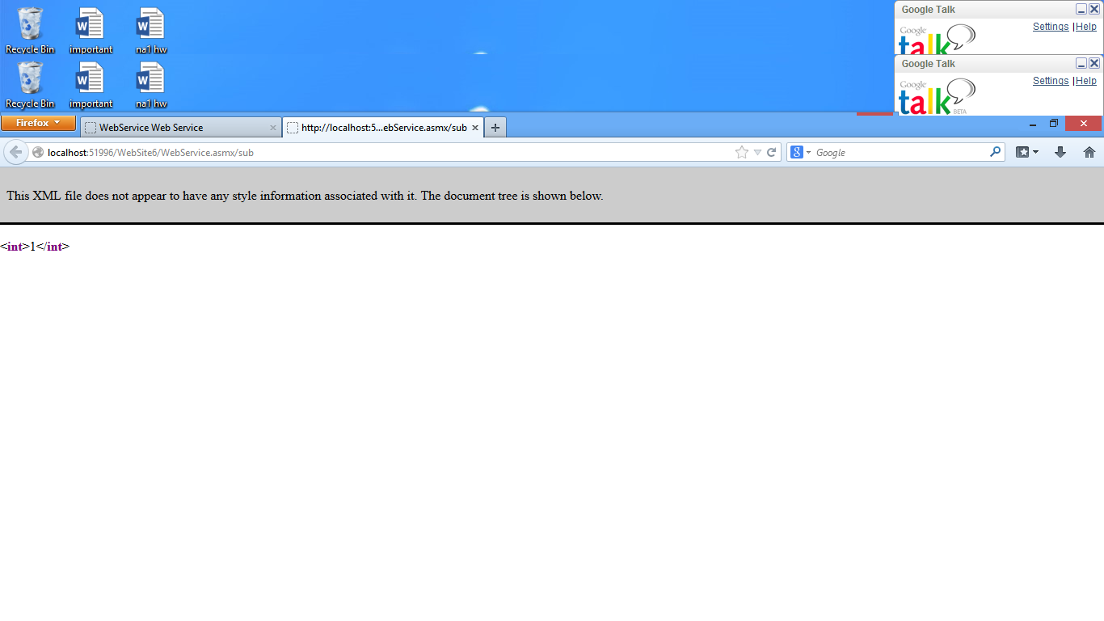

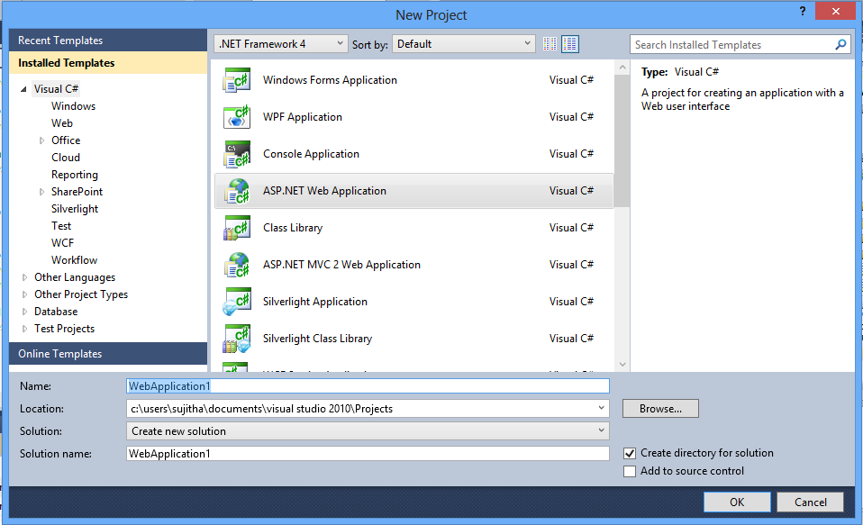

1. Afte succesful computation of the operation now create a new instance of the visual studio and create a web application. Create a calculator gui as shown below.

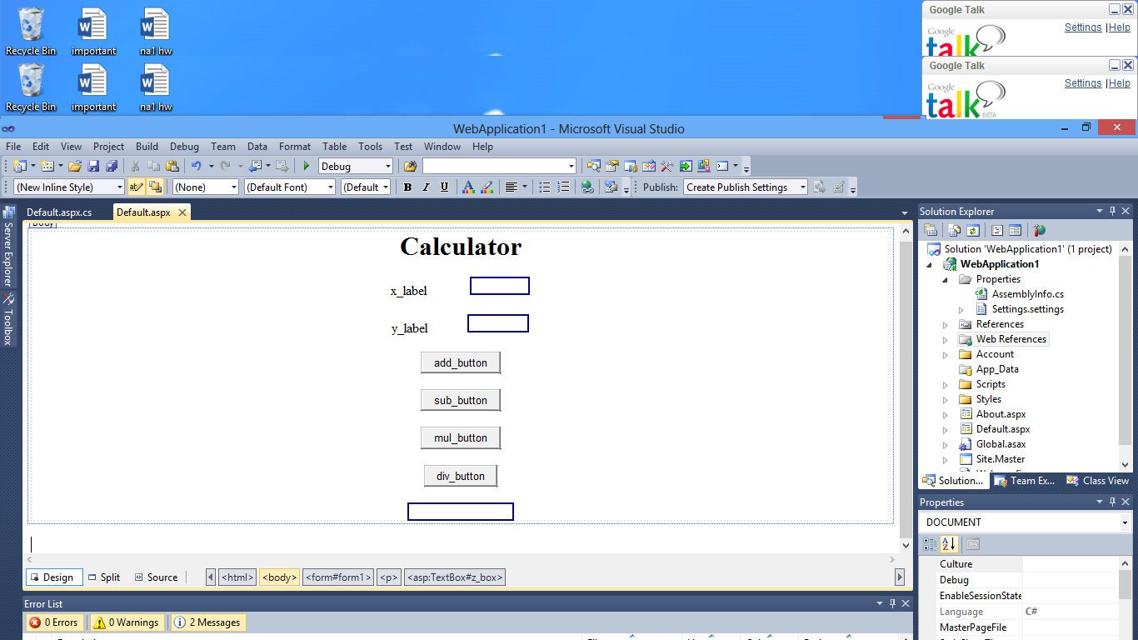

1. Now click on the add button it then redirects you to a page fod default.aspx.cs pointing towards the corresponding button function.
2. Add the web refernce by clicking (right) on the Webapplication and add web reference.

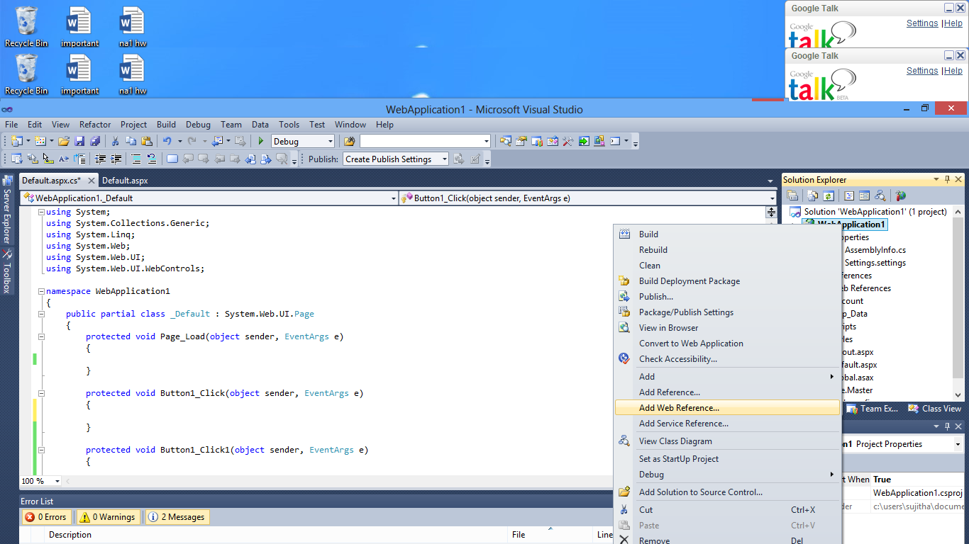

1. Copy paste the WSDL link from the browser, click on go we could then see the wsdl functional code. Thereafter enter a name for the reference and then click on add reference. 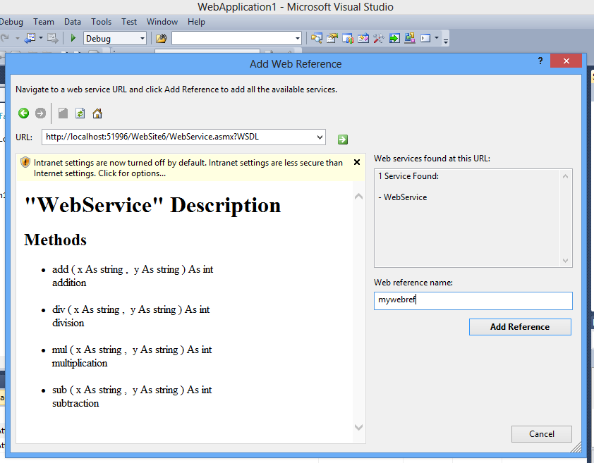

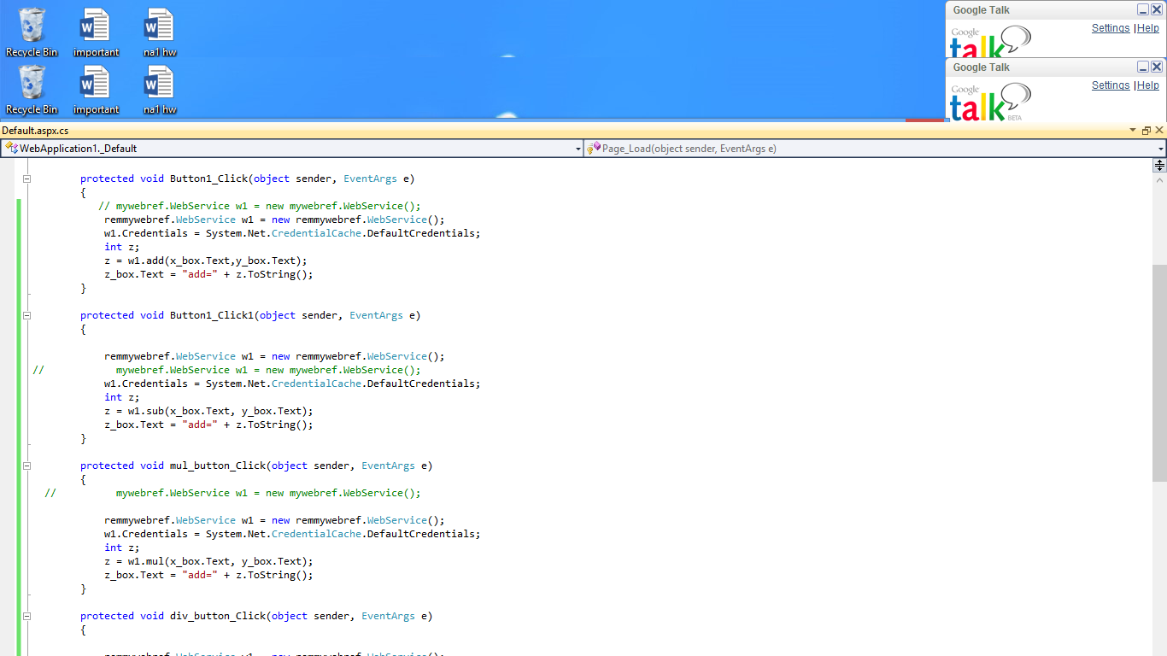

1. Next enter the respective operations code so that they perform the corresponding operation when they are requested for.

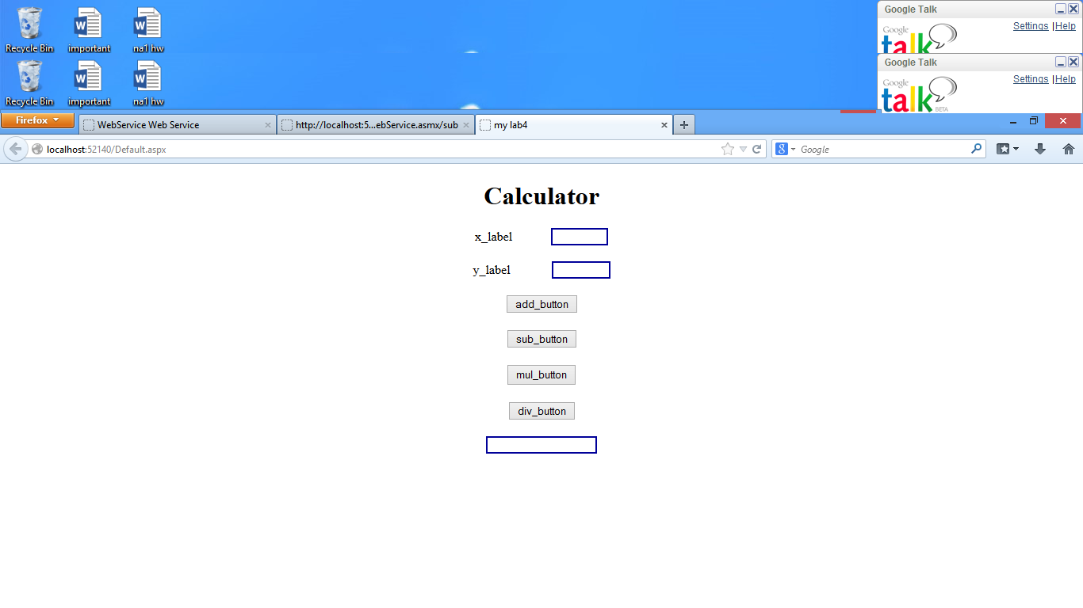

1. Then after write the code by creating a new webservice object. It can be used for calling the elements residing inside the webservice. As reference to the wsdl still exists the webservice object can be directly used.
2. After the page is displayed enter the elemts that are asked for namely x and y. Click on add, the result wil be displayed in the label that is assigned for the display of the output.

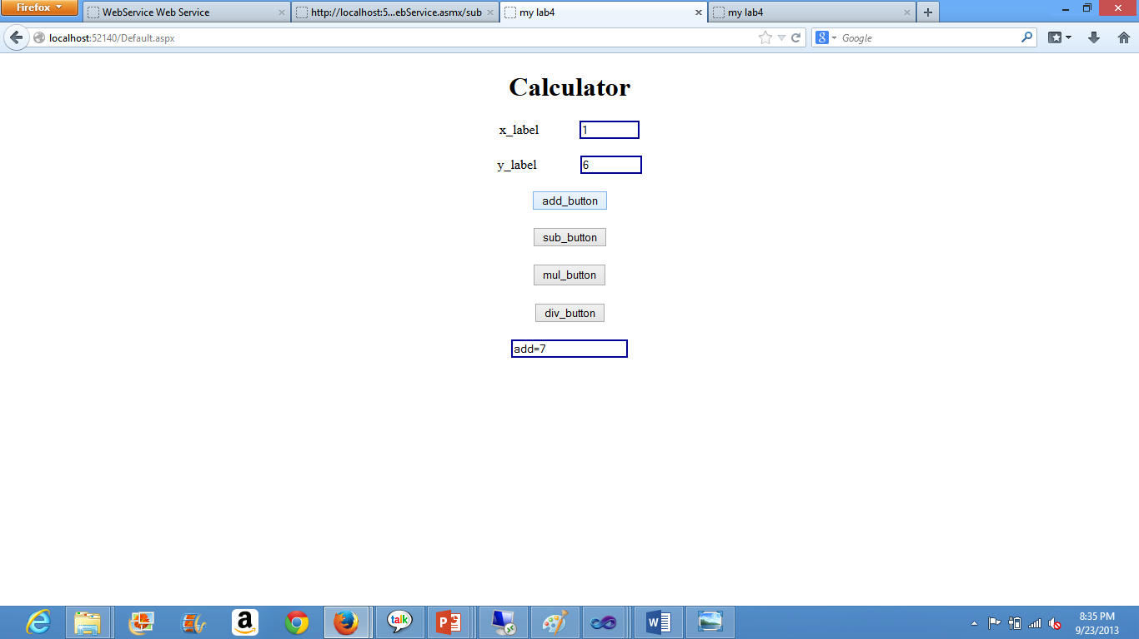

13. Now it is turn for deploying the project on to the cloud. Sign in into the ibm cloud in and use the clouud instance name for the remote desktop connection with the instance uid and password. Copy the webservice from local machine to the remote desktop.

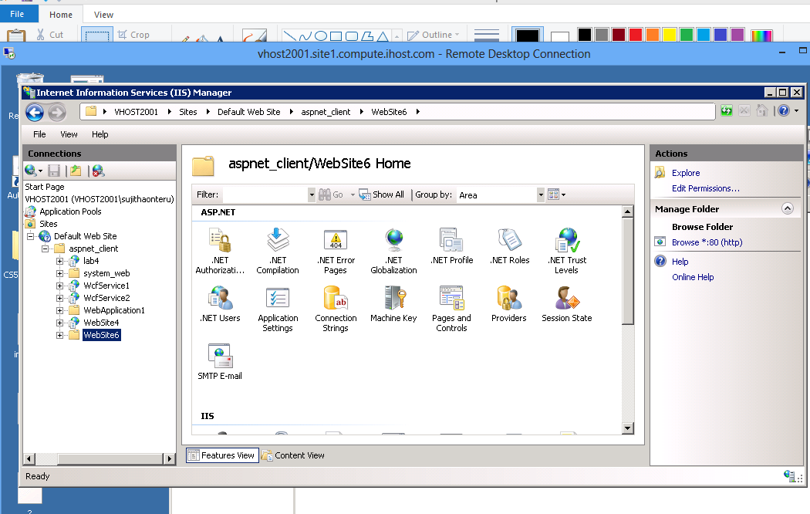14. under local machine it must be placed under the asp-client folder.

15. Now open IIS server and trace the path of the wevsite folder. Right click and convert it as appliation. Then edit its permissions, click on security and add “IIS_IUSRS” allow full control then add.

16.Under advanced setting convert the default pool as asp 4.0 pool.

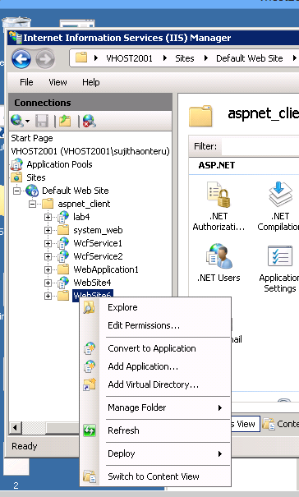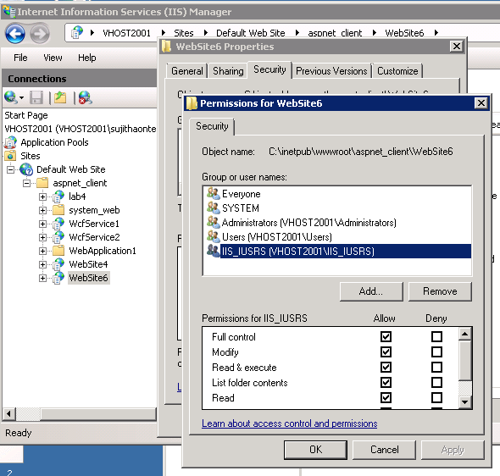

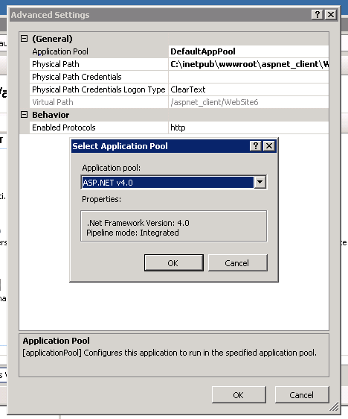

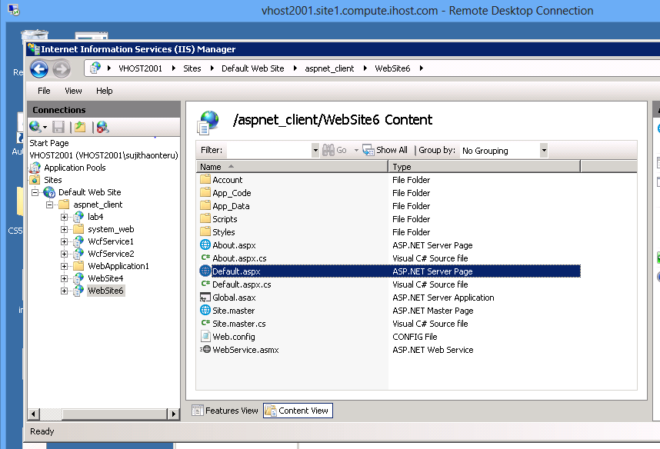

17. Under the content view of the web service opt for default.aspx and open it in browser. As it is displayed in the local machine the same gets displayed. Now use the local host and replace it with the remote desktop name that gets displayed as vhost. Now replace the local host with the vhost.

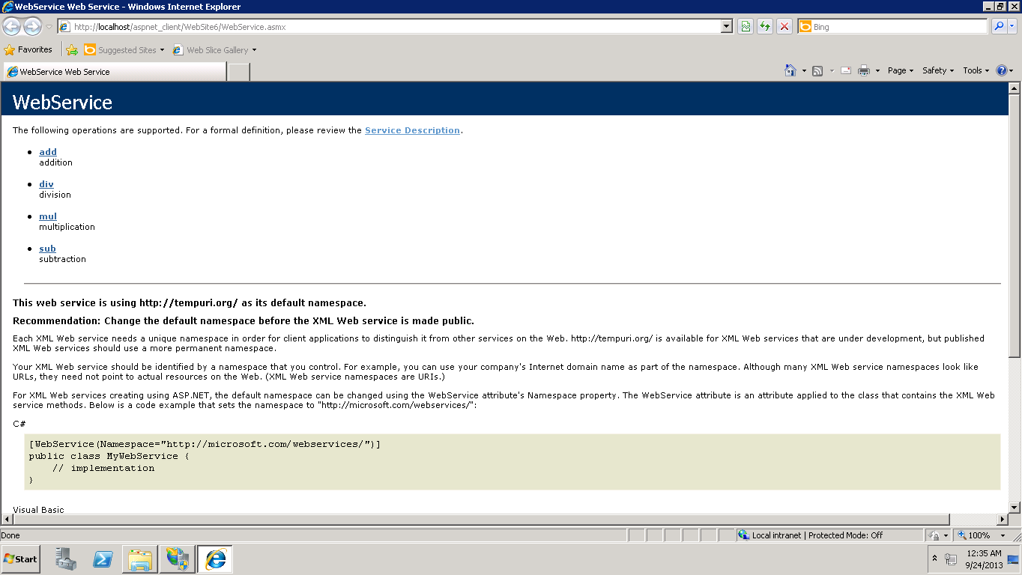

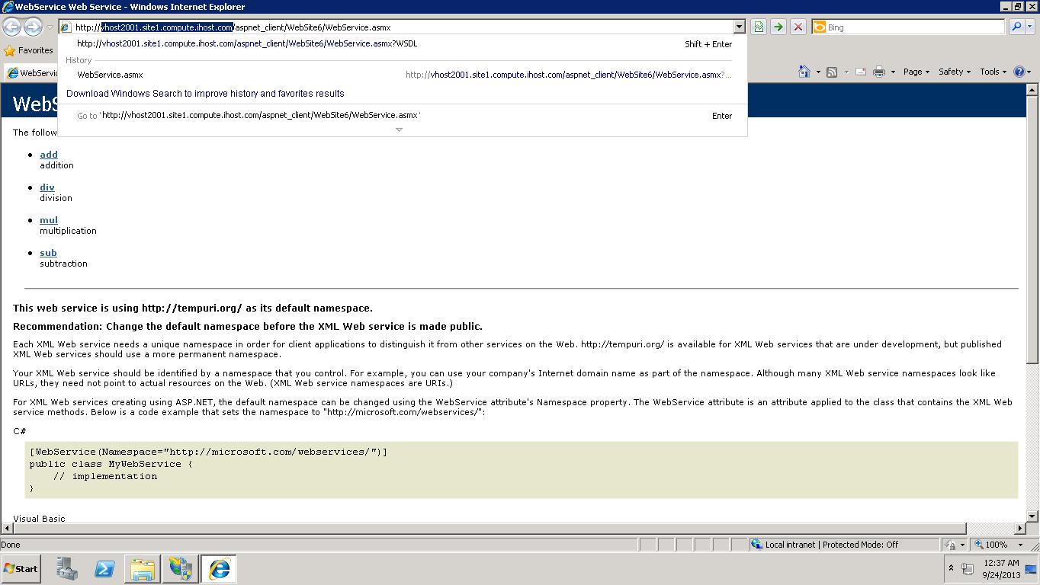

18. Same gets displayed if the connection is successful. Now copy the remote machine link by clicking on the service description and add reference under the web application.



<http://vhost2001.site1.compute.ihost.com/aspnet_client/WebSite6/WebService.asmx?WSDL>

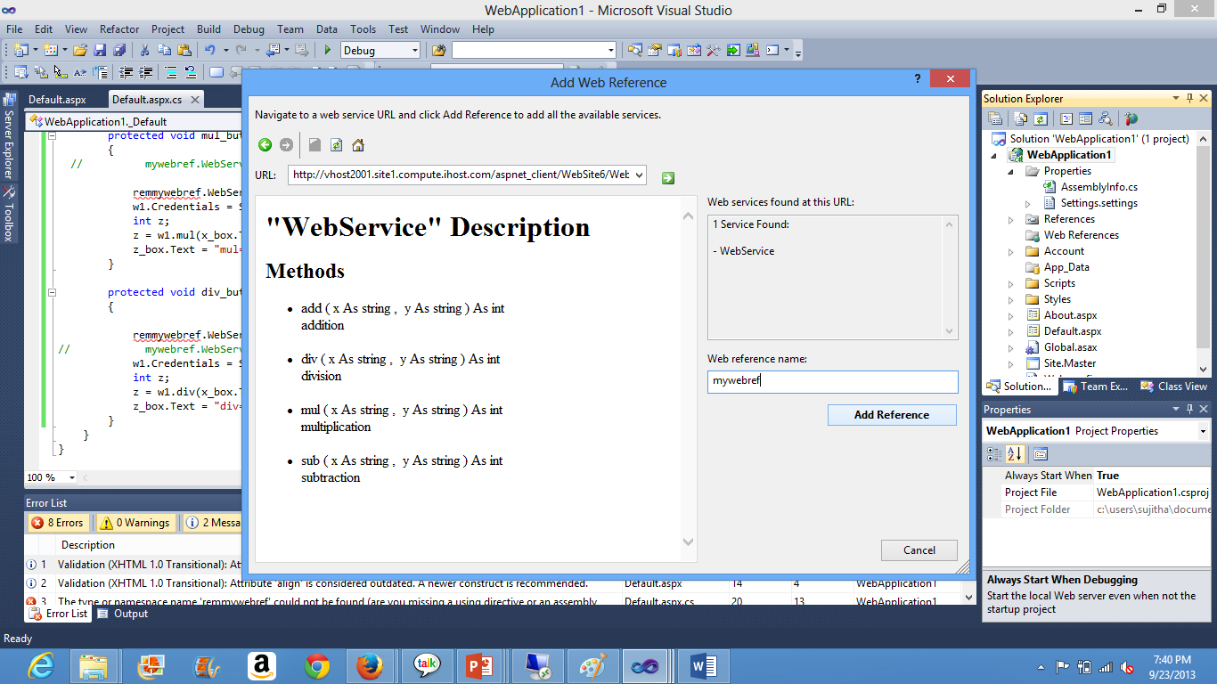

19. Replace the already existing web reference and replace it with the new remote link, give a name and add it. Now change the code according to the modifications in the reference name.

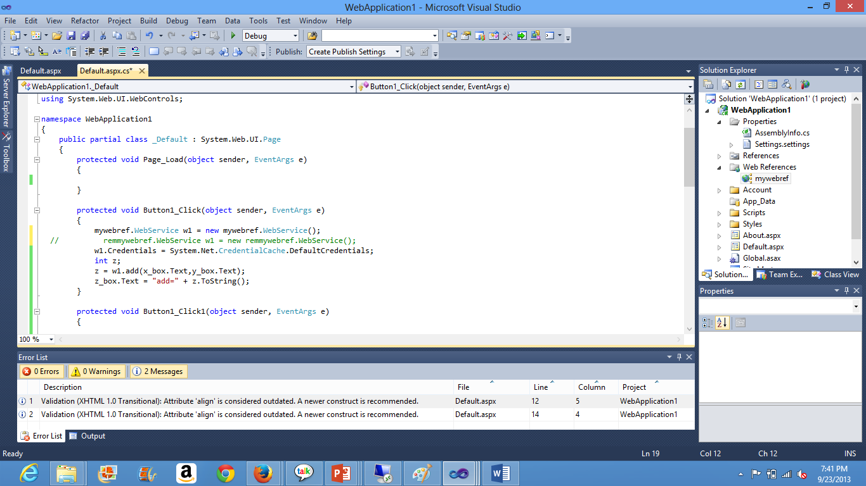

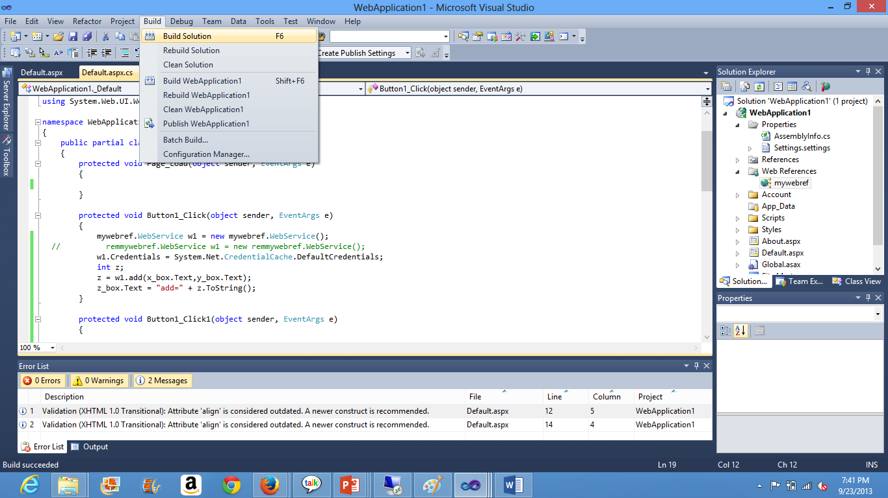

20. Build the solution, after successful building debug it. It is important to choose start without debugging.

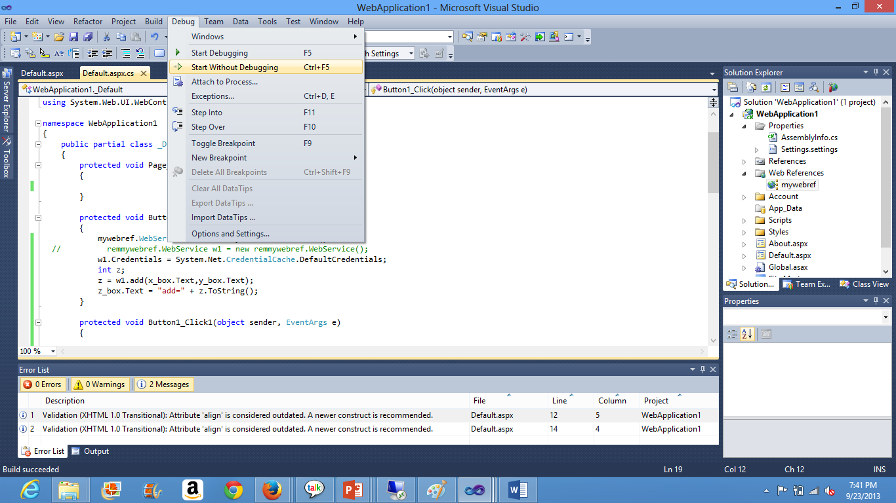

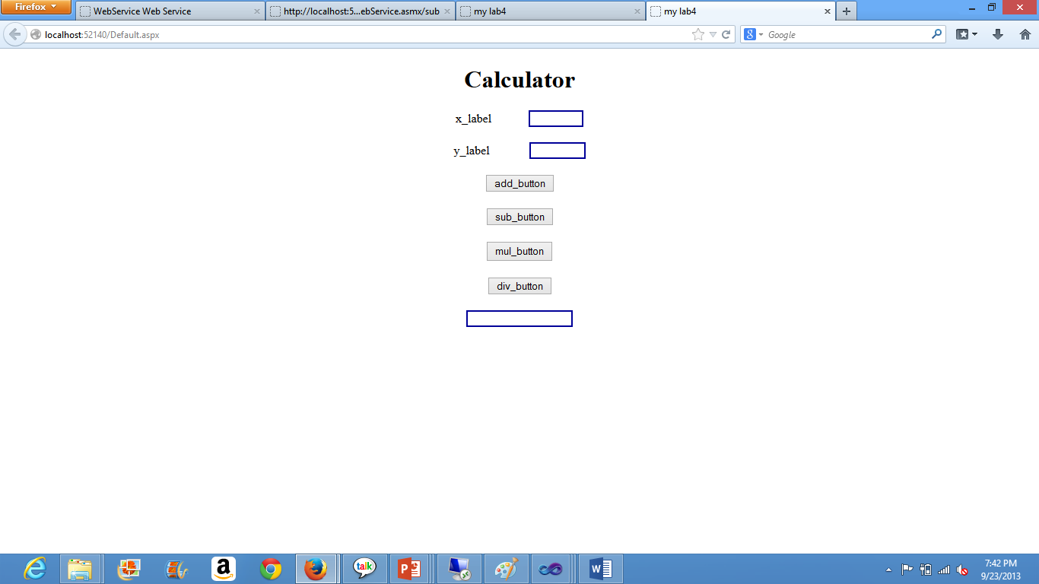

21. If the deployment of the service is successful then the above is displayed now give the numbers for x and y click on the necessary function. The corresponding function’s output displayed on the browser’s screen.

