Report :

1. Design
2. Architcture diagram

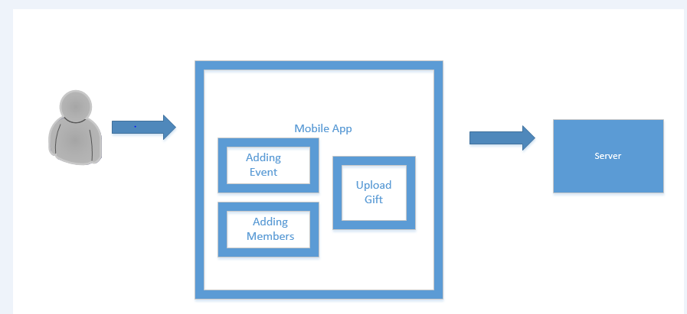

b. Class diagram

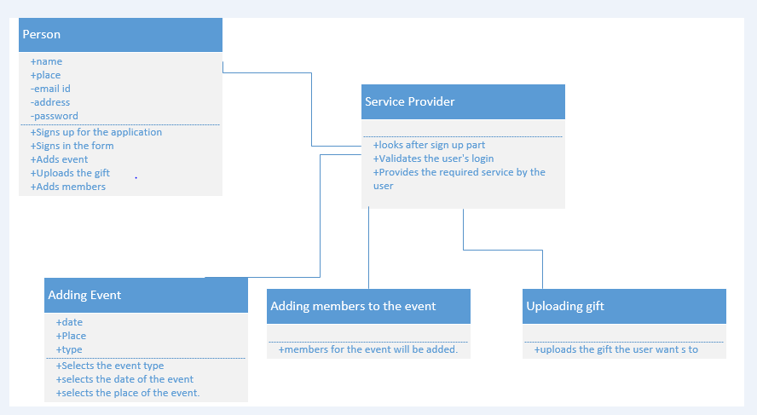

Person includes his details

Service provider looks after his services

Adding events manages the evenst

Adding members about the members for the event

Uploading the gift user handles his repository of gifts.

1. Features Implemented

**Sign up**

Takes in user’s details and saves it for further usage

Details like his name , email address, preferable password and Address. Once user gives them it will now allow him to login.

**Sign In**

Authenticates user o login with his details.

If the combination is wrong then it denies him/her from accessing the further pages.

**Adding Event**

As he gets into the page he can now add events according to his choice. May be a felicitation event, wedding, reception, birthday etc.

**Adding members:**

He can add members so as to make a list of people who are attending the event.

**Uploading images:**

He can upload pictures into the list so that people can make choices from those set of images.

1. Screeen shots:

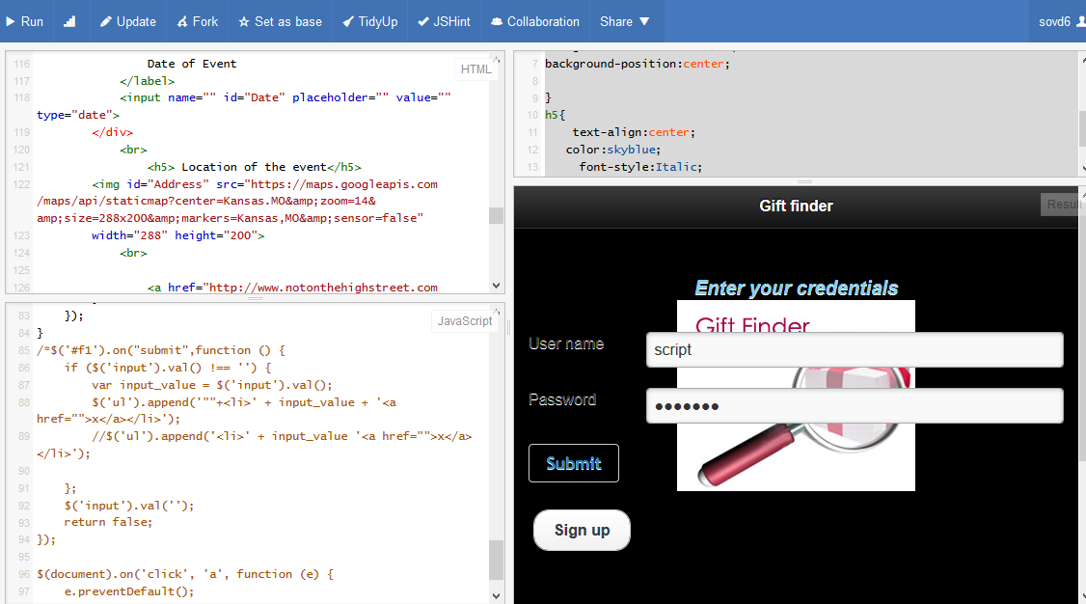

Shows how the intial page looks like. Initial fields are set up to some proximate values.

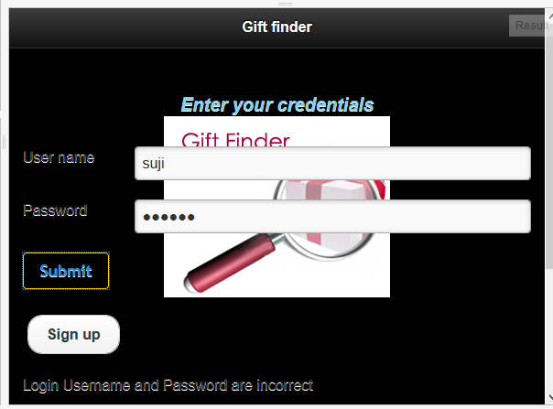

User did not yet sign up so while trying to login it shows him that the combo of the credentials is wrong. And does not allow him to login. He can opt for sign up.

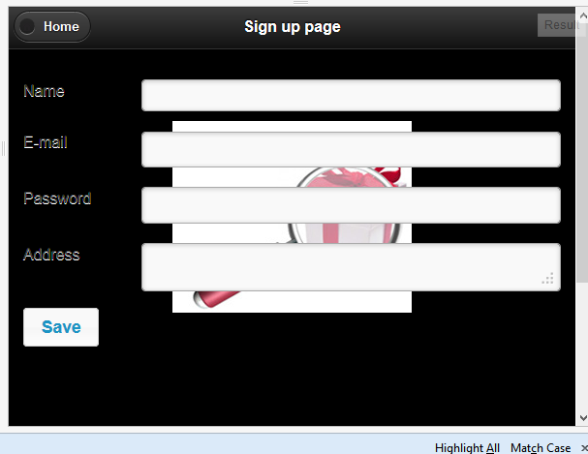

This is how the intial page looks like.

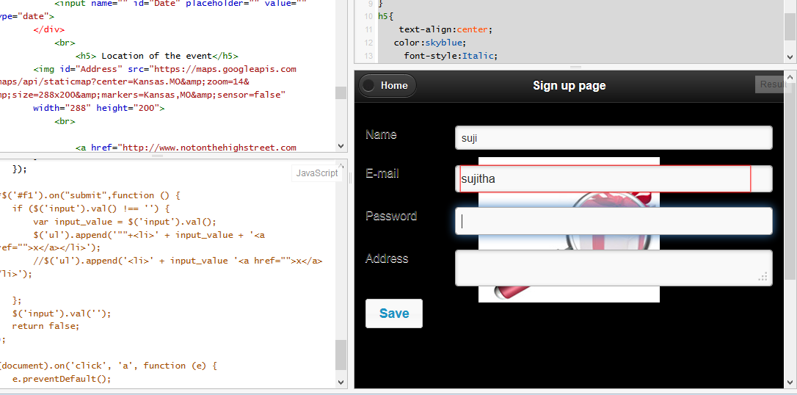

Checks if the email is given is given in correct format or not if not it indicates with a red mark asking him to re enter.

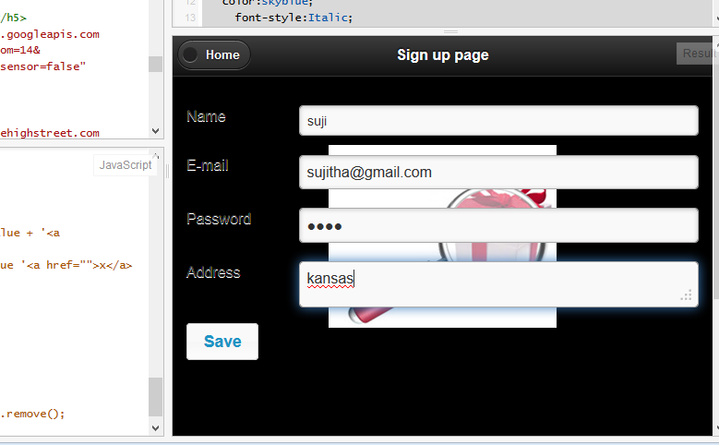

Gives the details and clicks on save.

Returns to the main page and now logs in with usual id and password.

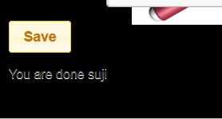

Confirms the user about his login.

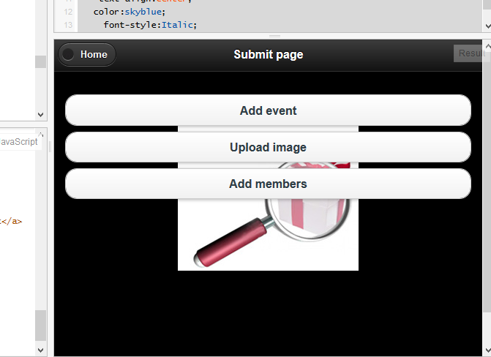

Submit page looks as above showing him the availabilities.

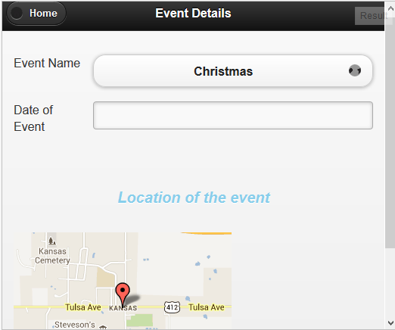

Event name he can get from the list of drop down and add accordingly his date and attain his location.

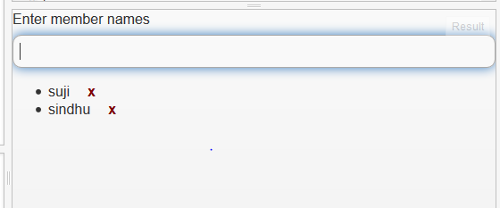

Adding members to the event.

On clicking cross mark he can cut the names or members if needed.

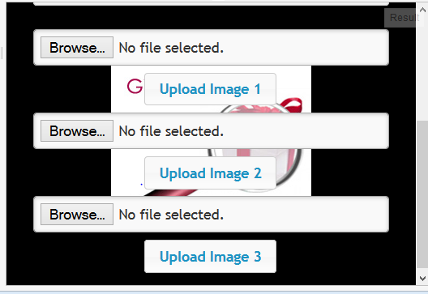

Can upload the pictures as needed from his local device.

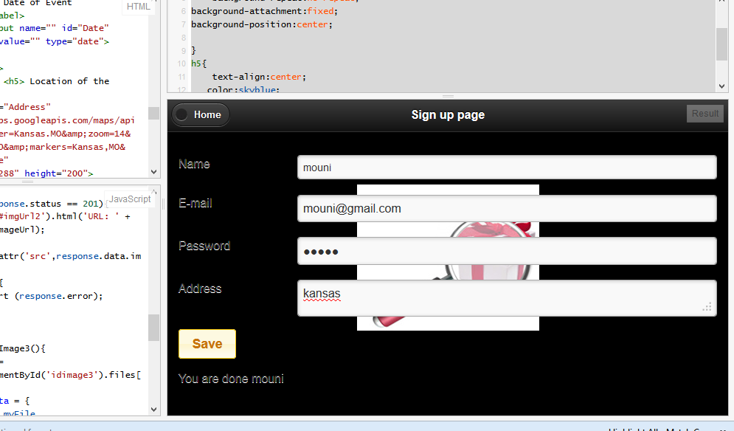

A new user creates his account and then saves his data as needed.

In the image he will have the flexibility in choosing up the images of the gift that he feels to present the inviter.

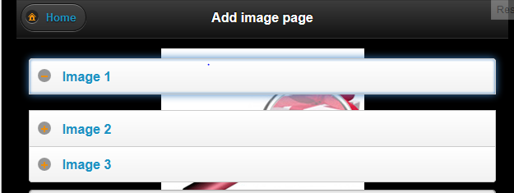

Clearly seen from the above as he selects image 1 it shows that it is now not available for rest of the users as denoted by the –ve symbol adjacent to it.

1. Web services and urls.

<http://www.notonthehighstreet.com/>

to do list of js fiddle

jquerymobile.com

w3schools.com

Stackoverflow.com

1. Limitations
2. References