**1.FACTORIAL IN JAVA**

class fact {

static int factorial(int n)

{

int res = 1, i;

for (i = 2; i <= n; i++)

res *= i;

return res;

}

public static void main(String[] args)

{

int num = 5;

System.out.println("Factorial of " + num + " is "

+ factorial(5));

}

}

**OUTPUT:**

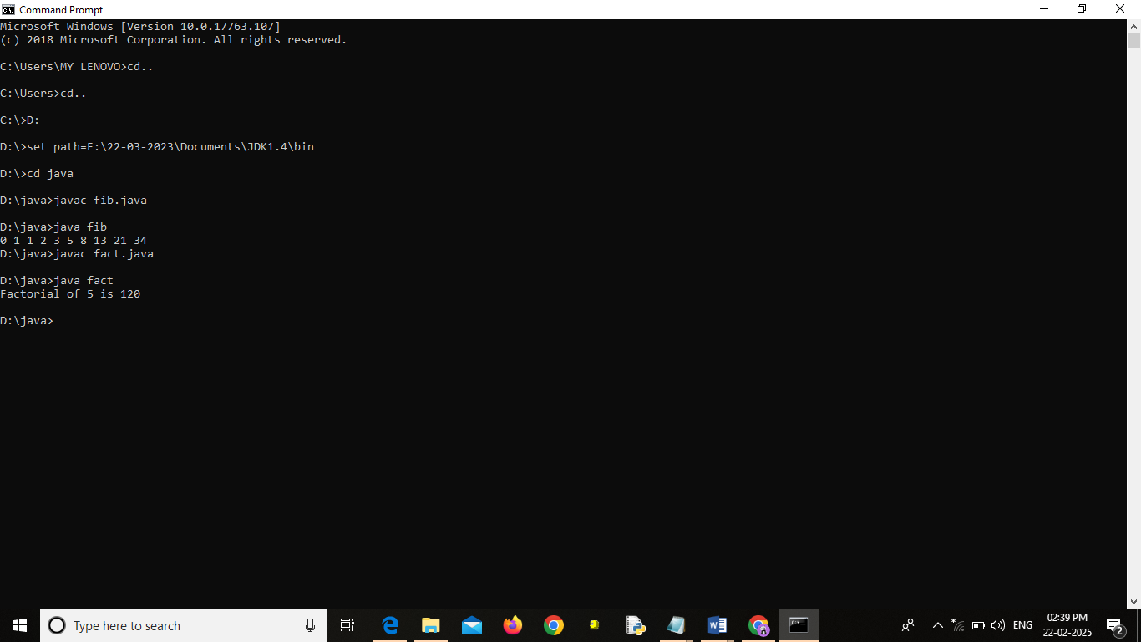

**2.SUM AND AVERAGE OF N NUMBERS IN JAVA**

import java.util.Scanner;

public class sum_avg {

public static void main(String[] args) {

Scanner in = new Scanner(System.in);

System.out.println("Enter The Limit: ");

int n=in.nextInt();

int sum=0,a;

for(int i=1;i<=n;i++)

{

System.out.println("Enter The Number "+i+": ");

a=in.nextInt();

sum+=a;//sum=sum+a;

}

System.out.println("The sum of given numbers is : "+sum);

System.out.println("The Average of given numbers is : "+sum/n);

}

}

**OUTPUT:**

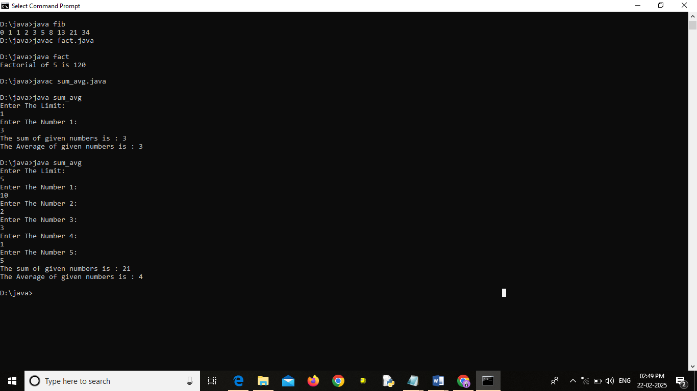

**3.NUMBER IS PALINDROME OR NOT IN JAVA**

class pali {

static int reversNumber(int n)

{

int reversed_n = 0;

while (n > 0) {

reversed_n = reversed_n * 10 + n % 10;

n = n / 10;

}

return reversed_n;

}

public static void main(String[] args)

{

int n = 123464321;

int reverseN = reversNumber(n);

System.out.println("Reverse of n = " + reverseN);

if (n == reverseN)

System.out.println("Palindrome = Yes");

else

System.out.println("Palindrome = No");

}

}

**OUTPUT:**

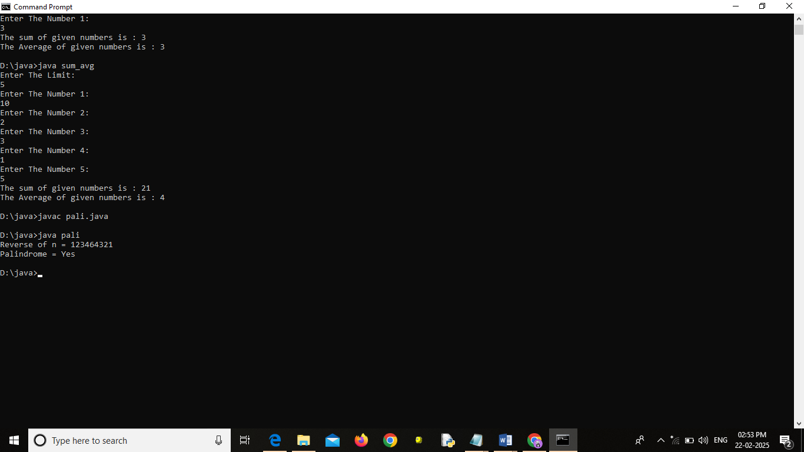

**4.FIBONACCI SERIES IN JAVA**

// Fibonacci series program in java

import java.io.*;

class fib {

// Function to print N Fibonacci Number

static void Fibonacci(int N)

{

int num1 = 0, num2 = 1;

for (int i = 0; i < N; i++) {

// Print the number

System.out.print(num1 + " ");

// Swap

int num3 = num2 + num1;

num1 = num2;

num2 = num3;

}

}

// Driver Code

public static void main(String args[])

{

// Given Number N

int N = 10;

// Function Call

Fibonacci(N);

}

}

**OUTPUT:**

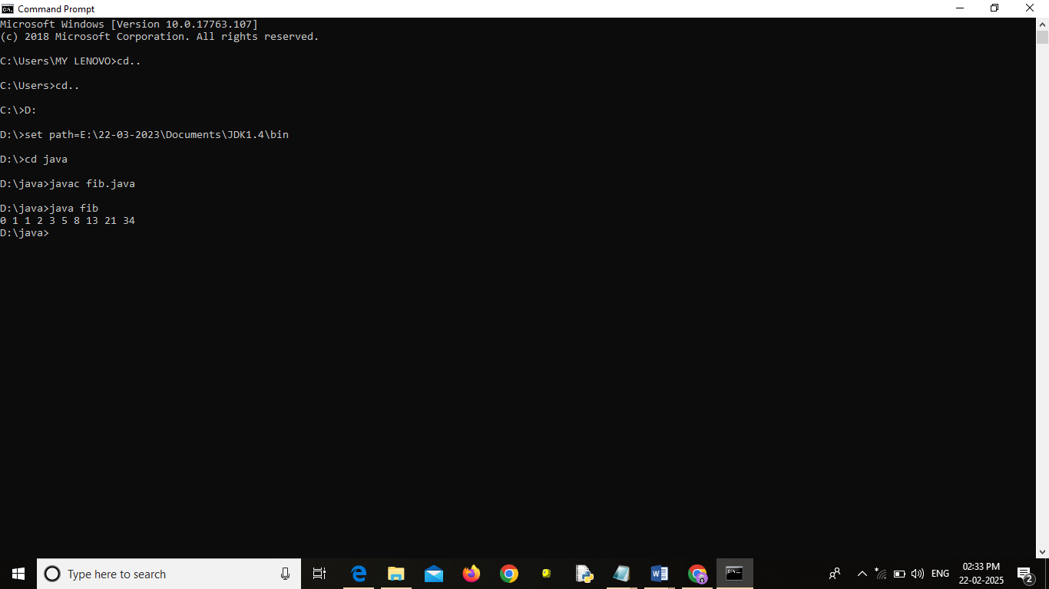

**5.ARMSTRONG NUMBER IN JAVA**

import java.util.Scanner;

public class ArmstrongNumber {

public static void main(String[] args) {

Scanner scanner = new Scanner(System.in);

System.out.print("Enter a number: ");

int num = scanner.nextInt();

scanner.close();

if (isArmstrong(num)) {

System.out.println(num + " is an Armstrong number.");

} else {

System.out.println(num + " is not an Armstrong number.");

}

}

public static boolean isArmstrong(int num) {

int originalNum = num, sum = 0, digits = String.valueOf(num).length();

while (num > 0) {

int digit = num % 10;

sum += Math.pow(digit, digits);

num /= 10;

}

return sum == originalNum;

}

}

**OUTPUT:**

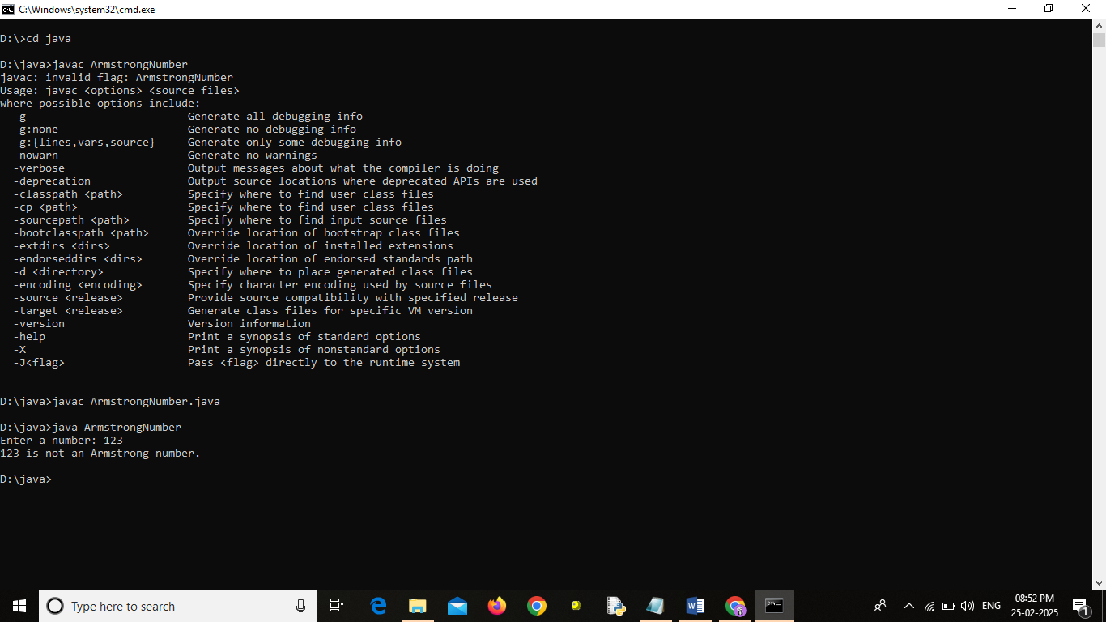

**6.NUMBER IS PRIME OR NOT IN JAVA**

import java.util.Scanner;

public class PrimeNumber {

public static void main(String[] args) {

Scanner scanner = new Scanner(System.in);

System.out.print("Enter a number: ");

int num = scanner.nextInt();

scanner.close();

if (isPrime(num)) {

System.out.println(num + " is a prime number.");

} else {

System.out.println(num + " is not a prime number.");

}

}

public static boolean isPrime(int num) {

if (num <= 1) return false;

for (int i = 2; i <= Math.sqrt(num); i++) {

if (num % i == 0) return false;

}

return true;

}

}

**OUTPUT:**

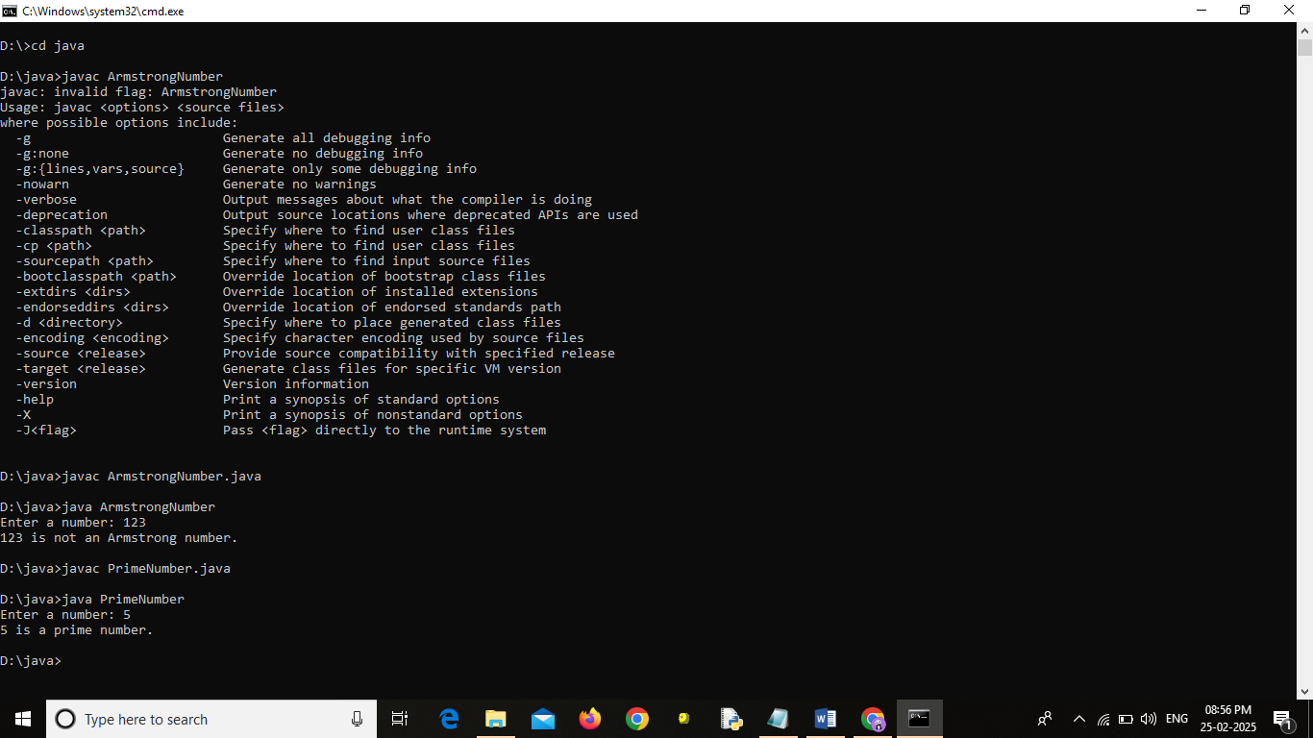

**7.INSERT AN ELEMENT[SPECIFIC POSITION]INTO AN ARRAY IN JAVA**

import java.util.Scanner;

public class InsertElement {

public static void main(String[] args) {

Scanner scanner = new Scanner(System.in);

// Get array size and elements

System.out.print("Enter the size of the array: ");

int size = scanner.nextInt();

int[] array = new int[size + 1]; // Extra space for the new element

System.out.println("Enter " + size + " elements:");

for (int i = 0; i < size; i++) {

array[i] = scanner.nextInt();

}

// Get element and position

System.out.print("Enter the element to insert: ");

int element = scanner.nextInt();

System.out.print("Enter the position (0-based index): ");

int position = scanner.nextInt();

// Shift elements to the right

if (position < 0 || position > size) {

System.out.println("Invalid position!");

} else {

for (int i = size; i > position; i--) {

array[i] = array[i - 1];

}

array[position] = element;

// Print updated array

System.out.print("Updated array: ");

for (int i = 0; i <= size; i++) {

System.out.print(array[i] + " ");

}

}

scanner.close();

}

}

**OUTPUT:**

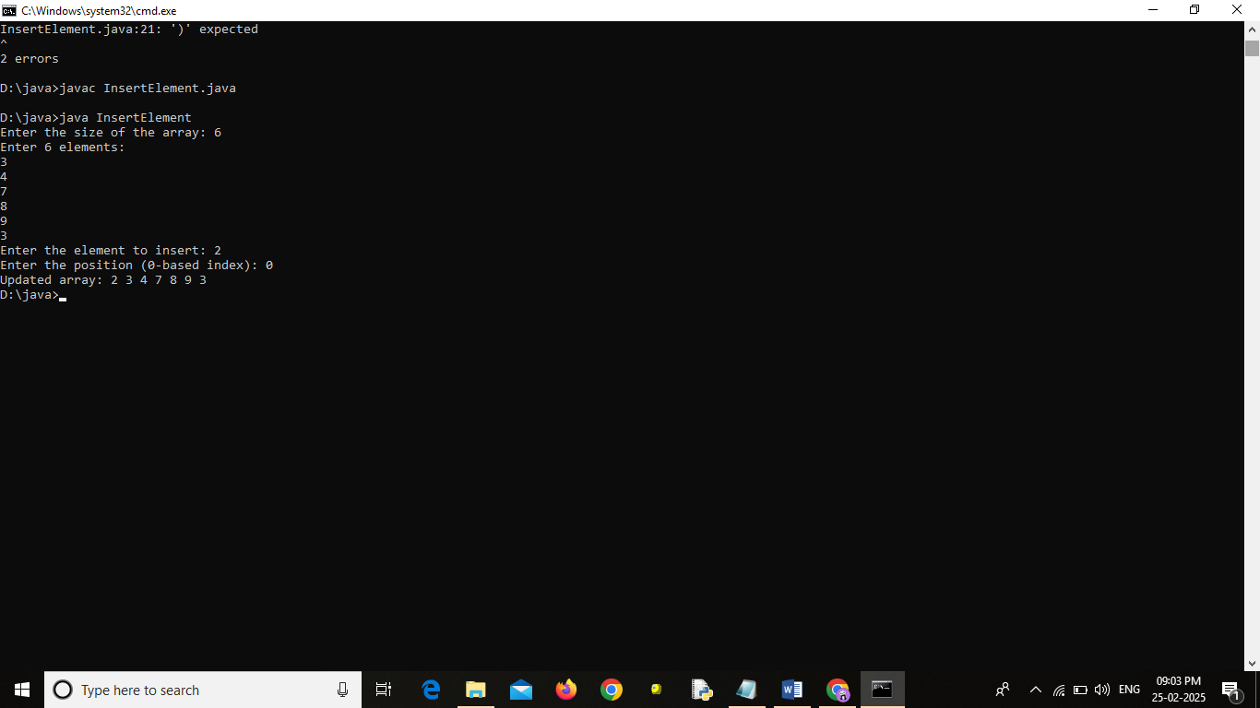

**8.FIND THE DUPLICATE VALUE OF AN ARRAY IN JAVA**

public class FindDuplicates {

public static void main(String[] args) {

int[] array = {1, 2, 3, 4, 2, 3, 5};

System.out.print("Duplicate values: ");

for (int i = 0; i < array.length; i++) {

for (int j = i + 1; j < array.length; j++) {

if (array[i] == array[j]) {

System.out.print(array[i] + " ");

break;

}

}

}

}

}

**OUTPUT:**

