Q1. Apply Relational Algebra Operations on Employee and Department Relations
Consider the following relations:
EMPLOYEE
EmpID | EmpName | DeptID | Salary
101 | Arun | D01 | 60000
102 | Ravi | D02 | 45000
103 | Priya | D01 | 70000
104 | Kumar | D03 | 50000

DEPARTMENT
DeptID | DeptName
D01 | IT
D02 | HR
D03 | Finance

Relational algebra is a procedural query language used to retrieve data from relations.
1. Selection (σ)
Selection is used to select rows satisfying a condition.
Find employees belonging to D01:
Result:
EmpID | EmpName | DeptID | Salary
101 | Arun | D01 | 60000
103 | Priya | D01 | 70000

2. Projection (π)
Projection is used to select specific columns.
Display employee names and salaries:

3. Union (∪)
Union combines tuples from two union-compatible relations.
It returns all records from both relations without duplicate tuples.

4. Set Difference (-)
It returns tuples present in the first relation but not in the second.

5. Cartesian Product (×)
It combines every tuple of one relation with every tuple of another relation.

6. Join (⋈)
To combine employee details with department details:
Result contains:
EmpName | DeptName | Salary
Arun | IT | 60000
Ravi | HR | 45000
Priya | IT | 70000
Kumar | Finance | 50000
Conclusion
Thus, σ, π, ∪, -, × and ⋈ operations can be used to retrieve and combine required information from Employee and Department relations.
Q2. Write SQL DDL Statements to Create STUDENT and DEPARTMENT Tables
DDL stands for Data Definition Language. It is used to create and modify database structures.
The important DDL commands are CREATE, ALTER, DROP and TRUNCATE.
Consider two tables:
- STUDENT
- DEPARTMENT
Step 1: Create DEPARTMENT table
CREATE TABLE DEPARTMENT (
DeptID INT PRIMARY KEY,
DeptName VARCHAR(50) NOT NULL UNIQUE
);
Step 2: Create STUDENT table
CREATE TABLE STUDENT (
SID INT PRIMARY KEY,
Name VARCHAR(50) NOT NULL,
DOB DATE NOT NULL,
DeptID INT,
FOREIGN KEY (DeptID)
REFERENCES DEPARTMENT(DeptID)
);
Constraints Used
1. PRIMARY KEY
SID INT PRIMARY KEY
It uniquely identifies each student.
2. NOT NULL
Name VARCHAR(50) NOT NULL
It prevents empty values.
3. UNIQUE
DeptName VARCHAR(50) UNIQUE
It does not allow duplicate department names.
4. FOREIGN KEY
FOREIGN KEY (DeptID)
REFERENCES DEPARTMENT(DeptID)
It establishes a relationship between STUDENT and DEPARTMENT.
ALTER Example
To add a phone number:
ALTER TABLE STUDENT
ADD Phone VARCHAR(15);
Conclusion
Thus, DDL statements can be used to create STUDENT and DEPARTMENT tables with appropriate primary key, foreign key, NOT NULL and UNIQUE constraints.

Q3. SQL Queries Using GROUP BY, HAVING and Aggregate Functions
Aggregate functions perform calculations on a group of rows.
Common aggregate functions are:
- COUNT() – counts records
- SUM() – calculates total
- AVG() – calculates average
- MAX() – finds maximum
- MIN() – finds minimum
Consider:
SALES
SaleID | Product | Category | Amount
1 | Laptop | Electronics | 50000
2 | Phone | Electronics | 30000
3 | Chair | Furniture | 10000
4 | Table | Furniture | 20000
5 | TV | Electronics | 40000

1. COUNT()
Find the number of sales in each category.
SELECT Category, COUNT(*) AS TotalSales
FROM SALES
GROUP BY Category;

2. SUM()
Find the total sales amount for each category.
SELECT Category, SUM(Amount) AS TotalAmount
FROM SALES
GROUP BY Category;

3. AVG()
Find the average sales amount.
SELECT Category, AVG(Amount) AS AverageAmount
FROM SALES
GROUP BY Category;

4. MAX() and MIN()
SELECT Category,
MAX(Amount) AS MaximumAmount,
MIN(Amount) AS MinimumAmount
FROM SALES
GROUP BY Category;

5. HAVING
HAVING is used to filter groups after GROUP BY.
Find categories whose total sales are greater than 50,000:
SELECT Category, SUM(Amount) AS TotalAmount
FROM SALES
GROUP BY Category
HAVING SUM(Amount) > 50000;
Difference between WHERE and HAVING
- WHERE filters individual rows.
- HAVING filters groups.
Conclusion
Thus, GROUP BY, HAVING and aggregate functions are useful for performing summary and statistical operations on a dataset.

Q4. Correlated Subquery to Find Employees Earning More Than Department Average
A correlated subquery is a subquery that depends on the outer query. The inner query is executed for each row of the outer query.
Consider:
EMPLOYEE
EmpID | EmpName | DeptID | Salary
101 | Arun | 10 | 60000
102 | Ravi | 10 | 45000
103 | Priya | 20 | 70000
104 | Kumar | 20 | 50000
105 | Anu | 10 | 55000

Query
SELECT E.EmpID,
E.EmpName,
E.DeptID,
E.Salary
FROM EMPLOYEE E
WHERE E.Salary >
(
SELECT AVG(E2.Salary)
FROM EMPLOYEE E2
WHERE E2.DeptID = E.DeptID
);
Explanation
- The outer query selects employees from the EMPLOYEE table.
- The inner query calculates the average salary of the employee's department.
- E2.DeptID = E.DeptID makes the subquery correlated with the outer query.
- The employee salary is compared with the department average.
- Employees whose salary is greater than the department average are displayed.
Example Calculation
For Department 10:
Therefore, Arun and Anu earn more than the department average.
For Department 20:
Therefore, Priya earns more than the department average.
Expected Result
EmpID | EmpName | DeptID | Salary
101 | Arun | 10 | 60000
103 | Priya | 20 | 70000
105 | Anu | 10 | 55000

Conclusion
Thus, a correlated subquery is used to compare each employee's salary with the average salary of their own department.

Q5. Apply All Types of JOIN Operations
Consider:
EMPLOYEE
EmpID | EmpName | DeptID
101 | Arun | D01
102 | Ravi | D02
103 | Priya | D03
104 | Kumar | NULL
PROJECT
ProjectID | ProjectName | EmpID
P01 | Banking App | 101
P02 | Web Portal | 102
P03 | AI System | 105

1. INNER JOIN
Returns only matching records from both tables.
SELECT E.EmpName, P.ProjectName
FROM EMPLOYEE E
INNER JOIN PROJECT P
ON E.EmpID = P.EmpID;
It displays employees who have matching projects.

2. LEFT OUTER JOIN
Returns all employees and matching project details.
SELECT E.EmpName, P.ProjectName
FROM EMPLOYEE E
LEFT OUTER JOIN PROJECT P
ON E.EmpID = P.EmpID;
Even employees without projects are displayed.

3. RIGHT OUTER JOIN
Returns all projects and matching employee details.
SELECT E.EmpName, P.ProjectName
FROM EMPLOYEE E
RIGHT OUTER JOIN PROJECT P
ON E.EmpID = P.EmpID;
Even projects without matching employees are displayed.

4. FULL OUTER JOIN
Returns all matching and non-matching records from both tables.
SELECT E.EmpName, P.ProjectName
FROM EMPLOYEE E
FULL OUTER JOIN PROJECT P
ON E.EmpID = P.EmpID;

5. CROSS JOIN
It produces the Cartesian product.
SELECT E.EmpName, P.ProjectName
FROM EMPLOYEE E
CROSS JOIN PROJECT P;
If there are 4 employees and 3 projects:
rows will be generated.
Conclusion
JOIN operations are used to retrieve related information from multiple tables. The major joins are INNER, LEFT OUTER, RIGHT OUTER, FULL OUTER and CROSS JOIN.

Q6. Create a View DeptSalaryView
A view is a virtual table created from one or more base tables. It does not normally store the actual data separately.
Consider:
EMPLOYEE(EmpID, EmpName, DeptID, Salary)
DEPARTMENT(DeptID, DeptName)
The requirement is to display:
- Department name
- Total number of employees
- Average salary
Create View
CREATE VIEW DeptSalaryView AS
SELECT D.DeptName,
COUNT(E.EmpID) AS TotalEmployees,
AVG(E.Salary) AS AverageSalary
FROM DEPARTMENT D
LEFT JOIN EMPLOYEE E
ON D.DeptID = E.DeptID
GROUP BY D.DeptID, D.DeptName;
Query the View
SELECT *
FROM DeptSalaryView;
Example Output
DeptName | TotalEmployees | AverageSalary
IT | 5 | 58000
HR | 3 | 45000
Finance | 4 | 52000

Query a Particular Department
SELECT *
FROM DeptSalaryView
WHERE DeptName = 'IT';
Advantages of View
- Provides simplified access to complex queries.
- Improves data security.
- Hides unnecessary columns.
- Can be reused like a table.
- Makes reporting easier.

Conclusion
Thus, DeptSalaryView provides department-wise employee count and average salary in a simple virtual table.

Q7. Relational Algebra – Students Enrolled in All Courses
Consider the following relations:
STUDENT
SID | SName
101 | Arun
102 | Ravi
103 | Priya

COURSE
CID | CourseName
C01 | DBMS
C02 | OS
C03 | CN

ENROLL
SID | CID
101 | C01
101 | C02
101 | C03
102 | C01
102 | C02
103 | C01

The question asks to find students who are enrolled in all courses offered.
For this type of question, Relational Division (÷) is used.
Step 1: Perform Division
This returns the SID values of students who are enrolled in every course.
Result
SID
101
Student 101 has enrolled in C01, C02 and C03.
Step 2: Join with STUDENT
Final Projection
Final Result
SName
Arun
Explanation
Relational division is used when the requirement contains words such as:
- all
- every
- each
Here, the requirement is "students enrolled in all courses", so relational division is appropriate.
Conclusion
Thus,
retrieves the names of students enrolled in all the courses offered.

Q8. SQL DML Statements – INSERT, UPDATE and DELETE
DML stands for Data Manipulation Language. It is used to insert, modify and delete data from tables.
The major DML commands are:
- INSERT
- UPDATE
- DELETE
Consider:
STUDENT(SID, Name, DOB, DeptID)
1. INSERT
The INSERT command is used to add new records.
INSERT INTO STUDENT
(SID, Name, DOB, DeptID)
VALUES
(101, 'Arun', '2005-05-10', 10);
Multiple Records
INSERT INTO STUDENT
(SID, Name, DOB, DeptID)
VALUES
(102, 'Ravi', '2005-06-15', 20),
(103, 'Priya', '2005-08-20', 10);

2. UPDATE
The UPDATE command modifies existing records.
Change student 101's department:
UPDATE STUDENT
SET DeptID = 20
WHERE SID = 101;
The WHERE condition is important because it identifies which record must be updated.

3. DELETE
The DELETE command removes records.
DELETE FROM STUDENT
WHERE SID = 103;
Only student 103 is deleted.

Integrity Constraint Enforcement
Suppose SID is a primary key.
INSERT INTO STUDENT
VALUES (101, 'Kumar', '2005-01-01', 10);
If SID 101 already exists, the DBMS rejects the operation because a primary key cannot contain duplicate values.
Similarly, if DeptID is a foreign key and we insert a department ID that does not exist in DEPARTMENT, the DBMS rejects the record.
Conclusion
Thus, DML commands are used to insert, update and delete records, while integrity constraints ensure that invalid data is not stored.

Q9. Tuple Relational Calculus
Question:
Find all employees who work in the IT department and earn more than ₹50,000.
Consider:
EMPLOYEE
EMPLOYEE(EmpID, EmpName, DeptID, Salary)
DEPARTMENT
DEPARTMENT(DeptID, DeptName)
Tuple Relational Calculus (TRC) is a non-procedural query language. It describes what data is required, rather than how to retrieve it.
TRC Expression
Explanation
Here:
- e represents an employee tuple.
- d represents a department tuple.
- EMPLOYEE(e) ensures that e is an employee.
- DEPARTMENT(d) ensures that d is a department.
- e.DeptID = d.DeptID connects employee and department.
- d.DeptName = 'IT' selects the IT department.
- e.Salary > 50000 selects employees earning more than ₹50,000.
Example
Suppose:
EmpID | EmpName | DeptID | Salary
101 | Arun | D01 | 60000
102 | Ravi | D02 | 70000
103 | Priya | D01 | 45000
104 | Kumar | D01 | 80000

And D01 = IT.
The result is:
EmpID | EmpName | Salary
101 | Arun | 60000
104 | Kumar | 80000

Conclusion
Thus, TRC can express the required query by specifying the conditions that the required employee tuples must satisfy.

Q10. Airline Reservation System – Relational Schema and SQL Queries
An Airline Reservation System manages passengers, flights, bookings, aircraft and payments.
Relational Schema
1. PASSENGER
PASSENGER(
PassengerID,
Name,
Phone,
Email
)
PassengerID is the Primary Key.

2. AIRCRAFT
AIRCRAFT(
AircraftID,
Model,
Capacity
)
AircraftID is the Primary Key.

3. FLIGHT
FLIGHT(
FlightID,
Source,
Destination,
DepartureTime,
ArrivalTime,
AircraftID
)
FlightID is the Primary Key.
AircraftID is a Foreign Key referencing AIRCRAFT.

4. BOOKING
BOOKING(
BookingID,
PassengerID,
FlightID,
BookingDate,
SeatNo
)
BookingID is the Primary Key.
PassengerID and FlightID are Foreign Keys.

5. PAYMENT
PAYMENT(
PaymentID,
BookingID,
Amount,
PaymentStatus
)
PaymentID is the Primary Key.
BookingID is a Foreign Key.

Relationships
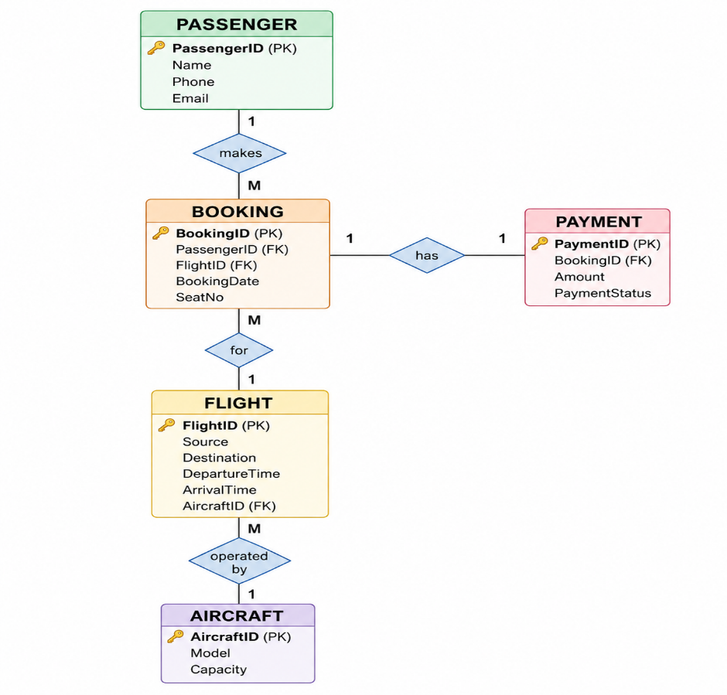

Query 1 – JOIN
Display passenger names and their flight details.
SELECT P.Name,
F.Source,
F.Destination
FROM PASSENGER P
JOIN BOOKING B
ON P.PassengerID = B.PassengerID
JOIN FLIGHT F
ON B.FlightID = F.FlightID;
This demonstrates multiple table joins.

Query 2 – JOIN with Aircraft
Display flight details along with aircraft model.
SELECT F.FlightID,
F.Source,
F.Destination,
A.Model
FROM FLIGHT F
JOIN AIRCRAFT A
ON F.AircraftID = A.AircraftID;

Query 3 – Subquery
Find passengers who booked flights going to Chennai.
SELECT Name
FROM PASSENGER
WHERE PassengerID IN
(
SELECT PassengerID
FROM BOOKING
WHERE FlightID IN
(
SELECT FlightID
FROM FLIGHT
WHERE Destination = 'Chennai'
)
);
This demonstrates a nested subquery.

Query 4 – View
Create a view that displays passenger booking information.
CREATE VIEW BookingDetails AS
SELECT P.Name,
F.Source,
F.Destination,
B.SeatNo,
B.BookingDate
FROM PASSENGER P
JOIN BOOKING B
ON P.PassengerID = B.PassengerID
JOIN FLIGHT F
ON B.FlightID = F.FlightID;
To display the view:
SELECT *
FROM BookingDetails;

Query 5 – GROUP BY
Find the total number of bookings for each flight.
SELECT FlightID,
COUNT(*) AS TotalBookings
FROM BOOKING
GROUP BY FlightID;
This demonstrates the use of GROUP BY and COUNT().
Conclusion
The Airline Reservation System uses multiple related tables such as PASSENGER, FLIGHT, AIRCRAFT, BOOKING and PAYMENT. SQL joins, subqueries, views and aggregate functions can be used to retrieve useful reservation information efficiently.

