|  |  |  |
| --- | --- | --- |
| From: | NJ Kernel team |  |
| Subject: | **Update BootSelector on SB-RRH** | |

|  |  |  |  |
| --- | --- | --- | --- |
| **Document Change History:** | | | |
| **Version No.** | **Release Date** | **Review Record Ref.** | **Description of Change** |
| 1.0 | XX-XX-2015 |  | Initial Version |

**Abstract:**

This describes a method to update BootSelector for SB-RRH.

Table Of Contents

Table Of Contents 1

1 SCOPE 2

2 ELECTRICAL CHARACTERISTICS 3

2.1 Input Requirements 3

2.2 Output Requirements 3

2.3 Efficiency 3

2.4 Alarms 3

3 INTERFACE 4

3.1 I2C Interface(s) 4

3.1.1 General Requirements 4

3.1.2 Alarms via I2C 6

3.1.3 48V Voltage via I2C 7

3.1.4 48V Current via I2C 7

3.1.5 Read store alarm in EEPROM 7

3.1.6 Temperature via I2C 8

3.1.7 AISG Voltage via I2C 9

3.1.8 AISG Current via I2C 9

3.1.9 OOK Voltage via I2C 10

3.1.10 OOK Current via I2C 10

3.1.11 Switching-on-off the 24V output via I2C 10

3.1.12 RESTART 10

3.1.13 Software version number 10

3.1.14 Hardware version number 11

# SCOPE

# ELECTRICAL CHARACTERISTICS

## Input Requirements

## Output Requirements

## Efficiency

## Alarms

# INTERFACE

## I2C Interface(s)

### General Requirements

I2C shall provide the low-speed mode(), Neither CRC or parity bits are required.

**Figure** 1 I2C Read Operation

STEP 1: WRITE REGISTER ADDRESS FOR READ OPERATION

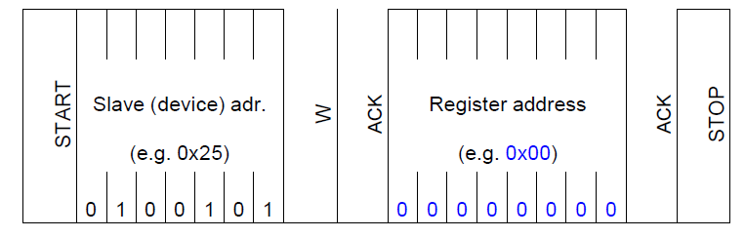

STEP 2: READ DATA FROM THAT REGISTER

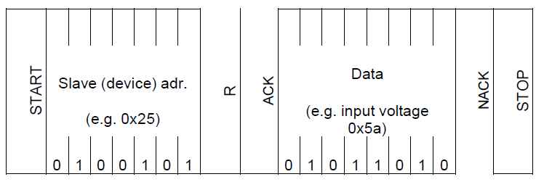

Write:

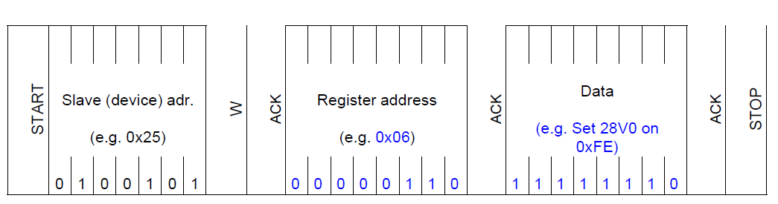

Device address is 0x52.

|  |  |  |  |
| --- | --- | --- | --- |
| Command | Register | Function | Type |
| 0x80 | 48V Alarm | Bit0:LVA_36V  Bit1: LVA_37V  Bit2: LVA_44V  Bit3: LVA_59V  Bit 4: LVA_58V  Bit5-7: no defined  1:Alarm invalid  0:Alarm valid | RL |
| 0x81 | Alarm | Bit0:AISG alarm  Bit1:OOK alarm  Bit2:Temperature alarm  Bit3-7: no defined  1:Alarm invalid  0:Alarm valid | RL |
| 0x82 | 48V voltage | Sample value of 48v voltage | RL |
| 0x83 | 48V current | Sample value of 48v current | RL |
| 0x84 | Alarm Clear | Bit0: AISG current alarm  Bit1: OOK current alarm  Bit2-7: no defined  1:Clear alarm | WL |
| 0x86 | Store alarm | Stored alarm in EEPROM  Bit0: VDD_LATCH_5V  Bit1: VDD_LATCH_AISG  Bit2: VDD_LATCH_OOK  Bit3: T_ALM  Bit4-7: no defined  1:Not Latch  0:Latch | RL |
| 0x87 | Temperature | Sample value of temperature | RL |
| 0x88 | AISG Voltage | Sample value of AISG voltage | RL |
| 0x89 | AISG Current | Sample value of AISG current | RL |
| 0x8A | OOK Voltage | Sample value of OOK voltage | RL |
| 0x8B | OOK Current | Sample value of OOK current | RL |
| 0x8C | 28v on-off | Bit0:switch on-off AISG 28v output  Bit1: switch on-off OOK 28v output  Bit2: switch on-off PA1 28v output  Bit3: switch on-off PA2 28v output  Bit4-7: no defined  1:switch on  0:switch off |  |
| 0x8D | RESTART | MCU restart  1:MCU power off 5.3v/24v and then restart | WL |
| 0x1D | Software Version | Software version number | RL |
| 0x1E | Hardware Version | Hardware version number | RL |

NOTE:

RL:READ ONLY

WL:WRITE ONLU

### Alarms via I2C

Register 0x80 is the 48V input alarm which contains 8 alarms. BIT0~BIT4 indicate5 difference alarms. If the BIT is 0, it means the alarm valid.

|  |  |  |  |  |  |  |  |
| --- | --- | --- | --- | --- | --- | --- | --- |
| Bit7 | Bit6 | Bit5 | Bit4 | Bit3 | Bit2 | Bit1 | Bit0 |
| NA | | | UVAR_58V | UVA_59V | LVW_44V | LVAR_37V | LVA_36V |

Bit 7:Bit5: NA

Bit4 UVAR_58V: 48V input voltage higher than 58V

0: Alarm valid.

1: Alarm invalid.

Bit3 UVA_59v:48V input voltage higher than 59V

0: Alarm valid.

1: Alarm invalid.

Bit2 LVW_44V:48V input voltage lower than 44V

0: Alarm valid.

1: Alarm invalid.

Bit1 LVAR_37V: 48V input voltage higher than 37V

0: Alarm valid.

1: Alarm invalid.

Bit0 LVA_36V:48V input voltage lower than 36V

0: Alarm valid.

1: Alarm invalid.

**Register 0x81** contains AISG OCP alarm, OOK OCP alarm, TEMP alarm,

|  |  |  |  |  |  |  |  |
| --- | --- | --- | --- | --- | --- | --- | --- |
| Bit7 | Bit6 | Bit5 | Bit4 | Bit3 | Bit2 | Bit1 | Bit0 |
| NA | NA | NA | NA | NA | TEMP | OOK OCP | AISG OCP |

Figure 4- 9 AISG OCP alarm,OOK OCP alarm, temperature alarm

Bit 7:Bit3 NA

Bit 2 TEMP: Over-temperature protection alarm

0: Alarm valid.

1: Alarm invalid

Bit1 OOK OCP: OOK over current protection alarm

1: Alarm valid.(VDD_LATCH_OOK).

0: Alarm invalid.

Bit 0 AISG OCP: AISG over current protection alarm

1: Alarm valid.. .(VDD_LATCH_AISG).

0: Alarm invalid.

### 48V Voltage via I2C

**Register 0x82**: Read 48v voltage ADC sampling value from MCU

Every ADC sample is 16bits value, The conversion voltage formula as follow:

**Voltage = 4*ADC/237.12;**

|  |  |  |  |  |  |  |  |  |
| --- | --- | --- | --- | --- | --- | --- | --- | --- |
| Bit15 | Bit14 | Bit13 | Bit12 | …… | Bit3 | Bit2 | Bit1 | Bit0 |
| NA | NA | NA | BD12 | …… | BD3 | BD2 | BD1 | BD0 |

### 48V Current via I2C

**Register 0x83**: Read 48v current ADC sampling value from MCU

Every ADC sample is 16bits value, The conversion current formula as follow:

**Current = ADC/50.0;**

|  |  |  |  |  |  |  |  |  |
| --- | --- | --- | --- | --- | --- | --- | --- | --- |
| Bit15 | Bit14 | Bit13 | Bit12 | …… | Bit3 | Bit2 | Bit1 | Bit0 |
| NA | CD18 | CD13 | CD12 | …… | CD3 | CD2 | CD1 | CD0 |

### Read store alarm in EEPROM

**Register 0x86**: Read the stored alarm in EEPROM, which will power off 2.5V or 28V output., and the PSU module will reply 1 byte which contains 4 alarms. BIT0~BIT3 indicate 4 difference alarms. If the BIT is 0, it means the alarm valid.

|  |  |  |  |  |  |  |  |
| --- | --- | --- | --- | --- | --- | --- | --- |
| Bit7 | Bit6 | Bit5 | Bit4 | Bit3 | Bit2 | Bit1 | Bit0 |
| NA | NA | NA | NA | T_ALM | VDD_LATCH_OOK | VDD_LATCH_AISG | VDD_LATCH_5V |

Figure 3- Alarm in EEPROM bits map

Bit 7-4 NA

Bit3 **T_ALM**

0: Alarm valid.

1: Alarm invalid.

Bit2 **VDD_LATCH_OOK**

1: OOK switch not latch

0: OOK switch latch

Bit 1 **VDD_LATCH_AISG**

1: 485 swtich not latch

0: 485 swtich latch.

Bit 0 **VDD_LATCH_5V**:

1: .5V not latch

0: latch 5v switch

### Temperature via I2C

**Register 0x87** contain the temperature ADC sample value in low 10 bits.

|  |  |  |  |  |  |  |  |  |
| --- | --- | --- | --- | --- | --- | --- | --- | --- |
| Bit15 | …… | Bit11 | Bit9 | …… | Bit3 | Bit2 | Bit1 | Bit0 |
| NA | …… | NA | D9 | …… | D3 | D2 | D1 | D0 |

Figure 3- 10 temperature ADC sample value

The 10bits ADC sample value is hexadecimal integers. It can transfer to the voltage value using following formula:

Vtemp(V) = ( [D10:D0]*3.3 )/1024

According toTable 4- 4, figure out the temperature using Vtemp.

温度的表格如下：

Table 4- Map between Vtemp and Temperature

|  |  |  |
| --- | --- | --- |
| Tempterature(℃) | F(RT/R25) | Temp_alarm |
| -40 | 50.89 | 0.006471857 |
| -35 | 35.49 | 0.009272267 |
| -30 | 25.03 | 0.013131715 |
| -25 | 17.85 | 0.018384401 |
| -20 | 12.86 | 0.025462963 |
| -15 | 9.353 | 0.034909553 |
| -10 | 6.869 | 0.047352561 |
| -5 | 5.09 | 0.063583815 |
| 0 | 3.805 | 0.084507042 |
| 5 | 2.868 | 0.111185984 |
| 10 | 2.179 | 0.144800351 |
| 15 | 1.669 | 0.186546071 |
| 20 | 1.287 | 0.237923576 |
| 25 | 1 | 0.3 |
| 30 | 0.7823 | 0.374022441 |
| 35 | 0.616 | 0.460893855 |
| 40 | 0.4882 | 0.561033662 |
| 45 | 0.3893 | 0.674432863 |
| 50 | 0.3123 | 0.800388067 |
| 55 | 0.252 | 0.9375 |
| 60 | 0.2044 | 1.084099869 |
| 65 | 0.1667 | 1.237345332 |
| 70 | 0.1367 | 1.394169835 |
| 75 | 0.1126 | 1.552210724 |
| 80 | 0.09325 | 1.7076326 |
| 85 | 0.07757 | 1.858422031 |
| 90 | 0.06482 | 2.002184201 |
| 95 | 0.0544 | 2.137305699 |
| 100 | 0.04584 | 2.262753703 |
| 105 | 0.03879 | 2.377692917 |
| 110 | 0.03295 | 2.482136141 |
| 115 | 0.0281 | 2.576112412 |
| 120 | 0.02405 | 2.660217654 |
| 125 | 0.02066 | 2.734957732 |

另  过温保护点为2.55V

### AISG Voltage via I2C

**Register 0x88**: Read AISG voltage ADC sampling value from MCU

Every ADC sample is 10bits value, The conversion voltage formula as follow:

**Voltage = (ADC*(3.3/1024))*(49.7/2.2);**

|  |  |  |  |  |  |  |  |  |
| --- | --- | --- | --- | --- | --- | --- | --- | --- |
| Bit15 | Bit14 | …… | Bit10 | Bit9 | …… | Bit2 | Bit1 | Bit0 |
| NA | NA | …… | NA | ADC9 | …… | ADC2 | ADC1 | ADC0 |

### AISG Current via I2C

**Register 0x89**: Read AISG voltage ADC sampling value from MCU

Every ADC sample is 10bits value, The conversion voltage formula as follow:

**Current = (ADC*(3.3/1024)*2*0.02)/60;**

|  |  |  |  |  |  |  |  |  |
| --- | --- | --- | --- | --- | --- | --- | --- | --- |
| Bit15 | Bit14 | …… | Bit10 | Bit9 | …… | Bit2 | Bit1 | Bit0 |
| NA | NA | …… | NA | ADC9 | …… | ADC2 | ADC1 | ADC0 |

### OOK Voltage via I2C

**Register 0x8A**: Read OOK voltage ADC sampling value from MCU

Every ADC sample is 10bits value, The conversion voltage formula as follow:

**Voltage = (ADC*(3.3/1024))*(49.7/2.2);**

|  |  |  |  |  |  |  |  |  |
| --- | --- | --- | --- | --- | --- | --- | --- | --- |
| Bit15 | Bit14 | …… | Bit10 | Bit9 | …… | Bit2 | Bit1 | Bit0 |
| NA | NA | …… | NA | ADC9 | …… | ADC2 | ADC1 | ADC0 |

### OOK Current via I2C

**Register 0x8B**: Read AISG voltage ADC sampling value from MCU

Every ADC sample is 10bits value, The conversion voltage formula as follow:

**Current = (ADC*(3.3/1024)*2*0.02)/60;**

|  |  |  |  |  |  |  |  |  |
| --- | --- | --- | --- | --- | --- | --- | --- | --- |
| Bit15 | Bit14 | …… | Bit10 | Bit9 | …… | Bit2 | Bit1 | Bit0 |
| NA | NA | …… | NA | ADC9 | …… | ADC2 | ADC1 | ADC0 |

### Switching-on-off the 24V output via I2C

**Register 0x8C**: switch on-off 28v output

|  |  |  |  |  |  |  |  |
| --- | --- | --- | --- | --- | --- | --- | --- |
| Bit7 | Bit6 | Bit5 | Bit4 | Bit3 | Bit2 | Bit1 | Bit0 |
| NA | NA | NA | NA | NA | NA | OOK | AISG |

Figure 3- 11 switch on-off 24v bits map

1: switch on 28V output

0: switch off 28v output

### RESTART

**Register 0x8D**: Restart register,

1:MCU Power off all of output and then restart

### Software version number

**Register 0x1D**: software/hardware version number

Software number: 2 byte, indicate the software version the MCU is in.

SoftwareVersion 0x1011 means the software version is V10.11

### Hardware version number

**Register 0x1E**: hardware version number

Hardware number: 2 byte, indicate the hardware version the MCU is in.

HardwareVersion = 0x1020 means the software version is V10.20