Experiment 5
Fourier Series Analysis of Periodic Signals
- To analyze Fourier series of continuous-time periodic signals and analyze their waveform characteristics.
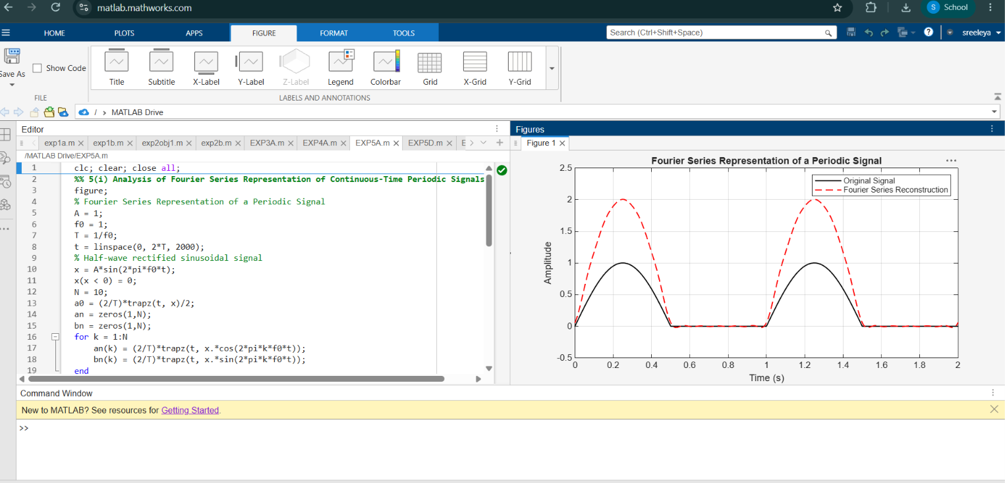

(iv) To reconstruct periodic signals using Fourier series and verify the reconstructed waveform with the original signal.

