Experiment – 6
Parseval's Relation and Harmonic Spectrum Analysis

(i)To verify Parseval’s relation for continuous-time periodic signals and analyze the
relationship between time-domain and frequency-domain power.
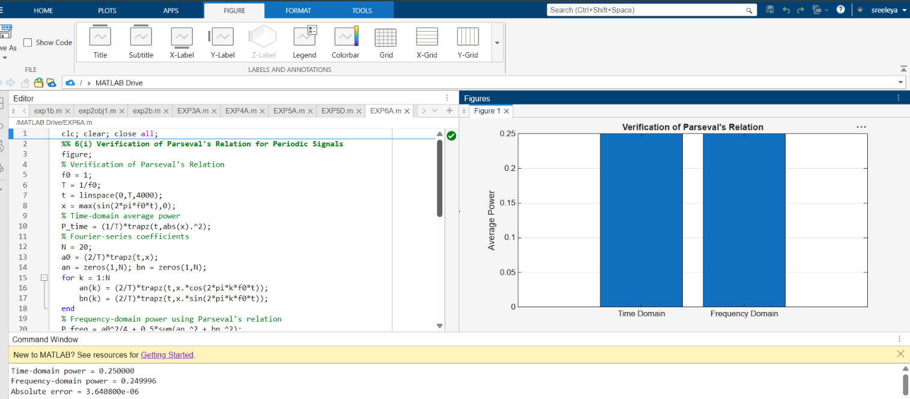

(iv) To compare the total power obtained in the time domain with the harmonic power
distribution in the frequency domain.

