Experiment No. 2
Signal Operations and Transformations

(i) To perform amplitude scaling and time scaling of continuous-time and discrete-time
signals and analyze their effects on signal characteristics.

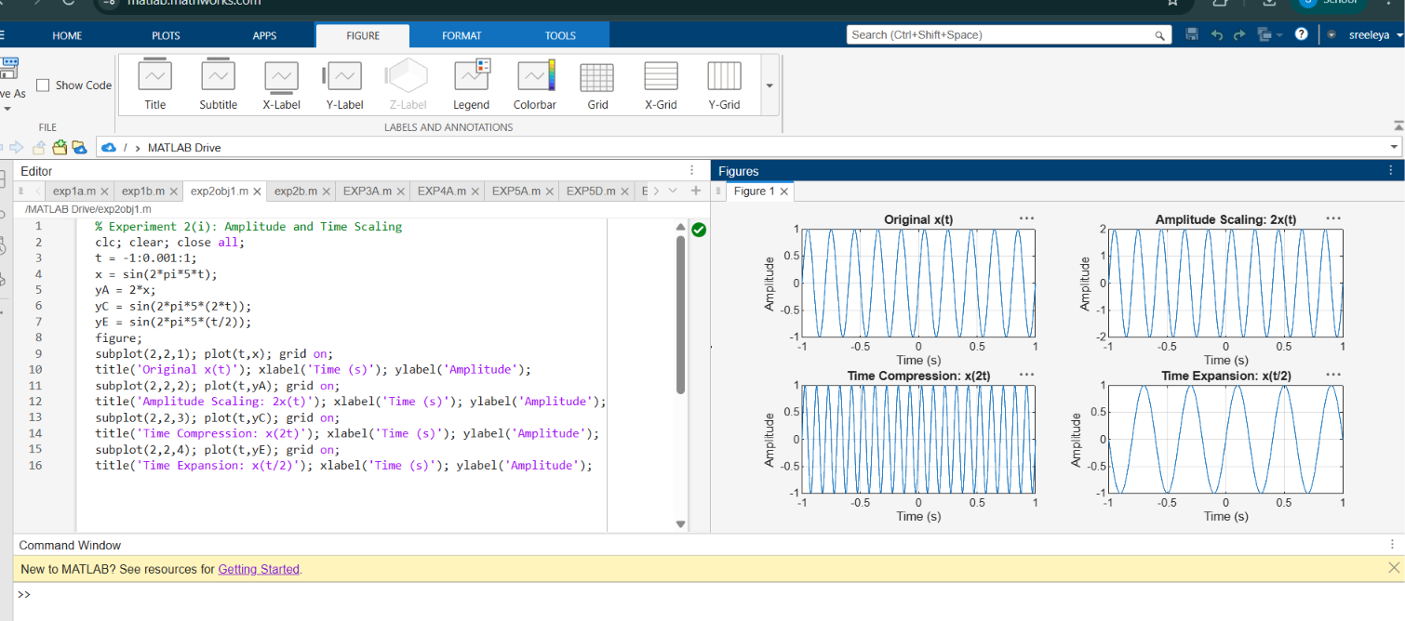

(iii) To perform addition and multiplication of two discrete-time sequences and analyze the resulting signal characteristics.

