# DAY 5

# 1)Install Maven

Command: sudo apt update

sudo apt install maven -y

To Check Version: mvn -version

# 2)Pipeline Script

pipeline { agent any

environment {

IMAGE_NAME = "reshma09/devops" // Replace with your Docker Hub username and image name

TAG = "latest"

CONTAINER_NAME = "my-container"

PORT = "3001"

}

stages {

stage('Clone Repository') {

steps {

echo "Cloning GitHub repository..."

git branch:'main', url: 'https://github.com/reshreshu/devops_.git' // Replace with your repo URL

}

}

stage('Build Docker Image') {

steps {

echo "Building Docker image..." sh 'chmod +x build.sh'

sh './build.sh'

}

}

stage('Login to Docker Hub') {

steps {

echo "Logging into Docker Hub..."

withCredentials([usernamePassword(credentialsId: 'docker-hub-creds', usernameVariable: 'DOCKER_USER', passwordVariable: 'DOCKER_PASS')]) {

sh 'docker login -u $DOCKER_USER -p $DOCKER_PASS'

}

}

}

stage('Push Docker Image') {

steps {

echo "Pushing Docker image to Docker Hub..."

sh "docker tag $IMAGE_NAME:$TAG $IMAGE_NAME:$TAG" sh "docker push $IMAGE_NAME:$TAG"

}

}

stage('Deploy Docker Container') {

steps {

echo "Deploying Docker container..." sh 'chmod +x deploy.sh' sh './deploy.sh'

}

}

}

post { success {

echo "Deployment Successful!"

}

failure {

echo "Deployment Failed!"

}

}

# 3)Build a new pipeline job

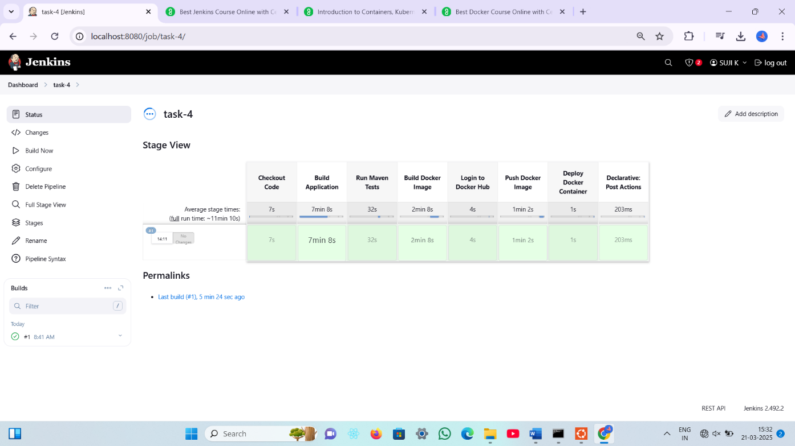

# 4)Console Output of the pipeline

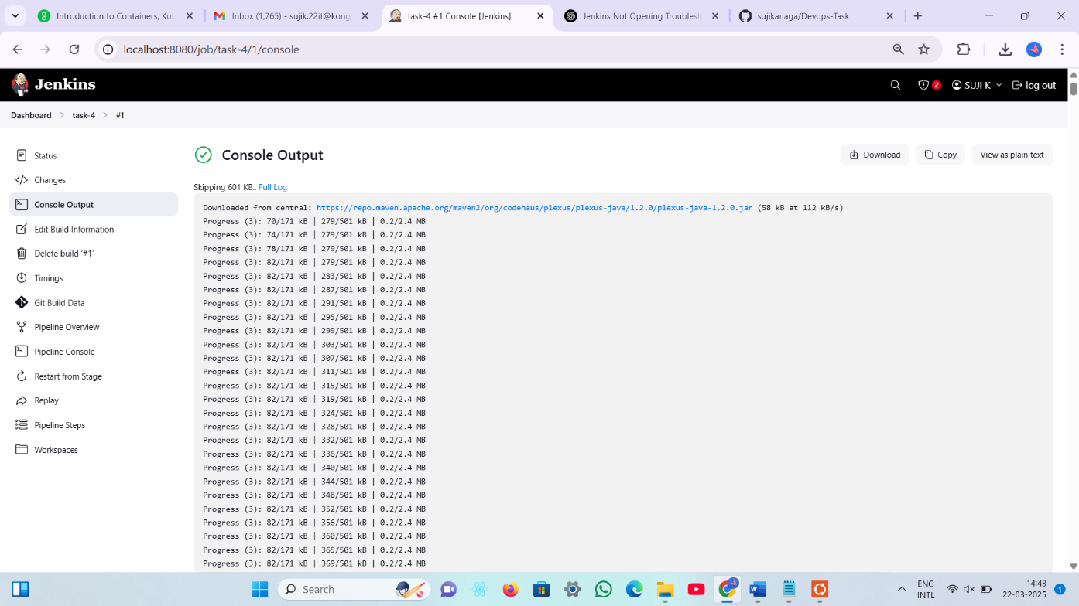

# 5)Status of the pipeline

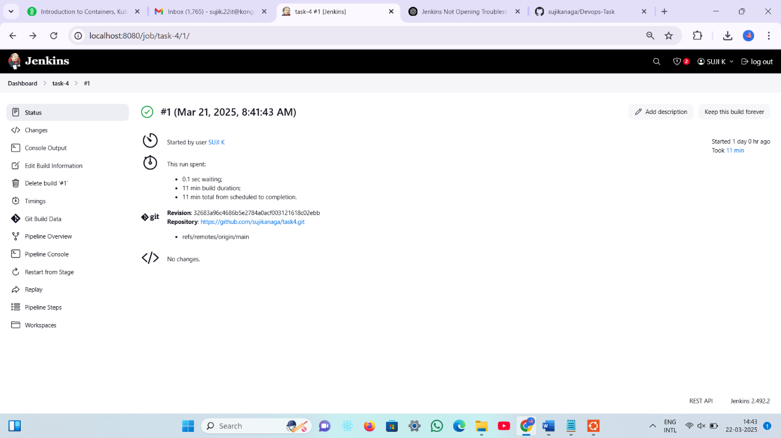

# 6)Pull docker image

