**Usability Study**

Anum Qureshi

**Assignment Overview**

This system will be used to let Dr. Zeitz’s Computer Science students use their timebank days. It was created so that students have an easy way to use their timebank days and Dr. Zeitz can easily keep track of the students and what days they earn or use. Timebank days are days that can be used to add one day extensions to assignments done individually. Dr. Zeitz will have the assumption that she should be able to go in and add timebank days to students and check to see what days they have used, she should not be the one to manually use timebank days for a student because it is their job to use them based on the Terms of Service agreement she has. The students should have the assumptions that they can easily go in before a assignment is due and be able to input a timebank day for the specific assignment they want to use it on. Students should also be able to go in and see how many timebanks days they have left and which assignments they have used them on. All students start with three timebank days and can be depleted depending on assignments. Dr. Zeitz does not allow timebank days to be used on group assignments, since those are with more than one student. The users should interact with the homepage and then press student log-in. After logging in with a correct verified username and password the student users should be directed to the student homepage where they can see the timebank days they have left and navigate to a form page to use their timebank days. On the form page the students can fill in the EXACT assignment name of the assignment they want and extension on and then submit the number of days they want the assignment extended. If the professor is using the system, they can navigate to the admin log in page. After the admin log in is verified, the professor can see a list of classes, students, or assignments. They can also navigate to an upload CSV page. If they try to upload something that is not a CSV on that page, they will be given an error. The CSV should only consist of students first and last names and UMW student ids. This will be used to generate generic student usernames and passwords. Students can change their passwords.

**Imaginary Users**

The first user we will talk about is the professor Dr. Werbenjagermanjensen. Dr. Werbenjagermanjensen has been teaching at UW University (UWU) for 30 years now. He wants to have an easier way to keep track of his students and their timebank days and which ones they’ve used. The students had been emailing him every time they wanted to use a day. Dr. Werbenjagermanjensen would get overburdened with emails the night before a project was due and would sometimes miss one or two students and then would get complaints from students. He decided to try and use a timebank day tracker for his students. Now, Dr. Werbenjagermanjensen is getting up there in his years, being 56, he has a hard time reading sometimes so he likes big font. Dr. Werbenjagermanjensen would also like an easy way to see all his students. Dr. Werbenjagermanjensen would like to upload a list of his students to the system so that it may automatically create usernames and passwords for each student. To do this Dr. Werbenjagermanjensen goes to the log on page. He logs into the admin page and navigates to the upload CSV page from the Admin homepage. He then gets his csv of students and uploads it to the website. He also specifies what class they are a part of so the system can create proper student usernames and passwords for which ever classes the students are in. After he uploads the file and the passwords are generated he can either print off the page with the usernames and passwords or he can email them individually to each student. It’s the start of the semester and Dr. Werbenjagermanjensen is feeling generous, so he also decides to give all the students one extra timebank day. He goes into the student database charts and updates the timebank days they have from the default three to four. He either uses an update straight into mysql or updates it from the mysql management page.

Our second user is the young, ambitious Danny Wiseman. Danny is a young student in Dr. Werbenjagermanjensen’s class this year and has found that he’s good at keeping up with the workload. Danny likes to keep track of his timebank days just to make sure he still has them should he ever need them. He’s also good at going to all the extra timebank day events that Dr. Werbenjagermanjensen offers for students to earn timebank days. While not a policy of all professor Dr. Werbenjagermanjensen enjoys giving students extra credit for having timebank days left, and Danny loves getting all the extra credit he can get, for those times he fumbles up an assignment. Danny is a good student and is very good at navigating hard webpages. Danny decides to go check his timebank days so he can check how many points he can miss on the next exam. He goes to the timebank homepage and presses the button for student log-in, he had tried once to get on the admin log-in, but his user name and password didn’t work. After logging into his student account Danny looks at which class he wants to check, he happened to be in two of Dr. Werbenjagermanjensen’s classes this semester, so he chose the one with an exam coming up, CPSC 498. After opening the page Danny found that he had 6 timebank days left for that class. He calculated his extra credit and then logged out.

Our last procrastinating young computer scientist is Jotarou Kujo. Jotarou isn’t a bad student, he’s very smart. He just sometimes gets overwhelmed and has panic attacks and forgets to do an assignment. He loves computer science and tries his best. Jotarou also goes to all the timebank extra days, but because he knows he is going to need the extra days because he’s having a rough semester. He loves Dr. Werbenjagermanjensen’s class and tries his best to participate. Today is a bad day for Jotarou, so he forgot to do some stuff for the big assignment due today in Dr. Werbenjagermanjensen’s class. It’s 11:30pm and he needs to hurry and go use the timebank day before its deadline time. He quickly opens the timebank main page and logs in on the student log-in page. Once in student view he sees that he still has 3 timebank days left. Jotarou then presses the use-timebank-day button that is displayed towards the top of the student main page. He goes in and inputs what assignment he wants to use the timebank days on and how many of them he needs. This is a rough week, so Jotarou inputs two timebank days for the assignment. After pressing submit he sees that he one more timebank day left, but he has two days past the displayed due date for the assignment. He breathes a sigh of relief and logs out.

**User Model**

Each semester at UMW, Dr. Zeitz teaches multiple computer science

classes. In each of these classes, she provides each student with three

“timebank days.” A timebank day acts as a 24-hour extension on the due

date of a selected assignment. The purpose of providing students with

timebank days is to allow them to extend the due dates of assignments if

they are crunched for time. This project will allow for both the Dr. Zeitz and

her students to keep track of how many extension days they have used.

The Extension Tracker will be a website hosted on the UMW CS server

that UMW students from Dr. Zeitz’s classes will register and login at.

Students will have access to a simple page that will show their remaining

timebank days and allow them to use one or more. Dr. Zeitz will have a

more comprehensive view that will allow her to look at the used timebank

days and remaining timebank days of her students. The Extension

Tracker will make providing timebank days to students easier for Dr. Zeitz

and prevent discrepancies between her and her students.

One of the features that is a large part of the system is the ability for students to input their timebank days with an assignment.

Feedback:

Name: Thomas Webb

How should you interact with this feature?

Time banks should be used when assignments coincide with heavy work load from other courses.

What should you be able to do with this feature?

A time bank should be able to extend the due date of an assignment by one period of 24 hours.

What should you not be able to do with this feature?

Time banks should not be able to extend an assignment's due date by multiple days.

Is there anything you feel is important with this feature?

There should be no reward for not using time banks. This seems to be meant as a flexibility tool for people with hectic schedules and big work loads. A reward or benefit for not using the time bank would undermine this and lead to poor decision making.

Name: Tiler

How should you interact with this feature?

Click interface: there is not much of a need for string based input that would have to be subject to error checking and such. Should be presented with a list of upcoming due assignments, and select which ones you would like to assign a time bank unit to, and then have a confirmation box to confirm the selection (with it listing the assignment, the prior due date, and the updated due date).

What should you be able to do with this feature?

Assign multiple bank days to a single assignment. It would not be necessary to allocate multiple bank days at a time, just to have the ability for them to properly stack with each other.

What should you not be able to do with this feature?

Allocate bank days to past due assignments, allocate bank days beyond the user's current remaining bank days, send the service invalid inputs or otherwise indulge in hacky trickery with the service, or otherwise engage in absurdities (allocating to non-existent assignments). Allocate bank days without express user understanding and confirmation of what is being done.

Is there anything you feel is important with this feature?

Clarity of signifying to the user when a bank day is expended, and when a due date is changed; err on the side of absolute, forced clarity and acknowledgement of understanding from the user to prevent confusion or "confusion" about due dates. Limiting bank day allocation to one at a time; more tedious than multiple allocations, but it prevents edge cases that require additional user input for clarity (and more chance for error). Making sure the additional allocations do not modify the stored actual assignment due date, to allow "undos" or "refunds" by other functions, and to accommodate situations such as a changed assignment due date in a more organic manner. Data for which assignment is modified can possibly be stored on the bank day's data instead, and the student's individual due date for an assignment can just be recreated procedurally as needed instead.

Name: Evan

How should you interact with this feature?

in emergencies to make sure you have enough time for a given assignment

What should you be able to do with this feature?

make up for sick days or other unexpected problems

What should you not be able to do with this feature?

be lazy and just take extra time because you can

Is there anything you feel is important with this feature?

the hard limit to how many time-bank days you're allowed

Name: Alex

How should you interact with this feature?

A simple web form which shows remaining hours.

What should you be able to do with this feature?

Input the amount of hours they want to allocate for the assignment.

What should you not be able to do with this feature?

Enter a negative value, or have your timebank enter negative values.

Is there anything you feel is important with this feature?

Ease of use.

Name: Stefano C. Coronado

How should you interact with this feature?

I would load the website and be able to look at a page that contains my name and the amount of time bank days I have left.

What should you be able to do with this feature?

You should be able to only look at your own information

What should you not be able to do with this feature?

You should definitely not be able to change other peoples' time bank day values. Nor should I be able to look at anyone else's time bank days

Is there anything you feel is important with this feature?

Not that I can really think of.

Model:

The users should be able to select from a list of assignments whose due dates have not yet passed. They should not be able to see other peoples uses of time bank days and they should not be able to use timebank days they do not have.

**Prototype Image**

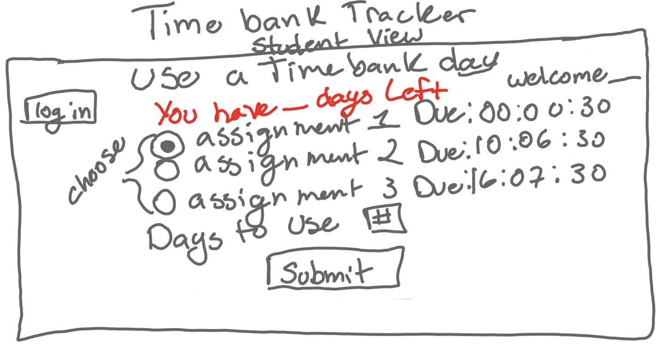

**Feedback**

Name: Alex

How they would use it:

The red needs to mention that its timebank days left. i would use the radio options to select my assignment, enter how many days i want to add and click submit

Any feedback:

As described above. click radio button, enter days, click submit

Name:Daniel

How they would use it:

Assuming I want to use a single time bank day for "Assignment 2", I would click the radio button next to that assignment, type "1" in the text box below, then click the submit button.

Any feedback:

Presumably the system keeps track of the total number of time bank days available for each student, as well as each use (assignment used on and number of days used). When a student uses time bank days, it logs the assignment used for as well as the number of days. It would then adjust the student's available days and the due date for the assignment in question accordingly.

Name: Evan

How they would use it:

I would use this webpage to request addition time for any assignments I'm not able to finish in the given due date. I would click log in to bring up my list of assignments, then select all that apply and then the number of days i needed before clicking submit.

Any feedback:

Once an assignment or assignments and number of days has been selected and submitted, the software would send the teacher and email or perhaps the teacher would have a dashboard to receive a notification about the request, then once the teacher has accepted or denied the request, send an email or notification to the students dashboard concerning it.

Name: James

How they would use it:

I would log in, see how many days I have left, use a time bank day on assignment 1 by highlighting assignment 1, typing in 1 for days to use, and hitting submit

Any feedback:

logging in connects to the list of how many time bank days are left for said account, picking an assignment checks if it's valid to use a day on, then submitting extends the timer

Name:Nathan

How they would use it:

I would first log into my student account using the top left button. Then I would select the assignment I would like to use my "time bank days" on using the radio buttons. Lastly I would select the amount of days I would like to use then click the submit button.

Any feedback:

For how the software functions I feel like it would use something easy and good looking for displaying like django. It would use a simple form and database in order to hold the amount of days certain users have left or it can just store that internally with a json file or something. The website would poll this database or file to check if they have enough days for the amount entered if they do then it would try to extend the due date within canvas on their due date. Other things it will check if they can still extend the assignment just incase it already passes the deadline.

**Changes Made**

I would change the way words were displayed on the screen and make it clearer how many timebank days are left for a student. I would also label the columns for the things to say that the time left is labeled days:hours:minutes. Otherwise the GUI seems like people thought it was relatively easy to use even for people who had no idea what it was supposed to do. The feedback group asked a few questions but let them mostly run the page themselves and most of them had a clear idea how to do.