Chris Watt

CPSC 430

4/17/19

1. Overview of System Functionality

Each semester at UMW, Dr. Zeitz teaches multiple computer science classes. In each of these classes, she provides each student with three “time-bank days.” A time-bank day acts as a 24-hour extension on the due date of a selected assignment. The purpose of providing students with time-bank days is to allow them to extend the due dates of assignments if they are crunched for time. This system will be a website that will allow for both Dr. Zeitz and her students to keep track of how many extension days they have used. The Extension Tracker will be a website hosted on the UMW CS server that UMW students from Dr. Zeitz’s classes will register and login at. Students will have access to a simple page that will show their remaining time-bank days and allow them to use one or more. Dr. Zeitz will have a more comprehensive view that will allow her to look at the used time-bank days and remaining time-bank days of her students. The Extension Tracker will make providing time-bank days to students easier for Dr. Zeitz and prevent discrepancies between her and her students

1. Imaginary Users

Yasmeme yaltimey as a student yasmeme has difficulty with online websites because she is color blind. Being colorblind prevents her from using specific websites and has to use plugins to make non-friendly websites easier to read. In order to make the website more accessible for her we are going to use a color pallet that is friendly to colorblind people. She like other students will login to manage their extension days, she will choose the assignment she wants to use it on and will lose as many days as she wants to use.

Glare Bearington is dyslexic and has had a hard time using websites because of the fonts that can be used. Such as Times New Roman and Calibri. In order to remedy this for Glare and other dyslexic students our website we will be using a font that is dyslexic friendly such as Comic Sans or Arial. Glare has been procrastinating a lot this semester and has used up all her time bank days, so when she goes to use another time bank day she gets an error telling her she doesn’t have any more left and to contact the professor if it is an extenuating circumstance.

Professor ziti is having a hard time keeping track of all the extensions she has kindly given her students to use and instead of keeping them in a spread sheet she would like to use a website to keep track of the extensions she gives her students. What she will do is use a .csv file that contains her student’s names to create a database that will help her keep track of how many extensions a student has and what assignments they have used them on.

1. User Model

The part of the system I will be showing is the student view page which will contain assignments, their due dates, how many extensions the student has used on the assignment and the new due date on the assignment. The page will also contain a way for students to use extensions on other assignments. They will be shown how many extensions they have left and a logout button.

Yasmeen

There should be a table containing assignments, due dates, the number of extensions and the new due date after extensions have been added which should be blank before extension is added. There will be a box with the assignment name and the date that the student wants to use the extension on. Once all that is done they will have a counter with remaining extensions and a logout button.

Harrison

I would do a table or a list where you can interact with assignments individually and make the number of time bank days left very prominent. Possibly have the due date and how many days left until the day is due.

Jorge

I hopefully will see a list or table that shows which assignments have been extended and the assignments that haven’t been extended. A counter that shows how many extension days one has left. Then a page that shows I have official logged out.

Clare

I think in very obvious format on top would be the students name, maybe the course, and the number of extendable days left. I would imagine the assignments to be listed in a single column, then the original date beside them, then either the updated date or an empty spot if not changed. Personally I don’t think noting how many days it has been extended by is necessary. You could either have a button at the top of the form that says extend then takes you to another webpage, or put a dropdown next to each one.

Consensus between the focus group is that there should be a table or list of some kind that shows the assignment, when it is due and possibly a new due date if an extension is used on the assignment. The focus group also concluded that there should also be a way to see how many extensions a student has left and that it should be very visible to the students.

4. Prototype Image/s

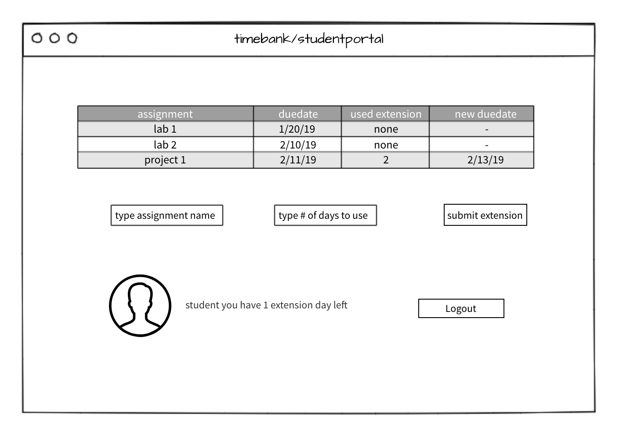

5. Group Feedback

Yasmeen

Words need to be capitalized and duedate needs to be two words

Harrison

Move profile, logout, and amount of time bank days left to the top. Then move submission to middle and have the table on the bottom. Consider errors and the placement of errors.

Jorge

Just move submit extension where the logout button is and move the logout button below the submit extension button. Make sure you have an error page if a student selects a number over the extension days they have left.

Clare

I would move your final group to the top. Are you expecting students to submit a photo? I don’t imagine that to happen. I like the simplicity of the extension capability.

Consensus in the focus group is that they liked the layout of the assignment list however they would prefer that the ordering of the page be formatted differently. Also the consideration of errors will needed to be taken into account and where those will be placed. There was also some confusion about what the profile picture was to be with some of the focus group. At least one person thought it was supposed to be a submission for a photo while other saw that is was supposed to be a representation of the student account.

1. Changes

As of now the changing of the page will be changed to have the account information at the top and possibly be a link to a student account page where they can change passwords and do some minor account management. The account information at the top will be formatted by the student name followed by the amount of extension days that the student has left. Below that we will have a series of inputs that will allow a student to submit an extension for an assignment. Almost all the focus group like the format of the assignments page so that will be maintained but shifted to the bottom of the page. Error handling will be done by refreshing the page and displaying the error directly under the submission button.