Anna Malyevac
Usability Study

- The system being built is called the Timebank Extension Tracker for professor Zeitz at the University of Mary Washington. Dr. Zeitz has a system for accepting late work from students, where she allocates each student three days that they may use for late work over the course of the semester. The ‘timebank days’ can be spent at any time, on any assignment, with multiple days being allowed to be spent on one assignment. The client, in the past, has not had a formal system for keeping track of her student’s time bank days; she would manually keep track of how many they’ve used and when in a spreadsheet, getting input from students on how they’d like to spend their days via email. To create a more organized system for the professor, we are building a website that incorporates a database of the students enrolled in the coarse, where they are able to individually manage their time bank days over the semester, and the professor is given an overview of students and their spent time days.

- Imaginary user one: Professor and administrator.
Professor Z would like to see how her students are doing on their major project due in an hour. She logs into the Timebank Extension Tracker with her administrator account to access the overview of students. To her shock, she sees that over 80% of the students have used a time bank day on this assignment. Believing that the assignment may have been too difficult, professor Z decides to extend the deadline for all the students, and go over some points on it in class. Professor Z has decided to give back the time bank day to all of the students that used one on this assignment. She presses the ‘add time bank day’ option on her overview, and adds +1 time bank days to all the students that used one for this assignment.
Pepe Jones is very sick, can barely get out of bed, and much less, cannot code. He knows that the project, due tomorrow, cannot be completed until he recovers. It is near the end of the semester, and Pepe cannot forsee himself using any more of his time bank days. With all three remaining, Pepe chooses the final assignment in the student overview, and chooses three time bank days to spend. He clicks submit with those values. Pepe now has no time bank days left, and three additional days to work on his assignment
Joe Shmoe would like to budget his time on his projects accordingly. He knows that he is a procrastinator, but he also knows that there are three major projects in the year. Joe decides he is going to be diligent with homework, and use his extra days on his projects. Joe logs into the Timebank Tracker with his student login, on the student login prompt. After logging in, Joe can see how many time bank days he has left on the overview. He forgot he already used one, after missing lab the first day of class, so he only has two time bank days left. Joe decides to start the first project early.

- The system, overall, gives the administrator an overview of all of their students and their time bank days that they have, in total, and the amount that they have currently used. Next to each student, the assignment that they used their time bank day on will be posted. The administrator will also have options to manage time bank days for students. For the student view, students will only be able to view their own individual time bank days, but will have a similar overview of total days, days left, and assignments on which it was used.
The function of the system I chose to highlight was the administrator’s overview

Comments on what the system should look like, based on these descriptions:
“The administrator view would incorporate a database of students and possibly display information including name, student ID, class(es) they’re enrolled in, late days used (and assignments completed during the late days), and late days remaining. It sounds like the admin would have the ability to edit a particular student’s days used or days remaining if there are extenuating circumstances, but to me, it doesn’t sound like anything else would be editable, it sounds like most database information would be view-only as a reference for the admin so that they can keep track of their students. For ease of viewing, maybe there could be a way of sorting/displaying students (by class, alphabetical order, number of late days used, etc).”
“The admin view will let the admin see every student in the system, how many bank days they’ve got, and what assignments they’ve used them on if any. they can also change the amount of time if they want.”
“I think there will list containing a count of how many extension days each student. Tracking what assignments were extended. Other than that I don’t know what else this program will do.”
“Got a big table overview of all students, all timebank days the students have and all the assignments they’ve used them on, I don’t know if its all visible or hidden in a menu. The admin should be able to make not visible information visible. The admin should be able to manually adjust what time bank days are available for students. The admin should not be able to not do anything because they are an admin”

4. 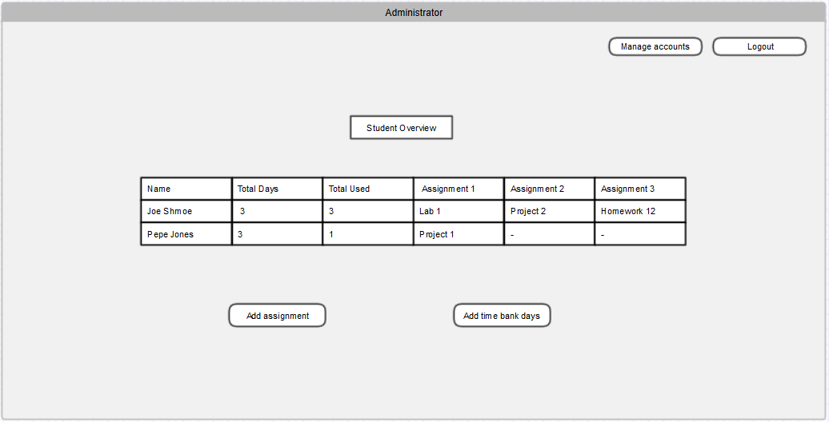

- Responses on how the website would work based on the diagram:

“Well student overview is showing all them students the table is a table. Add assignment i would guess allows the professor to add in different projects that the students in their view are able to select when they're applying bank days. Add time bank days just adds (and presumably removes if for some reason that’s a thing to do) to students who have them. Manage accounts is kind of vague. It could also be the one that leads to changing things on the students accounts but it could also just be like, I dunno basic admin settings for the admin account”

“Add assignment: manually add a student assignment to a student’s profile in the database and add one to the “days used” box for the student. Add time bank days: either adds one to the “days used” for a specific student or could add one to “total days” for a specific student. Manage accounts: can add/remove student profiles from the database (if students add or drop one of the professor’s classes), view other student data, other functionality not including adding assignments or time bank days. Logout: logs out of admin view. Because of the buttons, I’m assuming that means the chart itself is view-only/static and can not be purposefully or accidentally changed. I’m also assuming the “student overview” box is just a label and not a button, unless you can click that and get the same effect as the “manage accounts” button. Total days might be more clear if it were “late days remaining” since every student starts with three days. Unless there’s a significant trend of adding classes and making that total greater than three”

“I understand everything except that I think total days and total used should be more specific, like they’re talking about time bank days. I also think that the admin should have more options, more buttons, and more stuff that they need to do.”

“Logout and manage accounts seems cut and dry, logout is logout manage accounts gives you access to the students accounts and their management. Not clear to me what add assignment does. Add time bank days seems straightforward, but with how the table is laid out, I think it would be a mess.”

Some feedback is that some of the features were confusing. “Add assignment” was confusing to one, because he didn’t understand what assignments were being added, where and why. There seemed to be several discrepancies with what the users thought ‘manage accounts’ did. Some of the users also thought that there should be more options available for the admin.

6. Based on the feedback, I think I should change manage accounts to a drop down menu with all of the various meanings that that could have, i.e managing the passwords for student accounts, changing settings for the admin, etc. I also realized I forgot to add the add csv option to the model, which should also be in the admin view, which reflected several of the comments about ‘lacking options’. The names of the table variables should also be changed to reflect something more obvious, though I chose the names that the professor specifically wanted.

