Final Project Proposal

D00242726

Sujil Kumar K.M

**Student Name: Student ID:**

Insight to Suicides around the world

**Project Title:**

1. Background Research / Problem Description (200 words max)

*Explain the title and application of your work. Detail the problem(s) you are trying to solve, your proposed solution, and the techniques you will use. Give details of any similar studies, and how your study will differ from these.*

**T**hisiteration is a deep dive into the suicide dataset for knowing the reasons behind suicides around the world. Though, several studies related to this topic had been done in the past (example: - [covid-19 time](https://f1000research.com/articles/9-1097/v1) suicide research). This study is going to make new findings that are useful for authorities to make policies that could reduce the mortality rate in the future. I will be looking at different aspects of suicide and predicting how much more suicides are going to happen in the coming years in different countries.

**Time Series** and **Statistics** are used for this project. The purpose of this study is to understand the reasons for suicide. Suicide rate in many countries is higher than the total mortality rate. In order to make a change to this scenario, we need to study different patterns and clusters in the data and understand what factors are triggering the tendency for someone to make such decisions. whilst, a **web-based** system will be created that can dynamically create useful visualizations on the python dashboard. Every step will be well documented and updated from time to time on **GitHub** and this repo will be linked to the mocha host server.

1. List the research questions related to the problem statement. Subsequently list out your project goals.
2. How many suicides are expected to happen in the next year?
3. Which countries have the highest suicide rate?
4. Variation of suicide rate over the years?
5. Knowing the age group of people who are more likely to suicide?
6. Find GDP of countries with lowest and highest suicide rates
7. Check suicide rates in different continents.
8. Understand Population and suicide number ratio.

**Project Goals**

1. Support social sector to identify and help individuals who require help and mitigate the loss of life (by providing useful inferences).
2. Create and publish a web-based system to study the data online that can dynamically interact with the dashboard and database concurrently.
3. Identify the factors affecting suicides in different countries/times.
4. Make an insight by using all available variables in the dataset to identify different trends and clustering.
5. Data description, tools and software, references, link to data sources and ethics consideration.

Dataset contains total 12 Variables. No ordinal Data found in the dataset.

**Nominal Data :-**country, Year, sex, age, country-year, generation :- all these variables are nominal categorical

**Continuous Data :-** suicides/100k pop, HDI for year, gdp_for_year ($), gdp_per_capita ($)

**Discrete Data :-** suicides_no, population

**Tools Used**

**Visual Studio Code, Jupiter Notebook, GitHub repo, PHP Laravel Framework, PSQL DB, SSH Technology, Python Dash/Tableau/Power BI**, **xampp, Google Chrome**.

As per the page, the majority of the dataset has been taken from the WHO website (open source).

https://www.kaggle.com/lmorgan95/r-suicide-rates-in-depth-stats-insights/data

1. Gantt Chart

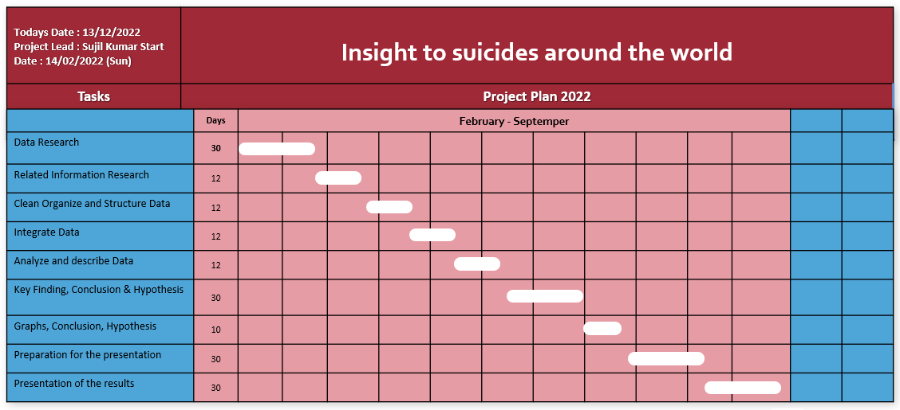

1. Special requirements and deliverables of the project

I need a server to publish the project online, So I will be using a Mochahost server owned by myself.

1. Risks – What risks can you identify? What will be the impact if the risk becomes a reality? What can you do to minimize the impact?

* Contingency plan in case you do not meet your project goals – prioritize the goals.
* Unexpected output – any output – you should report it.
* Loss of data/coding due to system failure – work on cloud/back up your work.
* System compatibility – look for virtual machine options.
* Ethics risks – work under the ethical guidelines detailed on DKIT/ Data protection website.