Setting pip env 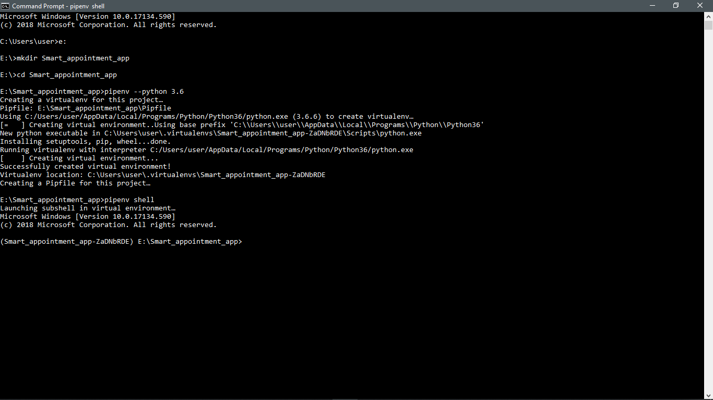

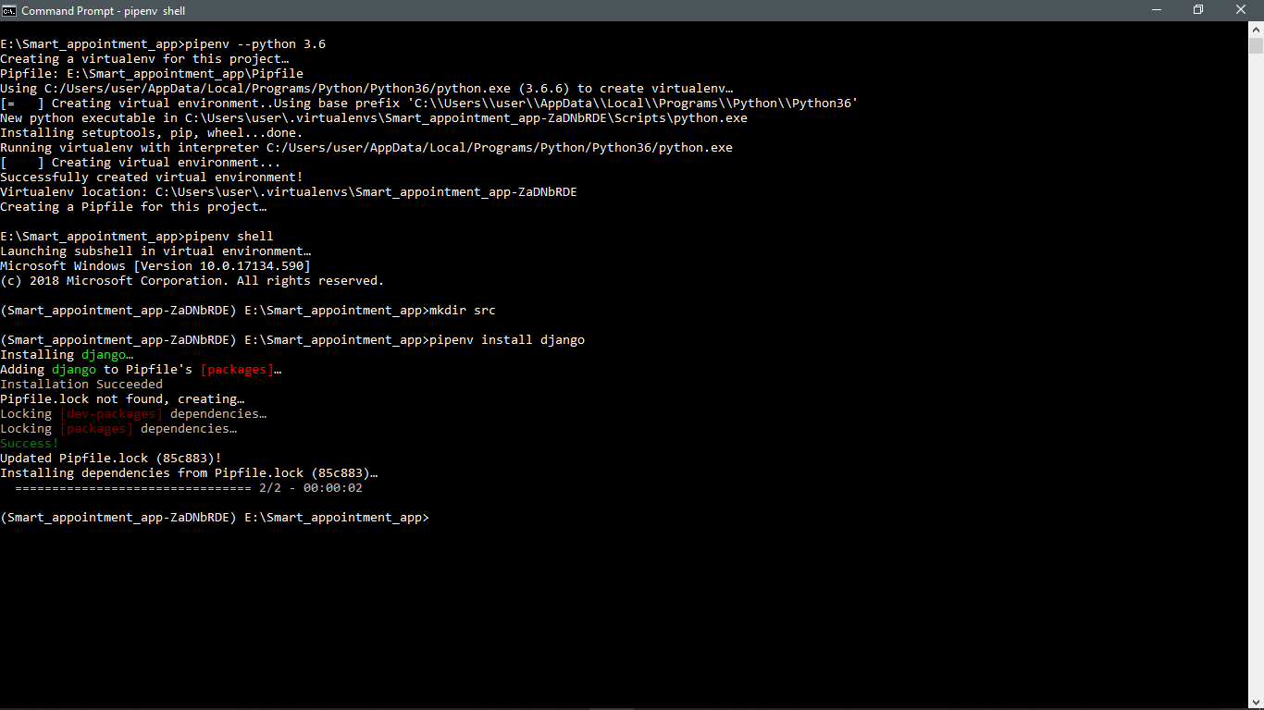

Installing django

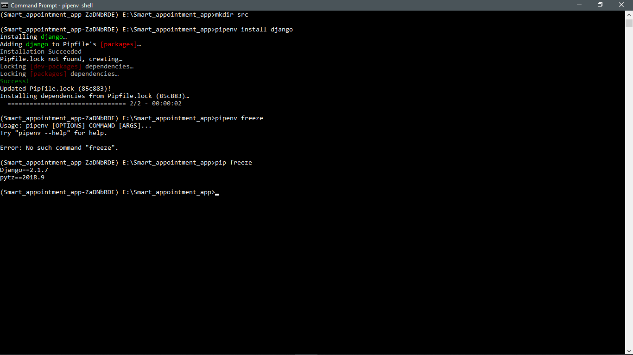

Creating requirements.txt file and adding it to git

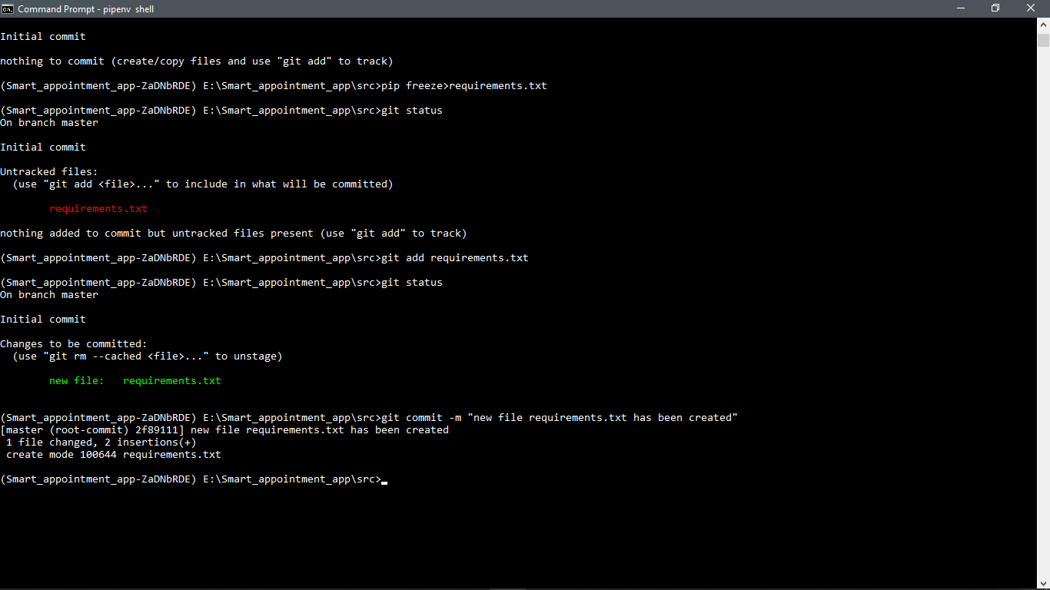

Initializing the project saa

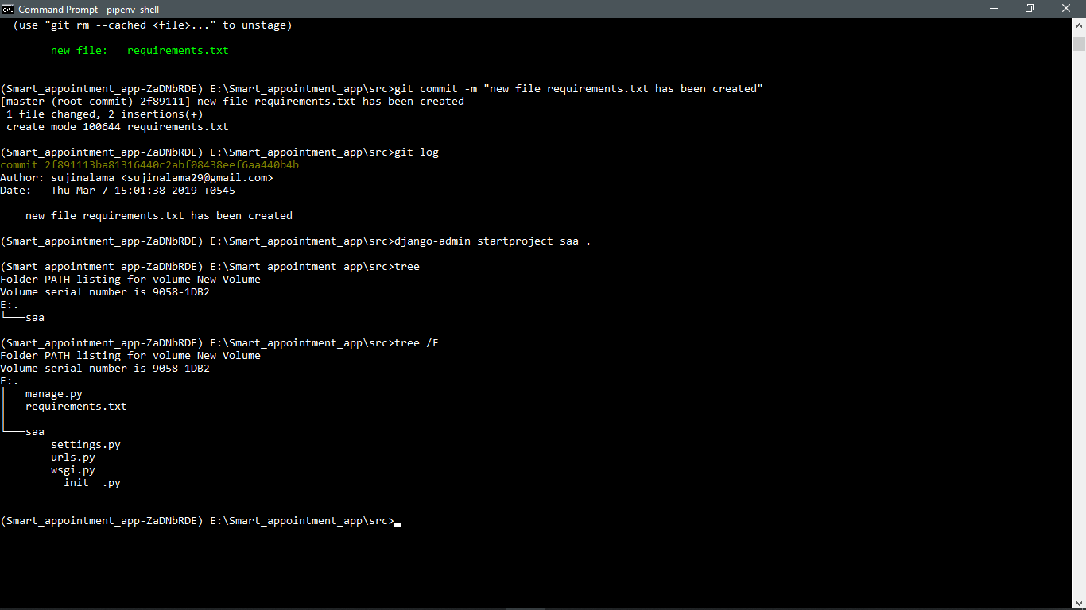

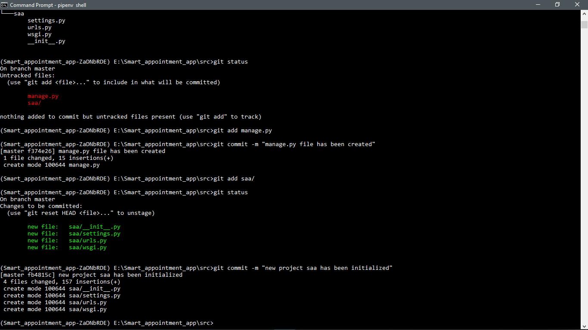

Default tables in Database has been initailzed

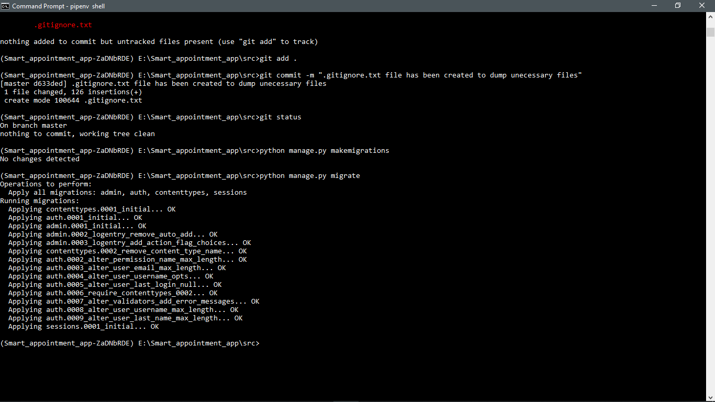

Running server

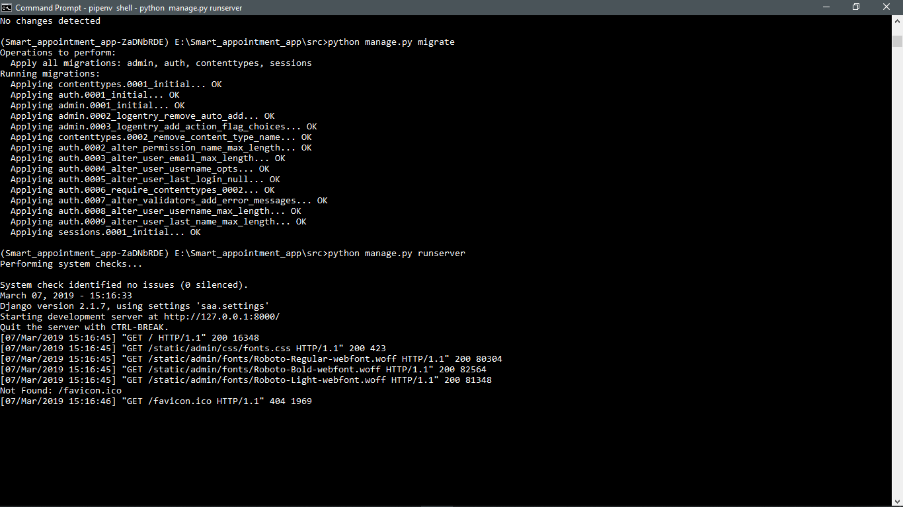

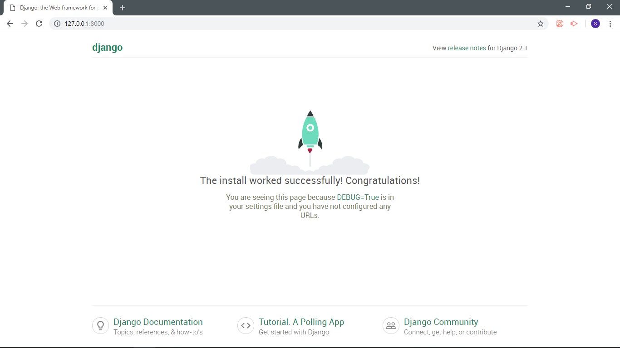

Super user has been created

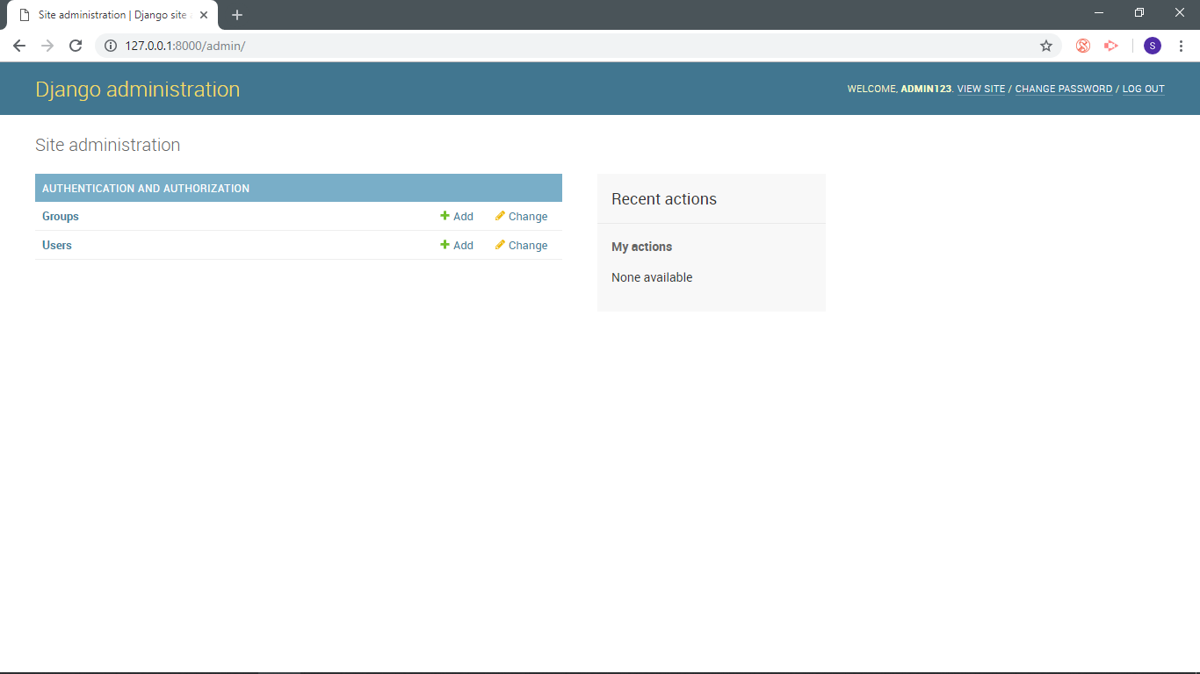

New app user_profile has been created

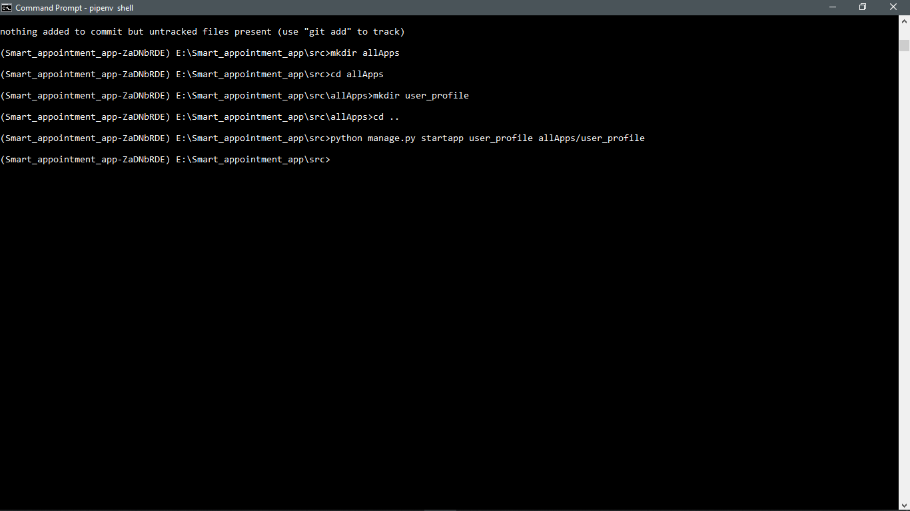

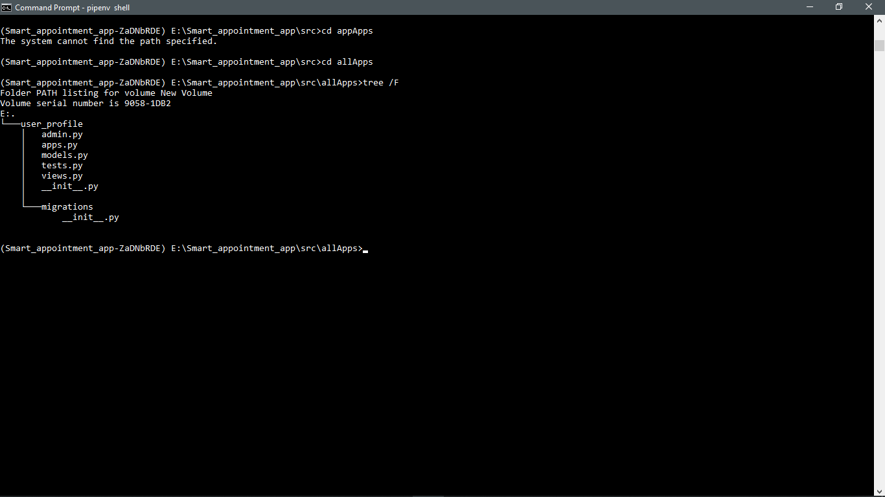

Initializing new app hospital

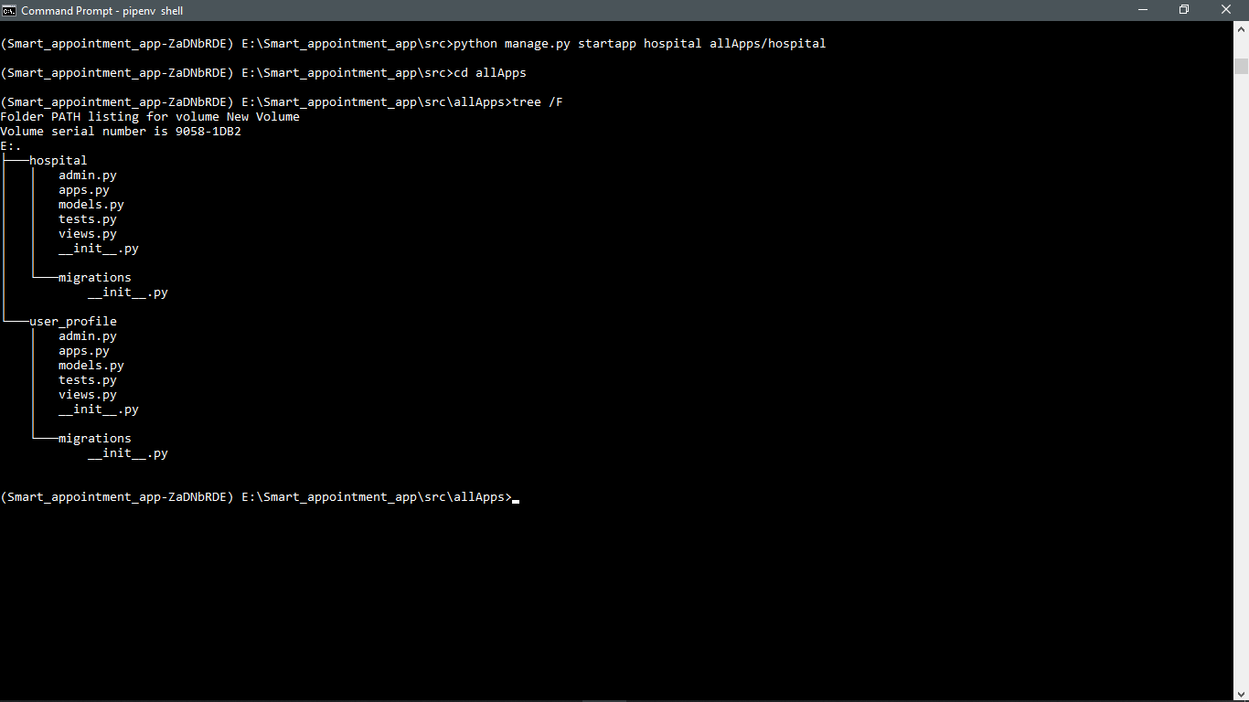

Initializing new app appointment

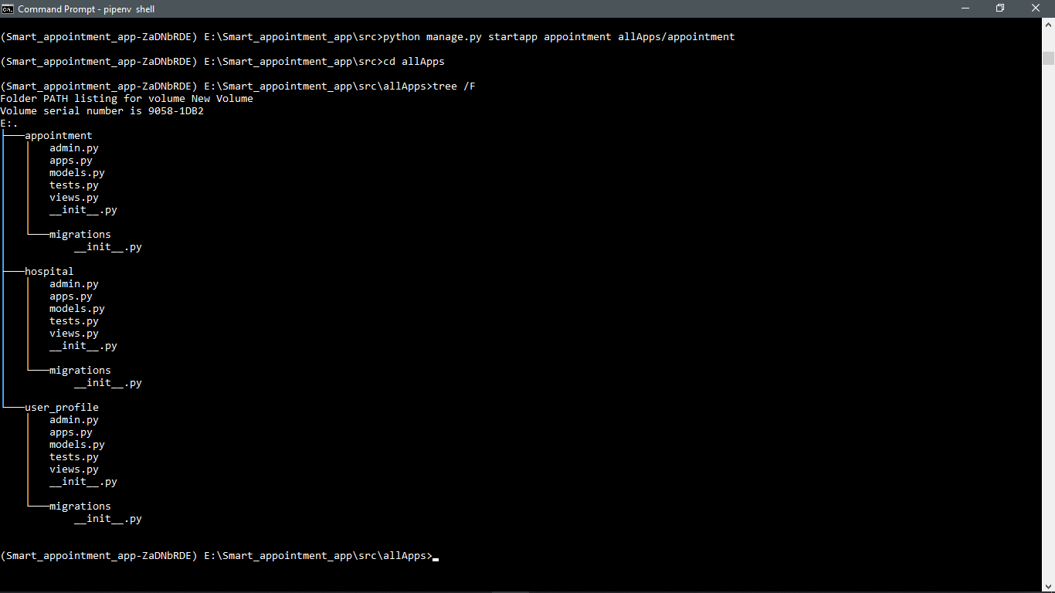

References:

<https://docs.djangoproject.com/en/2.1/topics/auth/customizing/>

<https://docs.djangoproject.com/en/2.1/topics/auth/customizing/#django.contrib.auth.models.AbstractBaseUser>

<https://www.botreetechnologies.com/blog/supporting-multiple-roles-using-djangos-user-model>

<https://medium.com/@piyushmaurya23/setting-up-django-using-pipenv-cf8ff9b2caa6>

<https://pypi.org/project/django-phone-field/>

<https://simpleisbetterthancomplex.com/tutorial/2018/01/29/how-to-implement-dependent-or-chained-dropdown-list-with-django.html>

<https://developer.mozilla.org/en-US/docs/Learn/Server-side/Django/Authentication>

<https://www.calazan.com/adding-basic-search-to-your-django-site/>

<https://docs.djangoproject.com/en/2.1/ref/contrib/postgres/search/>

<https://www.w3schools.com/bootstrap/bootstrap_ref_comp_glyphs.asp>

<https://bootsnipp.com/snippets/35V6b> <important

<https://getbootstrap.com/docs/4.0/utilities/text/>

<https://getbootstrap.com/docs/4.0/content/images/>

<https://getbootstrap.com/docs/4.3/content/tables/>

[https://github.com/django-notifications/django-notifications<](https://github.com/django-notifications/django-notifications%3c) main

<https://stackoverflow.com/questions/16356289/how-to-show-datepicker-calendar-on-datefield/16356818>

<https://wsvincent.com/django-custom-user-model-tutorial/>

<http://api.jqueryui.com/datepicker/#option-dateFormat>

<https://makitweb.com/set-minimum-maximum-date-jquery-ui-datepicker/>

<https://simpleisbetterthancomplex.com/tutorial/2019/01/03/how-to-use-date-picker-with-django.html>

<https://stackoverflow.com/questions/28583565/str-object-has-no-attribute-decode-python-3-error>

<https://django-book.readthedocs.io/en/latest/chapter06.html>

<https://tutorial.djangogirls.org/en/django_forms/>

<https://medidocnepal.com/>