**Mini Project 2 (Final Report)**

**(2019-20)**

**Website Development (the_social_network)**



**Submitted by: (1)**Shreyaskar Pratap Singh-171500330

**(2)**Sujit Kumar Yadav-171500346

**Submitted to:** Mr. Pankaj Kapoor

Department of Computer Engineering and Application, GLA University, Mathura

17km.Stone NH#2, Mathura –Delhi Road, P.O.-Chaumuha, Mathura-281406

**CERTIFICATE**

This is to certify that the project entitled “the_social_network” carried out in Mini Project – II Lab is a bona-fide work done by Shreyaskar Pratap Singh(171500330), and Sujit Kumar Yadav(171500346) is submitted in partial fulfilment of the requirements for the award of the degree Bachelor of Technology (Computer Science & Engineering).

Department of Computer Engineering and Application, GLA University, Mathura

17km.Stone NH#2, Mathura –Delhi Road, P.O.-Chaumuha, Mathura-281406

**DECLARATION**

I hereby declare that the work which is being presented in the “the_socail_network” in partial fulfilment of the requirements for Mini-Project II, is an authentic record of our own work carried under the supervision of Mr. Pankaj Kapoor Sir, GLA University, Mathura.

Signature of candidates: __________ __________

Name of Candidates: (1) Shreyaskar Pratap Singh(171500330), and

(2) Sujit Kumar Yadav(171500346)

Course: B.tech Computer Science Engineering

Year: 3rd

Semester: 6th

**ACKNOWLEDGEMENT**

It gives me a great sense of pleasure to present the report of the B. Tech Mini Project II undertaken during B. Tech. Third Year. This project in itself is an acknowledgement to the inspiration, drive and technical assistance contributed to it by many individuals. This project would never have seen the light of the day without the help and guidance that we have received.

My heartiest thanks to **Dr. (Prof). Anand Singh Jalal, Head of Dept., Department of CEA** for providing us with an encouraging platform to develop this project, which thus helped us in shaping our abilities towards a constructive goal.

I owe special debt of gratitude to **Mr. Pankaj Kapoor Sir, Technical Trainer, Department of CEA**, for his constant support and guidance throughout the course of our work. His sincerity, thoroughness and perseverance have been a constant source of inspiration for us. He has showered us with all his extensively experienced ideas and insightful comments at virtually all stages of the project & has also taught us about the latest industry-oriented technologies.

I also do not like to miss the opportunity to acknowledge the contribution of all faculty members of the department for their kind guidance and cooperation during the development of our project. Last but not the least, we acknowledge our friends for their contribution in the completion of the project.

Sincerely,

Shreyaskar Pratap Singh (171500330), and

Sujit Kumar Yadav (171500346)

**ABSTRACT**

This report documents the work done in the Mini-Project II. The report first shall give an overview of the tasks completed during the period of training with technical details. Then the results obtained shall be analyzed. Report shall also elaborate on the future works which can be persuaded as an advancement of the current work. I have tried my best to keep report simple yet technically correct. I hope I succeed in my attempt.

“the_social_network” is a social media website that allows users to share photos and videos from their lives, add captions, engage with others, explore and creep, and so, so much more, you just have to know what you're doing so you don't get overwhelmed. It is developed with full dedication and love using major Web Development Technologies like HTML, CSS, PHP, and Bootstrap.

**CONTENT**

1. Certificate…………………………………………………………………… 1

2. Declaration……………………………………………………………… 2

3. Acknowledgement…………………………………………………… 3

4. Abstract…………………………………………………………………… 4

5. Introduction …………………………………………………………… 6

5.1. Motivation and Overview……………………………………… 6

5.2. Objective.…………………………………………………………… 6

6. Software Requirements Analysis …………………………………. 7

6.1. Problem Definition……………………………………………….. 7

6.2. Modules and Functionalities.………………………………… 7

7. Software Design.………………………………………………………… 9

7.1. Data Flow Diagram……………………………………………… 9

8. Testing…………………………………………………………………………. 10

9. Technologies Used……………………………………………………….. 11

10. Future Prospects………………………………………………………… 17

11. Implementation and User Interface……………………………. 18

12. User Manual …………………………………………………………….… 24

**5. INTRODUCTION**

In this project we tried our best to make a website like Instagram using PHP & MySQL, JavaScript and BootStrap. So in this New Social Network a user will be able to follow his friends or people from around the world, a user can sent messages to them, a user can comment on his friend’s posts, a user can update posts and so on.

**5.1 MOTIVATION**

I have always been a great technology enthusiast. So, it was just another day when I was just going through my instagram account trying to reduce my boredom, I got struck with an idea that wouldn’t it be great if I can share my photos and videos on a page created by me. How cool would it be to just exactly learn how apps like instagram function rather than just using it for fun do? Not only that I could post photos and video online but now I can learn the functionality of the sites like this also it would be beneficial for my engineering life. So that is how I got the idea of building a website which allow us to post things online. It would allow the users to post their things online and get views of others. I know I could have simply looked up the internet and would have installed another fancy app but I didn’t. The fun of making something like this is simply amazing and that is the reason I decided to build this as a mini project.

**5.2 OBJECTIVE**

In short, the point of **“the_social_network”** is to make connections with people who see the world in interesting ways. You can find and follow people based on the kinds of images that inspire them, and if they like yours, they'll follow you back. The simple mechanisms of liking and commenting provide great fun and feedback.

**6. SOFTWARE REQUIREMENT ANALYSIS**

**6.1 THE PROBLEM DEFINATION**

There is only one problem i.e. how to get or motivate people to use “the_social_network” as there are various apps like our project is already present in the market.

**6.2 MODULES AND THEIR FUNCTIONALITIES**

**(1) main**

It the starting page of our website. At the top we have provided the name of our website i.e. “the_social_network”. On the left there is image just to make or page more attractive and there are some slogans written on that image. The main purpose of this module is to provide user with a option of either signing up or logging in as there are two buttons named “SIGN UP” and “LOGIN”.

**(2) signup**

A Signup page enables users and organizations to independently register and gain access to our website. Here a user have to provide some details like: first name, last name, date of birth, country, gender, and email id (valid). If the user already have an account then it show a message i.e. “already have an account”. If the user click on the button “already have an account” he/she will be directed to login page.

**(3) login**

A login page is a web page or an entry page to a website that requires user identification and authentication, regularly performed by entering a username and password combination. Logging in not only provides site access for the user, but also allows the website to track user actions and behavior.

**(4) header and footer**

We will separate header and footer in html (make header and footer files to be included in multiple html pages) and we will include on every page whenever we need header and footer. We are doing this because we do not want the repetition of same code again and again. So we are basically make the code clean by avoiding the repetition of code.

**(5) profile**

It used to store the description of the characteristics of a person. This information can be exploited by systems taking into account the person's characteristics and preferences. Here a user can change its profile pic and also update its cover photo. We can also see all the posts of particular user from here.

**(6) home**

The home page shows the feed of photos posted by you and by the other "the_social_network" users whom you follow. You can like and comment on the photos and videos in your Feed.

**(7) logout**

Logging out means to end access to a website. Logging out informs the website that the current user wishes to end the login session.

**(8) post**

It allows user to post the pics and videos.

**(9) getpost**

We created get post function in PHP, to retrieve post data from database.

**(10) pagination**

We added PHP pagination using MySQL database records with bootstrap and we will fetch data from MySQL database in PHP and we will display all users’ posts on Home Page.

**(11) chat**

It allows user to chat with their friends.

**7. SOFTWARE DESIGN**

**7.1 DATA FLOW DIAGRAM**

Data flow diagrams are used to graphically represent the flow of data in a business information system. DFD describes the processes that are involved in a system to transfer data from the input to the file storage and reports generation. Data flow diagrams can be divided into logical and physical. The logical data flow diagram describes flow of data through a system to perform certain functionality of a business. The physical data flow diagram describes the implementation of the logical data flow.

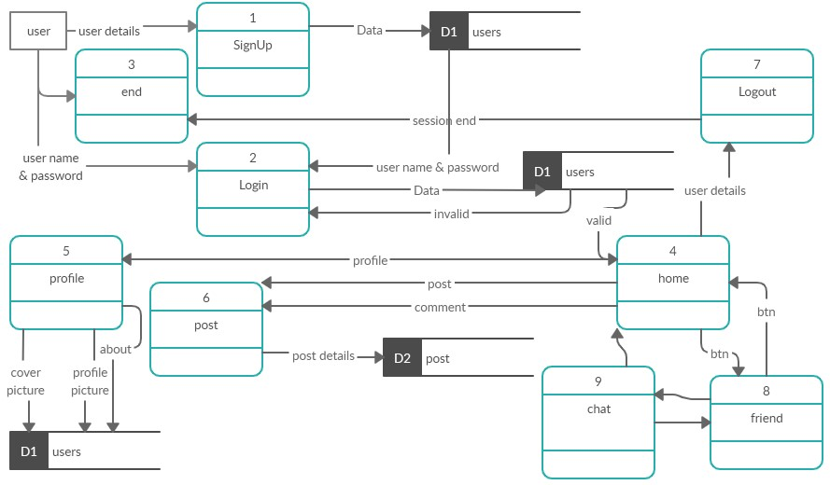

**8. TESTING**

A project must be tested on all its features. Type of testing a web application must go are:

(1)Functional Testing

(2)Usability Testing

(3)Security Testing

(4)Performance Testing

(5)Database Testing

(6)Responsiveness

For the testing purpose we ran our website on pc. It worked well. Then created an account and logged in. We checked the database then and as programmed the user account has been added to our database. After logging in the website redirected us to home page of website where we can see other users post and can post our pics and videos too. All the modules of home page were working well. At last we checked our profile page and logout button. In profile page we tried to change cover photo and profile photo and as programmed it changed. For responsiveness we changed our window size and as we had made it changes it size with respect window dimension.

**9. TECHONOLOGY USED**

**9.1 Sublime Text Editor**

Sublime Text editor is a sophisticated text editor which is widely used among developers. It includes wide features such as Syntax Highlight, Auto Indentation, File Type Recognition, Sidebar, Macros, Plug-in and Packages that make it easy for working with code base.

The following is a list of features of Sublime Text:

1. "Go to anything," quick navigation to files, symbols, or lines

2. "Command palette" uses adaptive matching for quick keyboard invocation of arbitrary commands

3. Simultaneous editing: simultaneously make the same interactive changes to multiple selected areas

4. Python-based plugin API

5. Project-specific preferences

6. Extensive customizability via JSON settings files, including project-specific and platform-specific settings

7. Cross-platform (Windows, mac OS, and Linux) and Supportive Plugins for cross-platform

8. Compatible with many language grammars from TextMate

Sublime Text contains 23 different visual themes, with the option to download additional themes and configure custom themes via third-party plugins. The mini map feature shows a reduced overview of the entire file in the top-right corner of the screen. The portion of the file visible in the main editor pane is highlighted and clicking or dragging in this view scrolls the editor through the file.

**9.2 HTML**

Hypertext Markup Language (HTML) is the standard markup language for documents designed to be displayed in a web browser. It can be assisted by technologies such as Cascading Style Sheets (CSS) and scripting languages such as JavaScript.

Web browsers receive HTML documents from a web server or from local storage and render the documents into multimedia web pages. HTML describes the structure of a web page semantically and originally included cues for the appearance of the document.

HTML elements are the building blocks of HTML pages. With HTML constructs, images and other objects such as interactive forms may be embedded into the rendered page. HTML provides a means to create structured documents by denoting structural semantics for text such as headings, paragraphs, lists, links, quotes and other items. HTML elements are delineated by tags, written using angle brackets.

Tags such as <img /> and <input /> directly introduce content into the page. Other tags such as <p> surround and provide information about document text and may include other tags as sub-elements. Browsers do not display the HTML tags, but use them to interpret the content of the page.

HTML can embed programs written in a scripting language such as JavaScript, which affects the behavior and content of web pages. Inclusion of CSS defines the look and layout of content. The World Wide Web Consortium (W3C), former maintainer of the HTML and current maintainer

of the CSS standards, has encouraged the use of CSS over explicit presentational HTML.

**9.3 CSS**

Cascading Style Sheets (CSS) is a style sheet language used for describing the presentation of a document written in a markup language like HTML CSS is a cornerstone technology of the World Wide Web, alongside HTML and JavaScript

CSS is designed to enable the separation of presentation and content, including layout, colors, and fonts This separation can improve content accessibility, provide more flexibility and control in the specification of presentation characteristics, enable multiple web pages to share formatting by specifying the relevant CSS in a separate .css file, and reduce complexity and repetition in the structural content.

Separation of formatting and content also makes it feasible to present the same markup page in different styles for different rendering methods, such as on-screen, in print, by voice (via speech-based browser or screen reader), and on Braille-based tactile devices. CSS also has rules for alternate formatting if the content is accessed on a mobile device.

The name cascading comes from the specified priority scheme to determine which style rule applies if more than one rule matches a particular element. This cascading priority scheme is predictable.

The CSS specifications are maintained by the World Wide Web Consortium (W3C). Internet media type (MIME type) text/css is registered for use with CSS by RFC 2318 (March 1998). The W3C operates a free CSS validation service for CSS documents.

**9.4 Bootstrap**

Bootstrap is a web framework that focuses on simplifying the development of informative web pages (as opposed to web apps). The primary purpose of adding it to a web project is to apply Bootstrap's choices of color, size, font and layout to that project. As such, the primary factor is whether the developers in charge find those choices to their liking. Once added to a project, Bootstrap provides basic style definitions for all HTML elements. The result is a uniform appearance for prose, tables and form elements across web browsers. In addition, developers can take advantage of CSS classes defined in Bootstrap to further customize the appearance of their contents. For example, Bootstrap has provisioned for light- and dark-colored tables, page headings, more prominent pull quotes, and text with a highlight.

Bootstrap also comes with several JavaScript components in the form of jQuery plugins. They provide additional user interface elements such as dialog boxes, tooltips, and carousels. Each Bootstrap component consists of an HTML structure, CSS declarations, and in some cases accompanying JavaScript code. They also extend the functionality of some existing interface elements, including for example an auto-complete function for input fields.

The most prominent components of Bootstrap are its layout components, as they affect an entire web page. The basic layout component is called "Container", as every other element in the page is placed in it. Developers can choose between a fixed-width container and a fluid-width container. While the latter always fills the width of the web page, the former uses one of the four predefined fixed widths, depending on the size of the screen showing the page:

1. Smaller than 576 pixels

2. 576–768 pixels

3. 768–992 pixels

4. 992–1200 pixels

5. Larger than 1200 pixels

**9.5 PHP**

PHP is a popular general-purpose scripting language that is especially suited to web development. It was originally created by Rasmus Lerdorf in 1994; the PHP reference implementation is now produced by The PHP Group. PHP originally stood for Personal Home Page, but it now stands for the recursive initialism PHP: Hypertext Preprocessor.

PHP code is usually processed on a web server by a PHP interpreter implemented as a module, a daemon or as a Common Gateway Interface (CGI) executable. On a web server, the result of the interpreted and executed PHP code – which may be any type of data, such as generated HTML or binary image data – would form the whole or part of a HTTP response. Various web template systems, web content management systems, and web frameworks exist which can be employed to orchestrate or facilitate the generation of that response. Additionally, PHP can be used for many programming tasks outside of the web context, such as standalone graphical applications and robotic drone control. Arbitrary PHP code can also be interpreted and executed via command line interface (CLI).

The standard PHP interpreter, powered by the Zend Engine, is free software released under the PHP License. PHP has been widely ported and can be deployed on most web servers on almost every operating system and platform, free of charge.

The PHP language evolved without a written formal specification or standard until 2014, with the original implementation acting as the de facto standard which other implementations aimed to follow. Since 2014, work has gone on to create a formal PHP specification.

As of April 2020, over half of sites on the web using PHP are still on discontinued/"EOLed" version 5.6 or older; and with version 7.0 and 7.1 over 68%, that are neither officially supported by The PHP Development Team, while security support is provided by third parties, such as Debian (up to June 2020 for PHP 5). Because of the popularity of PHP that means at least 53% of the websites in the world run on implementations of languages no longer supported by their designers. In addition, PHP version 7.2, the most popular supported PHP version, will stop getting security updates on November 30, 2020.

**9.6 XAMPP**

XAMPP is a free and open-source cross-platform web server solution stack package developed by Apache Friends, consisting mainly of the Apache HTTP Server, Maria DB database, and interpreters for scripts written in the PHP and Perl programming languages.

The most obvious characteristic of XAMPP is the ease at which a WAMP webserver stack can be deployed and instantiated. Later some common packaged applications that could be easily installed were provided by Bitnami.

Officially, XAMPP's designers intended it for use only as a development tool, to allow website designers and programmers to test their work on their own computers without any access to the Internet. To make this as easy as possible, many important security features are disabled by default. XAMPP has the ability to serve web pages on the World Wide Web. A special tool is provided to password-protect the most important parts of the package.

XAMPP also provides support for creating and manipulating databases in MariaDB and SQLite among others.

Once XAMPP is installed, it is possible to treat a local host like a remote host by connecting using an FTP client. Using a program like FileZilla has many advantages when installing a content management system (CMS) like Joomla or Word Press. It is also possible to connect to local host via FTP with an HTML editor.

**10. FUTURE PROSPECTS**

This page could be integrated well with technologies like Data Analysis and Machine Learning. With the power of Data Analysis and Content Recommending Engines, the user can be projected with the filtered content based on their history and their areas of interests. For instance, user “A” has watched post “X” and “Y”. Now if a user “B” searches for post “X” then the system will automatically suggest “Y” too from the data collected about user “A”.

At last we just want to say that the future of our “the_social_network” totally depends on the user. We try our best to provide what user want.

**11. IMPLEMENTATION AND USER INTERFACE**

**11.1 main**

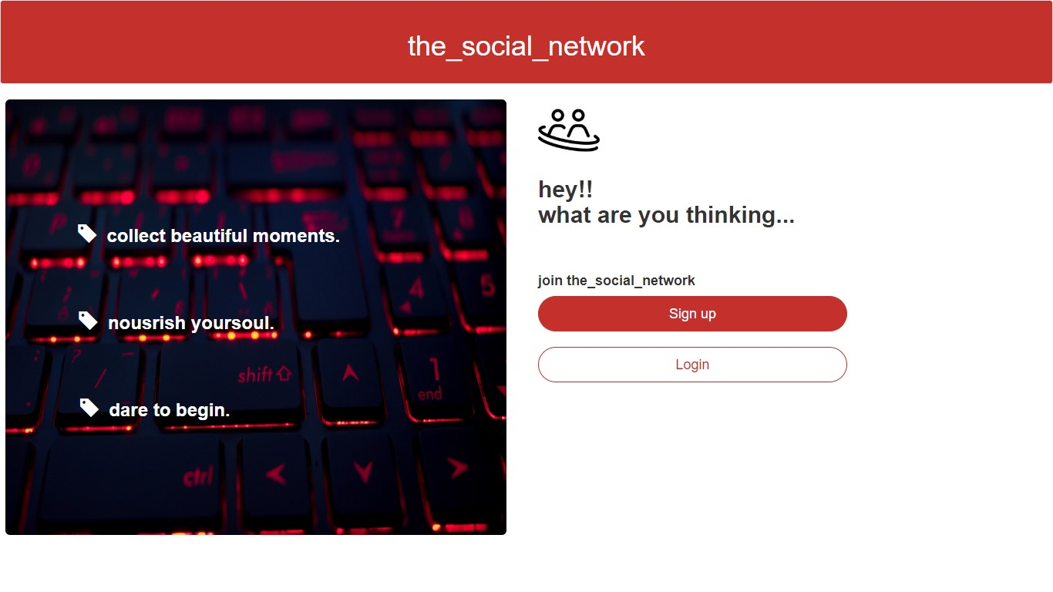

**11.2 signup**

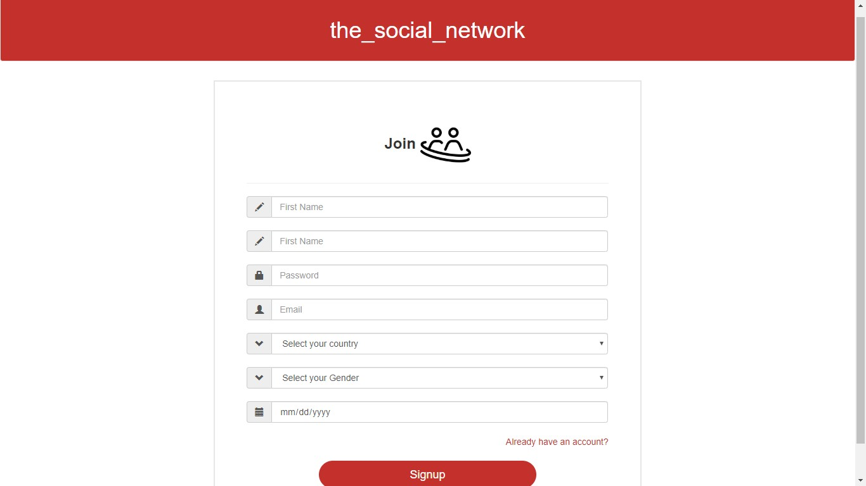

**11.3 login**

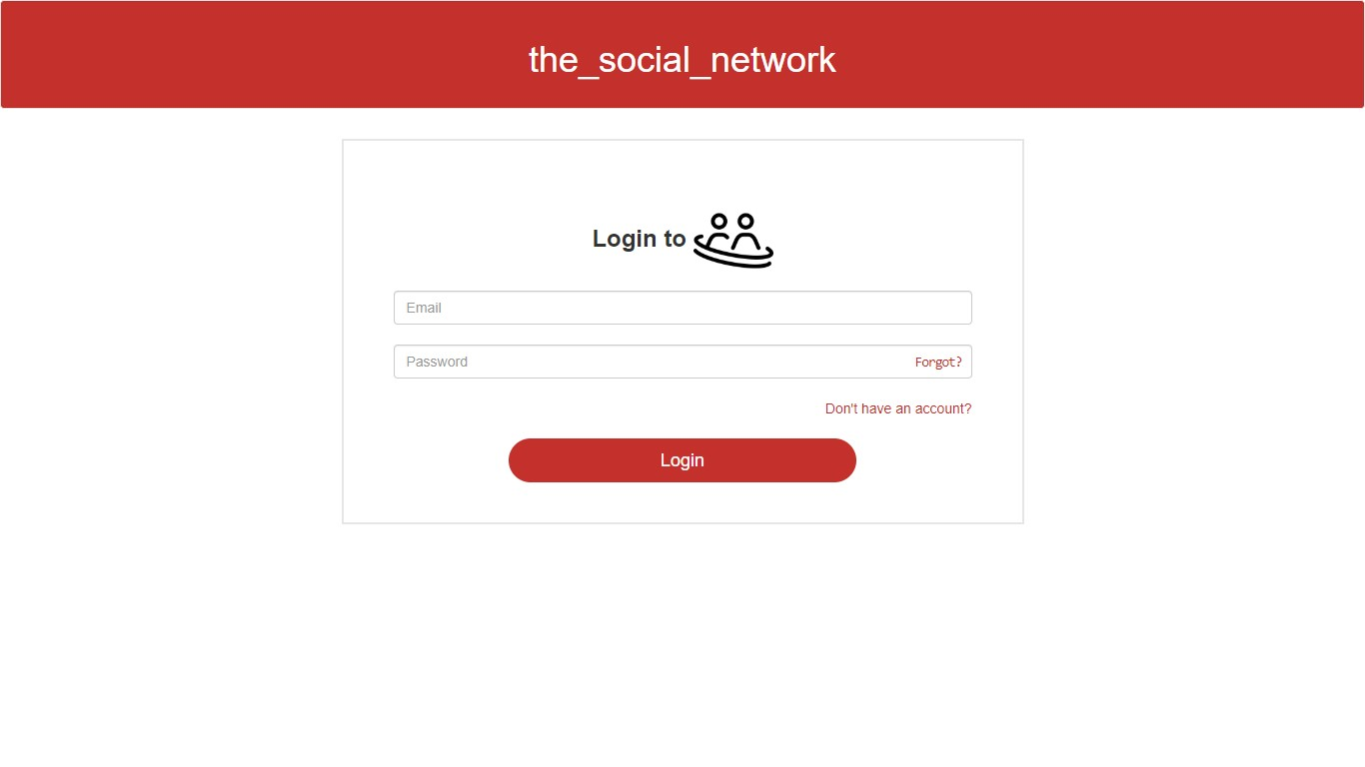

**11.4 home**

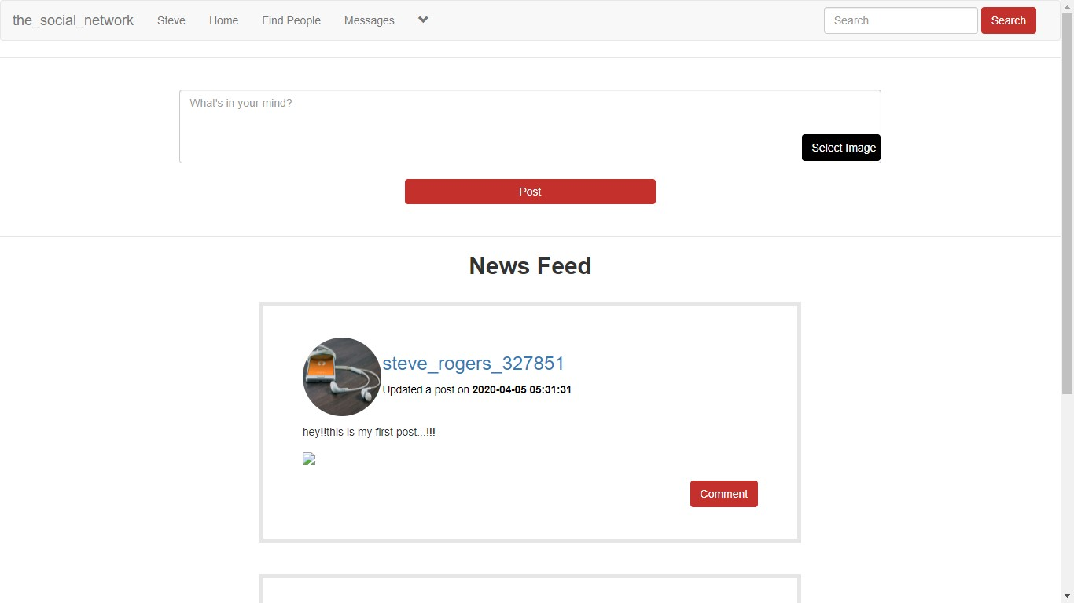

**11.5 profile**

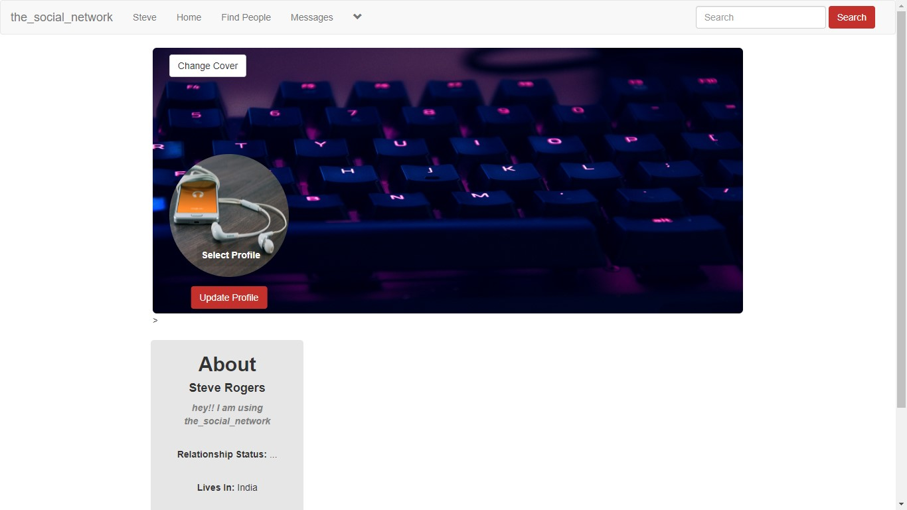

**11.6 Database**

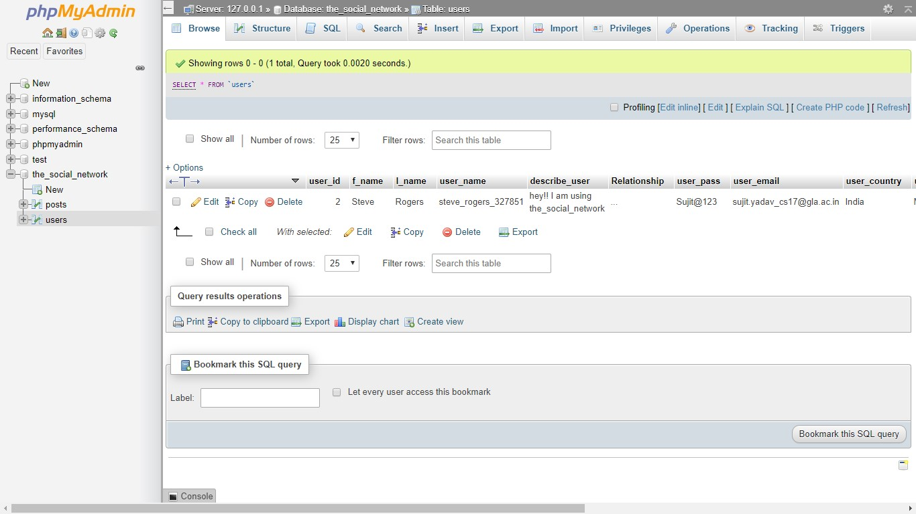

**12. USER MANUAL**

This project deals with the area of Web Development. It is developed with major Web Development Technologies like HTML, CSS, and PHP

Visit GitHub: <https://github.com/sujit-kumar-yadav/mini-project-2>

The installation of this application is described below:

1. Install GitBash
2. Clone or download the repository to your local machine.
3. Make sure xampp is installed.
4. Install other dependencies required for this project if needed
5. Open a new tab in web browser like google chrome
6. Run Xampp(apache)
7. Then go to `localhost/the_social_network/main.php` from any web browser to view the main page of the app.