**Topics: Factors Contributing to Antibiotic Misuse Among Parents of School-Going Children in Dhaka City, Bangladesh  
  
Table 1:** Demographic characteristics of study participants (N=704)

| **Characteristic** | **N = 704**1 |
| --- | --- |
| Parent’s age (years) |  |
| < 25 | 13 (1.8%) |
| > 45 | 47 (6.7%) |
| 25–35 | 377 (54%) |
| 36–45 | 267 (38%) |
| Parent’s sex |  |
| Female | 551 (78%) |
| Male | 153 (22%) |
| Parent’s education level |  |
| Postgraduate | 175 (25%) |
| Primary | 35 (5.0%) |
| Secondary | 381 (54%) |
| Undergraduate | 113 (16%) |
| Employment status |  |
| Employed | 95 (13%) |
| Not employed | 503 (71%) |
| Self employed | 106 (15%) |
| Family type |  |
| Extended family | 147 (21%) |
| Nuclear family | 372 (53%) |
| Single parent family | 185 (26%) |
| Your average household income per month (BDT) |  |
| High (greater than 50000 BDT) | 139 (20%) |
| Low (less than 30000 BDT) | 160 (23%) |
| Middle (less than 50000 BDT) | 405 (58%) |
| Child’s sex |  |
| Female | 379 (54%) |
| Male | 325 (46%) |
| Child’s age (years) |  |
| < 5 | 37 (5.3%) |
| > 10 | 313 (45%) |
| 5–9 | 353 (50%) |
| Unknown | 1 |
| Number of children |  |
| >= 3 | 104 (15%) |
| 1 | 176 (25%) |
| 2 | 424 (60%) |
| Who is the leading child caregiver at home? |  |
| Father | 54 (7.7%) |
| Grandmother | 16 (2.3%) |
| Mother | 629 (89%) |
| Others | 5 (0.7%) |
| Are grandparents at home involved in treatment decisions when your child is ill? |  |
| Always | 34 (4.8%) |
| Never | 459 (65%) |
| Often | 54 (7.7%) |
| Sometimes | 157 (22%) |
| 1n (%) | |

**Demographic characteristics of the participants**

A total of 704 respondents participated in the study, of which 153 (22%) were male and 551 (78%) were female. Parents’ ages were classified into four categories: < 25, 25–35, 36–45, and greater than 45 years (approximately 1.8%, 54%, 38%, and 6.7%, respectively). The educational status of parents was diverse; most parents had com- pleted higher secondary education (54%), followed by postgraduate (25%), undergraduate (16%), and primary education (5%). Among the respondents, 71.5% were unemployed, and 28.5% were employees. Most participants belonged to nuclear families (53%), followed by single-parent families (26%) and extended families (21%), while the majority (58%) belonged to middle-income families. Of the total respondents, 54% had female children, while the rest of the participants in the study had male children; 60% of parents had only two children, 25% had only one, and 15% had more than two children. Approximately 89% of parents reported that the mother was the leading caregiver of the child at home. In the case of disease treatment, 65% said that their child’s grandparents were not involved in decision making, whereas 35% reported that they were involved in decision making when their child was ill (Table 1).

**Distribution of knowledge regarding antibiotic resistance**

Figure 1 provides the distribution of knowledge regarding antibiotics, a significant proportion of the participants showed a lack of knowledge in recognizing the basic antibiotics of which 63% and 56% did not know that amoxi- cillin and azithromycin were antibiotics, respectively, while 79% knew that paracetamol was not an antibiotic. Of most participants, 75% knew that the misuse of antibiotics could lead to AR, and approximately 47% believed that antibiotic-resistant bacteria are difficult to treat.

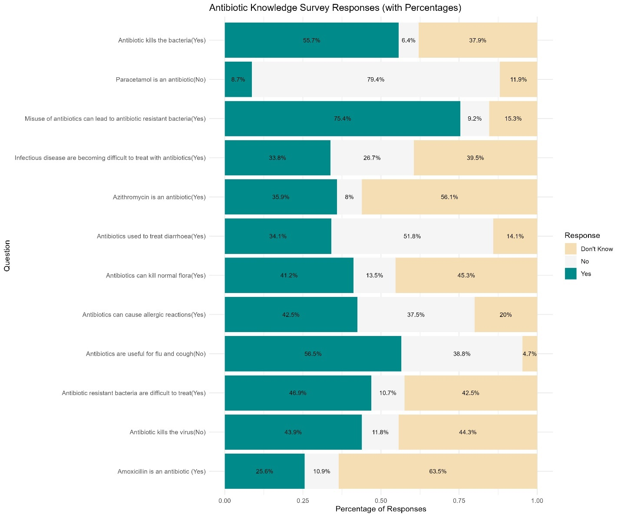

**Figure 1.** Distribution of knowledge of antibiotic resistance among parents of school-going children (N = 704).

**Attitude towards misuse of antibiotics**

Figure 2 shows the distribution of parents’ attitudes toward the misuse of antibiotics. More than 80% had a posi- tive attitude toward non-antibiotic prescriptions and were satisfied with the doctor’s prescription. In contrast, 75% disagreed with the provision of antibiotics to their children without indication. The majority of parents (approximately 63%) believed that antibiotics could be used for fever and cold improvement. Additionally, some parents 26% were ready to stop administering antibiotics to their children when there were improvements and 27% reused the same antibiotics for similar symptoms.



**Figure 2.** Attitude towards antibiotic resistance and the misuse of antibiotics among parents of school-going children (N = 704).

**Practices regarding the use of antibiotics**

The majority (58%) of respondents gave antibiotics to their children without consulting a doctor, and 36% liked taking antibiotics from pharmacies rather than from doctors. Approximately 51% of the parents gave antibiotics to their children when they had a cough. Regarding the expiry date, 24% reported that they did not check the expiration date of antibiotics before giving them to their children (Fig. 3).

**Major sources of information regarding antibiotics**

Most parents obtained their information from prescribers (86%), followed by dispensers (36%) and the Internet (30%). Few parents obtained information about antibiotics from social media (23%), pharmaceutical companies (11%), or other sources (23%) including colleagues, nurses, and university courses. (Table 2).



**Figure 3.** Practices among parents of school-going children regarding antibiotic resistance (N = 704).

**Level of knowledge, attitudes, and practices regarding antibiotic resistance**

Overall, the level of knowledge, attitudes, and practices regarding rational use of antibiotics in children. Of the 704 parents assessed on the KAP, 17% (n = 122) had good and 45% (n = 314) had moderate knowledge, 30% (n = 209) had a positive attitude, and 36% (n = 250) had good practices on rational antibiotic use in children.(Table 2, 3,4)

**Table 2: Level of knowledge**

| Characteristic | frequency | percent |
| --- | --- | --- |
| Poor | 268 | 38.07 |
| Moderate | 314 | 44.60 |
| Good | 122 | 17.33 |

**Table 3: Level of attitudes**

| **Characteristic** | frequency | percent |
| --- | --- | --- |
| Negative | 124 | 17.61 |
| Uncertain | 371 | 52.70 |
| Positive | 209 | 29.69 |

**Table 4: Level of practices**

| Characteristic | frequency | percent |
| --- | --- | --- |
| Misuse | 454 | 64.49 |
| Good | 250 | 35.51 |

**Table 5:**Factors associated with the level of knowledge among parents of school-going children (N=704). OR odds ratio, CI confidence interval. *p-value ˂0.05 was considered statistically significant. Significant values are in bold

| **Characteristic** | **N** | **OR***1* | **95% CI***1* | **p-value** |
| --- | --- | --- | --- | --- |
| **Parent’s age (years)** | 704 |  |  | **0.003** |
| *< 25* |  | — | — |  |
| *> 45* |  | 3.29 | 1.09, 10.4 |  |
| *25–35* |  | 2.67 | 1.00, 7.59 |  |
| *36–45* |  | 4.13 | 1.53, 11.8 |  |
| **Parent’s sex** | 704 |  |  | **<0.001** |
| *Female* |  | — | — |  |
| *Male* |  | 2.05 | 1.47, 2.89 |  |
| **Parent’s education level** | 704 |  |  | **<0.001** |
| *Postgraduate* |  | — | — |  |
| *Primary* |  | 0.10 | 0.04, 0.20 |  |
| *Secondary* |  | 0.34 | 0.24, 0.48 |  |
| *Undergraduate* |  | 0.80 | 0.51, 1.25 |  |
| **Employment status** | 704 |  |  | **<0.001** |
| *Employed* |  | — | — |  |
| *Not employed* |  | 0.33 | 0.21, 0.50 |  |
| *Self employed* |  | 0.85 | 0.50, 1.45 |  |
| **Family type** | 704 |  |  | >0.9 |
| *Extended family* |  | — | — |  |
| *Nuclear family* |  | 0.99 | 0.70, 1.41 |  |
| *Single parent family* |  | 0.98 | 0.66, 1.47 |  |
| **Your average household income per month (BDT)** | 704 |  |  | **<0.001** |
| *High (greater than 50000 BDT)* |  | — | — |  |
| *Low (less than 30000 BDT)* |  | 0.29 | 0.19, 0.45 |  |
| *Middle (less than 50000 BDT)* |  | 0.65 | 0.45, 0.93 |  |
| **Child’s sex** | 704 |  |  | 0.8 |
| *Female* |  | — | — |  |
| *Male* |  | 1.03 | 0.78, 1.36 |  |
| **Child’s age (years)** | 703 |  |  | **0.026** |
| *< 5* |  | — | — |  |
| *> 10* |  | 0.41 | 0.21, 0.80 |  |
| *5–9* |  | 0.41 | 0.21, 0.79 |  |
| **Number of children** | 704 |  |  | 0.8 |
| *>= 3* |  | — | — |  |
| *1* |  | 1.14 | 0.73, 1.80 |  |
| *2* |  | 1.08 | 0.73, 1.61 |  |
| *1*OR = Odds Ratio, CI = Confidence Interval | | | | |

**Table 6:** Factors associated with the level of knowledge among parents of school-going children (N = 704). OR odds ratio, CI confidence interval. *p-value ˂ 0.05 was considered statistically significant. Significant values are in bold.

| **Characteristic** | **N** | **OR***1* | **95% CI***1* | **p-value** |
| --- | --- | --- | --- | --- |
| **Parent’s age (years)** | 704 |  |  | 0.85 |
| *< 25* |  | — | — |  |
| *> 45* |  | 1.06 | 0.33, 3.44 |  |
| *25–35* |  | 0.94 | 0.33, 2.71 |  |
| *36–45* |  | 0.85 | 0.29, 2.47 |  |
| **Parent’s sex** | 704 |  |  | 0.79 |
| *Female* |  | — | — |  |
| *Male* |  | 0.95 | 0.68, 1.34 |  |
| **Parent’s education level** | 704 |  |  | **0.001** |
| *Postgraduate* |  | — | — |  |
| *Primary* |  | 0.31 | 0.15, 0.60 |  |
| *Secondary* |  | 0.59 | 0.42, 0.84 |  |
| *Undergraduate* |  | 0.78 | 0.50, 1.22 |  |
| **Employment status** | 704 |  |  | 0.40 |
| *Employed* |  | — | — |  |
| *Not employed* |  | 0.96 | 0.63, 1.46 |  |
| *Self employed* |  | 0.74 | 0.43, 1.25 |  |
| **Family type** | 704 |  |  | **<0.001** |
| *Extended family* |  | — | — |  |
| *Nuclear family* |  | 0.47 | 0.32, 0.68 |  |
| *Single parent family* |  | 0.73 | 0.48, 1.10 |  |
| **Your average household income per month (BDT)** | 704 |  |  | **0.006** |
| *High (greater than 50000 BDT)* |  | — | — |  |
| *Low (less than 30000 BDT)* |  | 0.50 | 0.32, 0.77 |  |
| *Middle (less than 50000 BDT)* |  | 0.62 | 0.43, 0.90 |  |
| **Child’s sex** | 704 |  |  | 0.38 |
| *Female* |  | — | — |  |
| *Male* |  | 0.88 | 0.66, 1.17 |  |
| **Child’s age (years)** | 703 |  |  | 0.69 |
| *< 5* |  | — | — |  |
| *> 10* |  | 0.95 | 0.50, 1.82 |  |
| *5–9* |  | 0.85 | 0.45, 1.61 |  |
| **Number of children** | 704 |  |  | 0.46 |
| *>= 3* |  | — | — |  |
| *1* |  | 0.77 | 0.48, 1.23 |  |
| *2* |  | 0.77 | 0.51, 1.17 |  |
| *1*OR = Odds Ratio, CI = Confidence Interval | | | | |

**Table 7**: Factors associated with the level of practices regarding antibiotic resistance among parents of school- going children (N = 704). odds ratio, CI confidence interval. *p value ˂ 0.05 was considered statistically significant. Significant values are in bold.

| **Characteristic** | **N** | **OR***1* | **95% CI***1* | **p-value** |
| --- | --- | --- | --- | --- |
| Parent’s age (years) | 704 |  |  |  |
| < 25 |  | — | — |  |
| > 45 |  | 6.81 | 1.60, 47.2 | 0.020 |
| 25–35 |  | 3.00 | 0.79, 19.6 | 0.2 |
| 36–45 |  | 2.75 | 0.72, 18.0 | 0.2 |
| Parent’s sex | 704 |  |  |  |
| Female |  | — | — |  |
| Male |  | 0.95 | 0.65, 1.38 | 0.8 |
| Parent’s education level | 704 |  |  |  |
| Postgraduate |  | — | — |  |
| Primary |  | 0.47 | 0.19, 1.04 | 0.077 |
| Secondary |  | 0.80 | 0.55, 1.16 | 0.2 |
| Undergraduate |  | 1.08 | 0.67, 1.75 | 0.8 |
| Employment status | 704 |  |  |  |
| Employed |  | — | — |  |
| Not employed |  | 0.94 | 0.60, 1.48 | 0.8 |
| Self employed |  | 0.68 | 0.37, 1.22 | 0.2 |
| Family type | 704 |  |  |  |
| Extended family |  | — | — |  |
| Nuclear family |  | 0.80 | 0.54, 1.19 | 0.3 |
| Single parent family |  | 0.73 | 0.47, 1.15 | 0.2 |
| Your average household income per month (BDT) | 704 |  |  |  |
| High (greater than 50000 BDT) |  | — | — |  |
| Low (less than 30000 BDT) |  | 0.33 | 0.20, 0.52 | <0.001 |
| Middle (less than 50000 BDT) |  | 0.31 | 0.21, 0.47 | <0.001 |
| Child’s sex | 704 |  |  |  |
| Female |  | — | — |  |
| Male |  | 0.75 | 0.55, 1.02 | 0.072 |
| Child’s age (years) | 703 |  |  |  |
| < 5 |  | — | — |  |
| > 10 |  | 1.51 | 0.74, 3.29 | 0.3 |
| 5–9 |  | 1.17 | 0.57, 2.55 | 0.7 |
| Number of children | 704 |  |  |  |
| >= 3 |  | — | — |  |
| 1 |  | 0.95 | 0.58, 1.58 | 0.8 |
| 2 |  | 0.88 | 0.57, 1.39 | 0.6 |
| knowledge_level | 704 |  |  |  |
| Poor |  | — | — |  |
| Moderate |  | 1.45 | 1.03, 2.05 | 0.036 |
| Good |  | 1.50 | 0.96, 2.34 | 0.077 |
| attitude_level | 704 |  |  |  |
| Negative |  | — | — |  |
| Uncertain |  | 4.44 | 2.49, 8.57 | <0.001 |
| Positive |  | 9.49 | 5.19, 18.7 | <0.001 |
| *1*OR = Odds Ratio, CI = Confidence Interval | | | | |