**ACE**

**Engineering College**

**Ankushapur (V),Ghatkesar (M),Medchal(Dist.) Telangana – 501 301**

**_____________________________________________________________________________________________**

**Application Format**

**(Post applied for Assistant Professor., in Electrcial and Electronics Dept)**

1. Name (as per SSC) : Sujit Mohapatra

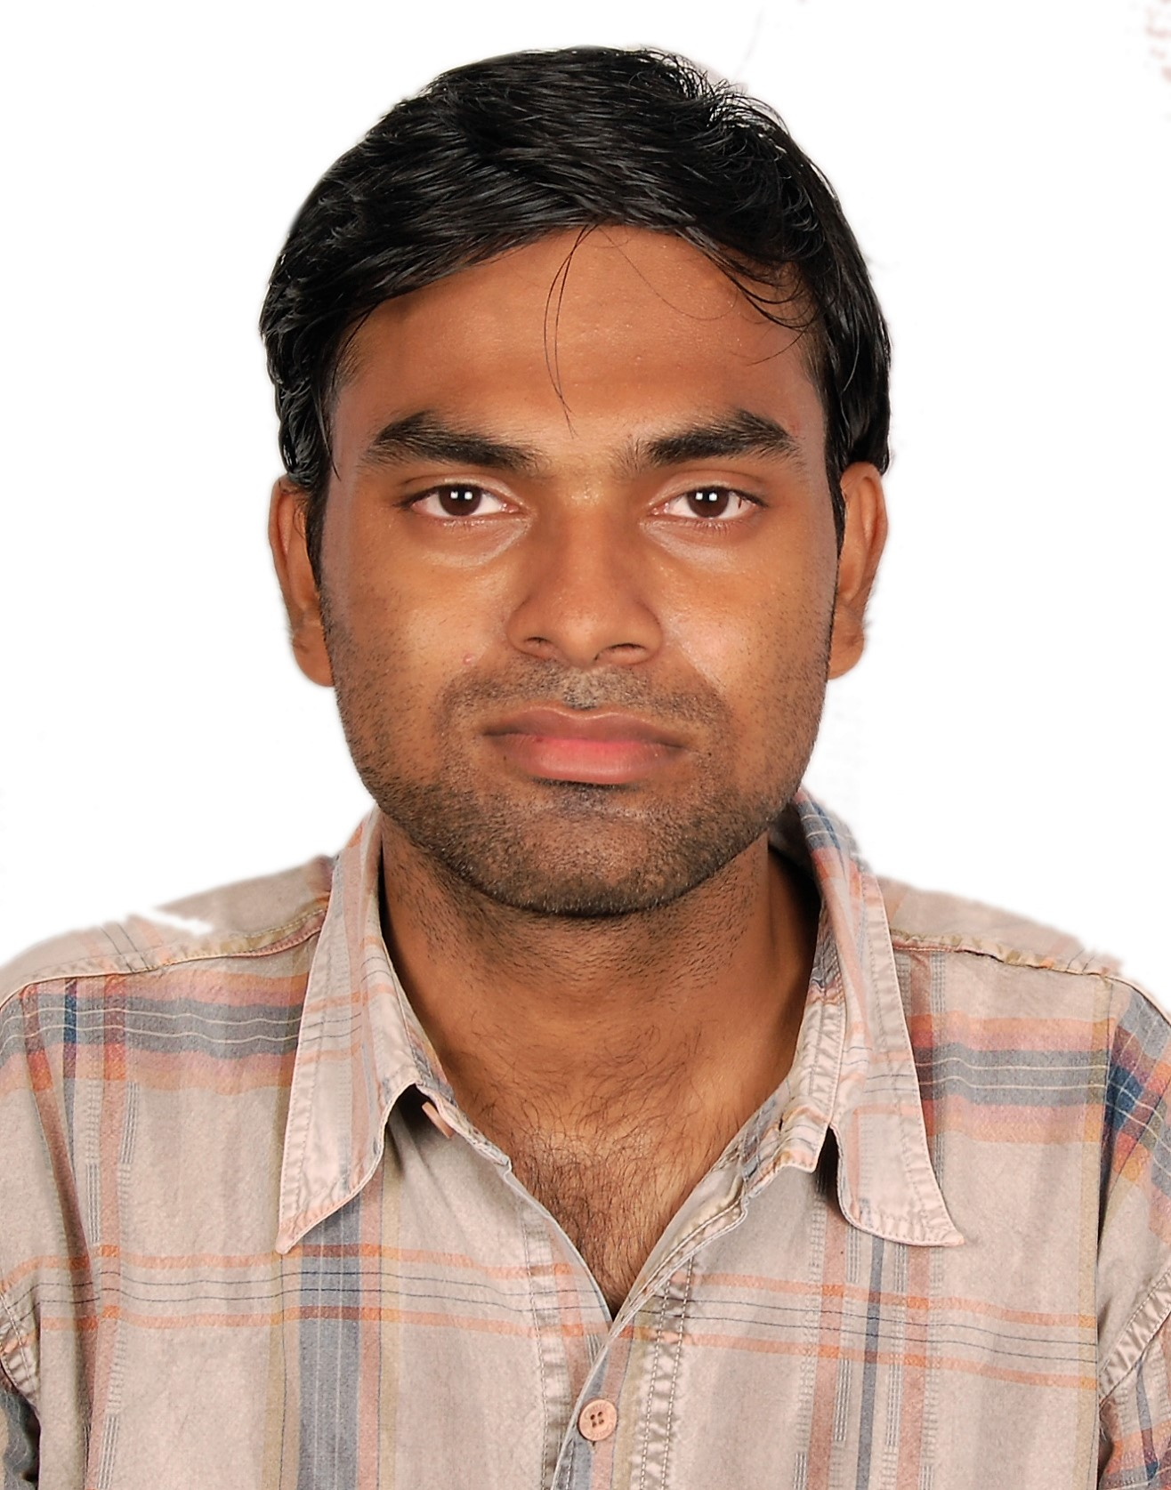

**Recent color**

**passport size**

**photograp**  **h**

2. Name of the Father : Hursikesh Mohapatra

3. Name of the Mother : Pratikshya Das

4. Residential Address : SVKRCET, Bhimavaram

5. Mobile No : 8763108949

6. E-mail id :sujitmohapatra@hotmail.com

7. PAN Number :CCOPM4023P

8. Adhar Card Number :328978411969

9. Total Experience : 2years and 6 months

10. Education Qualifications (Start from higher degree)

|  |  |  |  |  |  |
| --- | --- | --- | --- | --- | --- |
| **Qualification** | **Year of**  **Passing** | **Name of the College** | **Name of the University** | **Class**  **Obtained** | **% of Marks** |
| **M.Tech** | **2016** | **IIITDM Jabalpur** | **IIITDM Jabalpur** | **First** | **86** |
| **B.Tech** | **2013** | **IIIT Bhubaneswar** | **BPUT** | **First** | **77.7** |
| **12th** | **2008** | **DAV Public School** | **CBSE** | **First** | **85.4** |
| **10th** | **2006** | **DAV Public School** | **CBSE** | **First** | **92** |
|  |  |  |  |  |  |
|  |  |  |  |  |  |
|  |  |  |  |  |  |
|  |  |  |  |  |  |

11. Present Salary : Rs 20,000 pm + Accomodation

12. Expected Salary : Rs 30,000pm + Accomodation

13. Time required to join if selected:15 days

14. Particulars of Experience:

|  |  |  |  |
| --- | --- | --- | --- |
| **Place Worked** | **Position** | **From** | **To** |
| **SVKRCET, Bhimavaram** | **Assistant Professor** | **April, 2017** | **Presently working** |
| **IIITDM Jabalpur** | **Teaching Assistant** | **July, 2014** | **July, 2016** |
|  |  |  |  |
|  |  |  |  |
|  |  |  |  |
|  |  |  |  |
|  |  |  |  |

15. Subjects/Labs Handled:

|  |  |
| --- | --- |
| **Name of the subject/Labs taught** | **No. of times handled** |
| **Microprocessor Lab** | **1** |
| **Fundamentals of Electronics and Electrical Lab** | **1** |
| **Basic Electrical and Electronics** | **1** |
| **Electrical Systems** | **1** |
| **Physics** | **1** |
| **Engineering Literacy Lab** | **1** |
| **Analog Circuits Lab** | **1** |

16. Ratified by JNTUH: Yes( ) No( )

17. Number of UG/PG Projects Handled:

18. Details of Workshops/Seminars Attended/Organized:

i. National workshop on Smart Grid and Renewable Energy Integration 2015

ii. ICRAIE 2016

iii.

iv.

v.

19. No. of Paper published/Presented in National, International Conferences

& Journals

|  |  |  |  |
| --- | --- | --- | --- |
| **Conferences** | | **Journals** | |
| **National** | **International** | **National** | **International** |
|  | **1** |  |  |

20. Additional Information:

i. GATE percentile: 98.25

ii. Awards Received:

iii. Books Published:

iv. Others:

1. Certificate of Appreciation for Academic Excellence in M.Tech

b.

c.

I hereby declare that all the information furnished above are true to the best my knowledge and belief.

Place: Bhimavaram 

Date:09/09/2017 Signature