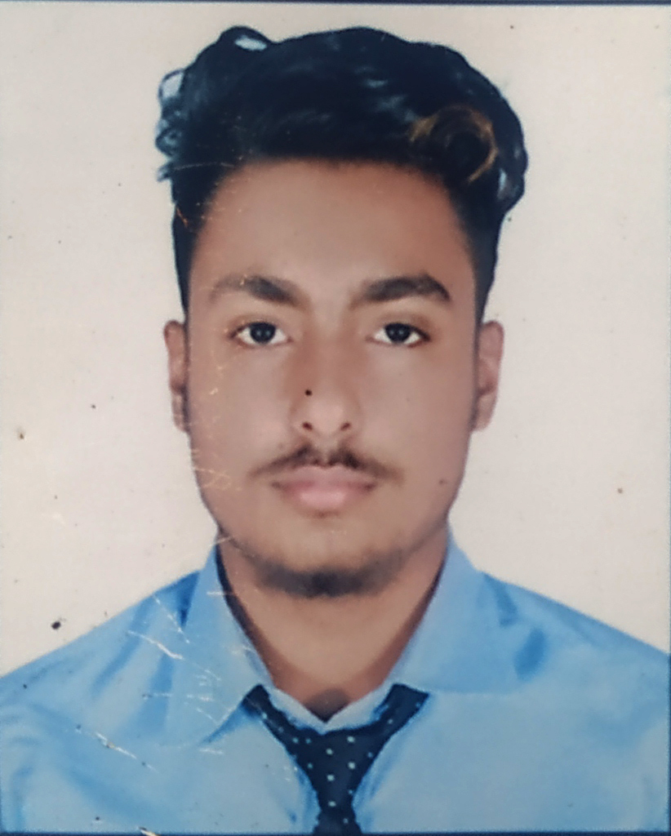

**Working Experience**

* Computer Teacher In Bidur English Boarding High School ,jhapa for 2 years
* National Identity Department Enrollment Computer Operator for 2 years.

**Personal Info**

**Name:Sadip Khatiwada**

**Address:** Bhadrapur Municipality Jhapa,Nepal

**Contact no.:**

+977 9824909002

**DOB & Place:**

jhapa, 21 November 1998

**E mail address:**

khatiwadasadip@gmail.com

**Other details:**

* Sex: Male
* Nationality: Nepali
* Religion: Hindu
* Marriage Status: Unmarried

**Education**

* School Leaving Certificate (SLC) -2016 AD
* N.E.B (+2) -2018 AD
* Bachelor of Business Studies(BBS)-2022 AD

**Skill**

* Advance bookkeeping
* Data entry
* Audit Coordination
* Cash flow analysis
* Account reconciliation
* Microsoft office package
* Accounting package

( Swastik Gold)

* Pumori (Banking Software)

**Language**

* Nepali
* Hindi
* English