

Assessment Cover Page

Student Full Name | Sujita Singh
Student Number | Sba26094
Module Title | Strategic Thinking
Assessment Title | CA-1 Capstone Project Proposal
Lecturer/Supervisor | Taufique Ahmed
Assessment Due Date | 25/10/2026
Date of Submission | 23/10/2026
GitHub Repository | https://github.com/sujitasingh8/hdsdab-01-capstone-project.git

Use of AI Tools
I acknowledge the use of Gemini for structuring the assignment.
I have not used any AI tools or technologies in the preparation of this assessment.
Declaration
By submitting this assessment, I confirm that I have read the CCT policy on academic misconduct and understand the implications of submitting work that is not my own or does not appropriately reference material taken from a third party or other source.
I declare it to be my own work and that all material from third parties has been appropriately referenced.
I further confirm that this work has not previously been submitted for assessment by myself or someone else in CCT College Dublin or any other higher education institution.

Contents
1 Project Title 4
2 Introduction 4
3 Problem Definition 4
4 Aim and Objectives 5
5 Scope 5
6 Methodology & Architecture 6
7 Data Sources 7
8 Expected Deliverables (Semester 1 & 2) 8
9 Project Timeline 9
10 Ethical and Legal Considerations 9

Project Title
Predictive Analytics for Electric Vehicle Charging Infrastructure: Supporting Strategic Public-Private Planning in Ireland

Introduction
Ireland’s Climate Action Plan sets an ambitious target of transitioning to sustainable transportation, targeting over 950,000 electric vehicles (EVs) on Irish roads by 2030. Achieving this target requires a proportional expansion of robust, accessible, and reliably placed public charging infrastructure across all local electoral areas and municipal regions.
Currently, local authorities, energy providers, and private operators face significant challenges in determining optimal geographic and capacity allocation for new EV charging stations. Misalignments between rapid vehicle adoption and infrastructure deployment result in severe localized congestion in high-adoption zones and underutilized capital investments in lower-demand corridors.
This project addresses this critical infrastructure gap through data analytics and predictive modelling. By synthesizing public vehicle registration statistics, demographic metrics, and spatial charging station locations published on the Irish open data portal (data.gov.ie), this initiative delivers a predictive framework to forecast charging demand scores and infrastructure deficits across Irish counties.

Problem Definition
The primary business problem investigated in this project is the lack of empirical, data-driven forecasting tools to guide public and private capital expenditure in EV charging infrastructure across Ireland.
Business Impact
- Capital Inefficiency: Local councils and charge point operators (CPOs) risk misallocating finite infrastructure grants into low-utilization regions while high-volume corridors remain underserved.
- Adoption Friction (Range & Queue Anxiety): Grid bottlenecks and long queuing times at public charging points create negative consumer sentiment, directly hindering Ireland’s national EV adoption targets.
- Operational Grid Strain: Unplanned charger installations create localized electric grid imbalances, requiring costly reactive infrastructure upgrades from utility providers.
Role of Data Analytics and Predictive Modelling
Data analytics allows stakeholders to transition from reactive installation policies to proactive, predictive deployment strategies. By analysing historical vehicle registration trends, county-level EV adoption rates, and existing spatial charger distributions, machine learning algorithms (e.g., Regression and Decision Tree models) can model complex non-linear relationships. These models produce a localized Infrastructure Demand Score, enabling decision-makers to prioritize investments where future demand will be highest.

Aim and Objectives
Overall Project Aim
The overall aim of this project is to develop a predictive analytics model and interactive business intelligence solution that forecasts regional EV charging demand in Ireland, empowering public planners and commercial operators to optimize future infrastructure allocation.
Key Objectives
- Data Acquisition & Integration: Extract, clean, and consolidate multi-source datasets from data.gov.ie, including Central Statistics Office (CSO) vehicle registration tables and local authority GIS charging location records.
- Exploratory & Spatial Analysis: Conduct exploratory data analysis (EDA) to evaluate regional disparities in EV adoption, charger density ratios, and temporal growth patterns across Irish counties.
- Feature Engineering: Derive composite indicators, such as the Vehicle-to-Charger Ratio, Regional EV Growth Rate, and Spatial Accessibility Indices.
- Predictive Model Development: Train, evaluate, and compare machine learning regression models (e.g., Multiple Linear Regression, Random Forest Regressor, XGBoost) to forecast county-level charging demand scores.
- Interactive Dashboard & Delivery: Build an interactive business intelligence dashboard (Power BI/Streamlit) that visualizes predicted demand, identifies underserved regions, and provides scenario-based planning tools for stakeholders.
Primary Business Hypothesis
Hypothesis ($H_1$): A predictive model incorporating regional EV registration growth rates, historical vehicle density, and spatial charging point distributions can forecast local charging demand with significantly higher accuracy ($R^2 > 0.80$) than simple historical linear projections.

Scope
In Scope
- Analysis of open public datasets from data.gov.ie covering Irish counties and local electoral areas.
- Historical vehicle registration trends and EV adoption metrics from 2019 to 2026.
- Spatial analysis of existing public charging points managed by local authorities and public bodies.
- Machine learning modelling in Python using supervised regression algorithms.
- Development of an interactive executive dashboard for visual scenario planning.
Out of Scope
- Real-time IoT sensor telemetry or live live-streamed charger occupancy tracking.
- Proprietary commercial pricing strategies, electricity tariff modelling, or financial ROI calculations for private operators.
- Electrical engineering smart-grid load balancing and circuit design.
Individual driver behavioural tracking or private home charger installation analysis.

Methodology & Architecture
Analytics Methodology (CRISP-DM)
This project follows the CRISP-DM (Cross-Industry Standard Process for Data Mining) methodology, structured into six iterative phases: Business Understanding, Data Understanding, Data Preparation, Modelling, Evaluation, and Deployment.
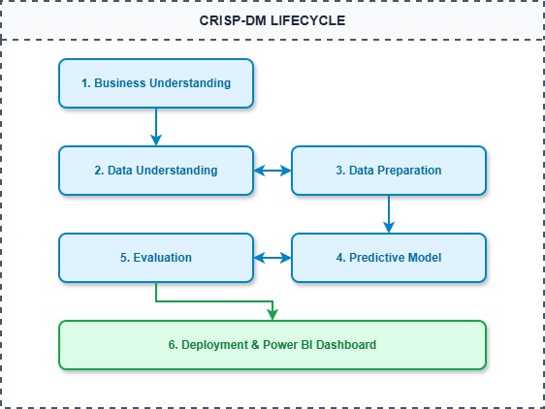
Proposed Technologies and Tools
- Programming & Pipeline: Python 3.x (Pandas, NumPy) for data wrangling and ETL processes.
- Machine Learning: Scikit-Learn, XGBoost for feature scaling, regression modelling, and cross-validation.
- Visualization & Reporting: Power BI / Streamlit for dynamic user dashboarding; Matplotlib & Seaborn for EDA.
- Environment & Version Control: Jupyter Notebooks, Git, GitHub repository.
System Architecture Diagram
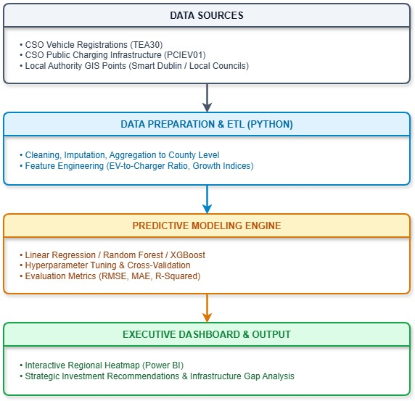

Data Sources
Dataset Description
The project relies on verified public open datasets published on data.gov.ie:
- CSO TEA30 - Vehicle Registrations and Licensing: Contains monthly and annual breakdown of electric, hybrid, and fossil-fuel vehicle registrations aggregated by Irish county.
- CSO PCIEV01 - Public EV Charging Infrastructure: Contains national and regional counts of public charging points (standard AC vs. fast DC chargers).
- Local Authority Open GIS Datasets (Smart Dublin, Cork City Council, FCC): Geolocation records (latitude/longitude), connector types, and charger power capacity.
Data Access and Rights
All selected datasets are published under the Creative Commons Attribution 4.0 International (CC BY 4.0) license or Open Government License. These rights grant full permission to access, combine, adapt, and use the data for academic research and commercial analytical modelling, provided appropriate attribution is maintained.

Expected Deliverables (Semester 1 & 2)
Semester 1 Deliverables
- Capstone Project Proposal (CA1): Word document report detailing strategic alignment, problem definition, scope, and architecture.
- Signed Ethics Form: Submitted in PDF format.
- AI Use Declaration: Comprehensive reflection adhering to the AI Fluency Framework.
- GitHub Repository: Established repository initialized with access granted to GitHub user tahmed1986.
Semester 2 Final Deliverables
- Automated ETL & Data Pipeline: Reproducible Python scripts/Jupyter Notebooks for data ingestion and preparation.
- Validated Predictive Model: Trained machine learning pipeline evaluated against standard statistical metrics ($R^2$, RMSE).
- Interactive Business Intelligence Dashboard: A functional Power BI report featuring regional infrastructure heatmaps and forecasting sliders.
- Final Capstone Project Report & Presentation: Comprehensive thesis-style documentation covering strategic insights, business impact, and recommendations.

Project Timeline
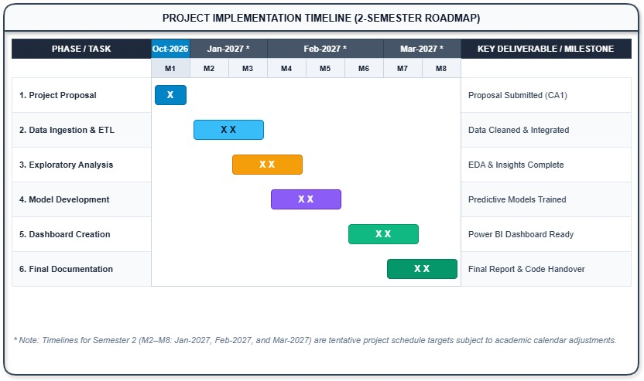
- Milestone 1 (End Semester 1): Project Proposal, Git setup, and Ethical approval completed.
- Milestone 2 (Mid Semester 2): Data cleaning, feature engineering, and baseline model training complete.
- Milestone 3 (Late Semester 2): Model optimization, Power BI dashboard deployment, and final presentation defence.

Ethical and Legal Considerations
Data Protection & GDPR
The datasets utilized consist strictly of aggregated regional statistics and public infrastructure coordinates published by official government bodies. No personally identifiable information (PII), individual vehicle license plates, driver movement logs, or private home addresses are collected or processed. Consequently, the project presents negligible GDPR or personal privacy risks.
Intellectual Property & Data Use
All sources are properly referenced in accordance with Harvard Referencing guidelines. Open data licensing conditions under CC BY 4.0 are fully respected by maintaining clear metadata lineage within the code repository.
Model Transparency & Algorithmic Bias
Predictive models used in public infrastructure planning must maintain transparency. The project will evaluate feature importance to ensure models do not unintentionally penalize economically disadvantaged or rural communities, supporting equitable access to public infrastructure.
References
- Central Statistics Office (2026) TEA30: Licensing of New and Used Vehicles. Available at: https://data.gov.ie (Accessed: 7 October 2026).
- Department of Transport (2022) Electric Vehicle Charging Infrastructure Strategy 2022–2025. Dublin: Government of Ireland.
Sustainable Energy Authority of Ireland (2025) EV Infrastructure and Registration Trends in Ireland. Dublin: SEAI.

