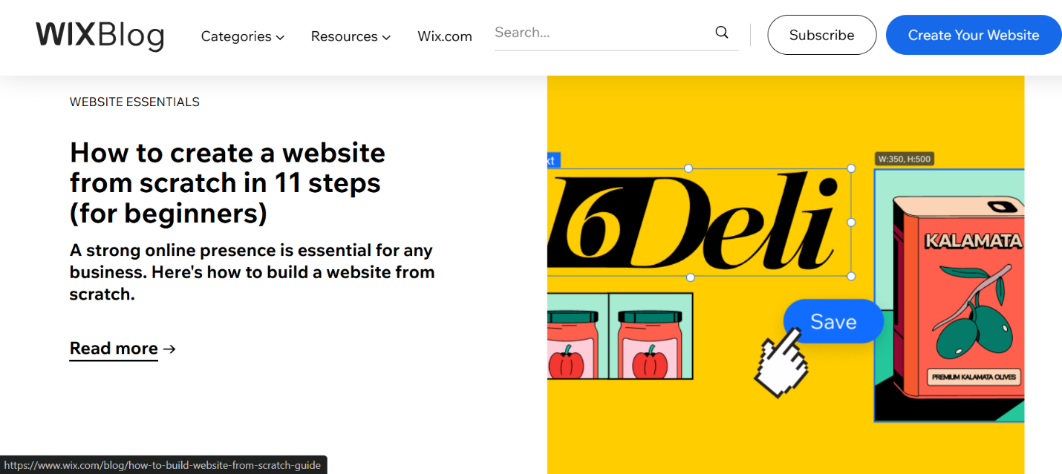

(Wix Blog, 2025)

# References

Wix Blog. (2025, 01 10). Retrieved from Wix Blog: https://www.wix.com/blog

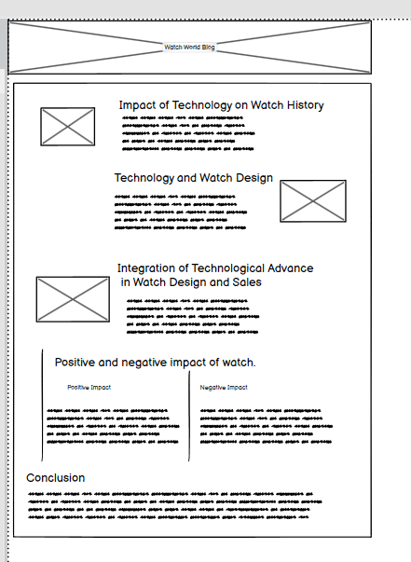

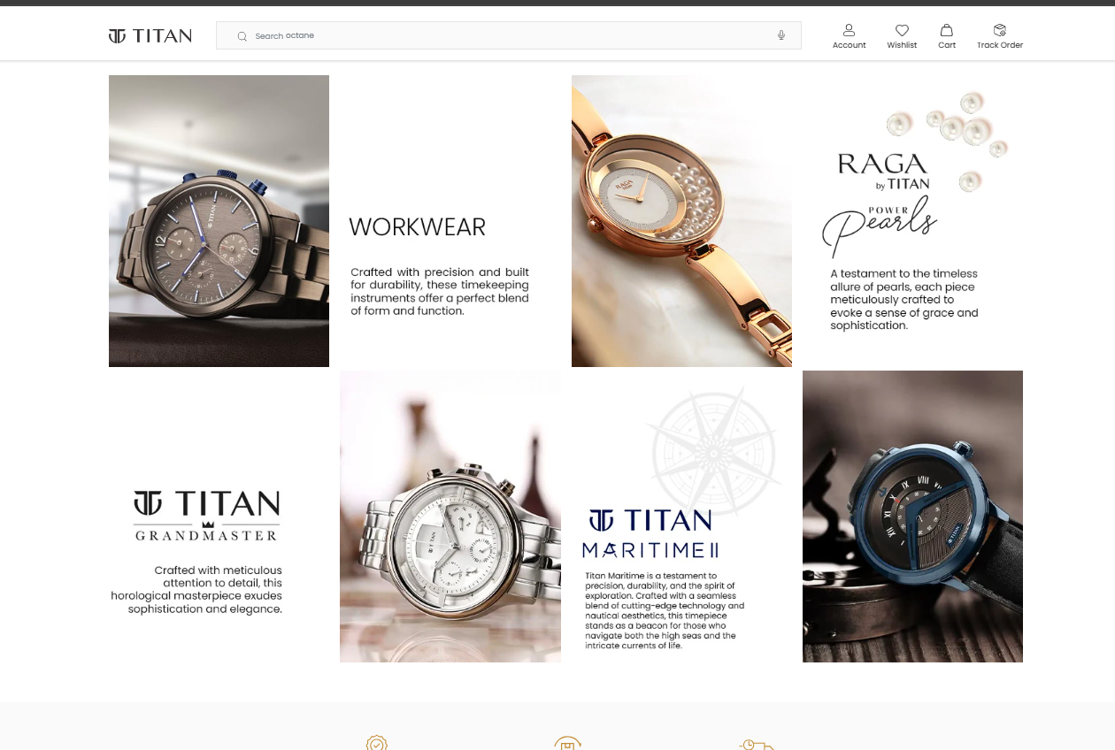 (Titan, 2025)

# References

Titan. (2025, 01 15). Retrieved from titan: https://www.titan.co.in/?srsltid=AfmBOor9EVbMmH33cUOcXMHFBzzdBUk4rUsTbshmJU_OhX-NoB6Vs6Zv

