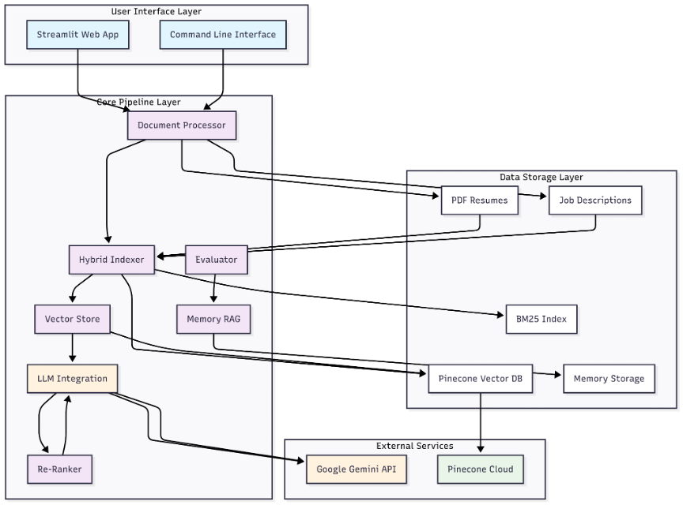

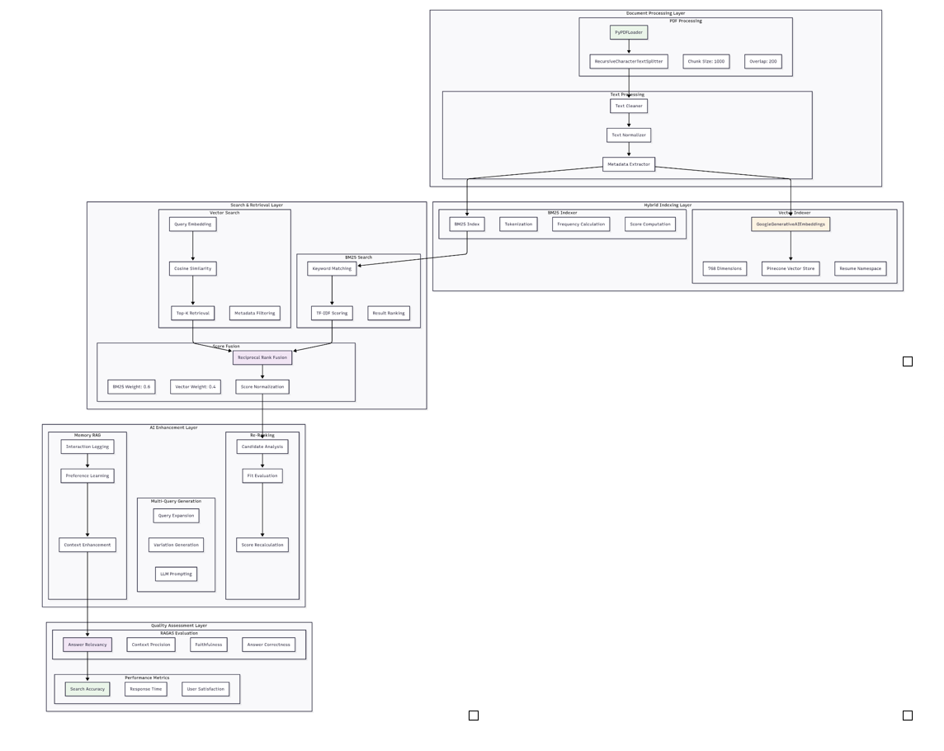

hireflow-system/
├── config.py # Central configuration
├── main.py # CLI interface
├── requirements.txt # Dependencies
├── .env # Environment variables
├── utils.py # Common helper functions
├── core/ # Core business logic
│ ├── ingestion.py # Document processing
│ ├── parsing.py # Text extraction and cleaning
│ ├── vector_store.py # Vector database management
│ ├── hybrid_indexer.py # Combined search indexing
│ ├── re_ranker.py # Result reordering
│ ├── memory_rag.py # User interaction tracking
│ ├── evaluator.py # System quality assessment
│ └── filters.py # Search filtering logic
├── streamlit/ # Web interface
│ └── app.py # Main Streamlit application
└── data/ # Data storage
├── resumes/ # Resume PDF files
├── hybrid_index/ # BM25 index files
└── memory/ # User interaction data

Complete Low-Level Architecture Overview
1. UI Layer (User Interface)
Streamlit App: Web interface with clean architecture and dependency injection

2. Core Layer (Business Logic)
Role : Coordinates the entire recruitment and search process

Main Components :
DocumentProcessor (core/ingestion.py): Handles PDF processing and text extraction
● PyPDFLoader integration for PDF text extraction
● RecursiveCharacterTextSplitter with configurable chunk sizes (1000 chars, 200 overlap)
● Text cleaning and normalization pipeline
● Metadata extraction and document structuring
HybridIndexer (core/hybrid_indexer.py): Manages combined search indexing
● BM25 keyword indexing with TF-IDF scoring
● Vector embedding generation using GoogleGenerativeAIEmbeddings (768 dimensions)
● Reciprocal Rank Fusion (RRF) for score combination
● Weighted scoring: BM25 (0.6) + Vector (0.4)
VectorStore (core/vector_store.py): Handles vector database operations
● Pinecone client integration
● Namespace management for resumes and job descriptions
● Metadata filtering and query optimization
● Automatic index creation and dimension validation
ReRanker (core/re_ranker.py): Improves search result ordering
● LLM-powered candidate evaluation
● Fit score calculation (0-10 scale)
● Strengths and gaps analysis
● Contextual ranking based on job requirements
MemoryRAG (core/memory_rag.py): Tracks user interactions
● LangChain ConversationBufferMemory integration
● Search query logging and analytics
● Candidate view tracking
● User preference learning
RAGEvaluator (core/evaluator.py): Assesses system performance
● RAGAS framework integration
● Answer relevancy, context precision, faithfulness metrics
● Overall quality scoring and improvement suggestions
● Performance benchmarking and optimization

3. Data Layer (Storage & Processing)
Role : Manages data persistence, indexing, and retrieval

Components :
Resume Storage : PDF files and processed text
● Local file system storage in data/resumes/
● Processed text chunks with metadata
● Candidate information extraction (name, skills, experience)
● Document versioning and update tracking
Vector Database : Pinecone for semantic search
● Serverless Pinecone index with 768 dimensions
● Resume and job description namespaces
● Metadata filtering capabilities
● Automatic scaling and performance optimization
BM25 Index : Keyword-based search index
● Local in-memory indexing for fast keyword search
● TF-IDF scoring with frequency calculations
● Tokenization and preprocessing
● Real-time index updates
Memory Storage : User interaction logs and analytics
● JSON-based conversation memory
● Search history and result analytics
● User behavior patterns and preferences
● Performance metrics and quality scores

4. Integration & Communication Layer
Role : Manages external service connections and data flow

Components :
LLM Integration : Google Gemini API
● Structured output parsing with Pydantic schemas
● Prompt engineering and optimization
● Response caching and error handling
● Rate limiting and cost management

Vector Database Integration : Pinecone Cloud
● REST API client with automatic retry logic
● Connection pooling and timeout management
● Index management and monitoring
● Data synchronization and backup

5. Configuration & Utilities Layer
Role : Provides system configuration and helper functions

Components :
Configuration Management (utils/config.py):
● Environment variable management
● API key configuration
● Model parameters and settings
● Logging configuration
Utility Functions (utils/utils.py):
● Text processing helpers
● File I/O operations
● Error handling utilities
● Performance monitoring tools
Data Schemas (utils/schemas.py):
● Pydantic models for data validation
● Resume and job description structures
● Search result schemas
● Evaluation metric models

