**Features of 8086**

1. It is **16 bit** **HMOS** (High Density MOS) microprocessor implemented in N-channel Silicon gate technology. Its ALU, internal registers works with 16 bit binary word resulting in faster processing.

2. It is available in **40-pin DIP** (Dual Inline Package) chip and operates at **5 to 10 MHZ** clock frequency.

3.8086 has a 16-bit data bus. It can read or write data to a memory/port either 16 bits

or 8 bit at a time.

4. 8086 has a 20 bit address bus which means, it can address upto 2^20 = 1MB memory. (1,048,576 memory locations).

4.8086 has 16-bit address lines to access I/O devices, hence it can access

                  2^16 = 64K I/O location

5. **Pipelining:-**8086 uses two stage of pipelining. First is Fetch Stage and the second is Execute Stage. Fetch stage that prefetchs up to 6 bytes of instructions store them in the queue. Execute stage executes these instructions. Pipelining improves the performance of the processor so that operation is faster.

**6. Operates in two modes:-**8086 operates in two modes:

a) Minimum Mode: A system with only one microprocessor.

b) Maximum Mode:-A system with multiprocessor.

**7. 8086 uses memory banks:-**The 8086 uses a memory banking system. It means entire data is not stored sequentially in a single memory of 1 MB but memory is divided into two banks (Even and Odd Banks) of 512KB each.

**8. Interrupts:-**8086 has 256 vectored interrupts.

**9. Multiplication and Division:-**8086 has a powerful instruction set. So that it supports multiply and Divide operation.

**Register Organisation of 8086**

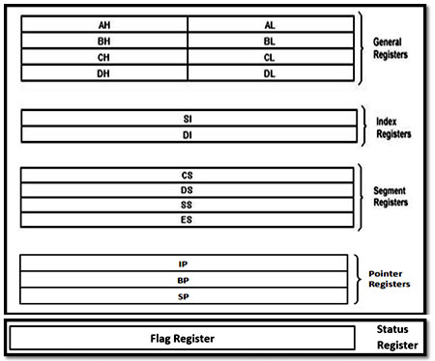

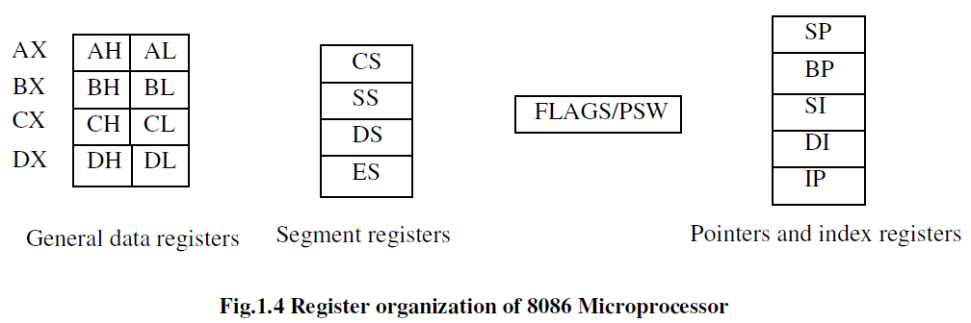

**General Registers**

The registers AX, BX, CX, and DX are the general 16-bit registers.

AX Register:

Accumulator register consists of two 8-bit registers AL and AH, which can be combined together and used as a 16- bit register AX. AL in this case contains the low-order byte of the word, and AH contains the high-order byte. Accumulator can be used for I/O operations, rotate and string manipulation.

BX Register:

This register is mainly used as a base register. It holds the starting base location of a memory region within a data segment.

It is used as offset storage for forming physical address in case of certain addressing mode.

CX Register:

It is used as default counter or count register in case of string and loop instructions.

DX Register:

Data register can be used as a port number in I/O operations and implicit operand or destination in case of few instructions.

Segment registers

To complete 1Mbyte memory is divided into 16 logical segments. The complete 1Mbyte memory segmentation is as shown in fig 1.5. Each segment contains 64Kbyte of memory. There are four segment registers.

Code segment (CS)

It is a 16-bit register containing address of 64 KB segment with processor instructions. The processor uses CS segment for all accesses to instructions referenced by instruction pointer (IP) register.

Stack segment (SS)

It is a 16-bit register containing address of 64KB segment with program stack. It is used for addressing stack segment of memory. The stack segment is that segment of memory, which is used to store stack data.

Data segment (DS)

It is a 16-bit register containing address of 64KB segment with program data. By default, the processor assumes that all data referenced by general registers (AX, BX, CX, DX) and index register (SI, DI) is located in the data segment. It points to the data segment memory where the data is resided.

Extra segment (ES)

It is a 16-bit register containing address of 64KB segment, usually with program data. By default, the processor assumes that the DI register references the ES segment in string manipulation instructions. It also refers to segment which essentially is another data  
segment of the memory. It also contains data.

Pointers and index registers.

The pointers contain within the particular segments. The pointers IP, BP, SP usually contain offsets within the code, data and stack segments respectively

Stack Pointer (SP)

is a 16-bit register pointing to program stack in stack segment.

Base Pointer (BP)

is a 16-bit register pointing to data in stack segment. BP register is usually used for based, based indexed or register indirect addressing.

Source Index (SI)

is a 16-bit register. SI is used for indexed, based indexed and register indirect addressing, as well as a source data addresses in string manipulation instructions.

Destination Index (DI)

is a 16-bit register. DI is used for indexed, based indexed and register indirect addressing, as well as a destination data address in string manipulation instructions.

**IP (Instruction Pointer):**The Instruction Pointer is a register that holds the address of the next instruction to be fetched from memory.It contains the offset of the next word of instruction code instead of its actual address