**Comprehensive Analysis of Performance metrics In NOMA Systems**

A Report on

Mini Project with Seminar

Submitted in partial fulfillment of the requirements for the award of Degree of

**MASTER OF TECHNOLOGY**

**in**

**ELECTRONICS AND COMMUNICATION ENGINEERING**

**Systems and Signal Processing**

**Submitted by**

**G. SUJITH 23011D4503**

**Under the esteemed guidance of**

**Dr. M. Madhavi Latha**

**Senior Professor**

**DEPARTMENT OF ELECTRONICS AND COMMUNICATION ENGINEERING**

**JNTUH UNIVERSITY COLLEGE OF ENGINEERING SCIENCE AND TECHNOLOGY**

**(AUTONOMOUS)**

**DEPARTMENT OF ELECTRONICS AND COMMUNICATION ENGINEERING**

**JNTUH UNIVERSITY COLLEGE OF ENGINEERING SCIENCE AND TECHNOLOGY**

**(AUTONOMOUS)**

**Kukatpally, Hyderabad – 500085, Telangana, India**

**2023 - 2024**

# DEPARTMENT OF ELECTRONICS AND COMMUNICATION ENGINEERING

# JNTUH UNIVERSITY COLLEGE OF ENGINEERING

# SCIENCE AND TECHNOLOGY

# HYDERABAD-500085, TELANGANA-INDIA

# The University Promo (Glimpse) | JNTUH-UCEJ | Students Activity Centre | Enactuss | - YouTube

# CERTIFICATE BY THE SUPERVISOR

This is to certify that the mini project report entitled **“COMPREHENSIVE ANALYSIS OF PERFORMANCE METRICS IN NOMA SYSTEMS”** that is being submitted by **Gurrapu Sujith** bearing **Roll No: 23011D4503** in partial fulfilment of the requirements for the award of the degree of **MASTER OF TECHNOLOGY** in **ELECTRONICS AND COMMUNICATIONS ENGINEERING** with specialization in **“Systems and Signal Processing”** from Jawaharlal Nehru Technological University - College of Engineering Science and Technology Hyderabad(Autonomous) is a bonafide record of project work carried out during the academic year 2024. The results obtained in this work have been verified and found satisfactory. The material contained in this report has not been submitted to any university or institution for the award of any degree.

|  |
| --- |
| Project Supervisor:Dr. M. MADHAVI LATHASenior Professor, Department of ECEJNTUHUCESTH |

# DEPARTMENT OF ELECTRONICS AND COMMUNICATION ENGINEERING

# JNTUH UNIVERSITY COLLEGE OF ENGINEERING

# SCIENCE AND TECHNOLOGY

# HYDERABAD-500085, TELANGANA-INDIA

# The University Promo (Glimpse) | JNTUH-UCEJ | Students Activity Centre | Enactuss | - YouTube

# CERTIFICATE BY HEAD OF THE DEPARTMENT

This is to certify that the mini project report entitled **“COMPREHENSIVE ANALYSIS OF PERFORMANCE METRICS IN NOMA SYSTEMS”** that is being submitted by Gaddam Aishwarya bearing **Roll No:23011D4503** in partial fulfilment of the requirements for the award of the degree of **MASTER OF TECHNOLOGY** in **ELECTRONICS AND COMMUNICATIONS ENGINEERING** with specialization in **“Systems and Signal Processing”** from Jawaharlal Nehru Technological University - College of Engineering Science and Technology Hyderabad(Autonomous) is a bonafide record of project work carried out during the academic year 2024. The results obtained in this work have been verified and found satisfactory. The material contained in this report has not been submitted to any university or institution for the award of any degree.

|  |
| --- |
| Head of the Department:Dr. AKULA RAJANISenior Professor, Head of ECEJNTUHUCESTH |

# DEPARTMENT OF ELECTRONICS AND COMMUNICATION ENGINEERING

# JNTUH UNIVERSITY COLLEGE OF ENGINEERING

# SCIENCE AND TECHNOLOGY

# HYDERABAD-500085, TELANGANA-INDIA

# The University Promo (Glimpse) | JNTUH-UCEJ | Students Activity Centre | Enactuss | - YouTube

# DECLARATION BY THE CANDIDATE

# I GURRAPU SUJITH, bearing Roll No: 23011D4503, hereby declare that the mini project report entitled “COMPREHENSIVE ANALYSIS OF PERFORMANCE METRICS IN NOMA SYSTEMS” carried out by me under the guidance of Dr. M. MADHAVI LATHA Senior Professor, is submitted in partial fulfilment of the requirements for the award of the degree of Master of Technology in Systems and Signal Processing, This is a record of Bonafide work carried out by me and the results embodied in this mini project have not been reproduced / copied from any source.

# Gurrapu Sujith

# 23011D4503

# ACKNOWLEDGEMENT

I write this acknowledgement with great honor, pride and pleasure to pay my respects to all who enabled us either directly or indirectly in reaching this stage.

I would like to pay respectful thanks to our principal **Dr. G. Venkata Narasimha Reddy** and management for providing all the facilities required for completing this dissertation work

I express my profound thanks to **Dr. A. Rajani**, Head of Department, Electronics and Communication Engineering Department for unflinching devotion, which lead me to complete this project. The support and encouragement given by her motivated me to complete this project.

I indebted forever to my guide **Dr. M. Madhavi Latha** Department of Electronics and Communication Engineering for her suggestions, guidance and inspiration in carrying out this project work.

I wish to extend my sincere thanks to parents and others, for their understanding and cooperation during the course of our research work. I take this opportunity to convey my sincere thanks to all my classmates who have directly and indirectly contributed for the successful completion of this work.

|  |
| --- |
| G. SUJITHRoll. No: 23011D4503Systems and Signal ProcessingJNTUHUCESTHyderabad -500085 |

# TABLE OF CONTENTS

# Page No.

# Certificate ii

# Certificate iii

# Declaration iv

# Acknowledgement v

# Table of Contents vi

# Abstract vii

# List of Figures ix

# List of Tables x

# List of Acronyms xi

# CHAPTER 1 1

# INTRODUCTION 1

# 1.1 Introduction 1

# 1.2 Objectives 3

# 1.3 Literature Survey 3

# 1.4 System model 5

# 1.5 Layout of project 5

# CHAPTER 2 6

# NOMA TECHNOLOGY 6

# 2.1 Introduction 6

# 2.2 Technique in NOMA 6

# 2.3 Benefits of NOMA Technology 7

# 2.4 NOMA in Cellular Networks 8

# 2.5 Distributed NOMA 8

# CHAPTER 3 11

# SYSTEM MODEL 11

# 3.1 Modules 11

# 3.2 Modules Explanation 11

# 3.2.1 System Model 11

# 3.2.2 Signal Model 11

# 3.2.3 Implementation of Capacity and Outage Probability 14

# 3.2.4 Implementation of Bit Error Rate 15

# CHAPTER 4 16

# SOFTWARE SPECIFICATION 16

# 4.1 Introduction to MATLAB 16

# 4.2 Features of MATLAB 16

# 4.3 The MATLAB System 17

# CHAPTER 5 19

# RESULTS AND ANALYSIS 19

# 5.1 Objectives 19

# 5.2 Results and Analysis 19

# CHAPTER 6 24

# CONCLUSION AND FUTURE SCOPE 24

# REFERENCES 25

# APPENXIX 26

**ABSTRACT**

Non-Orthogonal Multiple Access (NOMA) scheme there exists two techniques i.e., Power domain and code domain. NOMA utilize superposition coding at transmitter and successive interface cancellation (SIC) at receiver. This simulation investigates the performance of NOMA in a Rayleigh fading channel environment through comprehensive simulation of key metrics: Bit Error Rate (BER), capacity and outage probability. Through systematic simulation, this evaluates NOMA performs under Rayleigh fading channel, considering factors such as modulation schemes, power allocation strategies, and the impact of fading on BER and outage probability. Perception gained from these simulations provide valuable understandings of NOMA’s potential advantages over traditional Orthogonal Multiple Access (OMA) in realistic wireless scenarios, foreground its capacity to enhance spectral efficiency and mitigate outage occurrences.

# LIST OF FIGURES

|  |  |  |
| --- | --- | --- |
| Figure No | Figure Name | Page No |
| 2.1 | NOMA based Single-cell Single-Tier (SCST) Cellular System | 8 |
| 2.2 | Distributed NOMA. Architectural comparison of Traditional network and Heterogenous network | 9 |
| 3.1 | Network Model | 11 |
| 5.1 | Result plotted between Transmit power Vs Capacity | 20 |
| 5.2 | Outrage Probability Vs Transmit Power | 22 |
| 5.3 | BER vs Transmit Power | 23 |

# LIST OF TABLES

|  |  |  |
| --- | --- | --- |
| **Table No.** | **Table Name** | **Page No.** |
| 1.1 | Comparison of Orthogonal Multiple Access and Non-Orthogonal Multiple Access | 2 |
| 5.1 | Analysis of capacity | 20 |
| 5.2 | Analysis of Outrage probability | 21 |
| 5.3 | Analysis of BER | 22 |

# LIST OF ACRONYMS

|  |  |
| --- | --- |
| ACRONYM | ABBREVIATIONS |
| AWGN | Additive White Gaussian Noise |
| BER | Bit Error Rate |
| BPSK | Binary Phase Shift keying |
| DFT | Discrete Fourier Transform |
| MAC | Media Access Control |
| MATLAB | Matrix Laboratory |
| MGF | Moment Generation Function |
| NOMA | Non-Orthogonal Multiple Access |
| OFDMA | Orthogonal Frequency Division Multiple Access |
| OFDM | Orthogonal Frequency Division Multiplexing |
| OMA | Orthogonal Multiple Access |
| PD-NOMA | Power Domain Non-Orthogonal Multiple Access |
| SIC | Successive Interference Cancellation |
| TWDP | Two-wave With Diffuse Power |
| 1G | First Generation |
| 2G | Second Generation |
| 3G | Third Generation |
| 4G | Fourth Generation |
| 5G | Fifth Generation |

# CHAPTER-1

# INTRODUCTION

# INTRODUCTION

# The exponential growth of mobile data traffic has necessitated the development of highly efficient spectrum utilization techniques. Orthogonal Multiple Access (OMA) schemes, such as Orthogonal Frequency Division Multiple Access (OFDMA), have been the mainstay in cellular communication systems. However, OMA faces limitations in terms of spectral efficiency, especially when accommodating a massive number of devices. To address these challenges, Non-Orthogonal Multiple Access (NOMA) has emerged as a promising technology for 5G and beyond.

# NOMA Fundamentals

# Unlike OMA, NOMA allows multiple users to share the same time-frequency resource. This is achieved by employing power domain or code domain multiplexing. In power domain NOMA, users are differentiated based on their power levels, while in code domain NOMA, users are distinguished by different spreading sequences.

# A key enabling technology for NOMA is Successive Interference Cancellation (SIC). At the receiver, users with better channel conditions can decode and subtract the signals of users with weaker channel conditions. This process is iteratively performed until the desired signal is extracted.

# Advantages of NOMA

# Improved spectral efficiency: By allowing multiple users to share the same resource, NOMA can significantly enhance spectral efficiency compared to OMA.

# Enhanced user fairness: NOMA can serve users with varying channel conditions simultaneously, improving fairness compared to traditional user scheduling schemes.

# Massive connectivity: NOMA can accommodate a large number of devices, making it suitable for IoT applications.

# Low latency: Through careful power allocation and SIC, NOMA can potentially achieve lower latency compared to OMA.

# Challenges and Considerations

# High computational complexity: SIC requires complex signal processing algorithms, increasing the computational burden on user devices.

# Imperfect channel estimation: Errors in channel estimation can degrade the performance of SIC.

# Power allocation optimization: Determining optimal power levels for users is crucial for NOMA performance but can be challenging.

# Interference management: Careful management of interference between users is essential to avoid performance degradation.

# The capacity of Non orthogonal multiple access (NOMA) to serve numerous users at once utilizing the same time and frequency resources is the main driver for its adoption in 5G. It is key principle for radio access in 5G networks. NOMA is based on the fundamental idea that more than one user can served in each orthogonal resource block, e.g., Time Slot, Subcarrier, Spreading code etc.

# NOMA exploits superposition coding at transmitter and successive interference cancellation (SIC) at receiver. From the past we are seeing Orthogonal Multiple Access techniques are used where the number of users is limited due to exclusivity of orthogonal resources. Spectral efficiency, power allocation, capacity, bit error rate and outrage probability are some parameters to analyze the NOMA performances.

|  |  |  |
| --- | --- | --- |
|  | Orthogonal Multiple Access | Non-Orthogonal Multiple Access |
| Advantages | Simpler receiver detection | Low latency, Higher spectral efficiency, Higher connection density, Enhanced user fairness, Supporting diverse Quality of service. |
| Disadvantages | Lower spectral efficiency, limited no of users, unfairness for users | Increase complexity of receivers. |

# Table 1.1: Comparison of Orthogonal Multiple Access and Non-Orthogonal Multiple Access

# NOMA is a promising technology with the potential to revolutionize cellular communication systems. By overcoming the limitations of OMA, NOMA can contribute to the realization of the ambitious goals of 5G and beyond. However, significant research and development efforts are still required to address the challenges associated with NOMA deployment.

# The mobile generations which use multiple access techniques are listed as

# 1G – Frequency Division Multiple Access

# 2G – Time Division Multiple Access

# 3G – Code Division Multiple Access

# 4G – Orthogonal Frequency Division Multiple Access

# 5G – Non-Orthogonal Multiple Access

# OBJECTIVES

# To study the capacity and outage probability using Rayleigh fading channel

# To study the BER using BPSK modulation scheme

# LITERATURE SURVEY

# Prasheel N. Thakre *et.al* [1] given a survey titled as “A survey on Power Allocation in PD-NOMA for 5G Wireless Communication Systems”. They explained about the power domain NOMA. NOMA is proposed as a key technology for future 5G networks to enhance capacity, user fairness, spectrum efficiency, and mass connectivity. The main challenge in designing NOMA is the selection of resource allocation algorithms, as user pairing and power allocation are closely linked. The paper provides an overview of the algorithms designed for optimizing power allocation in PD-NOMA, considering three different parameters: Max-Min Fairness, maximizing Sum Rate, and maximizing Energy Efficiency in different radio networks. It also discusses the evolution of cellular networks from 1st Generation to 4th Generation and the limitations of orthogonality in resource allocation. The paper further explores power allocation strategies for PD-NOMA, including optimization for Max-Min Fairness, Maximization of Sum Rate, and Maximization of Energy Efficiency. Various power allocation algorithms are developed under different scenarios to enhance user fairness, sum rate, and energy efficiency.

# The paper concludes by suggesting that future research should focus on developing robust power allocation and advanced precoder design algorithms for NOMA with lower complexity.

# Himeur Hanane1 *et.al* [2] the paper titled “Achievable Capacity Analysis for Power Domain Non-Orthogonal Multiple Access Scheme” examines the non-orthogonal power domain multiple access (PD-NOMA) technique for 5G networks. It highlights the advantages of PD-NOMA in addressing the overhead issues arising from the growing number of users. Two power allocation schemes-fixed and fair-are analyzed for their impact on system capacity. The study shows that fair power allocation, which adjusts power based on channel conditions, outperforms fixed power allocation in terms of achievable capacity for near users. Simulations demonstrate that PD-NOMA can effectively enhance user capacity, particularly for users with poorer channel conditions.

# Veeraiyah Thangasamy *et.al* [3] the paper “Analysis of Capacity and Outage Probability for NOMA based Cellular Communication over Rician Fading Channel” evaluates the performance of Non-Orthogonal Multiple Access (NOMA) in 5G networks. It specifically examines channel capacity and outage probability over Rician fading channels, suitable for scenarios with a line-of-sight component. The paper provides analytical expressions for these metrics and uses Monte Carlo simulations for validation. Results show that NOMA offers superior capacity and reduced outage probability compared to traditional Orthogonal Multiple Access (OMA). The study highlights NOMA's potential for enhancing 5G network performance, especially under varying channel conditions.

# Pawan Kumar *et.al* [4] the paper titled “Average BER Analysis of NOMA Systems under TWDP Fading” investigates the average bit-error rate (BER) for downlink non-orthogonal multiple access (NOMA) systems using binary phase-shift keying (BPSK) modulation in a two-wave with diffuse power (TWDP) fading environment. It analyzes BER for two-user and three-user NOMA systems through the moment generating function (MGF)-based method and employs successive interference cancellation (SIC) for data detection. The study provides analytical expressions for average BER and validates them with simulations. The results demonstrate how varying fading parameters impact system performance, confirming the suitability of TWDP fading models for high-frequency transmissions in 5G and beyond networks.

# Kumuda D K *et.al* [5] the paper “BER, Capacity and Outage probability of NOMA for 5G Wireless Communication” presents an analysis of the performance of Non-Orthogonal Multiple Access (NOMA) in 5G communication systems. The study investigates the Bit Error Rate (BER) for different channel models and examines the capacity and outage probability relative to transmit power. The paper also delves into the power allocation methods and decoding process in NOMA. The results demonstrate that as transmit power increases, outage probability decreases, enhancing system reliability and service quality. The paper further indicates that the performance of BER is better in the Rician channel model compared to AWGN and Rayleigh models.

# SYSTEM MODEL

# OBJECTIVE:

# Determine the bit error rate (BER), capacity and outage probability for a NOMA (Non-Orthogonal Multiple Access) system under Rayleigh propagation using MATLAB.

# Components:

# Sender:

# Multiple users can send signals at the same time by superposition coded technique.

# Power distribution: different power levels for different users to improve accuracy and efficiency.

# Channel Model:

# Rayleigh Solution: Multipath propagation occurs where a signal arrives at a receiver through multiple paths, resulting in differences in amplitude.

# Gaussian White Noise (AWGN): adds noise to the signal to simulate real-world characteristics.

# Receiver:

# Successive Interference Cancellation (SIC): Detects and records signals by gradually removing detected strong signals to record weaker signals.

# Performance measurement:

# BER: Measures the error rate in received bits.

# Capacity: Calculates the data rate that can be received under certain conditions.

# Outage probability: the probability that the data rate will fall below a specified threshold.

# LAYOUT OF PROJECT

# The report is organized as follows. In Chapter 1 presents the introduction followed by objectives, literature survey, system model. Chapter 2 describes the NOMA technology. Chapter 3 presents the System model. Chapter 4 is about Software Specification. Chapter 5 is about Results and its analysis. And finally, Chapter 6 concludes the report.

**CHAPTER-2**

**NOMA TECHNOLOGY**

**2.1 INTRODUCTION**

NOMA superposes multiple users in the power domain although its basic signal waveform could be based on the orthogonal frequency division multiple access (OFDMA) or the discrete Fourier transform (DFT)-spread OFDM the same as LTE baseline. In NOMA adopts a successive interference cancellation (SIC) receiver as the baseline receiver scheme for robust multiple access, considering the expected evolution of device processing capabilities in the future. Based on system-level evaluations, I show that the downlink NOMA with Superposition coding at transmitter and SIC at receiver improves both the capacity. The BER and outage probability is also improved by defined system model

**2.2 TECHNIQUE IN NOMA**

* **SUPERPOSITION CODING**

In NOMA (Non-orthogonal Multiple Access) transmitters, spatial coding is a technique used to transmit multiple signals simultaneously on the same frequency source. Superposition coding on a NOMA transmitter allows multiple signals to be sent simultaneously on the same frequency source. This is achieved by multiplying the different signal streams and transmitting them simultaneously. Each signal stream is assigned a specific energy level to ensure proper encoding in the receiver. The receiver then separates the different signal streams using advanced signal processing techniques. This allows better use of the available limited frequency spectrum. Large-space encryption in NOMA allows multiple users to access network resources simultaneously. Improves system display efficiency and allows serving more users.

By allocating different performance levels to different users, it ensures fairness in resource allocation. NOMA can support a large number of users while maintaining high data flows. Wide-area coding in NOMA relies on advanced receiver algorithms to separate overlapping signals. Requires special power settings to prevent interference between different signal streams. NOMA can be implemented on upstream and downstream lines. Very useful in situations with high user density and limited bandwidth. A receiver in a NOMA system must be able to decode multiple overlapping signals simultaneously. Large space coding in NOMA is an advanced technique that enables efficient and fair resource allocation in wireless communication systems.

* **SUCCESSIVE INTERFERENCE CANCELLATION (SIC)**

Successive Interference Cancellation (SIC) is a popular physical layer technology. Simply put, SIC is the receiver's ability to receive two or more signals at the same time (without colliding with today's systems). SIC is possible because the receiver can decode the strong signal, subtract it from the combined signal, and subtract the weak signal from the remaining signal. A natural question is: what effect does this have on MAC protocol design considering SIC-powered radios. What are the scope and limitations? Through these questions, I systematically learned about the positive benefits that SICs can provide. I focus on two simple topologies: two transmitters transmitting to the same receiver, and two transmitters transmitting to different receivers. I found that the SIC features in this simple topology reflect the behavior of larger global networks.

**2.3 BENEFITS OF NOMA TECHNOLOGY**

The NOMA Technology centre provides computers, internet, office automation, and educational resources to the community. “The centre aims to bridge the technology gap, improve IT skills, and enhance the economic status of the people,” said NOMA, a large industrial company. The company has deployed IT staff to meet the needs of the center. Now more than ever, you can rely on a dedicated IT team to train basic computer skills and provide technical support for advanced users. The centre’s efforts are crucial in empowering the community with the tools needed to thrive in an increasingly digital world.

Exploitation of channel gain difference among users is a key feature of NOMA technology. Unlike OMA (OFDMA), where channel gain differences are translated into multi-user diversity gains via frequency-domain scheduling, in NOMA, these differences are utilized for multiplexing gains by superposing the transmit signals of multiple users with different channel gains in the power domain. As shown in Fig. 2.2, by exploiting the channel gain difference in NOMA, both UEs with high and low channel gains benefit. UEs with high channel gain (bandwidth-limited UEs) sacrifice a small amount of power but gain significantly more bandwidth, while UEs with low channel gain (power-limited UEs) experience minimal power reduction and "effective" bandwidth, but gain substantially more overall bandwidth. This win-win situation is the primary reason why NOMA's performance gains over OMA increase as the difference in channel gains between NOMA-paired users grows. Consequently, NOMA technology enables more efficient and equitable use of resources, further enhancing the performance of communication systems.

**2.4 NOMA IN CELLULAR NETWORKS**

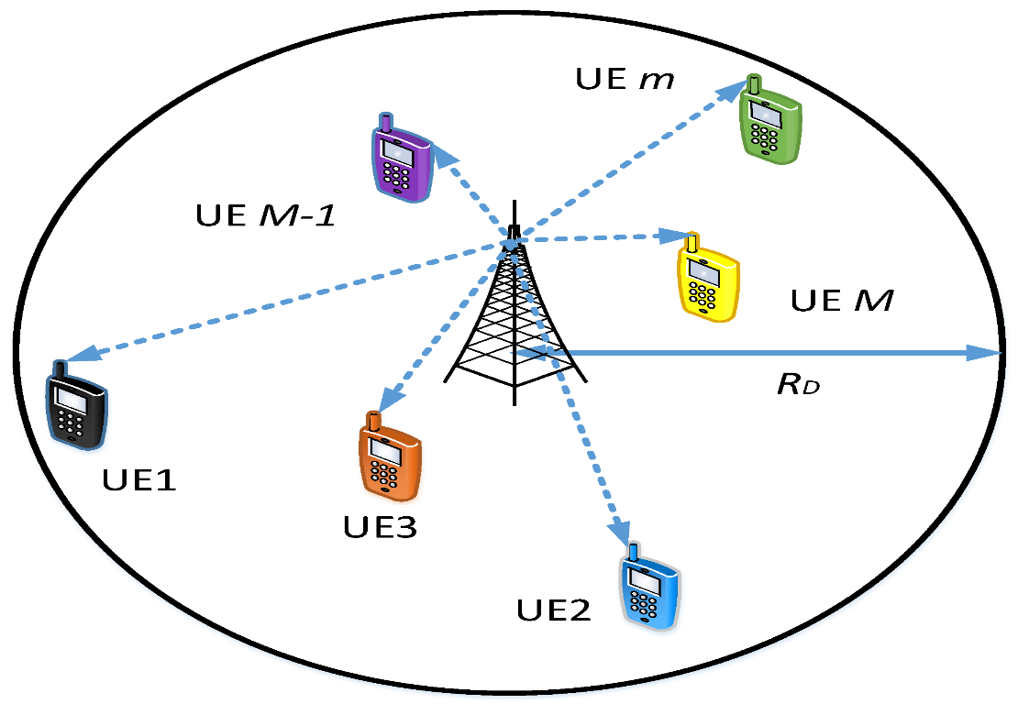NOMA (Non-Orthogonal Multiple Access) is a technology used in cellular networks, particularly in the context of 5G and beyond. It allows multiple users to share the same frequency resources simultaneously, improving spectral efficiency and system throughput. NOMA employs power-domain techniques to allocate different power levels to different users, enabling them to be superimposed on the same resource. Successive Interference Cancellation (SIC) is used at the receiver to separate and decode the overlapping signals from different users. Resource allocation algorithms play a crucial role in optimizing the performance of NOMA in cellular networks. However, NOMA introduces additional interference challenges that need to be addressed, requiring advanced interference management techniques. Ongoing research focuses on power control, interference management, and optimization to enhance the performance of NOMA in practical deployments. NOMA holds great potential for enhancing the efficiency and capacity of cellular networks, and ongoing research aims to address challenges and optimize its performance in practical deployments.

Figure 2.1: NOMA based Single-cell Single-Tier (SCST) Cellular System

**2.5 DISTRIBUTED NOMA**

Distributed NOMA (Non-Orthogonal Multiple Access) represents a significant advancement in wireless communication systems, aiming to improve spectral efficiency, system capacity, and user fairness. Traditional NOMA relies on power-domain techniques to allocate power levels among users at a single central base station. Users with different channel conditions are served simultaneously on the same frequency band, with stronger users allocated less power and weaker users more, allowing simultaneous communication.

However, as networks scale, centralized power allocation becomes less efficient and more complex. Distributed NOMA addresses these challenges by decentralizing the power allocation process across multiple base stations or access points, which coordinate with each other to manage resources. This distributed approach enables more flexible deployment, particularly in large-scale networks such as 5G and beyond, where the density of users and base stations is high.

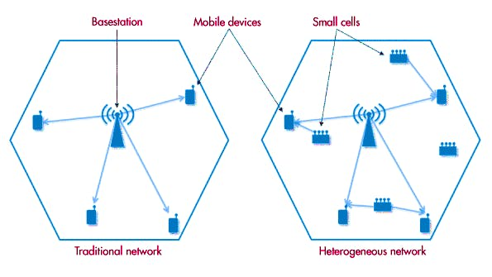The benefits of distributed NOMA include improved coverage, as multiple access points can better serve users in various locations, leading to enhanced network reliability. The approach also reduces latency by enabling closer proximity between users and access points, improving the overall user experience. Furthermore, distributed NOMA enhances device performance by more effectively managing interference, as the decentralized system can adapt to local conditions in real-time.

Figure 2.2: Distributed NOMA. Architectural comparison of Traditional network and Heterogenous network

Ongoing research in distributed NOMA focuses on optimizing resource allocation algorithms to ensure efficient and fair distribution of power and spectrum. Researchers are also exploring interference management techniques, as the decentralized nature of distributed NOMA introduces new challenges in controlling cross-channel interference. Additionally, the integration of cooperative communication techniques, where multiple access points work together to serve users, is being investigated to further boost the performance and scalability of distributed NOMA in practical deployments. As these advancements continue, distributed NOMA is expected to play a crucial role in future wireless communication networks, supporting a wide range of applications from IoT devices to high-speed mobile broadband.

**Applications of NOMA**

1. Wireless Network Design and Optimization
2. Quality of Service (QoS) Analysis
3. Standardization and Protocol Development
4. Academic Research and Development
5. Performance Evaluation in Emerging Technologies
6. Real-Time Systems and Applications
7. Simulation for Training and Education

**CHAPTER-3**

**SYSTEM MODEL**

**3.1 MODULES**

* SYSTEM MODEL
* SIGNAL MODEL
* IMPLEMENTATION OF CAPACITY AND OUTAGE PROBABILITY
* IMPLEMENTATION OF BIT ERROR RATE

**3.2 MODULES EXPLANATION**

**3.2.1 SYSTEM MODEL**

Assume a single cell downlink topology consisting of one base station, B and two users U1 and U2 and terminals are equipped with single antenna. User 1 is the far/weak as he is far away from the transmitting BS. User 2 is the near/strong user. Let d1 and d2 denote their distances from the BS. The NOMA scheme allows BS to simultaneously serve users by using the entire bandwidth to transmit data via a superposition coding technique at the transmitter side and SIC techniques at the users in this case, user multiplexing is performed in power domain.

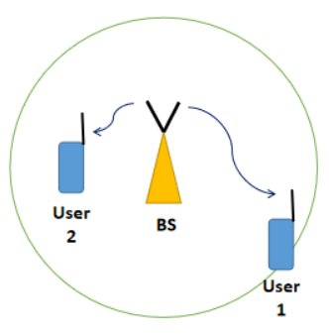

Figure 3.1: Network Model

**3.2.2 SIGNAL MODEL**

The BS has two distinct messages x1 to user 1 (far user), and x2 to user 2 (near user). α1 and α2 are the power allocation factors for the far and the near user respectively (α1 + α2 = 1). In NOMA, to promote user fairness, more power is given to the far user and less power to the near user. That is, α1 > α2. Throughout this project, I will use α1 = 0.75 and α2 = 0.25. Let h1 and h2 denote the channel from the BS to the far and the near user respectively.

**NOMA encoding and transmission**

The superposition coded NOMA signal transmitted by the BS is,

$$x=\sqrt{P}\left(\sqrt{α_{1}}x1+\sqrt{α_{2}}x_{2}\right)$$

P: Transmit power

X received at far user after propagating through channel h1 is

: noise

Similarly, X received at near user after propagating through channel h2 is

: noise

**NOMA decoding at User 1 (far user)**

Expanding the received signal at user 1,

$$y_{1}=h_{1}x+w_{1}$$

$$y_{1}=h_{1}\sqrt{P}\left(\sqrt{α_{1}}x_{1}+\sqrt{α_{2}}x_{2}\right)+w_{1}$$

$$y_{1}=h_{1}\sqrt{P}\sqrt{α_{1}}x_{1}+h_{1}\sqrt{P}\sqrt{α_{2}}x_{2}+w_{1}$$

$h_{1}\sqrt{P}\sqrt{α_{1}}x_{1}$: desired & dominating

$h_{1}\sqrt{P}\sqrt{α_{2}}x_{2}$: interference & low power

$w_{1}$: noise

Since α1 > α2, direct decoding of y1 would yield x1. The term containing the x2 component will be treated as an interference. The signal to interference and noise ratio for the far user is,

$$γ_{1}=\frac{{\left|h_{1}\right|}^{2}Pα_{1}}{{\left|h_{1}\right|}^{2}Pα_{2}+σ^{2}}$$

and his achievable data rate is,

R1= = log2(1+)

σ is the noise power.

The Shannon capacity formula is given by

$$c=\log_{2}\left(1+γ\right)$$

γ : Signal to Interference Noise Ratio

**NOMA decoding at User 2 (near user)**

Expanding the received signal au user 2,

$$y_{2}=h_{2}x+w_{2}$$

$$y_{2}=h_{2}\sqrt{P}\left(\sqrt{α_{1}}x_{1}+\sqrt{α_{2}}x_{2}\right)+w_{2}$$

$$y_{2}=h_{2}\sqrt{P}\sqrt{α_{1}}x_{1}+h_{2}\sqrt{P}\sqrt{α_{2}}x_{2}+w_{2}$$

$h_{2}\sqrt{P}\sqrt{α_{1}}x_{1}$: interference & dominating

$h_{2}\sqrt{P}\sqrt{α_{2}}x_{2}$: desired & low power

$w_{2}$: noise

User 2 perform [successive interference cancellation](https://ecewireless.blogspot.com/2020/04/noma-graphical-example-of-successive.html) (SIC) before decoding his own signal.

SIC is carried out as follows:

1. y2 is directly decoded to obtain x1 or rather, an estimate of x1, that is .
2. y2′=y2 − is computed.
3. y2′ is decoded to obtain an estimate of x2.

A perfect SIC assumption is assumed rather than imperfect SIC

The signal to interference and noise ratio at the user 2 for decoding the user 1 signal (before SIC) is,

$γ_{1,2}$ = $\frac{{\left|h_{2}\right|}^{2}Pα_{1}}{{\left|h_{2}\right|}^{2}Pα_{2}+σ^{2}}$

The corresponding achievable data rate is,

R1,2 = log2(1 + = log2(1+ )

After cancellation of user 1's signal using SIC, the signal to noise ratio at the user 2 for decoding its own signal is,

$γ_{2}$ = $\frac{{\left|h_{2}\right|}^{2}Pα_{2}}{σ^{2}}$

The corresponding achievable data rate is,

R2=log2(1+ )

Here, I considered only two NOMA users. You can also [multiplex more than two users in the same frequency carrier](https://ecewireless.blogspot.com/2020/06/ber-of-3-user-non-orthogonal-multiple.html) to accommodate more users in our network.

**3.2.3 IMPLEMENTATION OF CAPACITY AND OUTAGE PROBABILITY**

1. First, declare the values of some parameters. Say the distances are, d1= 1000 meters and d2=500 meters and the power allocation factors considered as α1= 0.75 and α2 = 0.25.
2. Plot the capacity and outage probability as a function of transmit power. So initialize a range of transmit power from 0 dBm to 40 dBm.
3. Set bandwidth as B = 1MHz and calculate the thermal noise power as N0 = kTB, where k = 1.38 x 10-23 J/K, T=300K
4. Next, generate the Rayleigh fading coefficients h1 and h2 to simulate the channel between two users.

hi= (randn(1, N) + 1i * randn(1,N))/ $\sqrt{2}$

Here, $η$ is called the pathloss exponent. Typically, $η$ = 4

di : Represents the distance between the transmitter and the receiver

1. To plot capacity, calculate the achievable data rate

R1=log2(1+),

R1,2=log2(1+ ), and

R2=log2(1+ )

σ is the noise power.

1. Find the average value of each of the above quantities for every transmit power
2. Calculating the above quantities for different power levels (for eg., from 0 to 40 dBm) and the plot the achievable capacity as a function of transmit power.
3. To plot the outage probabilities, set target rate for each user.

Pout, i = Pr(Ri < Rth, i)

Where Rth, i is the threshold rate for user i

1. Count the number of times the values calculated in step 5 fall below the target rates and take the average. Plot the outage probabilities as a function of transmit power

**3.2.4 IMPLEMENTATION OF BIT ERROR RATE**

1. For BER, follow same steps of capacity and outage simulation up to step 4.
2. Next generate noise samples for both users. The formula is,

$w_{i}=\sqrt{noⅈsⅇPoωⅇr}$ (randn(1,N) + 1i * randn(1, N))/ $\sqrt{2}$

randn(1,N) :Generates N samples of real-valued Gaussian random variables with zero mean and unit variance.

1i * randn(1,N) :Generates N samples of imaginary-valued Gaussian random variables with zero mean and unit variance.

1/ $\sqrt{2}$:Normalizes the Gaussian random variables to have unit variance for the real and imaginary parts.

1. Generate random binary data for both users. Modulate the data using any digital modulation scheme. In here BPSK is used for both users.
2. Calculate the superposition coded signal x. calculate y1 and y2 dividing by h1 and h2 respectively.
3. From the equalized version of y1 perform direct BPSK demodulation to get ${\overline{x}}_{1}$.
4. Compare ${\overline{x}}_{1}$ with the user 1’s original data and estimate BER using the biterr function.
5. Directly decode the equalized version of y2 to estimate x1
6. Remodulate x1 and subtract the remodulated x1 component after multiplying it with $\sqrt{α_{1}}$ from the equalized version of y2. Decode this signal to get ${\overline{x}}_{2}.$
7. Compare ${\overline{x}}_{2}$ with user 2’s original data and estimate BER using the biterr function.
8. Plot the BER’s as a function of transmit power.

**CHAPTER-4**

**SOFTWARE SPECIFICATION**

**4.1 INTRODUCTION TO MATLAB**

MATLAB (Matrix Laboratory) is a high-performance language for scientific and technological calculations. It integrates computation, visualization and programming in an easy-to-use environment where problems and solutions are expressed in familiar mathematical notation. It is a complete environment for high-level programming, as well as interactive data analysis. Some typical applications are

* system simulations
* algorithm development
* data acquisition, analysis, exploration, and visualization, as well as
* Modeling, simulation and prototyping.

MATLAB was originally designed as a more convenient tool (than BASIC, FORTRAN or C/C++) for the manipulation of matrices. It was originally written to provide easy access to matrix software developed by the LINPACK and EISPACK projects. After- wards, it gradually became the language of general scientific calculations, visualization and program design. Today, MATLAB engines incorporate the LAPACK and BLAS libraries, embedding the state of the art in software for matrix computations. It received more functionalities and it still remains a high-quality tool for scientific computation. MATLAB excels at numerical computations, especially when dealing with vectors or matrices of data. It is a procedural language, combining an efficient programming structure with a bunch of predefined mathematical commands. While simple problems can be solved interactively with MATLAB, its real power is its ability to create large program structures which can describe complex technical as well as non-technical systems. Mat- lab has evolved over a period of years with input from many users. In university environments, it is the standard computational tool for introductory and advanced courses in mathematics, engineering and science. In industry, MATLAB is the tool of choice for highly-productive research, development and analysis.

**4.2 FEATURE OF MATLAB**

MATLAB is a high-performance language for technical computing. It integrates computation, visualization, and programming in an easy-to-use environment where problems and solutions are expressed in familiar mathematical notation.

Typical uses include

* Math and computation
* Algorithm development
* Modeling, simulation, and prototyping
* Data analysis, exploration, and visualization
* Scientific and engineering graphics
* Application development, including graphical user interface building

MATLAB is an interactive system whose basic data element is an array that does not require dimensioning. This allows you to solve many technical computing problems, especially those with matrix and vector formulations, in a fraction of the time it would take to write a program in a scalar non-interactive language such as C or FORTRAN.

The name MATLAB stands for matrix laboratory. MATLAB was originally written to provide easy access to matrix software developed by the LINPACK and EISPACK projects. Today, MATLAB uses software developed by the LAPACK and ARPACK projects, which together represent the state-of-the-art in software for matrix computation.

MATLAB has evolved over a period of years with input from many users. In university environments, it is the standard instructional tool for introductory and advanced courses in mathematics, engineering, and science. In industry, MATLAB is the tool of choice for high-productivity research, development, and analysis.

MATLAB features a family of application-specific solutions called toolboxes. Very important to most users of MATLAB, toolboxes allow you to learn and apply specialized technology. Toolboxes are comprehensive collections of MATLAB functions (M-files) that extend the MATLAB environment to solve particular classes of problems. Areas in which toolboxes are available include signal processing, control systems, neural networks, fuzzy logic, wavelets, simulation, and many others.

**4.3 THE MATLAB SYSTEM**

The MATLAB system consists of five main parts:

**Development Environment**

This is the set of tools and facilities that help you use MATLAB functions and files. Many of these tools are graphical user interfaces. It includes the MATLAB desktop and Command Window, a command history, and browsers for viewing help, the workspace, files, and the search path.

**The MATLAB Mathematical Function Library**

This is a vast collection of computational algorithms ranging from elementary functions like sum, sine, cosine, and complex arithmetic, to more sophisticated functions like matrix inverse, matrix eigenvalues, Bessel functions, and fast Fourier transforms.

**The MATLAB Language**

This is a high-level matrix/array language with control flow statements, functions, data structures, input/output, and object-oriented programming features. It allows both “programming in the small” to rapidly create quick and dirty throw-away programs, and “programming in the large” to create complete large and complex application programs.

**Handle Graphics.**

This is the MATLAB graphics system. It includes high-level commands for two- dimensional and three-dimensional data visualization, image processing, animation, and presentation graphics. It also includes low-level commands that allow you to fully customize the appearance of graphics as well as to build complete graphical user interfaces on your MATLAB applications.

**The MATLAB Application Program Interface (API).**

This is a library that allows you to write C and FORTRAN programs that interact with MATLAB. It includes facilities for calling routines from MATLAB (dynamic linking), calling MATLAB as a computational engine, and for reading and writing MAT-files.

**CHAPTER-5**

**RESULTS AND ANALYSYS**

**5.1 OBJECTIVES**

# To study the capacity and outage probability using Rayleigh fading channel

# To study the BER using BPSK modulation scheme

# 5.2 RESULTS AND ANALYSIS

**Achievable data rate:**

Achievable data rate at any point is defined as the percentage of actual message received at the receiver, which is transmitted by transmitter. Because received data may contain interference and noise.

**Outage Probability:**

Outage probability is the likelihood that a communication system's signal quality falls below a certain threshold, leading to a failure in maintaining a reliable connection. It quantifies the probability of a system experiencing a performance drop that causes service disruption or loss of connectivity.

An Outage event occurs at the ith user when it is not able to decode its own data flow or the data flows of the weakest users m < i.

In order to find the 1st objective i.e., Achievable capacity and outage probability for 2 users I have declared distances as d1 and d2 as 1000 and 500 meters respectively and the power factors as a1 and a2 as 0.75 and 0.25 respectively i.e., (0.75 + 0.25 = 1)

Now generate Rayleigh fading coefficients for both users which is denoted by h1 and h2. Transmit power is defined with a range from 0 to 40 decibels per milliwatts(dBm) and converted to linear scale. System bandwidth is initialized as 10^6 and Noise power is found from BW in dBm and linear scale. Target rates (rate1 & rate2) for both the users is set at 1 and 2 bps/Hz.

Now by iterating the range as transmit power, for every iteration I found the SNR, achievable rate and its average. For every power the outage probability is been evaluated for both the users.

I had plotted the Capacity graph between Transmit power and Achievable rates and Outage probability is plotted in semiology graph between Transmit power and outages of two users.

In the Table 2, you can find the values to analyze the graph plotted between Transmit power and Achievable capacity.

|  |  |  |  |  |
| --- | --- | --- | --- | --- |
|  | **Pt** | **R1** | **R1,2** | **R2** |
| 1 | 0 | 0.2132 | 1.0748 | 0.8624 |
| 2 | 2 | 0.3046 | 1.2429 | 1.1606 |
| 3 | 4 | 0.4213 | 1.3963 | 1.5183 |
| 4 | 6 | 0.5625 | 1.5300 | 1.9326 |
| 5 | 8 | 0.7236 | 1.6420 | 2.3985 |
| 6 | 10 | 0.8967 | 1.7325 | 2.9091 |
| 7 | 12 | 1.0724 | 1.8036 | 3.4568 |
| 8 | 14 | 1.2411 | 1.8580 | 4.0344 |
| 9 | 16 | 1.3950 | 1.8988 | 4.6353 |

Table 5.1: Analysis of capacity

**Key Observations:**

* **Differential Growth:** R2 increases much faster with transmit power compared to R1​, suggesting that the second channel or user benefits more from increased transmit power.
* **Saturation:** R1 and R1,2​ both show signs of saturation, meaning that after a certain transmit power level, additional power yields diminishing returns in terms of capacity.
* **Relationship between Curves:** The difference in the growth rates of these curves indicates different channel conditions, such as varying path losses, interference levels, or channel state information available to each user.
* **Potential Application:** This graph might be useful in evaluating power allocation strategies in a multi-user or cooperative communication system. The differences between the curves suggest that the power should be allocated differently depending on the specific channel or user to maximize the overall system capacity.

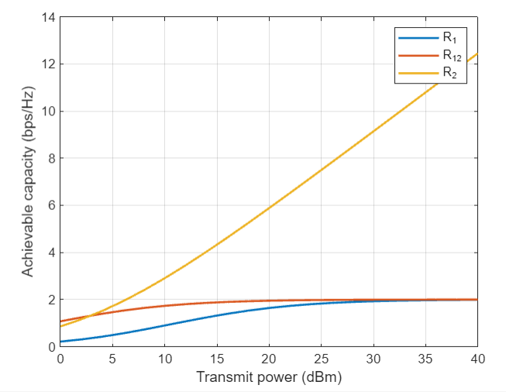Figure 5.1: Result plotted between Transmit power Vs Capacity

In the Table 3, you can find the values to analyze the graph plotted between Transmit power and outage probability.

|  |  |  |  |
| --- | --- | --- | --- |
|  | **Pt** | **User1** | **User2** |
| 1 | 0 | 0.9996 | 0.9491 |
| 2 | 2 | 0.9931 | 0.8494 |
| 3 | 4 | 0.9583 | 0.6980 |
| 4 | 6 | 0.8647 | 0.5270 |
| 5 | 8 | 0.7187 | 0.3752 |
| 6 | 10 | 0.5503 | 0.2584 |
| 7 | 12 | 0.3966 | 0.1721 |
| 8 | 14 | 0.2737 | 0.1129 |
| 9 | 16 | 0.1831 | 0.0729 |

Table 5.2: Analysis of Outrage probability

**Key Observations:**

* **Impact of Distance on Outage Probability:** The far user (User 1) has a higher outage probability at all power levels compared to the near user (User 2), highlighting the effect of distance on signal quality and reliability in wireless communication systems.
* **Power Threshold:** For both users, the outage probability decreases significantly as the transmit power increases, but even at high power levels, the far user still has a non-negligible outage probability, whereas the near user achieves very low outage probabilities.
* **Logarithmic Scale:** The use of a logarithmic scale on the y-axis indicates that even small reductions in outage probability are significant. For example, a drop from 10-2 to 10-3 represents a tenfold improvement in performance.

**Potential Application:**

* This graph could be used to assess the performance of a wireless communication system under different power allocation strategies, particularly in scenarios where users are at varying distances from the transmitter. It suggests that far users might need more transmit power or other mitigation techniques (like beamforming or relaying) to achieve acceptable performance levels, while near users can achieve good performance with less power.
* The difference in curves also underscores the challenge of providing uniform service quality in heterogeneous networks where users have different channel conditions due to their locations relative to the transmitter.

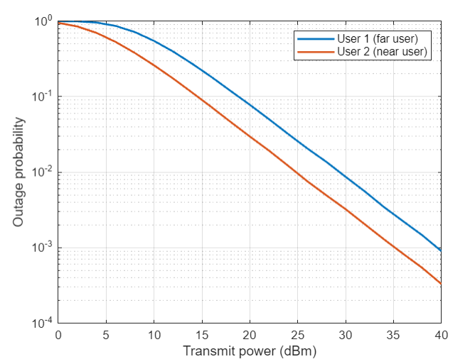Figure 5.2: Outrage Probability Vs Transmit Power

In the Table 4, you can find the values to analyze the graph plotted between Transmit power and Bit Error Rate.

|  |  |  |  |  |
| --- | --- | --- | --- | --- |
| **Pt** | **User1(sim.)** | **User2(Sim.)** | **User1(Theo.)** | **User2(Thero.)** |
| 0 | 0.3141 | 0.2201 | 0.3136 | 0.2207 |
| 2 | 0.2810 | 0.1701 | 0.2805 | 0.1705 |
| 4 | 0.2466 | 0.1253 | 0.2463 | 0.1256 |
| 6 | 0.2127 | 0.0887 | 0.2123 | 0.0888 |
| 8 | 0.1794 | 0.0607 | 0.1792 | 0.0608 |
| 10 | 0.1477 | 0.0405 | 0.1476 | 0.0405 |
| 12 | 0.1181 | 0.0265 | 0.1178 | 0.0265 |
| 14 | 0.0910 | 0.0169 | 0.0908 | 0.0172 |
| 16 | 0.0675 | 0.0108 | 0.0672 | 0.0110 |

Table 5.3:Analysis of BER

**Key Observations:**

* **Performance Comparison:** User 2 (near user) consistently achieves a lower BER than User 1 (far user) across all power levels. This is expected, as the near user benefits from a stronger signal due to closer proximity to the transmitter.
* **Simulated vs. Theoretical Results:** The theoretical results (markers) closely follow the simulation results (lines) for both users, indicating that the simulation accurately models the theoretical behaviour of the system.
* **BER Reduction with Power:** Both users experience a decrease in BER as transmit power increases, but the near user achieves significantly better performance, reducing the BER to 10-4 at high power levels, while the far user's BER remains higher.
* **Logarithmic Scale Insight:** The logarithmic scale on the y-axis emphasizes the significant improvement in BER with increasing power. A reduction in BER from 10-2 to 10-3 is a tenfold improvement, which is highly significant in communication systems.

**Potential Applications:**

* This graph is useful for evaluating the robustness of a communication system under different power levels, especially in scenarios involving users at different distances from the transmitter.
* The results suggest that power control strategies may need to be implemented to ensure acceptable BER levels for all users, particularly for those at a greater distance (far users).
* The comparison between simulated and theoretical results also validates the simulation model, indicating it can be reliably used for further system design and optimization.

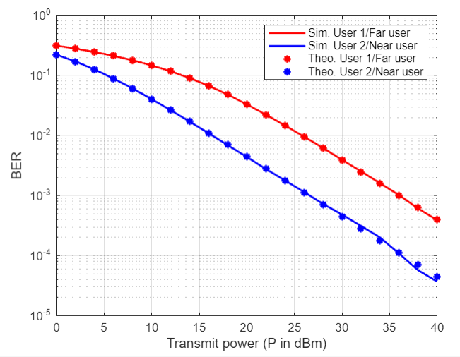Overall, the graph shows how increasing transmit power improves the reliability of communication (lower BER), with near users benefiting more significantly than far users.

Figure 5.3: BER vs Transmit Power

**CHAPTER-6**

**CONCLUSION AND FUTURE SCOPE**

**6.1 CONCLUSION**

NOMA (Non-Orthogonal Multiple Access) demonstrates a significant improvement in spectral efficiency compared to traditional OMA (Orthogonal Multiple Access) techniques. The simulation results indicate that NOMA can support a higher number of users with better capacity and lower outage probability in Rayleigh fading channels. Power allocation strategies and modulation schemes significantly impact the performance of NOMA in terms of BER (Bit Error Rate) and capacity.

**Key Insights:**

* Effective utilization of superposition coding at the transmitter and successive interference cancellation (SIC) at the receiver enhances overall system performance.
* The trade-offs between power allocation and BER must be carefully managed to optimize system performance.
* NOMA's potential to improve 5G network’s efficiency highlights its importance in future wireless communication systems.

**6.2 FUTURE SCOPE**

Further research could also focus on developing more sophisticated power allocation strategies to improve capacity and minimize outage probability. Investigating the integration of NOMA with other 5G technologies such as Massive MIMO could also be an interesting avenue. Additionally, the impact of different modulation schemes on the performance of NOMA could be explored. Lastly, real-world testing and validation of the study’s findings would be beneficial.

**REFERENCES**

[1] Prasheel N. Thakre, Sanjay B. Pokle, “A survey on Power Allocation in PD-NOMA for 5G Wireless Communication Systems”, 2022, DOI: 10.1109/ICETET-SIP-2254415.2022.9791576

[2] Himeur Hanane1, Meriah Sidi Mohammed1, Derraz Fouad1, “Achievable capacity analysis for power domain non orthogonal multiple access scheme”, 2022, DOI: 10.1109/ICAEE53772.

2022.9961969

[3] Veeraiyah Thangasamy, Indrasen Singh, Karishma, Yaswanth, and, Jathin Sai, “Analysis of Capacity and Outage Probability for NOMA based Cellular Communication over Rician Fading Channel”, 2022, DOI: 10.1109/ICEEICT53079.2022.9768575

[4] Pawan Kumar, Kalpana Dhaka, “Average BER Analysis of NOMA Systems under TWDP fading”, 2023, DOI: 10.1109/NCC56989.2023.10068065

[5] Kumuda D K, Sarala S M, “BER, Capacity and Outage probability of NOMA for 5G Wireless Communication”, 2024, DOI: 10.1109/ICSSES62373.2024.1056139

**APPENDIX**

* 1. **Code for Capacity and Outrage probability**

clc;

clear variables;

close all;

N = 10^5;

d1 = 1000; d2 = 500; %Distances of users from base station (BS)

a1 = 0.75; a2 = 0.25; %Power allocation factors

eta = 4; %Path loss exponent

%Generate rayleigh fading coefficient for both users

h1 = sqrt(d1^-eta)*(randn(1,N)+1i*randn(1,N))/sqrt(2);

h2 = sqrt(d2^-eta)*(randn(1,N)+1i*randn(1,N))/sqrt(2);

g1 = (abs(h1)).^2;

g2 = (abs(h2)).^2;

Pt = 0:2:40; %Transmit power in dBm

pt = (10^-3)*10.^(Pt/10); %Transmit power in linear scale

BW = 10^6; %System bandwidth

No = -174 + 10*log10(BW); %Noise power (dBm)

no = (10^-3)*10.^(No/10); %Noise power (linear scale)

p = length(Pt);

p1 = zeros(1,length(Pt));

p2 = zeros(1,length(Pt));

rate1 = 1; rate2 = 2; %Target rate of users in bps/Hz

for u = 1:p

%Calculate SNRs

gamma_1 = a1*pt(u)*g1./(a2*pt(u)*g1+no);

gamma_12 = a1*pt(u)*g2./(a2*pt(u)*g2+no);

gamma_2 = a2*pt(u)*g2/no;

%Calculate achievable rates

R1 = log2(1+gamma_1);

R12 = log2(1+gamma_12);

R2 = log2(1+gamma_2);

%Find average of achievable rates

R1_av(u) = mean(R1);

R12_av(u) = mean(R12);

R2_av(u) = mean(R2);

%Check for outage

for k = 1:N

if R1(k) < rate1

p1(u) = p1(u)+1;

end

if (R12(k) < rate1)||(R2(k) < rate2)

p2(u) = p2(u)+1;

end

end

end

pout1 = p1/N;

pout2 = p2/N;

figure;

semilogy(Pt, pout1, 'linewidth', 4); hold on; grid on;

semilogy(Pt, pout2, 'linewidth', 1.5);

xlabel('Transmit power (dBm)');

ylabel('Outage probability');

legend('User 1 (far user)','User 2 (near user)');

figure;

plot(Pt, R1_av, 'linewidth', 1.5); hold on; grid on;

plot(Pt, R12_av, 'linewidth', 1.5);

plot(Pt, R2_av, 'linewidth', 1.5);

xlabel('Transmit power (dBm)');

ylabel('Achievable capacity (bps/Hz)');

legend('R_1','R_{12}','R_2')

* 1. **Code for Bit Error Rate**

clc;

clear all;

close all;

%% BER for 2 users

N = 10^6;

d1 = 1000; d2 = 500; %Distances of users from base station (BS)

a1 = 0.75; a2 = 0.25; %Power allocation factors

eta = 4; %Path loss exponent

%Generate rayleigh fading coefficient for both users

h1 = sqrt(d1^-eta)*(randn(1,N)+1i*randn(1,N))/sqrt(2);

h2 = sqrt(d2^-eta)*(randn(1,N)+1i*randn(1,N))/sqrt(2);

g1 = (abs(h1)).^2;

g2 = (abs(h2)).^2;

Pt = 0:2:40; %Transmit power in dBm

pt = (10^-3)*10.^(Pt/10); %Transmit power in linear scale

BW = 10^6; %System bandwidth

No = -174 + 10*log10(BW); %Noise power (dBm)

no = (10^-3)*10.^(No/10); %Noise power (linear scale)

%Generate noise samples for both users

w1 = sqrt(no)*(randn(1,N)+1i*randn(1,N))/sqrt(2);

w2 = sqrt(no)*(randn(1,N)+1i*randn(1,N))/sqrt(2);

%Generate random binary data for two users

data1 = randi([0 1],1,N); %Data bits of user 1

data2 = randi([0 1],1,N); %Data bits of user 2

%Do BPSK modulation of data

x1 = 2*data1 - 1;

x2 = 2*data2 - 1;

p = length(Pt);

for u = 1:p

%Do superposition coding

x = sqrt(pt(u))*(sqrt(a1)*x1 + sqrt(a2)*x2);

%Received signals

y1 = h1.*x + w1;

y2 = h2.*x + w2;

%Equalize

eq1 = y1./h1;

eq2 = y2./h2;

%AT USER 1--------------------

%Direct decoding of x1 from y1

x1_hat = zeros(1,N);

x1_hat(eq1>0) = 1;

%Compare decoded x1_hat with data1 to estimate BER

ber1(u) = biterr(data1,x1_hat)/N;

%----------------------------------

%AT USER 2-------------------------

%Direct decoding of x1 from y2

x12_hat = ones(1,N);

x12_hat(eq2<0) = -1;

y2_dash = eq2 - sqrt(a1*pt(u))*x12_hat;

x2_hat = zeros(1,N);

x2_hat(real(y2_dash)>0) = 1;

ber2(u) = biterr(x2_hat, data2)/N;

%----------------------------------

gam_a = 2*((sqrt(a1*pt(u))-sqrt(a2*pt(u)))^2)*mean(g1)/no;

gam_b = 2*((sqrt(a1*pt(u))+sqrt(a2*pt(u)))^2)*mean(g1)/no;

ber_th1(u) = 0.25*(2 - sqrt(gam_a/(2+gam_a)) - sqrt(gam_b/(2+gam_b)));

gam_c = 2*a2*pt(u)*mean(g2)/no;

gam_d = 2*((sqrt(a2) + sqrt(a1))^2)*pt(u)*mean(g2)/no;

gam_e = 2*((sqrt(a2) + 2*sqrt(a1))^2)*pt(u)*mean(g2)/no;

gam_f = 2*((-sqrt(a2) + sqrt(a1))^2)*pt(u)*mean(g2)/no;

gam_g = 2*((-sqrt(a2) + 2*sqrt(a1))^2)*pt(u)*mean(g2)/no;

gc = (1 - sqrt(gam_c/(2+gam_c)));

gd = (1-sqrt(gam_d/(2+gam_d)));

ge = (1-sqrt(gam_e/(2+gam_e)));

gf = (1-sqrt(gam_f/(2+gam_f)));

gg = (1-sqrt(gam_g/(2+gam_g)));

ber_th2(u) = 0.5*gc - 0.25*gd + 0.25*(ge+gf-gg);

gamma1(u) = a1*pt(u)*mean(g1)/(a2*pt(u)*mean(g1) + no);

gamma2(u) = a2*pt(u)*mean(g2)/no;

end

semilogy(Pt, ber1,'r', 'linewidth',1.5); hold on; grid on;

semilogy(Pt, ber2,'b', 'linewidth',1.5);

semilogy(Pt, ber_th1, '*r','linewidth',1.5);

semilogy(Pt, ber_th2, '*b','linewidth',1.5);

xlabel('Transmit power (P in dBm)');

ylabel('BER');

legend('Sim. User 1/Far user','Sim. User 2/Near user','Theo. User 1/Far user','Theo. User 2/Near user');