MongoDB Command:
use CollegeDB
1)Rename Operator:
Java Code:
import com.mongodb.client.*;
import com.mongodb.client.model.Filters;
import com.mongodb.client.model.Updates;
import org.bson.Document;
public class MongoDB_CRUD {
public static void main(String[] args) {
// Connect to MongoDB
MongoClient mongoClient = MongoClients.create("mongodb://localhost:27017");
// Access database
MongoDatabase database = mongoClient.getDatabase("CollegeDB");
// Access collection
MongoCollection<Document> collection = database.getCollection("Students");
collection.insertMany(java.util.Arrays.asList(
new Document("id", 1).append("name", "Alice"),
new Document("id", 2).append("name", "Bob"),
new Document("id", 3).append("name", "Charlie")
));
System.out.println("Inserted Successfully");
//Rename operator
collection.updateOne( Filters.eq("id",1) , Updates.rename("name","fullname"));
System.out.println("Updated Successfully.Updated one:");
Document students = collection.find(Filters.eq("id",1)).first();
System.out.println(students.toJson());
}
}
Output:
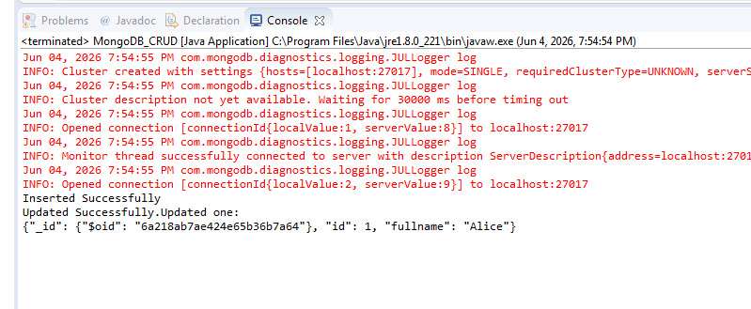

2)Unset Operator:
Java Code:
import com.mongodb.client.*;
import com.mongodb.client.model.Filters;
import com.mongodb.client.model.Updates;
import org.bson.Document;
public class MongoDB_CRUD {
public static void main(String[] args) {
// Connect to MongoDB
MongoClient mongoClient = MongoClients.create("mongodb://localhost:27017");
// Access database
MongoDatabase database = mongoClient.getDatabase("CollegeDB");
// Access collection
MongoCollection<Document> collection = database.getCollection("Students");
//unset Operator
collection.updateOne( Filters.eq("id",2) , Updates.unset("name"));
System.out.println("Updated Successfully.Updated one:");
Document students = collection.find(Filters.eq("id",2)).first();
System.out.println(students.toJson());
}
}
Output:
