mkdir C:\data\db0
mkdir C:\data\db1
mkdir C:\data\db2

"C:\Program Files\MongoDB\Server\8.3\bin\mongod.exe" --replSet myReplSet --dbpath C:\data\db0 --port 27017 --bind_ip localhost
"C:\Program Files\MongoDB\Server\8.3\bin\mongod.exe" --replSet myReplSet --dbpath C:\data\db0 --port 27018 --bind_ip localhost
"C:\Program Files\MongoDB\Server\8.3\bin\mongod.exe" --replSet myReplSet --dbpath C:\data\db0 --port 27019 --bind_ip localhost

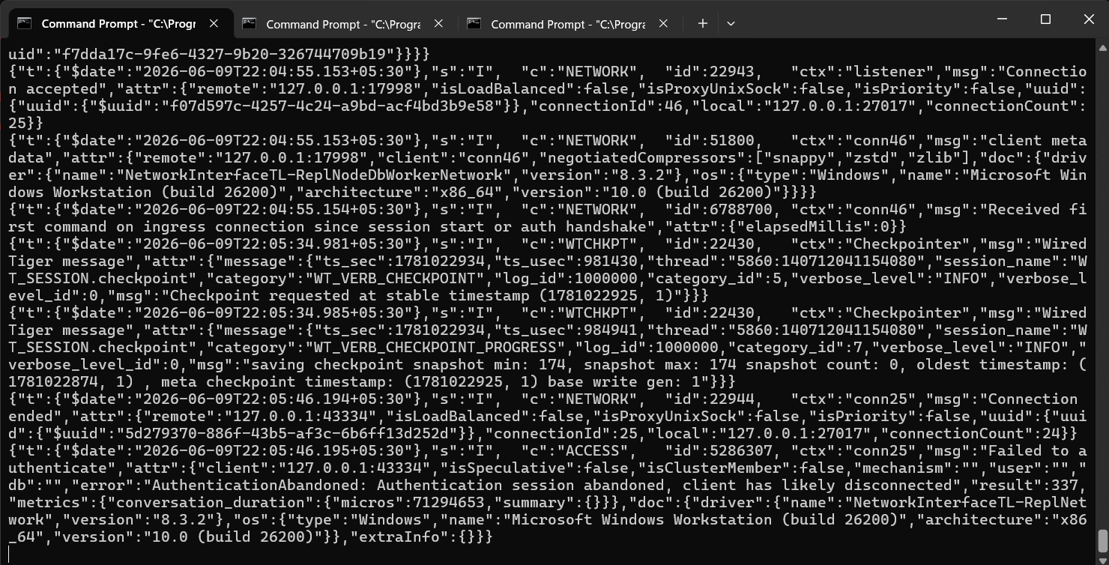

rs.initiate({
_id: "myReplSet",
members: [
{ _id: 0, host: "localhost:27017" },
{ _id: 1, host: "localhost:27018" },
{ _id: 2, host: "localhost:27019" }
]
})

{
ok: 1,
'$clusterTime': {
clusterTime: Timestamp({ t: 1781022874, i: 1 }),
signature: {
hash: Binary.createFromBase64('AAAAAAAAAAAAAAAAAAAAAAAAAAA=', 0),
keyId: Long('0')
}
},
operationTime: Timestamp({ t: 1781022874, i: 1 })
}

rs.status()

{
syncSourceId: -1,
infoMessage: 'Could not find member to sync from',
electionTime: Timestamp({ t: 1781022885, i: 1 }),
electionDate: 2026-06-09T16:34:45.000Z,
configVersion: 1,
configTerm: 1,
self: true,
lastHeartbeatMessage: ''
},
{
_id: 1,
name: 'localhost:27018',
health: 1,
state: 2,
stateStr: 'SECONDARY',
uptime: 18,
optime: { ts: Timestamp({ t: 1781022885, i: 17 }), t: Long('1') },
optimeDurable: { ts: Timestamp({ t: 1781022885, i: 17 }), t: Long('1') },
optimeWritten: { ts: Timestamp({ t: 1781022885, i: 17 }), t: Long('1') },
optimeDate: 2026-06-09T16:34:45.000Z,
optimeDurableDate: 2026-06-09T16:34:45.000Z,
optimeWrittenDate: 2026-06-09T16:34:45.000Z,
lastAppliedWallTime: 2026-06-09T16:34:45.788Z,
lastDurableWallTime: 2026-06-09T16:34:45.788Z,
lastWrittenWallTime: 2026-06-09T16:34:45.788Z,
lastHeartbeat: 2026-06-09T16:34:51.702Z,
lastHeartbeatRecv: 2026-06-09T16:34:52.711Z,
pingMs: Long('0'),
lastHeartbeatMessage: '',
syncSourceHost: 'localhost:27017',
syncSourceId: 0,
infoMessage: '',
configVersion: 1,
configTerm: 1
},
{
_id: 2,
name: 'localhost:27019',
health: 1,
state: 2,
stateStr: 'SECONDARY',
uptime: 18,
optime: { ts: Timestamp({ t: 1781022885, i: 17 }), t: Long('1') },
optimeDurable: { ts: Timestamp({ t: 1781022885, i: 17 }), t: Long('1') },
optimeWritten: { ts: Timestamp({ t: 1781022885, i: 17 }), t: Long('1') },
optimeDate: 2026-06-09T16:34:45.000Z,
optimeDurableDate: 2026-06-09T16:34:45.000Z,
optimeWrittenDate: 2026-06-09T16:34:45.000Z,
lastAppliedWallTime: 2026-06-09T16:34:45.788Z,
lastDurableWallTime: 2026-06-09T16:34:45.788Z,
lastWrittenWallTime: 2026-06-09T16:34:45.788Z,
lastHeartbeat: 2026-06-09T16:34:51.702Z,
lastHeartbeatRecv: 2026-06-09T16:34:52.710Z,
pingMs: Long('0'),
lastHeartbeatMessage: '',
syncSourceHost: 'localhost:27017',
syncSourceId: 0,
infoMessage: '',
configVersion: 1,
configTerm: 1
}
],
ok: 1,
'$clusterTime': {
clusterTime: Timestamp({ t: 1781022885, i: 17 }),
signature: {
hash: Binary.createFromBase64('AAAAAAAAAAAAAAAAAAAAAAAAAAA=', 0),
keyId: Long('0')
}
},
operationTime: Timestamp({ t: 1781022885, i: 17 })
}

