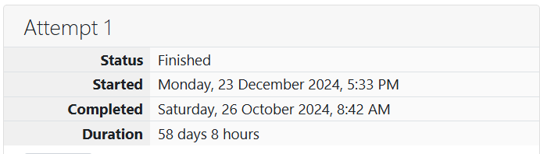

ROLL NO.: 241801281

NAME: suji

WEEK 01-01 PRACTICE SESSION

1. OBJECTIVE

This is a simple challenge to help you practice printing to stdout. We're starting out by printing the most famous computing phrase of all time! In the editor below, use either printf or cout to print the string Hello, World! to stdout.

CODE:

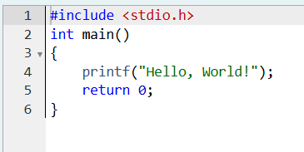

OUTPUT:

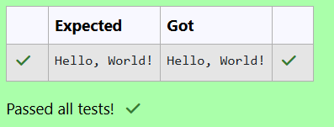

2.OBJECTIVE

This challenge will help you to learn how to take a character, a string and a sentence as input in C. To take a single character ch as input, you can use scanf("%c", &ch); and printf("%c", ch) writes a character specified by the argument char to stdout: char ch; scanf("%c", &ch); printf("%c", ch); This piece of code prints the character ch.

CODE:

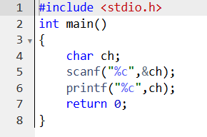

OUTPUT:

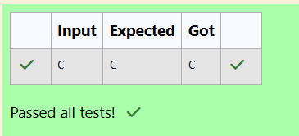

3.OBJECTIVE:

Your task is to take two numbers of int data type, two numbers of float data type as input and output their sum: 1. Declare 4 variables: two of type int and two of type float. 2. Read 2 lines of input from stdin (according to the sequence given in the 'Input Format' section below) and initialize your 4 variables. 3. Use the + and - operator to perform the following operations: o Print the sum and difference of two int variable on a new line. return 0; } 6 7 3 o Print the sum and difference of two float variable rounded to one decimal place on a new line.

CODE:

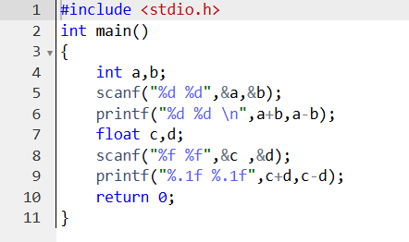

OUPUT:

