|  |  |  |
| --- | --- | --- |
| **Tech Saksham**  Final Project Report  **Web track capstone project** |  |  |

**“Computer Science Department Portal”**

**“AP IIIT RGUKT RK VALLEY”**

|  |  |
| --- | --- |
| **ROLL NO** | **NAME** |
| R170806 | Kandula Udayasree |
| R170820 | Jerripothu Sujitha Rani |
| R170821 | Nagarchi Sadhiya |

|  |  |
| --- | --- |
|  |  |
| Poova Ragavan Velumani | Trainer Name |
|  | Master Trainer |

**ABSTRACT**

The Computer Science Department portal is a web-based platform designed to provide a centralized space for computer science students, faculty to access important information, resources related to the department. The portal aims to streamline various administrative tasks.This portal includes main features like:

1.COURSE MANAGEMENT : A course management system that allows faculty to add and share content, course materials with students.

2.STUDENT RESOURCES : A repository of resources such as guides, tutorials, and links that students can access to improve their learning.

3.NEWS AND ANNOUNCEMENTS : A section for department news and announcements, like events, job oppurtunities, and updates.

4.ASSIGNMENT MANAGEMENT : A section where the faculty can add assignments and view the status of the assignments given and students can access those assignments

**INDEX**

|  |  |  |
| --- | --- | --- |
| **Sr. No.** | **Table of Contents** | **Page No.** |
| 1 | Chapter 1: Introduction | 1 |
| 2 | Chapter 2: Services and Tools Required | 4 |
| 3 | Chapter 3: Project Architecture | 7 |
| 4 | Chapter 4: Architecture Blocks Detail Working | 10 |
| 5 | Conclusion | 13 |
| 6 | References | 14 |
| 7 | Code | 15 |

**CHAPTER 1**

**INTRODUCTION**

* 1. **Overview**

|  |  |
| --- | --- |
|  |  |
| **1.1.1 WWW(World Wide Web)** |  |

The Internet is a global wide

Area network that connects computer system across the world. The Internet provides different online services.

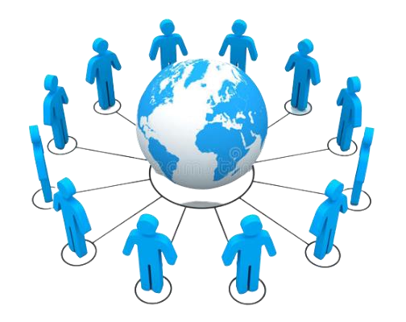

The World Wide Web is a set of all

The websites connected to the internet worldwide. It is

Also known as WWW or Web. It is a system of interlinked hypertext documents accessed via the internet. We can access a webpage by the use of a web browser and navigate between them by using hyperlinks.

**4**

**1.1.2Why web application?**

Web applications have become an essential component of business in today’s world. By using the web applications, businesses can now develop and become simpler, and achieve their objectives much faster. These applications can help target numerous clientele and customers at a time.

Organizations are rapidly embracing this aspect of the internet by creating web applications with the help of developers to meet their business demands, Web applications are important for a number of reasons.

* + 1. **How does the Web work?**

**1.1.3.a User Flow**

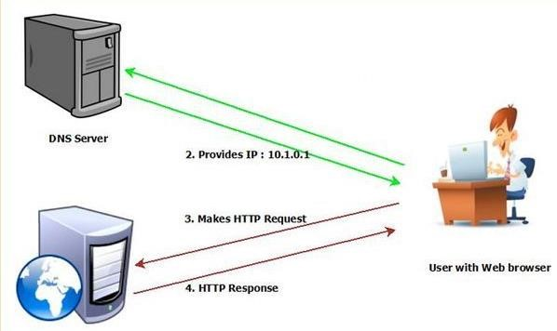

**1.1.3.b Developer flow**

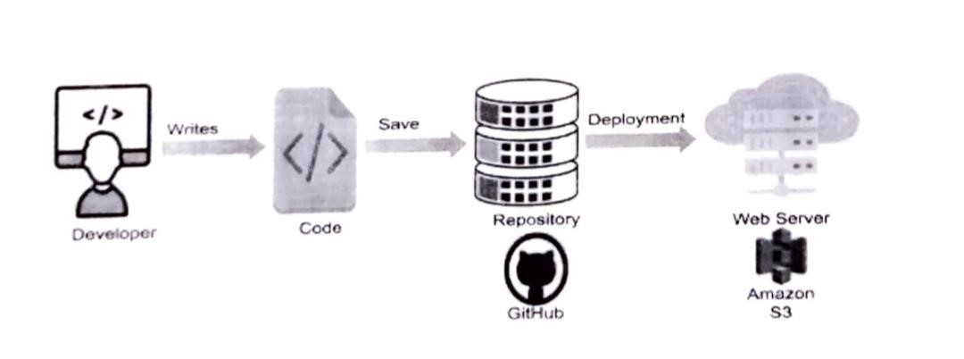

* 1. **Feature**

This portal introduces a new web-based department portal, which combines all useful features in other commercial systems and implements new functions. Its powerful features and friendly user interfaces allow teachers and students to handle their works in a convenient, efficient, and systematical way. In addition, this system also has very good portability and extensibility.

* 1. **Advantages**
* Provide an interactive platform between students and teachers.
* It is very much faster than manual system.
* Much flexible to work.
* User oriented.
* Data can be stored for a longer period.
  1. **Scope**

This computer science department portal will work efficiently in terms of giving assignments and giving their grades through it. It will also help the head of the department to edit and modify the teachers details .This portal will enable the head of the department to announce the news .

* 1. **Future Work**

As this website has many features like management, providing resources and giving assignments we can further develop this to help students and teachers to upload reference question papers and materials which will be useful to the students in their preparation. We can also add a new feature where we can take online classes and an interaction page where the students can post their doubts and clarify them.

**CHAPTER 2**

**SERVICES AND TOOLS REQUIRED**

**2.1 Services Used**

**Hardware Configuration:**

Client Side:

|  |  |
| --- | --- |
| Ram | 512 MB |
| Hard disk | 10 GB |
| Processor | 1.0 GHz |

Server side:

|  |  |
| --- | --- |
| Ram | 1 GB |
| Hard disk | 20 GB |
| Processor | 2.0 GHz |

**Software Requirement:**

|  |  |
| --- | --- |
| Front end | HTML ,CSS ,jquery ,java script,Bootstrap |
| Server side Language | PHP |
| Database server | MYSQL |
| Web Browser | Firefox ,Windows or any equivalent OS |
| Operating system | Ubuntu , Windows or any equivalent OS |
| Software | xampp |

**2.2 Tools and Softwares used**

**Frontend : HTML and CSS3, Bootstrap**

**Backend : PHP**

**Database : MySQL**

**Tool : Xampp**

* + 1. **HTML:**

HTML stands for **Hyper Text Markup Language.**

HTML is the standard markup language for Webpages.

HTML elements are the building blocksof the

HTML Markup. HTML elements consist of start tag, end tag and content in between them.

* + 1. **CSS3:**

**CSS** stands for **Cascading Style Sheets.** It describes how HTML elements are to be displayed on screen, paper or in other media. CSS saves a lot of work. It can control the layout of multiple web pages all at once.

* + 1. **PHP:**

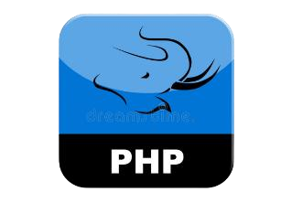**PHP** stands for **Hypertext preprocessor**. It is a server-side scripting language that is embedded in HTML. IT is used to manage dynamic content, database, session tracking, even build entire ecommerce sites. It is integrated with a number of

popular databases including MySQL, PostgreSQL, Oracle, Sybase, Informix and Microsoft SQL Server.

**2.2.4 MySQL:**

**MySQL** is a freely available open-source

Relational Database Management System

(RDBMS) that uses Structured Query Language (SQL). SQL is the most popular language for adding, accessing and managing content in a database. **MySQL** is an essential part of almost every open-source PHP application

**CHAPTER 3**

**PROJECT ARCHITECTURE**

**3.1 Architecture**

**USER FRONTEND BACKEND**

|  |  |  |
| --- | --- | --- |
|  | **HTML 5** | **PHP**    **Database** |

**CHAPTER 4**

**ARCHITECTURE BLOCKS DETAIL WORKING**

**4.1 Blocks**

 **4.1.1 Installing the xampp**

**4.1.2 Adding links to the page**



**4.1.3 Designing the web page**



**4.1.4 Creating a database**

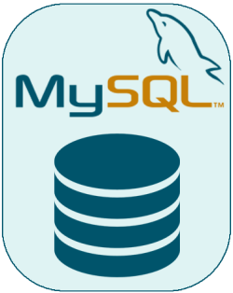

**4.1.5 run a query**

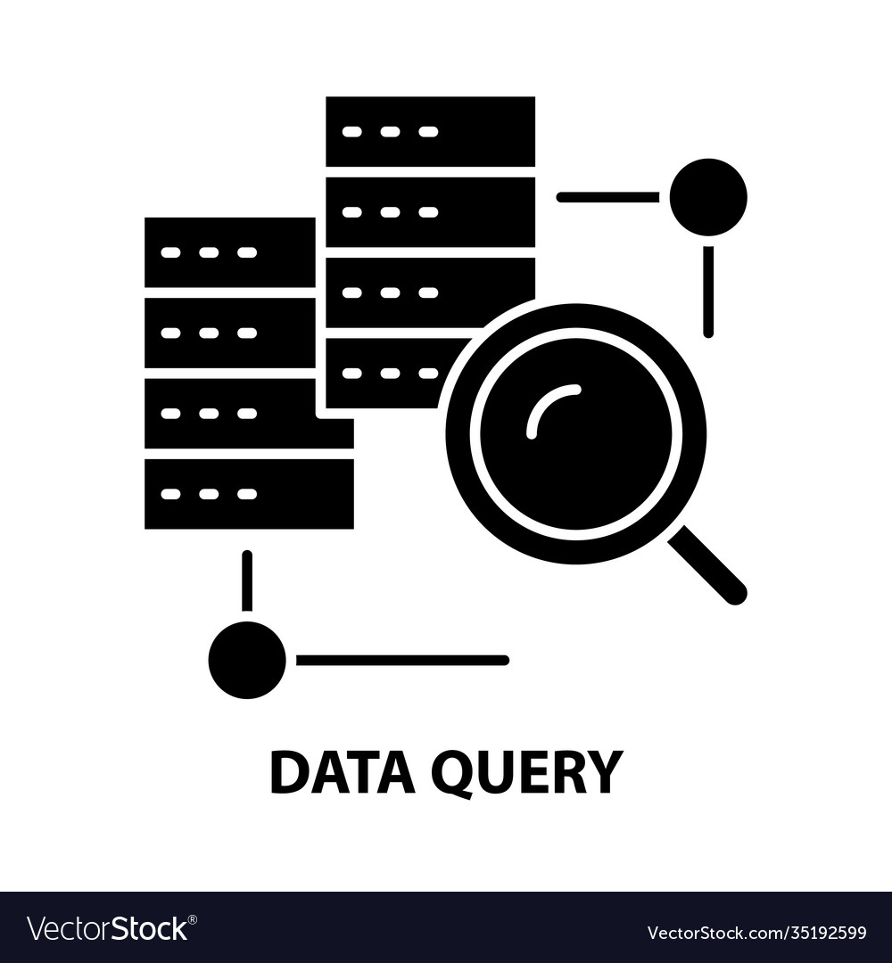

**CONCLUSION**

The currently implemented system provides faculty and students powerful features to handle resources and assignments. The utilization of DBMS produces high system efficiency in data manipulation. Cross platform attributes of PHP and MySQL make it a portable system on most operating systems with slight modifications. In addition, the system security is strengthened by multiple security schemes. The database design is very important during implementation because the database structure can significantly affect system efficiency and flexibility. Currently, the database structure is constructed in a very flexible manner, so that new data attributes or items can be easily added to the system without changing current structure significantly. For further implementation, more features can be added to the system, such as the management of backup data or disaster recovery. More information could be explored according to users’ requirements.

**REFERENCES**

For PHP https://www.w3schools.com/php/default.asp https://www.sitepoint.com/php/ https://www.php.net/ https://www.killerphp.com/ http://www.tutorialspoint.com/php/ For MySQL https://www.mysql.com/ http://www.mysqltutorial.org For XAMPP https://www.apachefriends.org/download.htm

**CODE**

**Please Provide Code through Git Hub Repo Link**

https://github.com/sujitharanij/Computer-science-department-portal-code/blob/main/computer%20science%20department%20portal.zip