**FETUS MONITORING SYSTEM**

**A CAPSTONE PROJECT REPORT**

*Submitted in partial fulfillment of the*

*requirement for the award of the*

*Degree of*

**BACHELOR OF TECHNOLOGY**

**IN**

**COMPUTER SCIENCE & ENGINEERING**

*by*

**PASUPULETI LAKSHMI SUJITH (21BEC7429)**

**ANGULURI PAVANI ANVITHA (21BEC7498)**

**PYDISETTY SAMPATH (21BEC8466)**

**C KISHAN REDDY (21BEC7282)**

*Under the Guidance of*

**Prof. M S Jagadeesh**



SCHOOL OF COMPUTER SCIENCE AND ENGINEERING

VIT-AP UNIVERSITY

AMARAVATI- 522237

*DECEMBER 2024*

**CERTIFICATE**

This is to certify that the Capstone Project work titled “**Fetus Monitoring System**” that is being submitted by PASUPULETI LAKSHMI SUJITH (21BCE7429), ANGULURI PAVANI ANVITHA (21BCE7498), PYDISETTY SAMPATH (21BCE8466), and C KISHAN REDDY (21BCE7282)is in partial fulfillment of the requirements for the award of Bachelor of Technology, is a record of bonafide work done under my guidance. The contents of this Project work, in full or in parts, have neither been taken from any other source nor have been submitted to any other Institute or University for award of any degree or diploma and the same is certified.

Prof. M S Jagadeesh

Guide

**The thesis is satisfactory / unsatisfactory**

**Internal Examiner1 Internal Examiner2**

**Approved by**

HoD, Department of ...

School of Computer Science and Engineering

**ACKNOWLEDGEMENTS**

I am pleased to acknowledge my sincere thanks to the Board of Management of VELLORE INSTITUTE OF TECHNOLOGY,Amaravati for their kind encouragement in doing this project and for completing it successfully. I am grateful to them.

I convey my thanks to Dean, School of Computing ,Dean Scope , Heads of the Department of Computer Science and Engineering for providing me necessary support and details at the right time during the progressive reviews

I would like to express my sincere and deep sense of gratitude to my Project Guide Prof. M S Jagadesh for his valuable guidance, suggestions and constant encouragement that paved way for the successful completion of my project work.

I wish to express my thanks to all Teaching and Non-teaching staff members of the Department of Computer Science and Engineering who were helpful in many ways for the completion of the project

**ABSTRACT**

The Fetus Monitoring System (FMS) project leverages machine learning algorithms to assess fetal health and classify it as either healthy or unhealthy, aiming to enhance the accuracy and reliability of prenatal care. Traditional fetal monitoring methods, while useful, often rely on manual interpretation, which can be prone to variability and human error. This project addresses these limitations by developing an automated system that uses a curated dataset of fetal health indicators, including fetal heart rate (FHR), accelerations, decelerations, uterine contractions, and other vital signs. The dataset undergoes rigorous preprocessing, involving noise reduction, normalization, and feature engineering to select the most relevant predictors for the model. This step ensures that the data fed into the machine learning models is clean and optimized for analysis, which is crucial for achieving reliable outputs.

Multiple machine learning algorithms are explored to determine the most suitable model for accurate classification. These include decision trees, which offer a clear, visual representation of decision-making pathways; random forests, which provide ensemble learning for better generalizability and reduced risk of overfitting; support vector machines (SVM), ideal for handling high-dimensional data; logistic regression, effective for binary classification tasks; and neural networks, which are powerful for capturing complex, non-linear relationships within the dataset. Each algorithm is evaluated on its performance using metrics such as accuracy, precision, recall, F1-score, and visual analysis tools like confusion matrices and receiver operating characteristic (ROC) curves.

The training and testing phases are critical to developing a reliable model that can be effectively used in clinical settings. The model's results indicate promising accuracy levels in distinguishing between healthy and unhealthy fetuses, providing a potential decision-support tool for healthcare practitioners. The FMS system can automate the interpretation of fetal health data, reduce the workload on healthcare providers, and help ensure that early warning signs of potential complications are detected promptly, leading to faster interventions and improved maternal-fetal outcomes.

In conclusion, this project demonstrates the feasibility of using machine learning to develop a Fetus Monitoring System capable of classifying fetal health status efficiently and accurately. Such a system has the potential to transform prenatal care by reducing reliance on subjective human interpretation, improving diagnostic consistency, and promoting timely interventions. Future work will focus on refining the model's interpretability, incorporating real-time capabilities, and ensuring diverse and comprehensive datasets to further validate and strengthen the system's effectiveness.

**Keywords:** Fetus Monitoring System, machine learning, fetal health classification, prenatal care, fetal heart rate (FHR), data preprocessing, decision support tool, medical diagnostics, feature engineering, predictive model, neural networks, decision trees, SVM, accuracy, healthcare technology.

**TABLE OF CONTENTS**

|  |  |  |  |
| --- | --- | --- | --- |
| **S.No.** | **Chapter** | **Title** | **Page Number** |
| **1.** |  | **Acknowledgement** | **3** |
| **2.** |  | **Abstract** | **4** |
| **3.** |  | **List of Figures and Table** | **6** |
| **4.** | **1**  **1.1**  **1.2**  **1.3** | **Introduction**  **Objectives**  **Background and Literature Survey**  **Organization of the Report** | **8**  **9**  **10**  **11** |
| **5.** | **2**  **2.1**  **2.2**  **2.3**  **2.4**  **2.4.1**  **2.4.2** | **Chapter Title (Work)**  **Proposed System**  **Working Methodology**  **Standards**  **System Details**  **Software**  **Hardware** | **12**  **12**  **13**  **13**  **14**  **14**  **25** |
| **6.** | **3**  **3.1** | **Cost Analysis**  **List of components and their cost** | **37**  **37** |
| **7.** | **4** | **Results and Discussion** | **38** |
| **8.** | **5** | **Conclusion & Future Works** | **40** |
| **9.** | **6** | **Appendix** | **41** |
| **10.** | **7** | **References** | **50** |

|  |  |  |
| --- | --- | --- |
| **Figure No.** | **Title** | **Page No.** |
| 1 | Caption of Figure 1 | 8 |
|  |  |  |
|  |  |  |

**List of Tables**

**List of Figures**

|  |  |  |
| --- | --- | --- |
| **Figure No.** | **Title** | **Page No.** |
| 1 | Caption of Figure 1 | 8 |
|  |  |  |
|  |  |  |

**CHAPTER 1**

**INTRODUCTION**

Prenatal care is fundamental to maternal and fetal health, ensuring the well-being of both the mother and the developing baby during pregnancy. One of the core components of effective prenatal care involves comprehensive fetal monitoring. This monitoring helps detect any signs of distress or complications that could pose risks during pregnancy or labor. Traditionally, this monitoring has been carried out using manual techniques such as auscultation and cardiotocography (CTG). CTG, which measures the fetal heart rate (FHR) and uterine contractions, has become a standard tool in obstetric practice. However, while these conventional methods have provided critical insights for decades, they are often limited by their dependence on human interpretation. This introduces variability and potential errors, as the readings can be subjective and heavily reliant on the clinician’s expertise.

The reliance on manual interpretation creates a significant challenge, especially in areas with limited access to specialized healthcare providers or in scenarios where continuous and consistent monitoring is needed. Human error, fatigue, and varying levels of expertise among clinicians can lead to inconsistent assessments and, in some cases, delayed interventions. This can adversely affect outcomes, potentially leading to preventable complications or interventions that are not optimally timed.

In response to these challenges, the Fetus Monitoring System (FMS) project aims to leverage machine learning (ML) algorithms to create an automated and robust system capable of assessing and classifying fetal health. Machine learning has emerged as a transformative tool in healthcare, capable of analyzing large volumes of complex data quickly and accurately. By using algorithms that learn from patterns in data, machine learning can provide objective, consistent, and precise health assessments. The FMS project is designed to take advantage of these capabilities, using a well-curated dataset that includes key indicators such as FHR, accelerations, decelerations, and other relevant parameters to classify the fetus’s health status as healthy or unhealthy.

This project not only seeks to introduce automation to the process but also aims to reduce the burden on healthcare providers, allowing them to focus on critical cases and reduce diagnostic errors. The potential of machine learning in enhancing prenatal care is profound, offering the ability to detect subtle, early-warning signs that may be missed by human observation alone. By integrating an automated system, clinicians can make more informed decisions and respond to potential risks with greater accuracy and confidence.

The scope of this project extends beyond clinical settings. The future potential of this technology includes its integration with wearable devices, enabling continuous, real-time monitoring outside hospital environments. This could provide expecting mothers and healthcare providers with timely information and alerts, promoting proactive management of pregnancy and reducing the risk of adverse outcomes.

**1.1 Objectives**

The Fetus Monitoring System (FMS) project aims to develop an innovative machine learning-based tool to enhance prenatal care by accurately classifying fetal health status. This system is designed to be integrated into clinical practices, providing healthcare professionals with an additional layer of diagnostic support. The specific objectives of this project encompass both technical development and clinical relevance, ensuring the solution is not only effective but also practical for real-world applications.

1.**Develop an Automated System**: The cornerstone of this project is to create an automated system powered by a gradient boosting model. Gradient boosting has been chosen for its high accuracy and strong predictive capabilities compared to logistic regression and random forest models. Gradient boosting algorithms, such as XGBoost or LightGBM, are known for their ability to build powerful models by combining multiple weak learners (typically decision trees). This method iteratively refines the model by minimizing error, making it highly effective for complex, non-linear data patterns. The automated system will be designed to ingest data directly from cardiotocography (CTG) recordings, pre-process it, and output real-time classifications regarding fetal health status. The automated nature of the system ensures that healthcare providers receive immediate, objective results, facilitating quick decision-making.

2.**Enhance Diagnostic Accuracy**: One of the primary objectives is to improve the diagnostic accuracy of fetal health assessments. Traditional manual methods of CTG interpretation are susceptible to errors due to human variability and subjective judgment. By using a gradient boosting model, which was found to outperform both logistic regression and random forest models in terms of accuracy, the FMS ensures that more subtle, complex patterns within the data are identified and accurately classified. Gradient boosting’s strong performance stems from its ability to optimize the learning process by sequentially reducing errors and incorporating past mistakes into each iteration. This results in a model that can discern nuanced relationships within the data, which may indicate potential risks or abnormalities that could be missed by simpler algorithms or human assessment.

3.**Reduce Human Workload**: The FMS project aims to automate the analysis of CTG recordings, reducing the need for continuous manual interpretation by healthcare professionals. The workload associated with analyzing and interpreting fetal monitoring data can be significant, especially in busy clinical settings. The automated nature of the gradient boosting model means that healthcare providers can rely on a consistent, high-quality analysis that frees them to focus on critical cases requiring human intervention and expertise. This shift not only improves workflow efficiency but also helps reduce the risk of diagnostic errors related to fatigue, cognitive overload, or subjective biases that can arise during manual interpretation.

4.**Facilitate Early Detection**: Early detection of fetal distress or potential complications is essential for preventing adverse outcomes during pregnancy. By utilizing machine learning, the FMS project can analyze vast amounts of data and identify patterns indicative of potential risks earlier than traditional methods. The gradient boosting model’s ability to highlight small but significant deviations in fetal heart rate (FHR) and other indicators makes it a powerful tool for early diagnosis. This capability provides healthcare providers with the information needed to make timely decisions, which can lead to better management of pregnancy and improved maternal and fetal outcomes. Detecting potential issues early can prompt interventions such as adjustments to the mother’s activity level, medication, or even early delivery if necessary.

5.**Evaluate and Compare ML Algorithms**: An essential objective of the FMS project is to test, validate, and compare different machine learning algorithms to ensure that the most effective model is used. Although the gradient boosting model was ultimately chosen for its superior performance, the project initially explored logistic regression and random forest models to benchmark results. Logistic regression, known for its simplicity and interpretability, was evaluated but found less capable of capturing the complex, non-linear relationships in the data compared to ensemble methods. Random forests, while more robust than logistic regression due to their use of multiple decision trees, did not reach the accuracy levels observed with gradient boosting. This comprehensive comparison provides a strong foundation for selecting the optimal algorithm and highlights the value gradient boosting adds to fetal health classification.

6.**Ensure Scalability and Usability**: The scalability and usability of the FMS are critical to its real-world adoption. The system is designed to be flexible and adaptable to various clinical environments, from high-tech hospitals to rural clinics with limited resources. Scalability ensures that as new data is collected or the system is deployed in different regions, it can be updated and re-trained to maintain high performance. The usability aspect focuses on creating an intuitive user interface that enables healthcare professionals to operate the system without extensive training. By incorporating user feedback during the design phase, the project ensures that the final product meets the practical needs of clinicians and integrates seamlessly into existing workflows.

7.**Integrate Explainable AI**: Although not a primary objective, the project recognizes the importance of model interpretability in medical settings. While gradient boosting models are often considered “black boxes” due to their complexity, integrating elements of explainable AI (XAI) is essential to build trust with healthcare providers. Techniques such as SHAP (Shapley Additive Explanations) values can be used to break down model predictions and explain which features contributed most to a particular classification. By providing this transparency, clinicians can better understand the model’s decision-making process, which can enhance their trust in the system and improve its adoption in clinical practice.

8.**Enhance Data Security and Privacy**: In any healthcare application, data security and patient privacy are paramount. The FMS project includes measures to ensure that all data used is handled securely and in compliance with relevant regulations such as HIPAA or GDPR. This objective involves implementing encryption protocols, secure data storage, and strict access controls. Ensuring the privacy of patient data not only safeguards individuals’ rights but also contributes to the system's credibility and trustworthiness, which are crucial for widespread adoption.

9.**Optimize Performance and Real-time Capabilities**: The FMS is designed to deliver near real-time analysis to support prompt decision-making during critical moments in prenatal care. Achieving this requires optimizing the performance of the gradient boosting model through efficient data preprocessing, fast prediction algorithms, and the use of lightweight software frameworks. The model should be capable of running on standard hardware used in medical facilities, ensuring that even resource-constrained settings can benefit from its capabilities

10.**Facilitate Remote Monitoring**: One of the potential future objectives of the FMS project is the integration of remote monitoring capabilities. By connecting the system with wearable devices that can record and transmit fetal heart rate and other vital signs, pregnant women could be monitored continuously from home. This would enable healthcare providers to track high-risk pregnancies more closely, providing timely interventions when needed and offering peace of mind to expectant mothers. Remote monitoring can also help bridge the gap in maternal healthcare access for those living in remote or underserved areas, ensuring that they receive the same level of care as those in more urban settings.

**Benefits and Future Implications**

The objectives of the FMS project align with the broader goal of integrating cutting-edge technology into prenatal care. The implementation of an automated, accurate, and user-friendly system has the potential to revolutionize how fetal health is monitored, shifting from reactive care to proactive management. The use of machine learning not only enhances the diagnostic capabilities of healthcare providers but also paves the way for future innovations in prenatal monitoring. As data collection becomes more comprehensive and technology continues to evolve, the FMS can be expanded to include additional features, such as predictive analytics for long-term health outcomes or integration with electronic medical record (EMR) systems for seamless data sharing.

**1.2 Background and Literature Survey**

Fetal monitoring has long been recognized as an essential component of obstetric care, contributing to the timely detection and management of potential risks during pregnancy and labor. The most common method of fetal monitoring, cardiotocography (CTG), measures the fetal heart rate (FHR) and uterine contractions, generating data that clinicians interpret to assess fetal well-being. Despite the widespread use of CTG, challenges remain in ensuring consistent and accurate interpretation due to the subjective nature of manual analysis.

The development of digital health technologies has introduced opportunities for enhancing prenatal care. In particular, machine learning has gained traction for its potential to revolutionize the field of medical diagnostics. Machine learning involves the use of algorithms that learn from data to identify patterns, make predictions, and automate decision-making processes

Several studies have explored the application of machine learning in healthcare, including fetal monitoring. For example, decision tree algorithms, known for their simplicity and transparency, have been used for initial classification tasks. These models are easy to interpret and can provide clear, rule-based outputs that medical professionals can understand. However, decision trees may lack the complexity needed to capture intricate relationships in the data.

To address this, ensemble methods such as random forests have been employed. Random forests use multiple decision trees to improve classification performance by averaging the results, reducing the likelihood of overfitting and enhancing model stability. Support vector machines (SVM), which excel at handling high-dimensional data, have also shown promise in healthcare applications due to their ability to create robust decision boundaries. Neural networks, with their capacity to model non-linear relationships, offer even greater accuracy but are often criticized for their “black box” nature, which makes them difficult to interpret.

Despite these advancements, challenges remain. One significant issue is data quality. To train an effective ML model, a high-quality, diverse dataset is required to ensure the model generalizes well across different populations. Biases in training data can lead to models that perform inconsistently across patient groups, highlighting the importance of using comprehensive datasets. Additionally, the interpretability of complex models like neural networks poses challenges in a clinical setting where medical professionals need to understand and trust the system's outputs.

The literature suggests that while significant progress has been made, there is still a gap in translating these models into practical clinical tools. This project aims to address these challenges by incorporating explainable AI (XAI) techniques to make model outputs more transparent and by using rigorous cross-validation to ensure the model’s generalizability. The integration of these elements into the FMS project seeks to build on the existing body of research while overcoming the limitations highlighted in previous studies.

**1.3 Organization of the Report**

The report is structured to provide a comprehensive overview of the Fetus Monitoring System project, guiding the reader through the various stages of development and analysis. The sections are designed to ensure clarity and coherence, making it easy for readers to follow the progression of the project from concept to results. The report is organized as follows:

1. **Introduction:** This section introduces the project, discussing its significance and the challenges it aims to address within the realm of prenatal care. It sets the context for why an automated Fetus Monitoring System using machine learning is essential and outlines the objectives of the project.

2. **Background and Literature Survey**: Provides a detailed overview of the existing research related to fetal monitoring and machine learning in healthcare. This section discusses the traditional methods used in prenatal care, their limitations, and how recent advancements in machine learning have been applied to address these challenges. It also highlights the gaps in current methodologies that the FMS project aims to fill.

3. **Methodology:** Outlines the data collection process, data preprocessing techniques such as noise reduction and normalization, and feature selection to ensure relevant data is used for model training. This section details the different machine learning algorithms tested, the rationale for their selection, and the evaluation metrics used to assess their performance.

4. **Implementation:** Explains how the models were developed and trained, including the setup of the training environment, the approach to hyperparameter tuning, and the validation process. It includes diagrams, flowcharts, and code snippets to illustrate the implementation process step by step.

5. **Results and Discussion:** Presents the results of the model training and testing phases, supported by quantitative metrics and visual tools such as confusion matrices and ROC curves. This section discusses the practical implications of the findings, compares the performance of different algorithms, and identifies the strengths and limitations of the chosen model.

6. **Challenges and Limitations**: Addresses the challenges encountered during the project, such as data biases, model interpretability, and computational constraints. It discusses potential solutions to these challenges and suggests areas for future research to further enhance the system.

7. **Conclusion and Future Work:** Summarizes the main findings of the project, emphasizing the contributions made to the field of prenatal care. This section also outlines future enhancements, such as real-time integration with wearable devices and the application of explainable AI to improve model transparency.

**CHAPTER 2**

**TITLE OF THE CHAPTER**

This Chapter describes the proposed system, working methodology, software and hardware details.

**2.1 Proposed System**

The following block diagram (figure 1) shows the system architecture of this project.

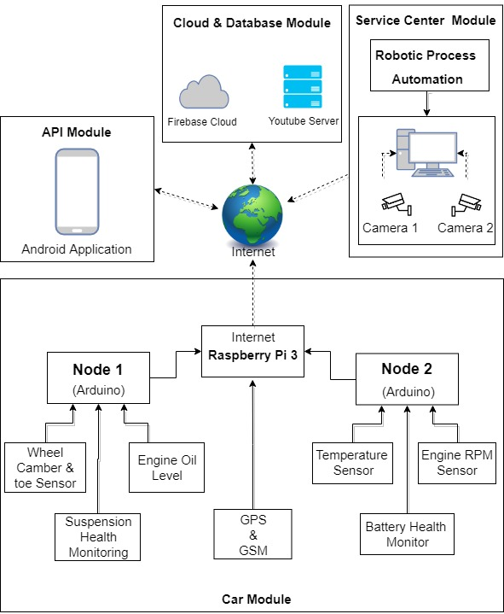

Figure 2. System Block Diagram

**2.2 Working Methodology**

The system has two sections, hardware and software. Hardware consists of Raspberry pi 3 which is connected to several Arduino which act as nodes. Arduino is connected to several sensors which constantly monitors different subsystems of the automobile.

Engine RPM is monitored using hall sensor. Alignment of wheels (Camber and toe) is monitored using Accelerometer and gyro sensor. Position of automobile is constantly monitored using GPS. Location of automobile can be checked anytime by customers using the application. Dedicated temperature sensors are used for monitoring temperature of engine. An oil level sensor is used for monitoring level of oil in engine. Brake failure can be very dangerous, a dedicated pressure sensor in brake lines is used to detect the pressure of fluid. Battery health is monitored using battery level indicator circuit. User is warned through application. If the automobile is taken out of garage due to any reason, customers will be notified through application. For this GPS system is used.

**2.3 Standards**

Various standards used in this project are:

* **SSL secured connection using firebase**

The Secure Sockets Layer (SSL)—now technically known as Transport Layer Security (TLS)—is a common building block for encrypted communications between clients and servers. In a typical SSL usage scenario, a server is configured with a certificate containing a public key as well as a matching private key. As part of the handshake between an SSL client and server, the server proves it has the private key by signing its certificate with public-key cryptography.

* **Secure Shell** (**SSH**)

It is a cryptographic network protocol for operating network services securely over an unsecured network. Typical applications include remote command-line login and remote command execution, but any network service can be secured with SSH. SSH provides a secure channel over an unsecured network in a client–server architecture, connecting an SSH client application with an SSH server. The protocol specification distinguishes between two major versions, referred to as SSH-1 and SSH-2. The standard TCP port for SSH is 22. We are using it for PuTTy as SSH Client here in our project for connection with Raspberry Pi.

**2.4 System Details**

This section describes the software and hardware details of the system:

**2.4.1 Software Details**

YouTube, android app, firebase and robotic process automation are used.

1. **Android Application**

The android application is built on the platform called **MIT App Inventor [Reference].** App Inventor for Android is an open-source web application. It allows newcomers to create apps for the Android operating system. It uses a graphical interface, which allows users to drag-and-drop visual objects to create an app for android phones.

**Developing Mobile Application**

* Make an account on <http://ai2.appinventor.mit.edu/(MIT> App Inventor)
* In App Inventor Designer, design the App's User Interface by arranging both on- and off-screen components by adding different screens as needed on the application.

.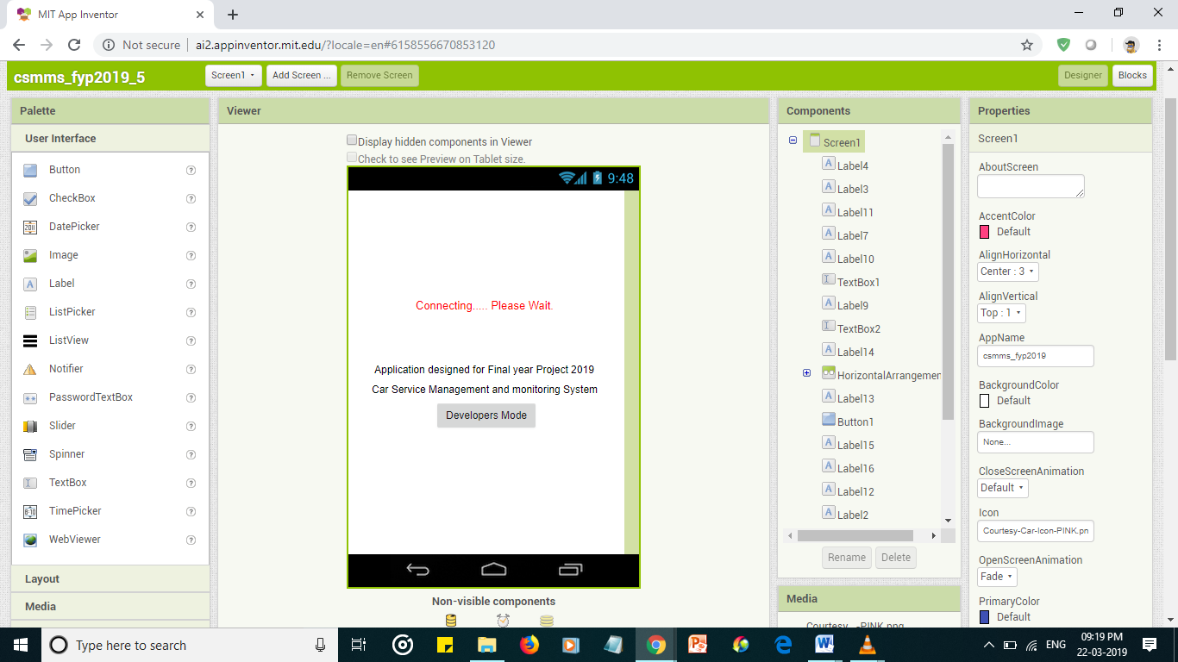

Figure 3. Screen 1

**2.4.2 Hardware Details**

As shown in Figure 2 we have various hardware components being used in this system. The details of each component is as follows

1. **Raspberry Pi**

The Raspberry Pi is a low cost, credit-card sized computer as shown in Figure 4 that plugs into a computer monitor or TV and uses a standard keyboard and mouse.

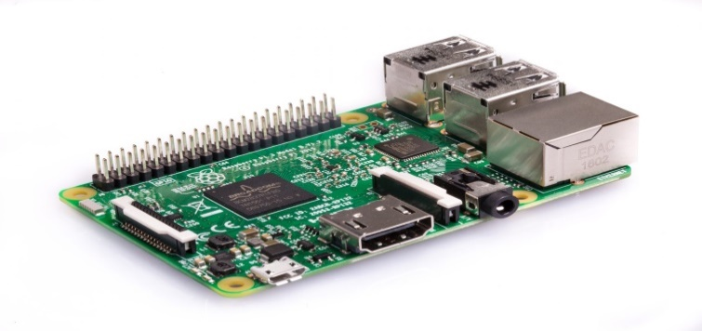

**Figure4. Raspberry Pi**

1. **Arduino**

Arduino is an open source microcontroller as shown in Figure 5 which can be easily programmed, erased and reprogrammed at any instant of time. Introduced in 2005 the Arduino platform was designed to provide an inexpensive and easy way for hobbyists, students and professionals to create devices that interact with their environment using sensors and actuators. Based on simple microcontroller boards, it is an open source computing platform that is used for constructing and programming electronic devices.

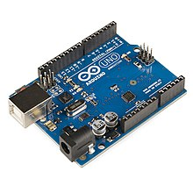

Figure 5. Arduino Board

The main purpose of the component is to collect the values, data from the various sensors and send it to the Raspberry Pi

**CHAPTER 3**

**COST ANALYSIS**

**3.1 List of components and their cost**

The costs of the various components used in this project are given below in Table 1.

**Table 1. List of components and their costs**

|  |  |
| --- | --- |
| **COMPONENT** | **COST** |
| Raspberry Pi | ₹ 3000 |
| Arduino (2 nos.) | ₹ 1000 |
| Hall Effect | ₹ 120 |
| Linear Potentiometer | ₹ 350 |
| SIM808 (GSM/GPS) | ₹ 2200 |
| Temperature Sensor | ₹ 65 |
| 3-Axis Accelerometer | ₹ 250 |
| Voltage Detector | ₹ 150 |
| Miscellaneous | ₹ 500 |
| TOTAL | ₹ 7635 |

**CHAPTER 4**

**RESULTS AND DISCUSSIONS**

* 1. **Sensor Readings**

The end nodes were able to transmit the values collected from the sensors by the system to the Raspberry Pi, which is shown in Figure 6.

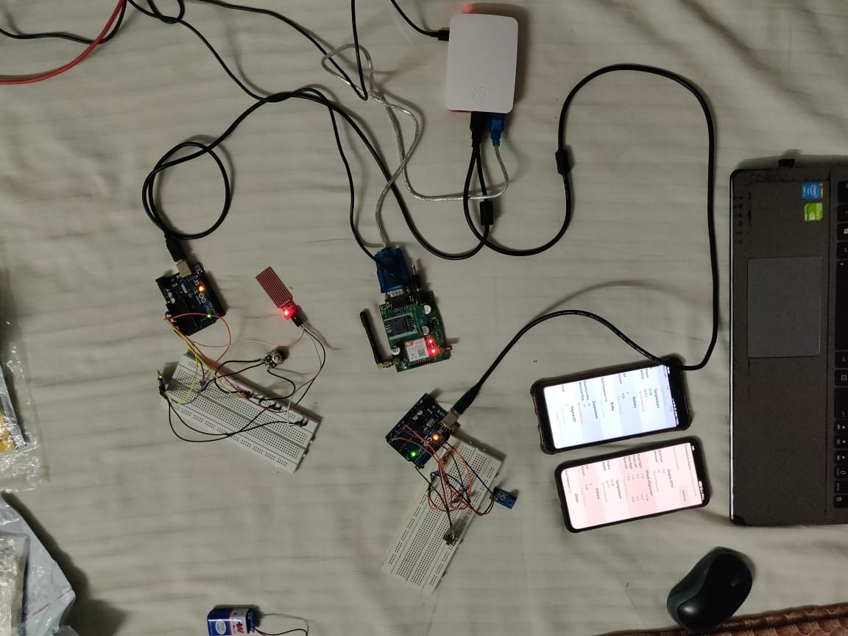

Figure 6. Hardware Setup

* 1. **Integration Hardware and Software**

**CHAPTER 5**

**CONCLUSION AND FUTURE WORK**

Car being an important part of our daily life needs to be regularly serviced for efficient working. Automation with IoT makes the whole experience of car servicing smart and fast. Above proposed system not only manages real-time health of our car but also provides necessary data and predictions to help us determine the time for next service and approximate cost. Though this system adds to the servicing cost, but it prevents service centers from charging more and makes customer aware about all the modulations done on car. All in all, this system saves time and money of customer. Technologies like IoT and RPA has fundamentally altered the way we live and work. It has made our life easier. This system increases the efficiency of our car and also reduces customer's effort at the same time.

Lot can be done in this area. There is a large scope which could be ventured, and new designs or system could be made to improve the conditions and efficiency of the vehicles and by using AI we can figure out if in near future any of the component might need attention.

**CHAPTER 6**

**APPENDIX**

**Raspberry Pi Code**

import serial

import time

from firebase import firebase

ser1 = serial.Serial('/dev/ttyACM0', 9600)

ser2 = serial.Serial('/dev/ttyACM1', 9600)

port = serial.Serial("/dev/ttyUSB0", baudrate=9600, timeout=1)

firebase = firebase.FirebaseApplication('https://csmms-fyp2019.firebaseio.com/', None)

data1=[]

data2=[]

dataGPS=[]

**REFERENCES**

[1] Jr-Jen Huang, Yi-Yu Chu, and Yen-Jen Chen, “The System Design and Implementation of Vehicle Management”, Journal of Advances in Computer Networks, Vol. 1, No. 1, March 2013

[2] Rohit Dhall, Vijender Solanki, “An IoT Based Predictive Connected Car Maintenance Approach”,

International Journal of Interactive Multimedia and Artificial Intelligence, Vol. 4, Nº3

[3] MIT App Inventor http://ai2.appinventor.mit.edu/

[4] K.N. Manoj Kumar, Kailasa Akhi, Sai Kumar Gunti, M. Sai Prathap Reddy, “Implementing smart home using firebase”, International Journal of Research in Engineering and Applied Sciences (IJREAS), Vol. 6 Issue 10, October - 2016, pp. 193~198

[5] Navdeep Singh, “Study of Google Firebase API for Android”, International Journal of Innovative Research in Computer and Communication Engineering (An ISO 3297: 2007 Certified Organization) Vol. 4, Issue 9, September 2016

[6] Sonam Khedkar, Swapnil Thube, “Real Time Databases for Applications”, International Research Journal of Engineering and Technology (IRJET) Real Time Databases for Applications, Volume: 04 Issue: 06 | June -2017

[7] Harshada Chaudhari, “Raspberry Pi Technology: A Review” International Journal of Innovative and Emerging Research in Engineering Volume 2, Issue 3, 2015

[8] Cheah Wai Zhao, Jayanand Jegatheesan, Son Chee Loon, “Exploring IOT Application Using Raspberry Pi”, International Journal of Computer Networks and Applications Volume 2, Issue 1, January - February (2015)

[9] How to set up Raspberrypi https://www.raspberrypi.org/help/videos/

[10] Connecting an Arduino to Raspberry Pi for the best of both worlds <https://conoroneill.net/2013/06/05/connecting-an-arduino-to-raspberry-pi-for-the-best-of-both-worlds/>

[11] Maria-Alexandra Paun, Jean-Michel Sallese and Maher Kayal, “Hall Effect Sensors Design, Integration and Behavior Analysis” Journal of Sensor and Actuator Networks ISSN 2224-2708, Published: 8 February 2013

[12] Paun, M.A.; Sallese, J.M.; Kayal, M. “Temperature Considerations on Hall Effect Sensors

Current-Related Sensitivity Behaviour”, In *Proceedings of the 19th IEEE International* Conference *on Electronics, Circuits, and Systems (ICECS)*, Seville, Spain, 9–12 December 2012

[13] Electronics Basics – How a Potentiometer Works https://randomnerdtutorials.com/electronics-basics-how-a-potentiometer-works/

[14] Working Principle of Temperature Sensor and Its Application

<https://www.efxkits.us/lm35-temperature-sensor-circuit-working/>

**BIODATA**

Photo

Name : xxxxx

Mobile Number : 123456789

E-mail : xx.xxxx@vitap.ac.in

Permanaent Address :