SOLUTION FOR E-COMMERCE PLATFORM

Sujith Delpachithra

1. Introduction

Assessment is based on the e-commerce platform, and as a solution architect I must consider few things when developing solution. Following points are captured when studying the requirement.

1. Company is a startup
2. Both services and products are available in the platform
3. CEO wants to go live as a minimum viable product
4. CEO expects a growth and need to facilitate
5. Need to provide both mobile and web-based applications
6. Only for Sri Lankans
7. Need to develop campaign management
8. Minimize the failure
9. Security concerns
10. Agile software development

This is a startup company. Therefor, we must consider about the cost of the solutions. As a solution developer, I would not recommend deploying full solution at once. As per CEO, I also agree with him to go live with minimum viable product where customers can do their basic needs in the e-commerce platform. Furthermore, this platform is required to have both products and services. Therefore, solution will be complex due to inventory/product management. In this solution, I will not discuss for much low level due to time constraints.

In addition, CEO expects a growth in the platform. Therefore, we must design solution to increase the performance without doing major architectural changes for the initial solution. As a solution architect, we must design solution at present to suit for future. Therefore, I have done some changes in architectural solution of the e-commerce platform to cater those future requirements.

Solution needs to cater both mobile and web-based applications for customer to use the platform. Therefore, I have design solution based on that. However, I would like to propose for the management to use responsive based mobile application at first to reduce cost and after that company can introduce a mobile app. Moreover, the suggested solution is designed for mobile app.

As per marketing team, they need to do campaign management and promotions based on the customer usage patterns. To achieve that feature, I must have some knowledge on data to collect for future references. Therefore, solution is designed to capture data in both node and application levels. As per solution, all most all the data like network packet level data will be stored in platform to analyze and predict patterns and usages. I will discuss each of in the solution section.

Availability of the systems is the main concern any company. Therefore, I have added feature to reduce failures of the system in each of point. However, we can remove some components to reduce cost of the solution. I will discuss each of the points where we can add or remove nodes in the solution description. In future, proposed solution must implement to reduce the failures of the e-commerce platform.

Security is the major concern of a solution architects of the company. As a solution developer, I always try to bring my knowledge to the solutions. Company must store customers’ personally identifiable information in secure manner. Here in the platform, it is storing not only customer information but also payment details. Therefore, system must be fully secured. Since this is a new e-commerce platform attackers may try frequently. I have considered those concerns in my solution design.

One of the most important things is the software development phase. Since CEO wants to launch the platform as a minimum viable product, I have designed the solution to deploy as sprints. I will discuss the solution development in later of the solution section.

As per the requirement, there is no proper decision about the deployment of the solution. Whether it is on premises or cloud. Therefore, I will design two solutions for both on premise and cloud solutions.

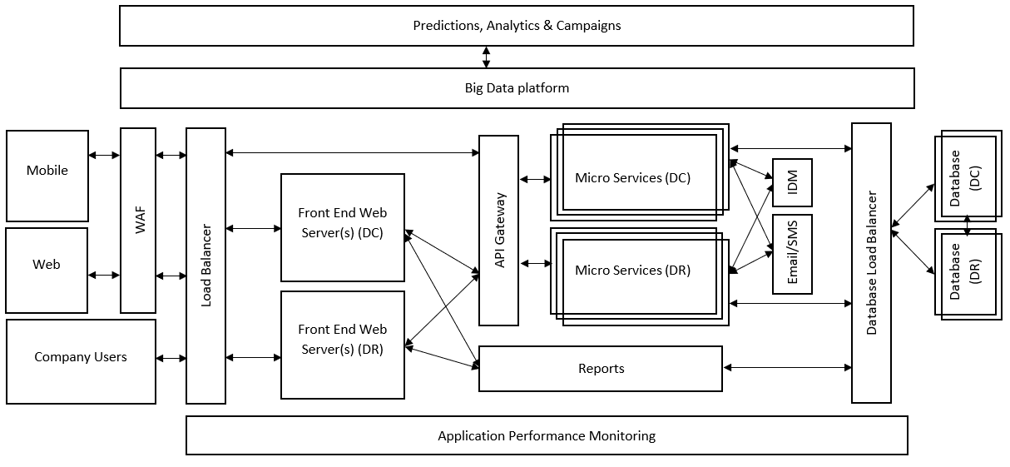

Figure 1: High level design of the e-commerce platform

1. Solution 1 (Onsite deployment)

Figure 1 is illustrating the high-level solution diagram for the e-commerce platform. In the solution diagram, I have tried to implement all the required features from stakeholders as discussed in introduction section and other suggestions from my experiences. However, due to time constraint I’m not going to deep dive into the architecture.

2.1 Discussion

Solution is capable of handling both mobile and web applications in the proposed solution. For security purposes, I have implemented a web application firewall (WAF) Infront of both web and mobile apps. Platform must be secured by internet users. However, I have excluded the internal stakeholders from the WAF. The reason behind this is to reduce traffic through WAF and improve performance of the platform. In addition, I assume that employees are connected through behind the company firewalls. Moreover, employee access can be secured using company VPN.

Both mobile and web application are exposed to WAF via application load balancer. This application load balancer will be able to balance the load depends on the traffic to sites. Micro services are exposed over API gateway to secure the micro services from unauthorized access. Frontend applications must use OAuth2 authentication to access the micro services. Moreover, there is a requirement to store customers’ data in a secure manner. Therefore, it is suggested to deploy the IDM (Identity Access Manager) for user authentication and authorization. User management micro service(s) will directly use the IDM to create/validate users in IDM. I am proposing to differentiate two user categories in IDM. They are internal and external users. Because of that differentiation, we can store more data about customers in IDM than internal users. After successful validation of users in IDM, other micro services in the platform can use IDM token(s) to define the user privileges (authentication/authorization).

As per requirement, I have identified following high level micro services for the e-commerce platform. However, we need to go deep into each micro service and identify proper segregation of services to reduce complexities.

1. User Service
2. Product Service
3. Order Service
4. Inventory Service
5. Plans Service
6. Discount Service
7. Payment Service
8. Support Service

I have segregated the frontend and backend of the solution. This will improve the application performance and will lead for decoupling of business logics from user interfaces. Because of this each segregation, we can modify backend anytime with minimum changes to frontend. However, we must design the micro services properly with correct payloads/endpoints to minimize the interface changes between services and frontend applications. Because of micro services, we can increase the number of micro service instances to improve the application performance. For example, if there are high number of requests for order management micro service, we can increase its instances to increase the performance.

This e-commerce platform must be able to communicate with email and SMS services to send notifications to customers. Therefore, I have integrated a queue management solution for email and SMS. After micro services execution, they will push the notifications to email and SMS components. Those components will execute email/SMS based on queue management. We can use ActiveMQ or RabbitMQ as messaging platform to store messages. I will discuss relevant technologies in later chapter.

Customers and internal users also will connect to web application through frontend application. I suppose to have two separate applications for back office and customers. Because of that, it will reduce the complexity of the management in later. We can use existing micro services for both customer and back-office applications. As per proposed solution, N number of application servers will be deployed in data center (DC) and N number of servers are in disaster recovery (DR) data center since there are no clear definition about traffic. In addition, CEO expects a growth in e-commerce platform, architecture must be able to facilitate. However, I would like to suggest using two application server instances in DC and one instance in DR in the initial phase of deployment to reduce cost. After having proper statistics, QA team can be performing a performance acceptance testing (PAT) for required traffic and request for fine tune hardware and software according. All the traffic is followed through load balancer to frontend application. If there is a failure in DC servers, load balancer can be configured to send traffic to DR servers. Moreover, we redirect DC server failures automatically using probing in frontend applications. Therefore, failures in DC servers’ traffic will be switched to DR site server automatically without having any human intervention while engineers are solving the DC issues. As per Figure 1, application performance monitoring application (APM) is deployed across the e-commerce platform. Nodes logs, application logs will be redirected to APM tool using APM agent. Then, APM can analyze the error using patterns and action according. APM will generate server failures directly to application support team to action. I will discuss about tools in later chapters. Here, I am suggesting deploying DC and DR as ACTIVE/PASSIVE servers. Because DR site must deploy in another location and there may be a latency between DC and DR sites. Global server load balancing (GSLB) will help to handle DC server failures.

I have suggested to bypass API gateway to get report since there is no security issue or performance issue there. In addition, reports are used by internal staff of the company. Therefore, developers can develop reports using direct database access without having micro service access. However, it depends on the report type. We must think deep about reports in depth architectural discussions.

Databases are connected to applications using database load balancer. However, as per application servers, it is supposed to deploy ACTIVE/PASSIVE databases for failures. As discussed above for application servers, database must be deployed in separate location for disaster. Therefore, to reduce latency, it is better to deploy databases as ACTIVE/PASSIVE. ACTIVE node data changes (delta of changes) will be synced between DC and DR databases to reduce data loss. However, it is recommended to deploy hourly/daily data backup in tapes to reduce the data loss in case of both DC and DR site failures. Backup retention policy can be agreed upon discussion with storage teams.

There is a requirement from marketing head to deploy promotions based on usages and other statistics. Therefore, it our duty to collect as much as data from customers to analyze and predict patterns. Here, in the solution architecture, I’m proposing to deploy a big data cluster to collect every possible information. In Figure 1, I have illustrated the big data platform across the WAF to database layers. Using the collected information, big data team can analyze user patterns predict promotions and campaigns.

* 1. Software development

As per assessment, there is a requirement to develop software as agile development. To achieve that, as discussed earlier, I have separated the frontend and backend applications. In addition, I have suggested to develop separate applications for internal and external users of the platform. Because of the use of micro services, we can use agile development practices for this. Moreover, as CEO wants to deploy the platform as MVP, we must identify MVP features in depth analysis with relevant stakeholders and agree on development. As per solution design, we can add features later phases on the platform enhancements.

* 1. Nonfunctional requirement

A

Availability

Scalability

Security

Pricing

Operational excellence

* 1. technology stack