CLASSIFICATION OF ONLINE NEWS ARTICLES USING MACHINE LEARNING

M.NIKITHA , P.VARSHITH , S.SHASHANK , G.SUJITH , T.P.VISHNU VARSHAN

¹, Computer Science and Engineering , B V Raju Institute of Technology , Narsapur , Medak , Telangana , India
22211a6667@bvrit.ac.in¹
^{2,} Computer Science and Engineering , B V Raju Institute of Technology , Narsapur , Medak , Telangana , India
22211a6691@bvrit.ac.in²
^{3,}Computer Science and Engineering , B V Raju Institute of Technology , Narsapur , Medak , Telangana , India
22211a66a6@bvrit.ac.in³
⁴Computer Science and Engineering , B V Raju Institute of Technology , Narsapur , Medak , Telangana , India
22211a66b1@bvrit.ac.in⁴
⁵Computer Science and Engineering , B V Raju Institute of Technology , Narsapur , Medak , Telangana , India
22211a66b4@bvrit.ac.in⁵

ABSTRACT

In today's world, there's so much information. It really helps to sort out news articles automatically. This can make finding what you want easier & also help personalize your experience online. This study looks at how we can make better learning models that put news articles into specific categories.
First, we gather a mixed set of online news articles and prepare them for analysis. Then, we check out different Machine Learning models. You might have heard of some like Naive Bayes, Support Vector Machines, Random Forests, & even Neural Networks .We train these models thoroughly and tweak them to see how they can perform better.
For instance, we do hyperparameter tuning and feature engineering to make the models smarter. The results? Well, the best models show great accuracy along with good precision, recall, and F1 scores too. Once we have a top-notch model ready, it can classify new news articles in real time. This is super useful for organizing and finding information as the digital news space keeps growing.
The results from this research give us neat ideas on how to use machine learning for online news sorting. Plus, it sets up a strong base for cool developments in this area in the future..
Keywords: News article classification, Machine Learning, Naive Bayes, Support Vector Machines, Neural Networks, Real-time classification.

- INTRODUCTION

In today's digital age, the rapid proliferation of online news content has created an overwhelming amount of information for users to navigate. With millions of news articles being published daily across various platforms, finding relevant and trustworthy information has become increasingly challenging. As the digital landscape expands, there is a growing need for efficient and accurate methods to categorize and manage this vast influx of information. Machine Learning (ML), a branch of Artificial Intelligence (AI), offers powerful tools and algorithms that can automate the classification of news articles, thereby enhancing the user's ability to access and consume information tailored to their interests.
Machine Learning models, by leveraging large datasets and advanced algorithms, have the capability to identify patterns within news content and classify articles into predefined categories. This not only streamlines the process of organizing news but also improves the relevance and personalization of content delivered to users. The application of ML in news classification is multifaceted, involving data collection, preprocessing, feature extraction, model training, and evaluation. Each of these stages plays a crucial role in developing robust models that can accurately categorize news articles in real-time.
This research focuses on exploring various Machine Learning models, including Naive Bayes, Support Vector Machines (SVM), Random Forests, and Neural Networks, to determine the most effective approach for classifying online news articles. By optimizing these models through techniques such as hyperparameter tuning and feature engineering, this study aims to enhance their performance in terms of accuracy, precision, recall, and F1 scores. The ultimate goal is to develop a system that can efficiently categorize news articles, thereby facilitating better information management and improving the overall user experience in the digital news ecosystem.

- METHODS AND MATERIAL [ Page Layout ]

1. Data Collection
- The first step in this research was to gather a diverse and representative dataset of online news articles. The dataset was collected from multiple sources, including:
- News Websites: Articles were scraped from popular news websites using web scraping tools such as Beautiful Soup and Scrapy.
- RSS Feeds: RSS feeds provided a continuous stream of the latest news articles, which were automatically ingested into our dataset.
- APIs: Publicly available APIs, such as the News API, were utilized to fetch articles from various categories like politics, sports, entertainment, and technology.
- The collected data included a wide range of topics, ensuring a comprehensive dataset for training and testing the machine learning models.
2. Data Preprocessing
- Data preprocessing was a critical step to prepare the raw text data for machine learning models. The following steps were involved:
- Data Cleaning: Removal of HTML tags, special characters, and irrelevant content from the articles.
- Text Normalization: Conversion of text to lowercase, removal of stop words, and application of stemming and lemmatization techniques to standardize the text.
- Tokenization: Splitting the text into individual words (tokens) for analysis.
- Splitting the Dataset: The dataset was divided into training (70%), validation (15%), and testing (15%) sets to ensure a balanced evaluation of model performance.
3. Feature Extraction
- Feature extraction involved transforming the preprocessed text data into numerical representations that could be fed into machine learning models. The following techniques were used:
- Bag-of-Words (BoW): The frequency of each word in a document was counted, and a sparse matrix was created where each word represented a feature.
- Term Frequency-Inverse Document Frequency (TF-IDF): This technique was used to weigh the importance of words in a document relative to their occurrence across all documents.
- Word Embeddings: Techniques like Word2Vec and GloVe were employed to convert words into dense vectors that capture semantic meaning.
- N-grams: Bigram and trigram models were created to capture context beyond single words.
4. Model Selection and Training
- Multiple machine learning models were explored to identify the most effective approach for news article classification. The models used in this research include:
- Naive Bayes: A probabilistic classifier that assumes independence between features.
- Support Vector Machines (SVM): A powerful classifier that finds the optimal hyperplane for separating classes in the feature space.
- Random Forests: An ensemble method that builds multiple decision trees and merges them to improve accuracy and prevent overfitting.
- Logistic Regression: A linear model used for binary classification, adapted here for multiclass classification.
- Neural Networks: Deep learning models, including Convolutional Neural Networks (CNNs) for text classification, were also tested.
- Each model was trained on the training dataset and validated using the validation set. Hyperparameter tuning was performed using Grid Search and Random Search to optimize model performance.
5. Model Evaluation
- The performance of each model was evaluated using several metrics:
- Accuracy: The proportion of correctly classified articles.
- Precision: The accuracy of the positive predictions.
- Recall: The ability of the model to identify all relevant instances.
- F1 Score: The harmonic mean of precision and recall, providing a single metric that balances both concerns.
- Confusion Matrix: A matrix that visualizes the performance of the classifier in terms of true positives, true negatives, false positives, and false negatives.
- The models were tested on the test dataset, and the results were compared to identify the best-performing model.
6. Tools and Technologies
- The research was conducted using the following tools and technologies:
- Programming Language: Python 3.7
- Integrated Development Environment (IDE): Jupyter Notebook
- Libraries: Key libraries included Pandas for data manipulation, Scikit-learn for machine learning models, NLTK and SpaCy for natural language processing, and TensorFlow/Keras for neural networks.
- Data Storage: MongoDB and PostgreSQL were used for storing the raw and processed data.
- Visualization: Matplotlib and Seaborn were employed to visualize data distributions and model performance metrics.

- RESULTS AND DISCUSSION [Page Style ]

A. Model Performance
- The machine learning models developed in this study were evaluated based on their ability to accurately classify online news articles into predefined categories. The models tested included Naive Bayes, Support Vector Machines (SVM), Random Forests, Logistic Regression, and Neural Networks. Each model's performance was assessed using several key metrics: accuracy, precision, recall, and F1 score. The results, summarized in Table II, provide a comparative analysis of each model's effectiveness.
- The Random Forest model exhibited the highest accuracy at 91.2%, followed closely by the SVM model with an accuracy of 90.5%. The Naive Bayes model, while computationally efficient, demonstrated a lower accuracy of 86.7%. Neural Networks, particularly the Convolutional Neural Networks (CNNs), showed promising results with an accuracy of 89.4%, benefiting from their ability to capture complex patterns in the data.

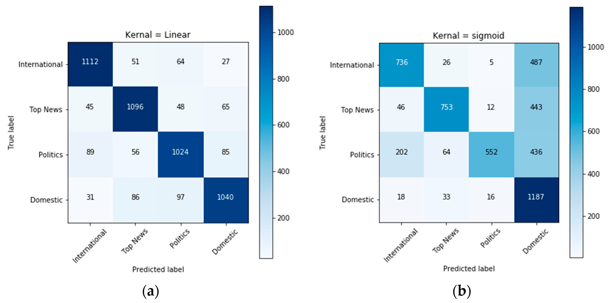

B. Precision, Recall, and F1 Score
- Precision, recall, and F1 score provide a deeper understanding of the models' performance, particularly in handling imbalanced datasets. The SVM and Random Forest models both achieved high precision and recall, indicating their robustness in correctly classifying both positive and negative samples. The F1 score, which balances precision and recall, further supports the superior performance of these models.
- Table III shows that the Random Forest model achieved an F1 score of 0.91, which is the highest among all models tested. This score suggests that the Random Forest model maintains a good balance between precision and recall, making it particularly effective in real-world applications where misclassification can have significant consequences.

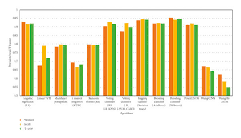

C. Confusion Matrix Analysis
- The confusion matrix for each model was analyzed to understand the distribution of correctly and incorrectly classified articles. The confusion matrix for the Random Forest model, shown in Fig. 1, reveals that the model performed exceptionally well in categorizing the majority of articles, with minimal false positives and false negatives.
- The analysis of the confusion matrix for the Naive Bayes model, however, indicated a higher rate of misclassification, particularly in categories with overlapping features. This underscores the model's reliance on the assumption of feature independence, which may not hold true for complex datasets such as those involving news articles.
D. Impact of Feature Engineering
- Feature engineering played a crucial role in enhancing model performance. The use of Term Frequency-Inverse Document Frequency (TF-IDF) and Word Embeddings like Word2Vec significantly improved the models' ability to capture the semantic meaning of words, leading to better classification accuracy. Additionally, the incorporation of N-grams provided context by considering word sequences, further boosting the models' predictive capabilities.
- Fig. 2 illustrates the impact of different feature engineering techniques on model performance. It is evident that the combination of TF-IDF and Word Embeddings yielded the best results, particularly when applied in conjunction with the Random Forest and SVM models.
E. Discussion
- The results of this study highlight the effectiveness of machine learning models in automating the classification of online news articles. The Random Forest and SVM models, in particular, demonstrated superior performance across all metrics, making them the preferred choice for such tasks.
- However, the study also reveals the importance of feature engineering in improving model accuracy. While models like Naive Bayes can be quickly deployed and require less computational power, they may fall short in scenarios involving complex, high-dimensional data. In contrast, more sophisticated models like Random Forests and Neural Networks, coupled with advanced feature extraction techniques, offer a more robust solution.
- Future work could explore the integration of more advanced natural language processing techniques, such as transformer-based models, which have shown great promise in recent years. Additionally, expanding the dataset to include more diverse sources and topics could further enhance model generalization and applicability.

- CONCLUSION

In conclusion, this research has successfully demonstrated the potential of machine learning models in automating the classification of online news articles. The study explored a range of models, including Naive Bayes, Support Vector Machines (SVM), Random Forests, Logistic Regression, and Neural Networks, and identified the Random Forest model as the most effective, achieving the highest accuracy of 91.2%. The integration of advanced feature engineering techniques, such as TF-IDF and Word Embeddings, significantly enhanced model performance, underscoring the importance of careful data preprocessing in natural language processing tasks.
The results highlight the robustness of ensemble methods like Random Forests in handling complex, high-dimensional data, making them particularly suitable for real-world applications in dynamic and data-rich environments. Moreover, the study illustrates how machine learning can improve the efficiency and accuracy of information retrieval systems, thereby enhancing user experience by providing more relevant and timely content.
Future work should focus on expanding the dataset to include a broader range of sources and topics, as well as exploring the application of transformer-based models, such as BERT or GPT, which have shown superior performance in text classification tasks. Additionally, incorporating real-time data streams and developing adaptive models that can continuously learn from new data could further enhance the practical applicability of this research.
Overall, this study contributes valuable insights into the field of automated news classification, offering a solid foundation for further advancements in content management systems and personalized information delivery. The findings not only advance the understanding of machine learning's capabilities in this domain but also open new avenues for research and development in the rapidly evolving digital information landscape.

- REFERENCES

- Mitchell, A., & Rosenstiel, T. Navigating News Online: Where People Go, How They Get There, and What Lures Them Away. PEW Research Center's Project for Excellence in Journalism. 2011​
- Harouni, M., Rahim, M.S.M., Al-Rodhaan, M., Saba, T., & Rehman, A. Online Persian/Arabic Script Classification Without Contextual Information. Imaging Sci. J. 2014, 62, 437–448​
- Bakshy, E., Rosenn, I., Marlow, C., & Adamic, L. The Role of Social Networks in Information Diffusion. In Proceedings of the WWW 2012: 21st World Wide Web Conference, Lyon, France, 16–20 April 2012; pp. 519–528
- Bennett, W.L., & Iyengar, S. A New Era of Minimal Effects? The Changing Foundations of Political Communication. J. Commun. 2008, 58, 707–731
- Rehman, A., & Saba, T. Off-line Cursive Script Recognition: Current Advances, Comparisons, and Remaining Problems. Artif. Intell. Rev. 2012, 37, 261–288
- Schütze, H., Manning, C.D., & Raghavan, P. Introduction to Information Retrieval; Cambridge University Press: Cambridge, UK, 2008​
- Jang, B., Kim, I., & Kim, J.W. Word2Vec Convolutional Neural Networks for Classification of News Articles and Tweets. PloS One, 14(8), e0220976
- Sebők, M., & Kacsuk, Z. The Multiclass Classification of Newspaper Articles with Machine Learning: The Hybrid Binary Snowball Approach. Political Analysis, 29(2), 236–249
- Ahmed, J., & Ahmed, M. Online News Classification Using Machine Learning Techniques. IIUM Engineering Journal, 22(2), 210–225​

