9384754439


harisujith158@gmail.com karunya nagar,coimbatore 641114
O B J E C T I V E

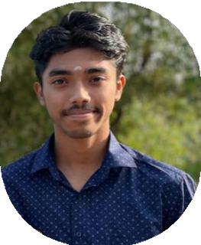
Motivated college student majoring in Computer Science with a strong passion for coding and problem-solving.

SUJITH
HARI
Seeking an internship to apply technical and collaborative skills while contributing to innovative projects in software development.

S K I L L S
TECHNICAL SKILLS
C language
python language

SOFT SKILLS
Problem-Solving
Team collaboration Time Management
Strong Communication

E D U C A T I O N

SECONDARY SCHOOL
Evangeline matric 2011 - 2023

BACHELOR OF TECHNOLOGY
Karunya university , coimbatore 2024 - 2028

L A N G U A G E

English telugu kannada tamil

P R O J E C T S

PERSONAL BUDGET TRACKER (PYTHON)
Developed a Python-based application to help users track income and expenses.
Integrated data visualization using Matplotlib to display spending trends
Designed user-friendly interfaces and streamlined functionality, improving user experience.

STRATEGIC AND MARKETING SKILLS
Brand Development: Creating and maintaining a consistent brand image
Public Relations: Managing communication to build a positive public image.
Event Marketing: Planning events to increase brand visibility and engagement.
Influencer Collaboration: Partnering with influencers to promote products.

EXTRACURRICULAR ACTIVITIES

Sports and Athletics

Captain, higher secondary Team
Led the team to two regional championships while fostering teamwork and discipline.
Participant, Intramural Basketball League Organized practice sessions and fostered
camaraderie among players.

