The dataset I have used is body-measurement-data-set from partyrock resources.
The main features in this dataset are calf, chest, biceps, arms, forearms.
Let’s dive into insights gained from whiskers partyrock.
Linear Relationships
The relationship between the chest and the bicep is the strongest. It has a correlation of 0.85. This means the chest and the bicep have a strong positive relationship. When the chest gets bigger the bicep gets bigger too. They increase in size together.
The calf and the bicep have a correlation of 0.73. The calf and the chest have a correlation of 0.72. These relationships are strong. They show that the calf and the bicep and the calf and the chest are connected.. They are not as strong as the relationship, between the chest and the bicep.
Comparisons Across Body Types:
When we look at people grouped by their calf size a clear pattern emerges:
* The Small Calf group, which has calf sizes than 35 cm has an average chest size of 92.5 cm and an average bicep size of 27.0 cm.
The Medium Calf group, with calf sizes between 35-40 cm shows a chest size of 101.6 cm and an average bicep size of 30.4 cm.
* For people, in the Large Calf group, who have calf sizes over 40 cm the average chest size is 114.6 cm. The average bicep size is 34.9 cm.
Summary of the trend:
People with bigger calves tend to have bigger chest and bicep sizes. The chest measurement has the most difference (22 cm between the small and large groups), while the bicep measurement has about 8 cm difference. This means that these body measurements tend to grow together. For example, people with bigger or more muscular lower bodies also tend to have bigger upper bodies.

Average chest by calf category:
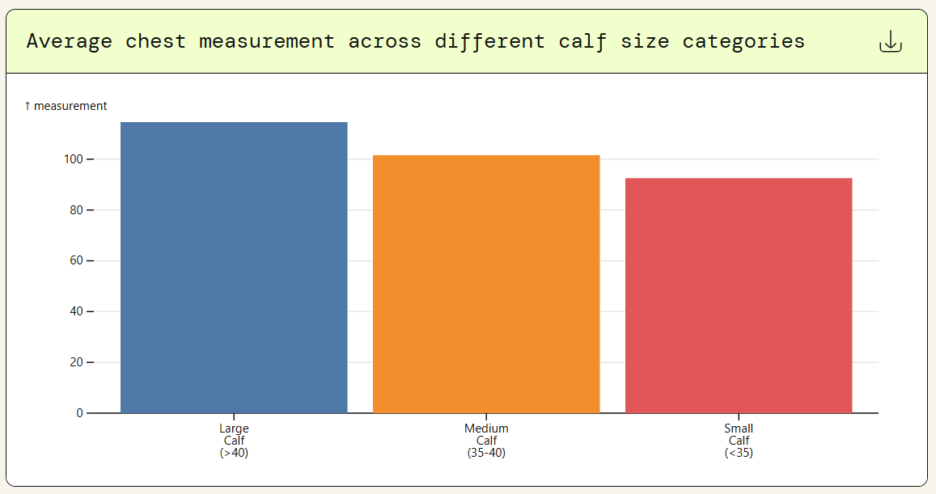
Shows how chest measurements go up from small to large calf groups. The smallest group is 22 cm bigger than the biggest group.

Average bicep by calf category:
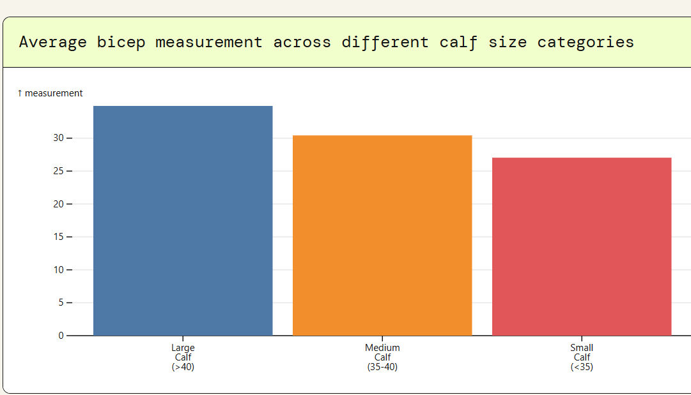
Shows how bicep size changes across calf groups, with an 8 cm increase from small to large groups.

Chest vs Bicep Linear relationship:
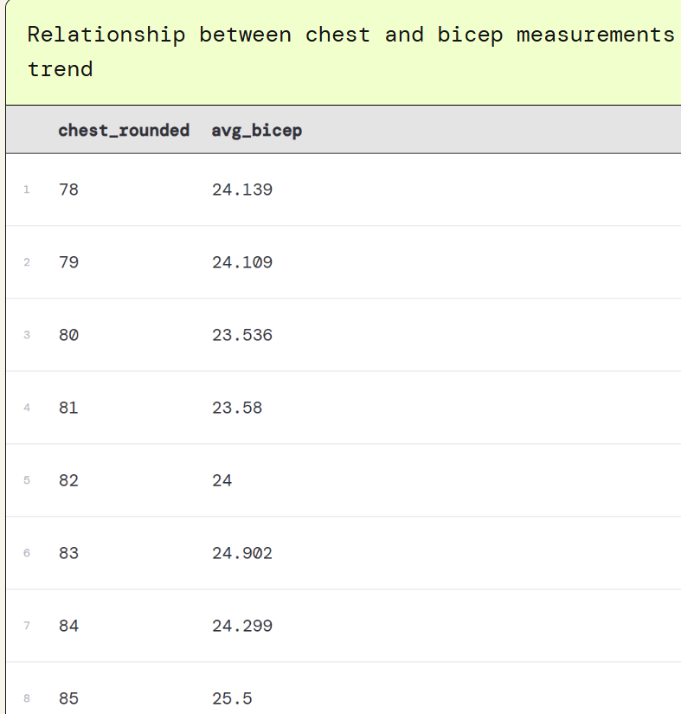
This shows very clearly that there is a strong linear relationship between chest and bicep measurements. As the chest size goes from 78 cm to 136 cm, the bicep size goes up by the same amount, from about 24 cm to 43 cm. This shows the correlation is 0.85
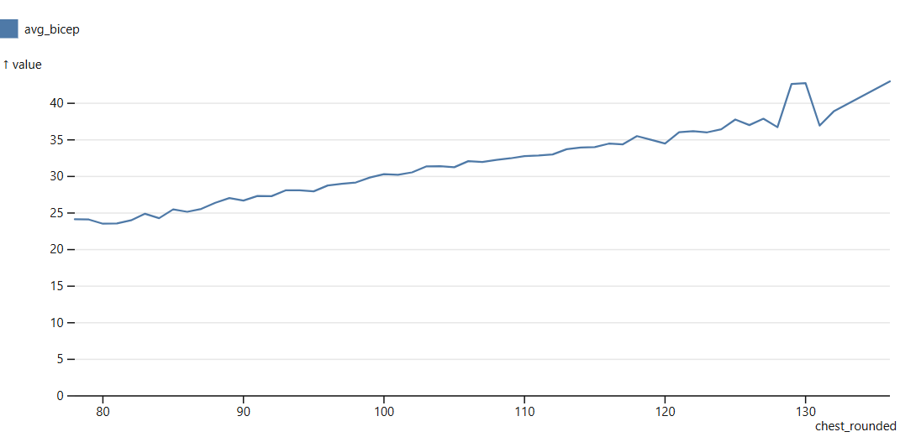
The line chart shows very clearly why the chest-bicep measurement has the strongest relationship of the three: it has a smooth, steady upward trend with very few changes.

