* **Install Power BI Desktop and share the final screenshot of the report view page which appears when power desktop starts.**

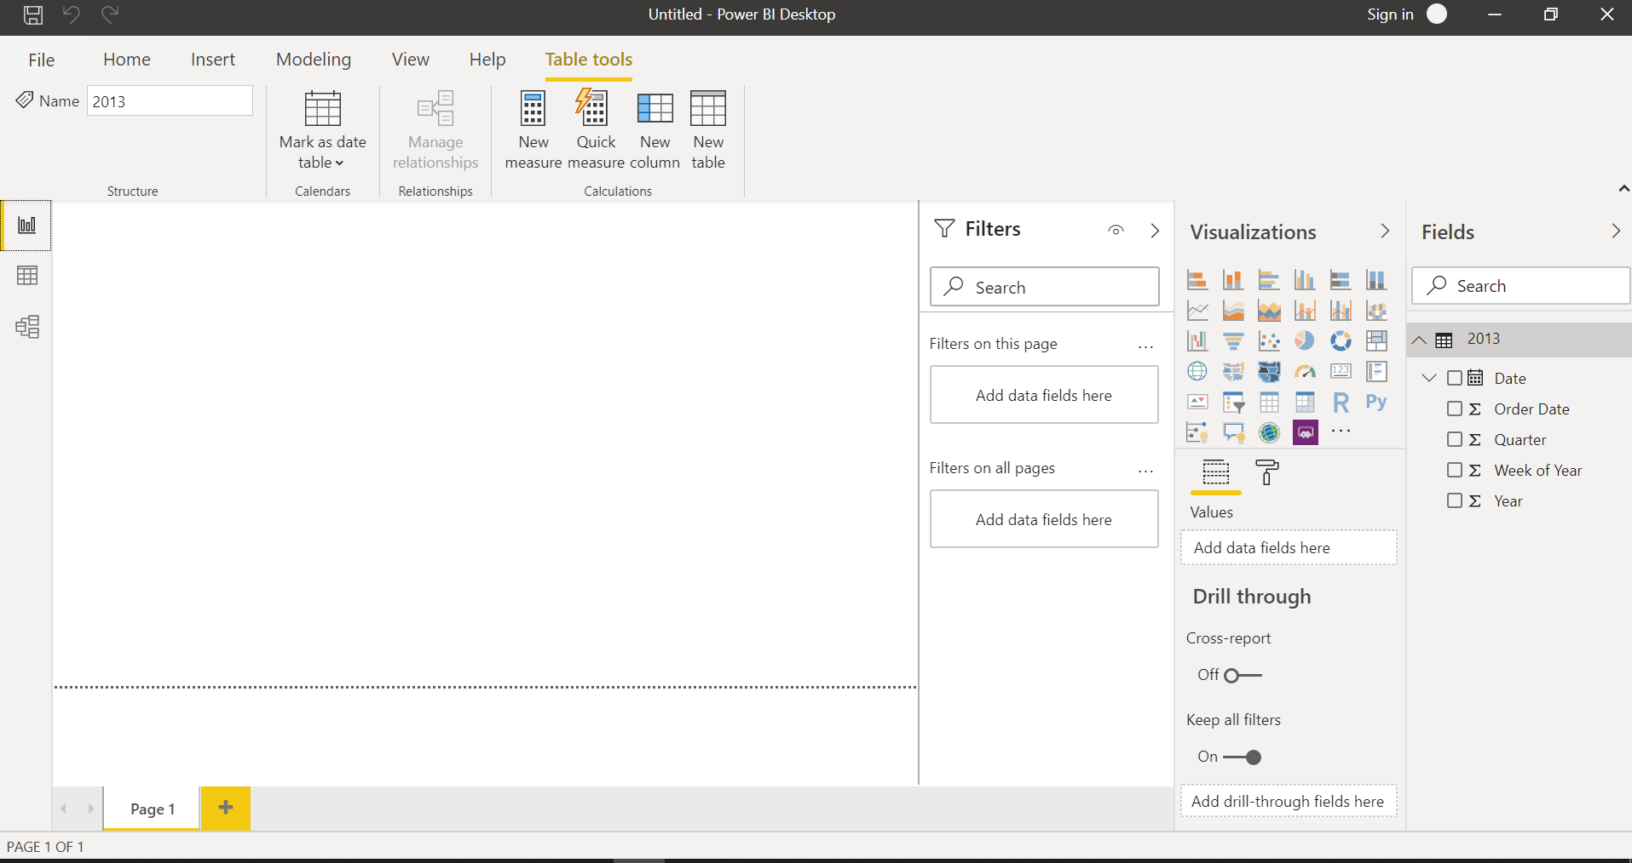

* Prepare a document and with the following screenshot
* Report View

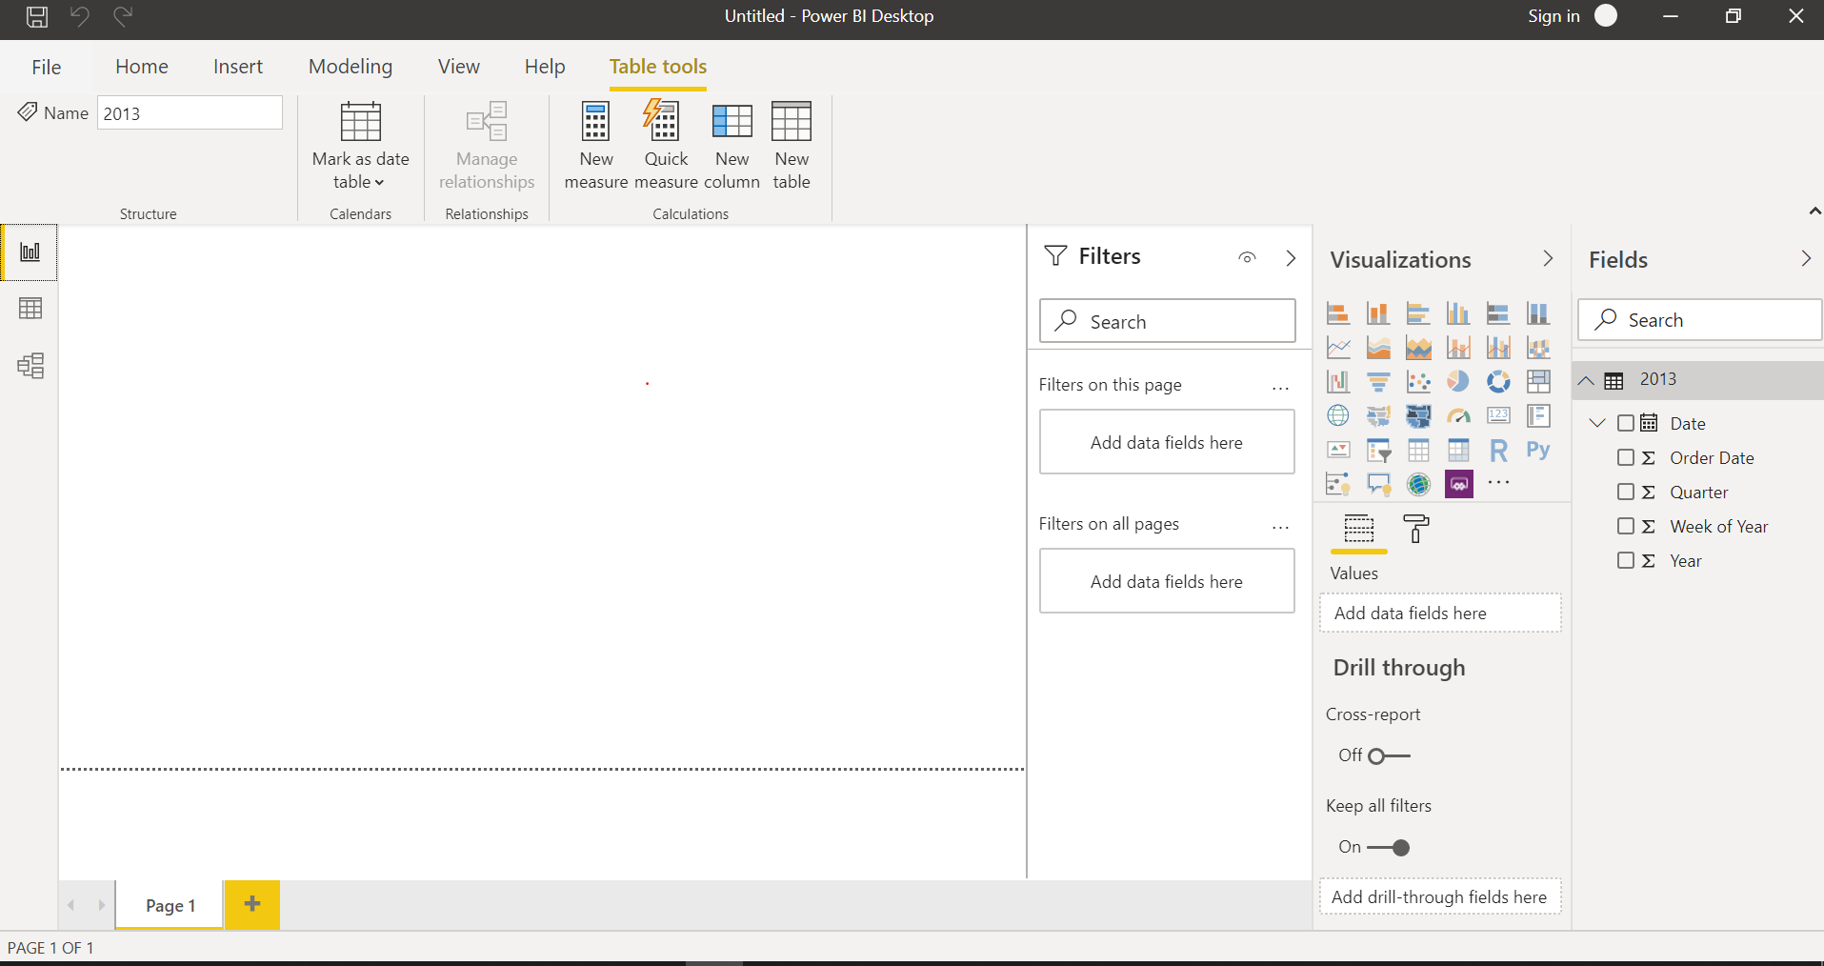

* Data View

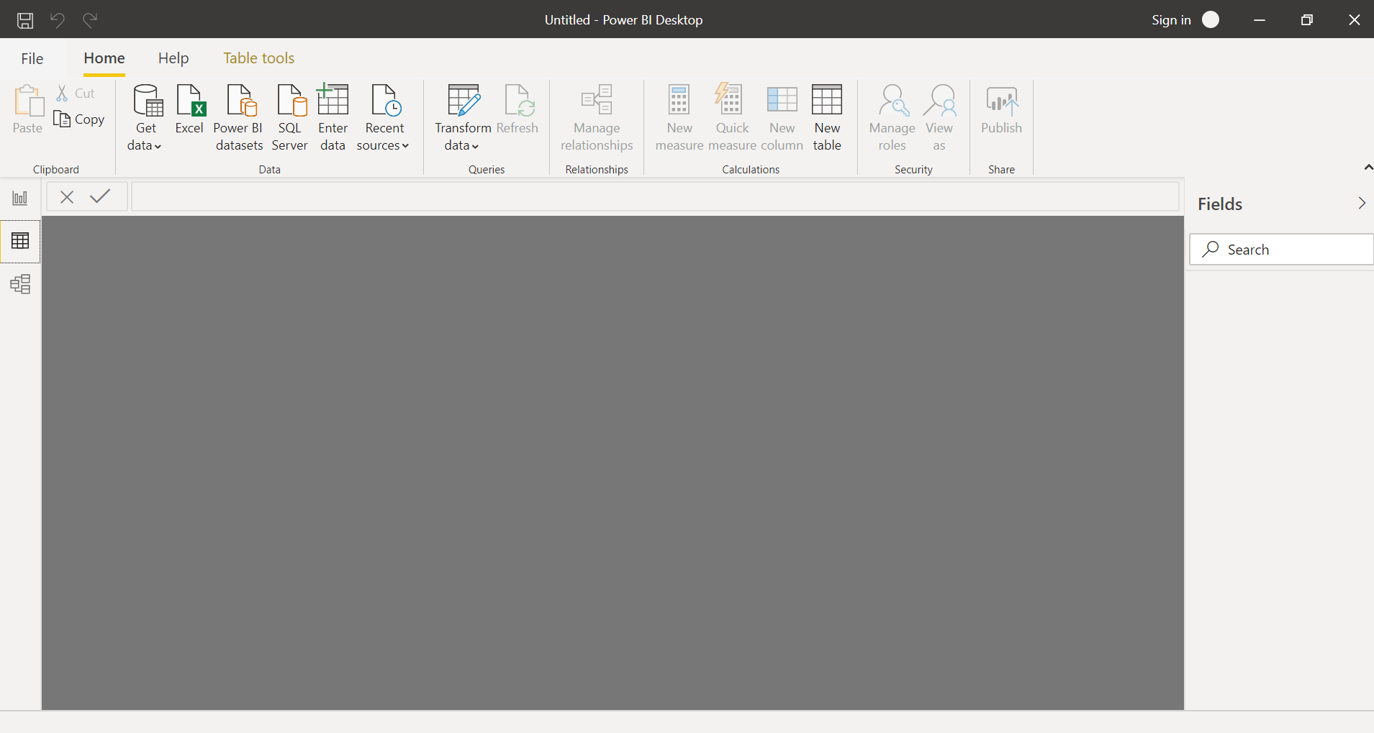

* Model View

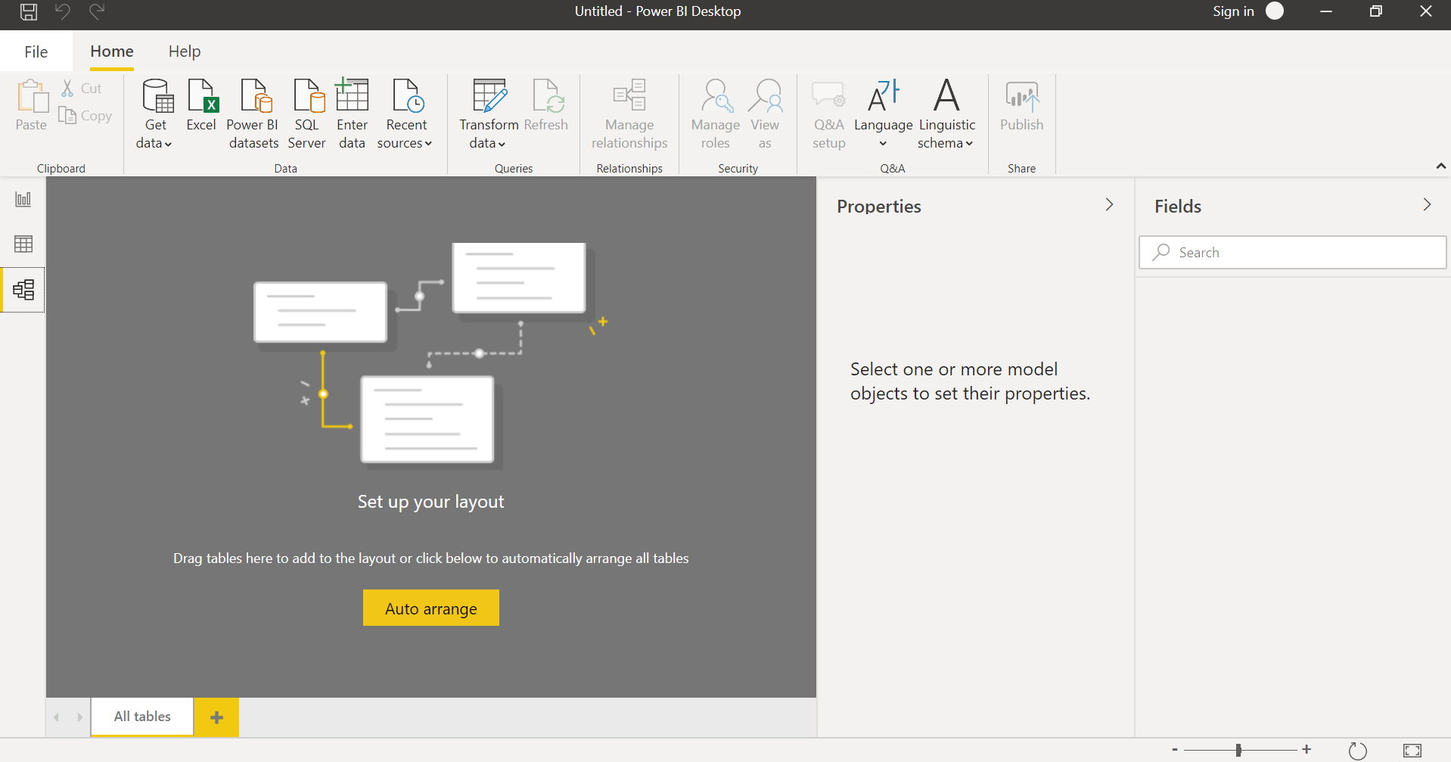

* Power Query Editor

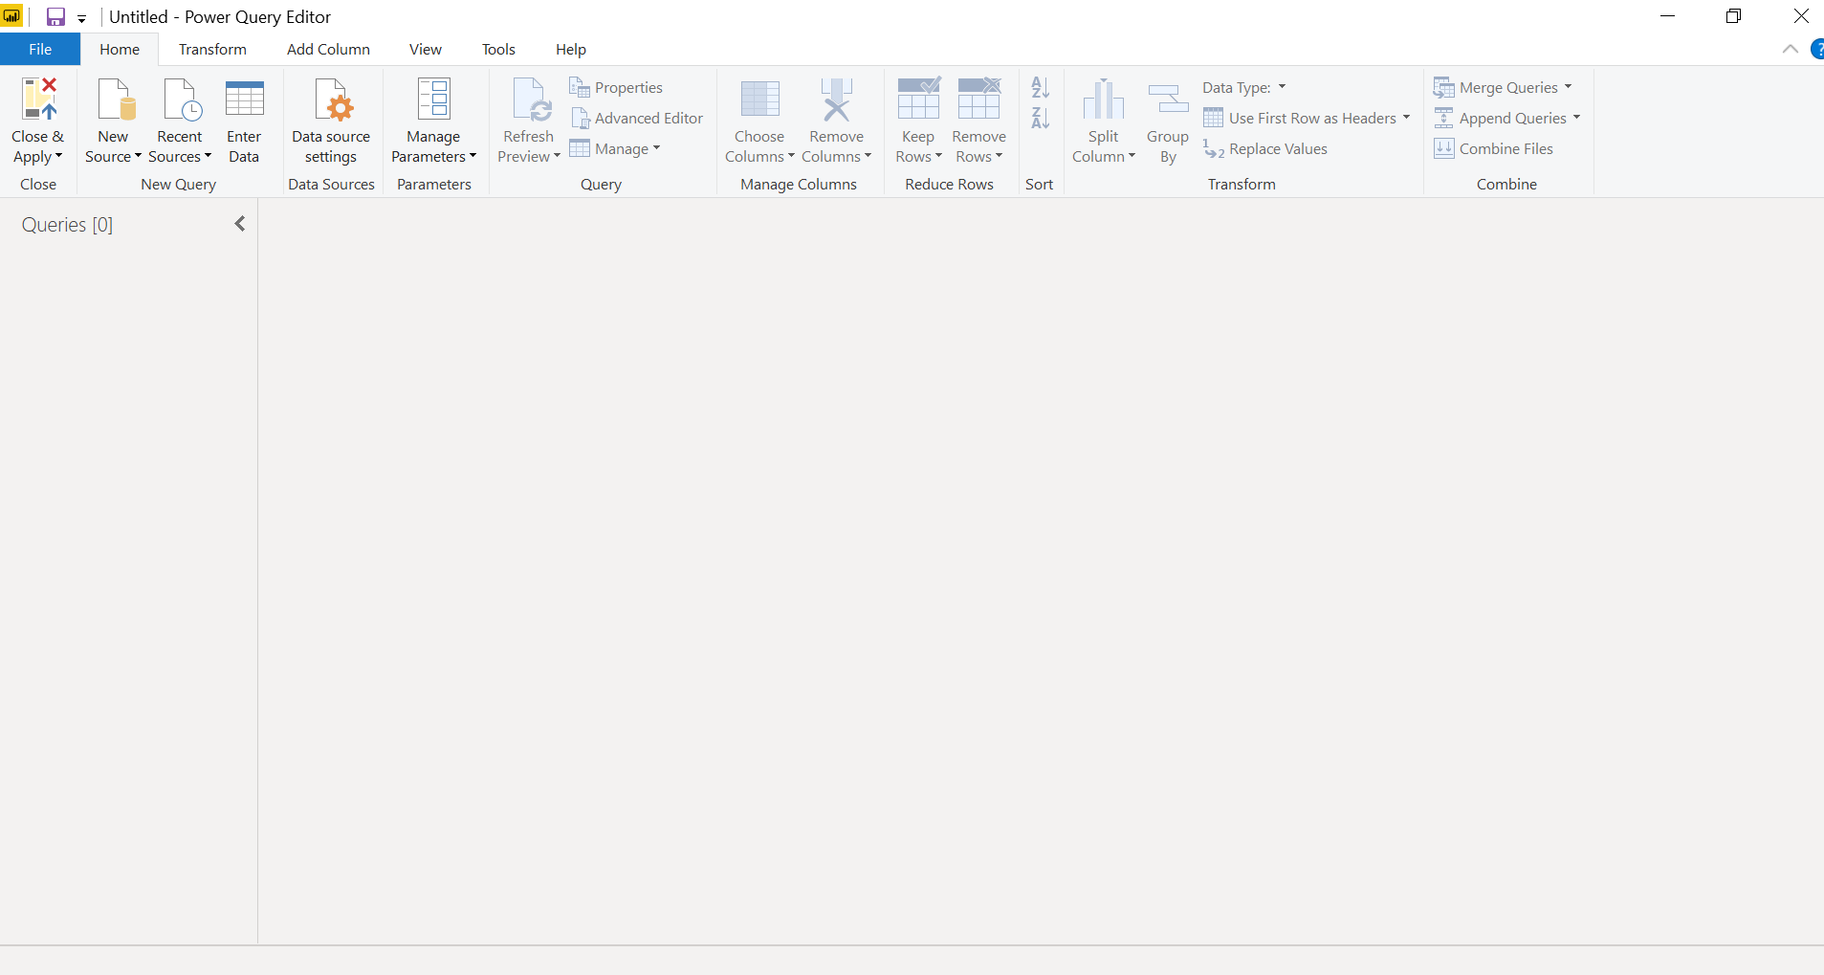

* Advance Editor

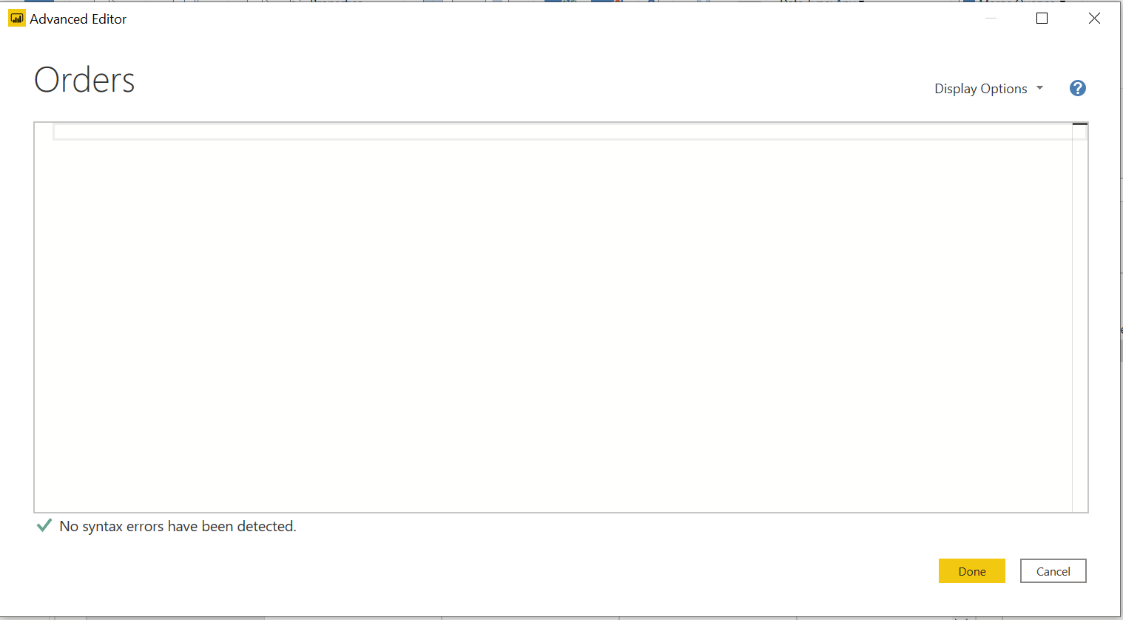

* Prepare a document with details of the following along with their price
* Power BI Desktop
* Power BI Pro
* Power BI Premium

|  |  |  |
| --- | --- | --- |
| Power BI Desktop | Power BI Pro | Power BI Premium |
| Free | $9.99 | $4,995 |