**ONLINE EVENT MANAGEMENT**

## PROJECT REPORT

*Submitted by*

**B. GIRIDHAR [RA2211003011259]**

**C. MANIKANTA REDDY** **[RA2211003011251]**

**K. J. SUJITH REDDY[RA2211003011214]**

*Under the Guidance of*

**Dr P. Kirubanantham**

Assistant Professor, Department of Networking and Communications

*In partial fulfillment of the requirementsfor the degree of*

**BACHELOR OF TECHNOLOGY**

**in**

**COMPUTER SCIENCE ENGINEERING**



**DEPARTMENT OF NETWORKING AND COMMUNICATIONS** **SCHOOL OF COMPUTING**

**COLLEGE OF ENGINEERING AND TECHNOLOGY SRM INSTITUTE OF SCIENCE ANDTECHNOLOGY**

**KATTANKULATHUR- 603**

**APRIL 2024**

# LogoSRM INSTITUTE OF SCIENCE AND TECHNOLOGY KATTANKULATHUR – 603 203

**BONAFIDE CERTIFICATE**

Certified that this B. Tech project report titled **“ONLINE EVENT MANAGEMENT”** is the bonafide work of **B.Giridhar(RA2211003011259), C Manikanta Reddy(RA2211003011251), K.J Sujith Reddy(RA2211003011214)** who carried out the project work under my/our supervision. Certified further, that to the best of my knowledge the work reported herein does not form part of any other thesis or dissertation on the basis of which a degree or award was conferred on an earlier occasion for this or any other candidate.

#### Dr P.Kirubanantham DR.K. ANNAPURANI

Supervisor and Associate Professor Professor and Head of the Department Dept. of Networking and Communications Dept. of Networking and Communications SRM Institute of Science and Technology SRM Institute of Science and Technology

#### Signature of Examiner I Signature of Examiner II



**Department of Networking and Communications**

**SRM Institute of Science Technology**

OWN WORK DECLARATION Form

**Degree/ Course: Bachelor of Technology, Computer Science Engineering Student Name:** B.Giridhar,C.Manikanta Reddy,K.J Sujith Reddy.

**Registration Number:** RA2211003011259, RA2211003011251, RA2211003011214.

#### Title of Work: TRIPLE RIDING AND HELMET DETECTION

We hereby certify that this assessment compiles with the University’s Rules and Regulations relating to Academic misconduct and plagiarism**, as listed in the University Website, Regulations, and the Education Committee guidelines.

We confirm that all the work contained in this assessment is our own except where indicated, and that we have met the following conditions:

* Clearly references / listed all sources as appropriate
* Referenced and put in inverted commas all quoted text (from books, web, etc)
* Given the sources of all pictures, data etc. that are not my own
* Not made any use of the report(s) or essay(s) of any other student(s) either past or present
* Acknowledged in appropriate places any help that I have received from others (e.g. fellow students, technicians, statisticians, external sources)
* Compiled with any other plagiarism criteria specified in the Course handbook / University website

We understand that any false claim for this work will be penalized in accordance with the University policies and regulations.

|  |
| --- |
| **DECLARATION:** |
| We are aware of and understand the University’s policy on Academic misconduct and plagiarism and I certify that this assessment is my / our own work, except were indicated by referring, and that I have followed the good academic practices noted above.  Student 1 Signature:  Student 2 Signature:  Student 3 Signature:  Student 4 Signature:  Date: |
|  |

# ACKNOWLEDGEMENT

We express our humble gratitude **to Dr C. Muthamizhchelvan**, Vice-Chancellor, SRM Institute of Science and Technology, for the facilities extended for the project work and his continued support.

We extend our sincere thanks to Dean-CET, SRM Institute of Science and Technology, **Dr T.V.Gopal**, for his invaluable support.

We wish to thank **Dr Revathi Venkataraman**, Professor & Chairperson, School of Computing, SRM Institute of Science and Technology, for her support throughout the project work.

We are incredibly grateful to our Head of the Department, **Dr. Annapurani K**, Professor, Department of Networking and Communications, SRM Institute of Science and Technology, for her suggestions and encouragement at all the stages of the project work.

We want to convey our thanks to our program coordinator **Dr. G. Suseela**, Associate Professor, Panel Head, Department of Networking and Communications, SRM Institute of Science and Technology, for her inputs during the project reviews and support.

We register our immeasurable thanks to our Faculty Advisor**, Dr. S Saravanan,** Assistant Professor, Department of Networking and Communications, SRM Institute of Science and Technology, for leading and helping us to complete our course.

Our inexpressible respect and thanks to our guide, **Dr. TYJ Naga Malleswari**, Associate Professor, Department of Networking and Communications, SRM Institute of Science and Technology, for providing us with an opportunity to pursue our project under her mentorship. She provided me/us with the freedom and support to explore the research topics of our interest. Her passion for solving problems and making a difference in the world has always been inspiring.

We sincerely thank the Networking and Communications Department, staff and students, SRM Institute of Science and Technology, for their help during our project. Finally, we would like to thank parents, family members, and friends for their unconditional love, constant support, and encouragement.

PRASHANKH AJIT MAMODIA [RA2211003011569] GAUTAM LUNAWAT [RA2211003011557] G.VENKATESWARA REDDY [RA2211003011460] K.AKSHAY [RA2211003011454]

**ABSTRACT**

Event management is a strong and fastgrowing profession with a rather low level of standardization. Often, we take event management as a part of project management, but we have to consider that event management has very specific concepts and issues which needs further developed methods and tools. In order to overcome the problems of record maintenance, delay of events, miscommunication between clients and manager, we have developed an event management software which would help the manager to organize as well as supervise the events. The system allows the registered user to login and new user are allowed to register on the application. The system helps in the organizing of events, users and the aspects related to them. This proposed to be a web application. The project provides the basic functionality required for an event type e.g. [party, wedding, commercial, etc.], the system then allows the user to select their requirements. All the data is logged in the database. The data is then sent to the administrator and they may interact with the client as per his requirement and also with the vendors

**Table of Contents**

1. INTRODUCTION 7

1.1 Introduction 7

1.2 Aim 7

1.3 Existing System 7

1.4 Proposed System 7

1.5Scope of The Project 8

2. LITERATURE REVIEW 9

2.1 Existing System 9

2.2 Feasibility Study 10

2.3 Non-Functional Requirements 12

3. SYSTEM DESIGN 14

3.1 Software Development Life Cycle Model 14

3.2 User Data-flow 15

3.3 Use Case Diagram 16

3.4 ER Diagram 17

3.5 DFD Diagram 18

4. SYSTEM ANALYSIS 19

4.1 Front-End 19

4.2 Back-End 21

4.4 Hardware Requirements 23

4.5 Software Requirements 23

5. SYSTEM TESTING 24

5.1 Unit Testing 24

5.2 Integration Testing 25

5.3 Software Verification and Validation 27

5.4 Black-Box Testing 29

5.5 White-Box Testing 29

5.6 System Testing 31

6. CONCLUSION 32

7. REFERENCES 33

**INTRODUCTION**

**1.1 Introduction**

This is an Online event management system software project that serves the functionality of an event manager. The system allows only registered users to login and new users are allowed to resister on the application. This is a web application developed in Asp.net and Sql but desktop application of the same application is also available. The project provides most of the basic functionality required for an event. It allows the user to select from a list of event types. Once the user enters an event type eg(Marriage, Dance Show etc), the system then allows the user to select the date and time of event, place and the event equipment’s. All this data is logged in the database and the user is given a receipt number for his booking. This data is then sent to the administrator (website owner) and they may interact with the client as per his requirements and his contact data stored in the database.

**1.2 Aim**

The aim of the Event Management Process is identifying events and determining corresponding control measures. There can be several updates or changes in a service or configuration item. Some of these changes can be critical while some changes can be minor without impacting other aspects of the IT services. The categorization of these events and defining appropriate control measures for these different events is an objective of the Event Management Process. Event Management Process is providing a basis for service assurance, reporting and service improvement. IT service providers aim for service improvement to improve the provided services consistently to increase the value provided to the customers. The Event Management Process helps to increase this value delivered to the customers.

**1.3 Existing System**

In the present scenario, existing system has many drawbacks which make it inefficient to carry on with it. The present working system of the referred company is manual. It is difficult to maintain all details of events, customers and the services. The execution of the event sometimes delays due to unmanaged planning. As far as quality is concerned it is ok but not as good when handled using computerized system.

**1.4 Proposed System**

The proposed system is computerized and has been developed using advance language therefore it gives more facilities than present system. It provides quick access to any data. In this system user have to enter the data only once and then it get linked with all files. This reduces the workload of user and it is also a time saving process. The information about any event can be easily retrieved. The system maintains all records easy. The proposed system consists of packages such as Silver, Golden and Platinum,e-card distribution, DJ service etc and updating the records at regular interval.

**1.5Scope of The Project**

The objective of this application is to develop a system that effectively manages all the data related to the various events that take place in an organization. The purpose is to maintain a centralized database of all event related information. The goal is to support various functions and processes necessary to manage the data efficiently.

**LITERATURE REVIEW**

We have studied various papers related to the event management system.

A central idea to maintain the College Event information and also to organize the event and send the Student Registration time in the way of sums with a verification code sent to the student using a mobile application on Android App. The tools contain Android SDK development, Java.

Assistant Prof. Khalil Pinjari introduced a system which will be computerized as well and has been developed using advanced language. It was a given web application. Now a day’s, the events taking place such as festivals, wedding, birthdays, etc. have become an important part of life which has eventually resulted in event organisers and Management Company to rise well. With the rate of customers, as well as events, increasing, it is quite difficult to manage using traditional systems of spreadsheets, traditional database. In the view and aim to overcome the drawbacks of the traditional Event Managing System, a new Smart Event Management System has been proposed which implements the modern technology of.Net Framework for managing different tasks and plans for employees, customer, location, transport and many more.

**2.1 Existing System**

In the current scenario, the existing system has many flaws which make it inefficient to carry on with it. Event management work of the referred company is done manually. It becomes difficult maintaining all details of events, customers and the services. The execution of the event sometimes delays due to some unmanageable obstruction in planning. As far as quality is concerned it is ok and not satisficing but not as good when handled using a computerized system. Now the drawbacks of the existing system can be stated in terms as follows:

* It is time consuming as the system is handled manually.
* Assurance of data security is not given.
* In long run, it is difficult to maintain records.
* Manpower requirement is huge.
* It is hectic to handle the huge transaction.

**2.2 Feasibility Study**

A feasibility study is a high-level capsule version of the entire System analysis and Design Process. The study begins by classifying the problem definition. Feasibility is to determine if it’s worth doing. Once an acceptance problem definition has been generated, the analyst develops a logical model of the system. A search for alternatives is analyzed carefully. There are 3 parts in feasibility study.

**2.2.1 OPERATIONAL FEASIBILITY**

Operational feasibility is the measure of how well a proposed system solves the problems, and takes advantage of the opportunities identified during scope definition and how it satisfies the requirements identified in the requirements analysis phase of system development. The operational feasibility assessment focuses on the degree to which the proposed development projects fits in with the existing business environment and objectives with regard to development schedule, delivery date, corporate culture and existing business processes. To ensure success, desired operational outcomes must be imparted during design and development. These include such design-dependent parameters as reliability, maintainability, supportability, usability, producibility, disposability, sustainability, affordability and others. These parameters are required to be considered at the early stages of design if desired operational behaviours are to be realised. A system design and development requires appropriate and timely application of engineering and management efforts to meet the previously mentioned parameters. A system may serve its intended purpose most effectively when its technical and operating characteristics are engineered into the design. Therefore, operational feasibility is a critical aspect of systems engineering that needs to be an integral part of the early design phases.

**2.2.2 TECHNICAL FEASIBILITY**

This involves questions such as whether the technology needed for the system exists, how difficult it will be to build, and whether the firm has enough experience using that technology. The assessment is based on outline design of system requirements in terms of input, processes, output, fields, programs and procedures. This can be qualified in terms of volume of data, trends, frequency of updating in order to give an introduction to the technical system. The application is the fact that it has been developed on windows XP platform and a high configuration of 1GB RAM on Intel Pentium Dual core processor. This is technically feasible .The technical feasibility assessment is focused on gaining an understanding of the present technical resources of the organization and their applicability to the expected needs of the proposed system. It is an evaluation of the hardware and software and how it meets the need of the proposed system.

**2.2.3 ECONOMICAL FEASIBILITY**

Establishing the cost-effectiveness of the proposed system i.e. if the benefits do not outweigh the costs then it is not worth going ahead. In the fast paced world today there is a great need of online social networking facilities. Thus the benefits of this project in the current scenario make it economically feasible. The purpose of the economic feasibility assessment is to determine the positive economic benefits to the organization that the proposed system will provide. It includes quantification and identification of all the benefits expected. This assessment typically involves a cost/benefits analysis.

**NUMBER OF MODULES**

The system after careful analysis has been identified to be presented with the following modules:

The Modules involved are

**Event Management Module :**

The employees who can use the application their personal information, contact information and other information etc…

This module consist of events information. All the information like type of the event, incharge of the event. These all information is maintained here.

Here in this module application is maintaining the total information of the event and the resources. Like type of the resource, resource details and resource management.

**Event Task Manager Module :**

The module is having the information of the events and their task manager details. Events task are maintained here, the total details of the events and incharge details maintained. In this module the information of the event and their details like, what are the events are there and from which event and to which event the movement is going on , which date , status of the event etc.

**Scheduling :**

This module consists of events information. All the information like type of the event, in charge of the event. These all information is maintained here.

**Security & Authentication Module :**

Security & Authentication module is main module which can provide security for entire processing of the system by using username, password, login, password

modifications etc.

**Reports Module :**

In this module system can generate different type of the reports.

**Payment Module:**

In this module user can pay the amount.

**2.3 Non-Functional Requirements**

**Performance** **Requirements:**

Performance is measured in terms of the output provided by the application. Requirement specification plays an important part in the analysis of a system. Only when the requirement specifications are properly given, it is possible to design a system, which will fit into required environment. It rests largely with the users of the existing system to give the requirement specifications because they are the people who finally use the system. This is because the requirements have to be known during the initial stages so that the system can be designed according to those requirements. It is very difficult to change the system once it has been designed and on the other hand designing a system, which does not cater to the requirements of the user, is of no use.

The requirement specification for any system can be broadly stated as given below:

The system should be able to interface with the existing system

The system should be accurate

The system should be better than the existing system

**Reliability :**

In this system reliability means the mail which is send by the source must reach the target user with any modification and accurate.

**Security :**

The web server and database server should be protected from hacking, virus etc

**Portability :**

The application will be developed using standard open source software (Except Oracle) like Java, tomcat web server, Internet Explorer Browser etc these software will work both on Windows and Linux o/s. Hence portability problems will not arise.

**Availability :**

This software will be available always.

**Maintainability :**

In this system the presentation layer is clearly separated from the service layer. So any modification in future will be done with less efforts. The database will be running at the server. Users access these forms by using the user-ids and the passwords.

* SYSTEM DESIGN

**3.1 Software Development Life Cycle Model**

3.1.1 WATERFALL MODEL

The waterfall model was selected as the SDLC model due to the following reasons:

Requirements were very well documented, clear and fixed.

Technology was adequately understood.

Simple and easy to understand and use.

There were no ambiguous requirements.

Easy to manage due to the rigidity of the model. Each phase has specific deliverables and a review process.

Clearly defined stages.

Well understood milestones. Easy to arrange tasks.

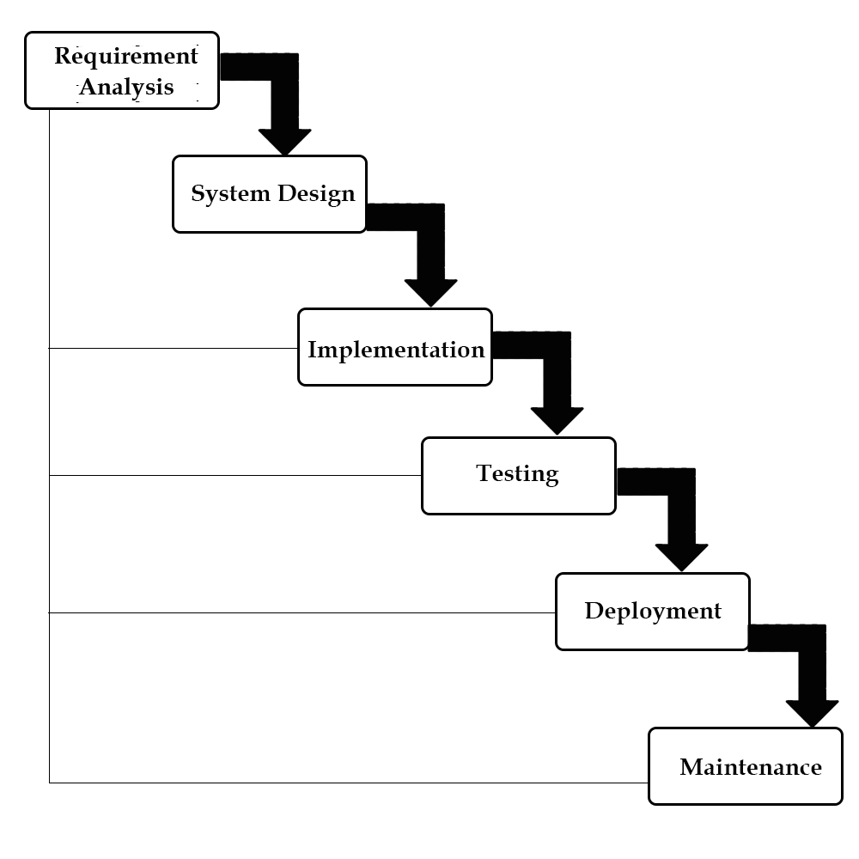

**3.2 User Data-flow**

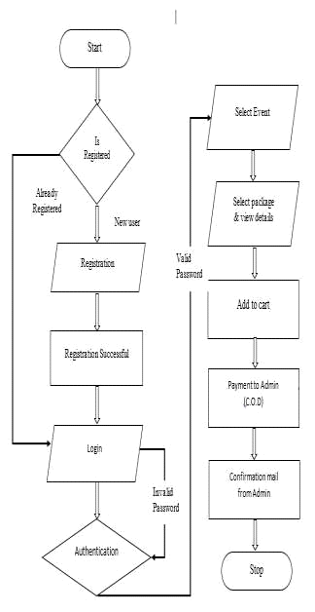

**Login User Details**

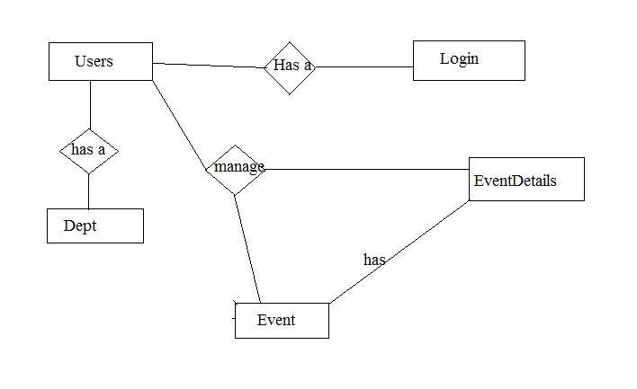

**3.3 Use Case Diagram**



**3.4 ER Diagram**

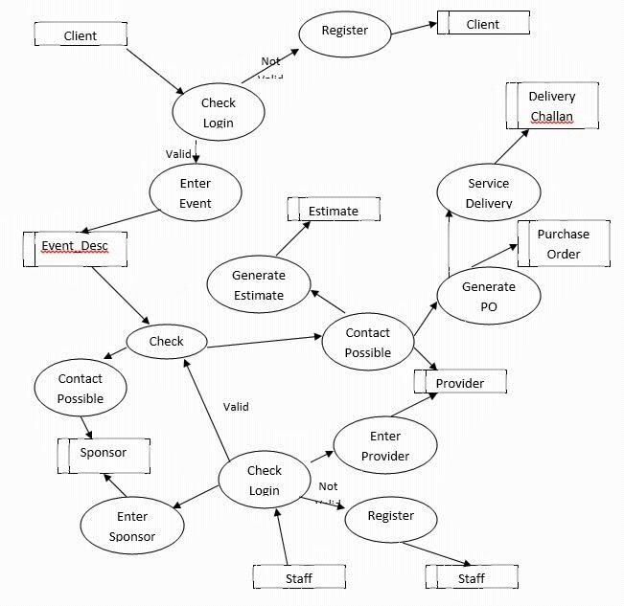

**4. SYSTEM ANALYSIS**

In this Section we will do Analysis of Technologies to use for implementing the project.

**4.1 Front-End**

**4.1.1 HTML**

Hypertext Markup Language (HTML) is the standard markup language for documents designed to be displayed in a web browser. It can be assisted by technologies such as Cascading Style Sheets (CSS) and scripting languages such as JavaScript. Web browsers receive HTML documents from a web server or from local storage and render the documents into multimedia web pages. HTML describes the structure of a web page semantically and originally included cues for the appearance of the document.

HTML elements are the building blocks of HTML pages. With HTML constructs, images and other objects such as interactive forms may be embedded into the rendered page. HTML provides a means to create structured documents by denoting structural semantics for text such as headings, paragraphs, lists, links, quotes and other items. HTML elements are delineated by tags, written using angle brackets. Tags such as <img /> and <input /> directly introduce content into the page. Other tags such as <p> surround and provide information about document text and may include other tags as sub-elements. Browsers do not display the HTML tags, but use them to interpret the content of the page.

HTML can embed programs written in a scripting language such as JavaScript, which affects the behavior and content of web pages. Inclusion of CSS defines the look and layout of content. The World Wide Web Consortium (W3C), former maintainer of the HTML and current maintainer of the CSS standards, has encouraged the use of CSS over explicit presentational HTML since 1997.

**4.1.2 Css**

Cascading Style Sheets (CSS) is a style sheet language used for describing the presentation of a document written in a markup language like HTML.CSS is a cornerstone technology of the World Wide Web, alongside HTML and JavaScript.CSS is designed to enable the separation of presentation and content, including layout, colors, and fonts.This separation can improve content accessibility, provide more flexibility and control in the specification of presentation characteristics, enable multiple web pages to share formatting by specifying the relevant CSS in a separate .css file, and reduce complexity and repetition in the structural content.

CSS information can be provided from various sources. These sources can be the web browser, the user and the author. The information from the author can be further classified into inline, media type, importance, selector specificity, rule order, inheritance and property definition. CSS style information can be in a separate document or it can be embedded into an HTML document. Multiple style sheets can be imported. Different styles can be applied depending on the output device being used; for example, the screen version can be quite different from the printed version, so that authors can tailor the presentation appropriately for each medium.The style sheet with the highest priority controls the content display. Declarations not set in the highest priority source are passed on to a source of lower priority, such as the user agent style. The process is called cascading.

One of the goals of CSS is to allow users greater control over presentation. Someone who finds red italic headings difficult to read may apply a different style sheet. Depending on the browser and the web site, a user may choose from various style sheets provided by the designers, or may remove all added styles and view the site using the browser's default styling, or may override just the red italic heading style without altering other attributes.

**4.1.3 JavaScript**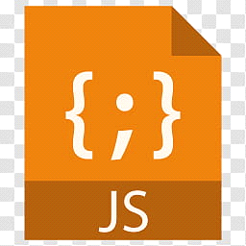

JavaScript s a high-level, interpreted scripting language that conforms to the ECMAScript specification. JavaScript has curly-bracket syntax, dynamic typing, prototype-based object-orientation, and first-class functions.Alongside HTML and CSS, JavaScript is one of the core technologies of the World Wide Web.JavaScript enables interactive web pages and is an essential part of web applications. The vast majority of websites use it,and major web browsers have a dedicated JavaScript engine to execute it.As a multi-paradigm language, JavaScript supports event-driven, functional, and imperative (including object-oriented and prototype-based) programming styles. It has APIs for working with text, arrays, dates, regular expressions, and the DOM, but the language itself does not include any I/O, such as networking, storage, or graphics facilities. It relies upon the host environment in which it is embedded to provide these features.

Initially only implemented client-side in web browsers, JavaScript engines are now embedded in many other types of host software, including server-side in web servers and databases, and in non-web programs such as word processors and PDF software, and in runtime environments that make JavaScript available for writing mobile and desktop applications, including desktop widgets.

The terms Vanilla JavaScript and Vanilla JS refer to JavaScript not extended by any frameworks or additional libraries. Scripts written in Vanilla JS are plain JavaScript code.Google's Chrome extensions, Opera's extensions, Apple's Safari 5 extensions, Apple's Dashboard Widgets, Microsoft's Gadgets, Yahoo! Widgets, Google Desktop Gadgets, and Serence Klipfolio are implemented using JavaScript.

**4.2 Back-End**

**4.2.1 PHP**

PHP is a server side scripting language that is used to develop Static websites or Dynamic websites or Web applications. PHP stands for Hypertext Pre-processor, that earlier stood for Personal Home Pages. PHP scripts can only be interpreted on a server that has PHP installed. The client computers accessing the PHP scripts require a web browser only. A PHP file contains PHP tags and ends with the extension ".php".

The term PHP is an acronym for PHP: Hypertext Preprocessor. PHP is a server-side scripting language designed specifically for web development. PHP can be easily embedded in HTML files and HTML codes can also be written in a PHP file. The thing that differentiates PHP with client-side language like HTML is, PHP codes are executed on the server whereas HTML codes are directly rendered on the browser.

PHP: Hypertext Preprocessor (or simply PHP) is a general-purpose programming language originally designed for web development. It was originally created by Rasmus Lerdorf in 1994.PHP code may be executed with a command line interface (CLI), embedded into HTML code, or used in combination with various web template systems, web content management systems, and web frameworks. PHP code is usually processed by a PHP interpreter implemented as a module in a web server or as a Common Gateway Interface (CGI) executable. The web server outputs the results of the interpreted and executed PHP code, which may be any type of data, such as generated HTML code or binary image data. PHP can be used for many programming tasks outside of the web context, such as standalone graphical applications and robotic drone control.

**4.2.2 MySQL**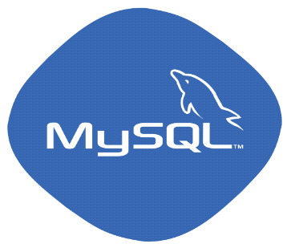

MySQL is an open source relational database management system (RDBMS) based on Structured Query Language (SQL). It is one part of the very popular LAMP platform consisting of Linux, Apache, My SQL, and PHP. Currently My SQL is owned by Oracle. My SQL database is available on most important OS platforms. It runs on BSD Unix, Linux, Windows, or Mac OS. Wikipedia and YouTube use My SQL. These sites manage millions of queries each day. My SQL comes in two versions: My SQL server system and My SQL embedded system.

RDBMS TERMINOLOGY

Before we proceed to explain MySQL database system, let's revise few definitions related to database.

**Database:**A database is a collection of tables, with related data.

**Table:**A table is a matrix with data. A table in a database looks like a simple spadsheet.

**Column:**One column (data element) contains data of one and the same kind, for example the column postcode.

**Row:**A row (= tuple, entry or record) is a group of related data, for example the data of one subscription.

**Redundancy:**Storing data twice, redundantly to make the system faster.

**Primary Key:**A primary key is unique. A key value cannot occur twice in one table. With a key, you can find at most one row.

**Foreign Key:**A foreign key is the linking pin between two tables.

**Compound Key:**A compound key (composite key) is a key that consists of multiple columns, because one column is not sufficiently unique.

**Index:**An index in a database resembles an index at the back of a book.

**Referential Integrity:**Referential Integrity makes sure that a foreign key value always points to an existing row.

**4.4 Hardware Requirements**

Processor : Intel P-IV based system

Processor Speed : 2.0. GHz

RAM : 1GB

Hard Disk : 40GB to 80GB

**4.5 Software Requirements**

Database : MYSQL

Server : APACHE

Frontend : HTML

Scripting language : JAVA SCRIPT

Web Technologies : PHP,MYSQL

IDE : XAMP

Technology : PHP

**5. SYSTEM TESTING**

The term implementation has different meanings ranging from the conversation of a basic application to a complete replacement of a computer system. The procedures however, are virtually the same. Implementation includes all those activities that take place to convert from old system to new. The new system may be totally new replacing an existing manual or automated system or it may be major modification to an existing system. The method of implementation and time scale to be adopted is found out initially. Proper implementation is essential to provide a reliable system to meet organization requirement.

**5.1 Unit Testing**

**5.1.1 Introduction**

In computer programming, unit testing is a software testing method by which individual units of source code, sets of one or more computer program modules together with associated control data, usage procedures, and operating procedures, are tested to determine whether they are fit for use. Intuitively, one can view a unit as the smallest testable part of an application. In procedural programming, a unit could be an entire module, but it is more commonly an individual function or procedure. In object-oriented programming, a unit is often an entire interface, such as a class, but could be an individual method. Unit tests are short code fragments created by programmers or occasionally by white box testers during the development process. It forms the basis for component testing. Ideally, each test case is independent from the others. Substitutes such as method stubs, mock objects, fakes, and test harnesses can be used to assist testing a module in isolation. Unit tests are typically written and run by software developers to ensure that code meets its design and behaves as intended.

**5.1.2 Benifits**

The goal of unit testing is to isolate each part of the program and show that the individual parts are correct. A unit test provides a strict, written contract that the piece of code must satisfy. As a result, it affords several benefits.

**1) Find problems early :**Unit testing finds problems early in the development cycle. In test-driven development (TDD), which is frequently used in both extreme programming and scrum, unit tests are created before the code itself is written. When the tests pass, that code is considered complete. The same unit tests are run against that function frequently as the larger code base is developed either as the code is changed or via an automated process with the build. If the unit tests fail, it is considered to be a bug either in the changed code or the tests themselves. The unit tests then allow the location of the fault or failure to be easily traced. Since the unit tests alert the development team of the problem before handing the code off to testers or clients, it is still early in the development process.

**2 ) Facilitates Change :**Unit testing allows the programmer to refactor code or upgrade system libraries at a later date, and make sure the module still works correctly (e.g., in regression testing). The procedure is to write test cases for all functions and methods so that whenever a change causes a fault, it can be quickly identified. Unit tests detect changes which may break a design contract.

**3 ) Simplifies Integration :**Unit testing may reduce uncertainty in the units themselves and can be used in a bottom-up testing style approach. By testing the parts of a program first and then testing the sum of its parts, integration testing becomes much easier.

**4 ) Documentation :**Unit testing provides a sort of living documentation of the system. Developers looking to learn what functionality is provided by a unit, and how to use it, can look at the unit tests to gain a basic understanding of the unit's interface (API).Unit test cases embody characteristics that are critical to the success of the unit. These characteristics can indicate appropriate/inappropriate use of a unit as well as negative behaviors that are to be trapped by the unit. A unit test case, in and of itself, documents these critical characteristics, although many software development environments do not rely solely upon code to document the product in development.

**5.2 Integration Testing**

Integration testing (sometimes called integration and testing, abbreviated I&T) is the phase in software testing in which individual software modules are combined and tested as a group. It occurs after unit testing and before validation testing. Integration testing takes as its input modules that have been unit tested, groups them in larger aggregates, applies tests defined in an integration test plan to those aggregates, and delivers as its output the integrated system ready for system testing.

**5.2.1 Purpose**

The purpose of integration testing is to verify functional, performance, and reliability requirements placed on major design items. These "design items", i.e., assemblages (or groups of units), are exercised through their interfaces using black-box testing, success and error cases being simulated via appropriate parameter and data inputs. Simulated usage of shared data areas and inter-process communication is tested and individual subsystems are exercised through their input interface. Test cases are constructed to test whether all the components within assemblages interact correctly, for example across procedure calls or process activations, and this is done after testing individual modules, i.e., unit testing. The overall idea is a "building block" approach, in which verified assemblages are added to a verified base which is then used to support the integration testing of further assemblages.Software integration testing is performed according to the software development life cycle (SDLC) after module and functional tests. The cross-dependencies for software integration testing are: schedule for integration testing, strategy and selection of the tools used for integration, define the cyclomatical complexity of the software and software architecture, reusability of modules and life-cycle and versioning management.Some different types of integration testing are big-bang, top-down, and bottom-up, mixed (sandwich) and risky-hardest. Other Integration Patterns[2] are: collaboration integration, backbone integration, layer integration, client-server integration, distributed services integration and high-frequency integration.

**5.2.1.1 Big Bang**

In the big-bang approach, most of the developed modules are coupled together to form a complete software system or major part of the system and then used for integration testing. This method is very effective for saving time in the integration testing process. However, if the test cases and their results are not recorded properly, the entire integration process will be more complicated and may prevent the testing team from achieving the goal of integration testing.A type of big-bang integration testing is called "usage model testing" which can be used in both software and hardware integration testing. The basis behind this type of integration testing is to run user-like workloads in integrated user-like environments. In doing the testing in this manner, the environment is proofed, while the individual components are proofed indirectly through their use. Usage Model testing takes an optimistic approach to testing, because it expects to have few problems with the individual components. The strategy relies heavily on the component developers to do the isolated unit testing for their product. The goal of the strategy is to avoid redoing the testing done by the developers, and instead flesh-out problems caused by the interaction of the components in the environment. For integration testing, Usage Model testing can be more efficient and provides better test coverage than traditional focused functional integration testing. To be more efficient and accurate, care must be used in defining the user-like workloads for creating realistic scenarios in exercising the environment. This gives confidence that the integrated environment will work as expected for the target customers.

**5.2.1.2 Top-down And Bottom-up**

Bottom-up testing is an approach to integrated testing where the lowest level components are tested first, then used to facilitate the testing of higher level components. The process is repeated until the component at the top of the hierarchy is tested.All the bottom or low-level modules, procedures or functions are integrated and then tested. After the integration testing of lower level integrated modules, the next level of modules will be formed and can be used for integration testing. This approach is helpful only when all or most of the modules of the same development level are ready. This method also helps to determine the levels of software developed and makes it easier to report testing progress in the form of a percentage.Top-down testing is an approach to integrated testing where the top integrated modules are tested and the branch of the module is tested step by step until the end of the related module.Sandwich testing is an approach to combine top down testing with bottom up testing.

**5.3 Software Verification and Validation**

**5.3.1 Introduction**

In software project management, software testing, and software engineering, verification and validation (V&V) is the process of checking that a software system meets specifications and that it fulfills its intended purpose. It may also be referred to as software quality control. It is normally the responsibility of software testers as part of the software development lifecycle. Validation checks that the product design satisfies or fits the intended use (high-level checking), i.e., the software meets the user requirements.This is done through dynamic testing and other forms of review.Verification and validation are not the same thing, although they are often confused. Boehm succinctly expressed the difference between

Validation : Are we building the right product?

Verification : Are we building the product right?

According to the Capability Maturity Model (CMMI-SW v1.1)

Software Verification: The process of evaluating software to determine whether the products of a given development phase satisfy the conditions imposed at the start of that phase.

Software Validation: The process of evaluating software during or at the end of the development process to determine whether it satisfies specified requirements.

In other words, software verification is ensuring that the product has been built according to the requirements and design specifications, while software validation ensures that the product meets the user's needs, and that the specifications were correct in the first place. Software verification ensures that "you built it right". Software validation ensures that "you built the right thing". Software validation confirms that the product, as provided, will fulfill its intended use.

From Testing Perspective

Fault – wrong or missing function in the code.

Failure – the manifestation of a fault during execution.

Malfunction – according to its specification the system does not meet its specified functionality

Both verification and validation are related to the concepts of quality and of software quality assurance. By themselves, verification and validation do not guarantee software quality; planning, traceability, configuration management and other aspects of software engineering are required.Within the modeling and simulation (M&S) community, the definitions of verification, validation and accreditation are similar:

M&S Verification is the process of determining that a ⦁ computer model, simulation, or federation of models and simulations implementations and their associated data accurately represent the developer's conceptual description and specifications.

M&S Validation is the process of determining the degree to which a model, simulation, or federation of models and simulations, and their associated data are accurate representations of the real world from the perspective of the intended use(s).

**5.3.2 Classification of Methods**

In mission-critical software systems, where flawless performance is absolutely necessary, formal methods may be used to ensure the correct operation of a system. However, often for non-mission-critical software systems, formal methods prove to be very costly and an alternative method of software V&V must be sought out. In such cases, syntactic methods are often used.

**5.3.3 Test Cases**

A test case is a tool used in the process. Test cases may be prepared for software verification and software validation to determine if the product was built according to the requirements of the user. Other methods, such as reviews, may be used early in the life cycle to provide for software validation.

**5.4 Black-Box Testing**

Black-box testing is a method of software testing that examines the functionality of an application without peering into its internal structures or workings. This method of test can be applied virtually to every level of software testing: unit, integration, system and acceptance. It typically comprises most if not all higher level testing, but can also dominate unit testing as well.

**5.4.1 Test Procedures**

Specific knowledge of the application's code/internal structure and programming knowledge in general is not required. The tester is aware of what the software is supposed to do but is not aware of how it does it. For instance, the tester is aware that a particular input returns a certain, invariable output but is not aware of how the software produces the output in the first place.

**5.4.2 Test Cases**

Test cases are built around specifications and requirements, i.e., what the application is supposed to do. Test cases are generally derived from external descriptions of the software, including specifications, requirements and design parameters. Although the tests used are primarily functional in nature, non-functional tests may also be used. The test designer selects both valid and invalid inputs and determines the correct output, often with the help of an oracle or a previous result that is known to be good, without any knowledge of the test object's internal structure.

**5.5 White-Box Testing**

White-box testing (also known as clear box testing, glass box testing, transparent box testing, and structural testing) is a method of testing software that tests internal structures or workings of an application, as opposed to its functionality (i.e. black-box testing). In white-box testing an internal perspective of the system, as well as programming skills, are used to design test cases. The tester chooses inputs to exercise paths through the code and determine the appropriate outputs. This is analogous to testing nodes in a circuit, e.g. in-circuit testing (ICT). White-box testing can be applied at the unit, integration and system levels of the software testing process. Although traditional testers tended to think of white-box testing as being done at the unit level, it is used for integration and system testing more frequently today. It can test paths within a unit, paths between units during integration, and between subsystems during a system–level test. Though this method of test design can uncover many errors or problems, it has the potential to miss unimplemented parts of the specification or missing requirements.

**5.5.1 Levels**

**1 ) Unit testing :**White-box testing is done during unit testing to ensure that the code is working as intended, before any integration happens with previously tested code. White-box testing during unit testing catches any defects early on and aids in any defects that happen later on after the code is integrated with the rest of the application and therefore prevents any type of errors later on.

**2 ) Integration testing :**White-box testing at this level are written to test the interactions of each interface with each other. The Unit level testing made sure that each code was tested and working accordingly in an isolated environment and integration examines the correctness of the behaviour in an open environment through the use of white-box testing for any interactions of interfaces that are known to the programmer.

**3 ) Regression testing :**White-box testing during regression testing is the use of recycled white-box test cases at the unit and integration testing levels.

**5.5.2 Procedures**

White-box testing's basic procedures involves the tester having a deep level of understanding of the source code being tested. The programmer must have a deep understanding of the application to know what kinds of test cases to create so that every visible path is exercised for testing. Once the source code is understood then the source code can be analyzed for test cases to be created. These are the three basic steps that white-box testing takes in order to create test cases:

Input involves different types of requirements, functional specifications, detailed designing of documents, proper source code, security specifications. This is the preparation stage of white-box testing to layout all of the basic information.

Processing involves performing risk analysis to guide whole testing process, proper test plan, execute test cases and communicate results. This is the phase of building test cases to make sure they thoroughly test the application the given results are recorded accordingly.

Output involves preparing final report that encompasses all of the above preparations and results.

**5.5.3 Advantages**

White-box testing is one of the two biggest testing methodologies used today. It has several major advantages:

Side effects of having the knowledge of the source code is beneficial to thorough testing.

Optimization of code by revealing hidden errors and being able to remove these possible defects.

Gives the programmer introspection because developers carefully describe any new implementation.

Provides traceability of tests from the source, allowing future changes to the software to be easily captured in changes to the tests.

White box testing give clear, engineering-based, rules for when to stop testing.

**5.5.5 Disadvantages**

Although white-box testing has great advantages, it is not perfect and contains some disadvantages:

White-box testing brings complexity to testing because the tester must have knowledge of the program, including being a programmer. White-box testing requires a programmer with a high level of knowledge due to the complexity of the level of testing that needs to be done.

On some occasions, it is not realistic to be able to test every single existing condition of the application and some conditions will be untested.

The tests focus on the software as it exists, and missing functionality may not be discovered.

**5.6 System Testing**

System testing of software or hardware is testing conducted on a complete, integrated system to evaluate the system's compliance with its specified requirements. System testing falls within the scope of black-box testing, and as such, should require no knowledge of the inner design of the code or logic. As a rule, system testing takes, as its input, all of the "integrated" software components that have passed integration testing and also the software system itself integrated with any applicable hardware system(s). The purpose of integration testing is to detect any inconsistencies between the software units that are integrated together (called assemblages) or between any of the assemblages and the hardware. System testing is a more limited type of testing; it seeks to detect defects both within the "inter-assemblages" and also within the system as a whole.

System testing is performed on the entire system in the context of a Functional Requirement Specification(s) (FRS) and/or a System Requirement Specification (SRS). System testing tests not only the design, but also the behavior and even the believed expectations of the customer. It is also intended to test up to and beyond the bounds defined in the software/hardware requirements specification(s).

## 5.6 Coding

**Index.php**

<!DOCTYPE html>

<html>

<head>

<meta http-equiv="Content-Type" content="text/html; charset=UTF-8">

<title>Bootstrap Web Design</title>

<?php require 'utils/styles.php'; ?><!--css links. file found in utils folder-->

<?php require 'utils/scripts.php'; ?><!--js links. file found in utils folder-->

</head>

<body>

<?php require 'utils/header.php'; ?><!--header content. file found in utils folder-->

<div class = "content"><!--body content holder-->

<div class = "container">

<div class = "col-md-12"><!--body content title holder with 12 grid columns-->

<h1>What we organize</h1><!--body content title-->

</div>

</div>

<div class="container">

<div class="col-md-12">

<hr>

</div>

</div>

<div class="row"><!--wedding content-->

<section>

<div class="container">

<div class="col-md-6"><!--image holder with 6 grid columns-->

<img src="images/wedding2.jpg" class="img-responsive">

</div>

<div class="subcontent col-md-6"><!--Text holder with 6 column grid-->

<h1>Wedding</h1><!--title-->

<p><!--content-->

The most important day in a couple's life.

Guaranteeing personalized solutions and flawless execution, our venues provide the perfect

location for your special day.

</p>

<hr class="customline"><!--css modified horizontal line-->

<button type="button" class="btn btn-default btn-lg"><!--view event button (no function implemented)-->

View Events <span class="glyphicon glyphicon-arrow-right" aria-hidden="true"></span><!--arrow right glyphicon-->

</button>

</div><!--subcontent div-->

</div><!--container div-->

</section>

</div><!--row div-->

<div class="container">

<div class="col-md-12">

<hr>

</div>

</div>

<div class="row">

<section>

<div class="container">

<div class="col-md-6"><!--image holder with 6 grid columns-->

<img src="images/birthday2.jpg" class="img-responsive">

</div>

<div class="subcontent col-md-6"><!--Text holder with 6 column grid-->

<h1>Birthday</h1><!--title-->

<p><!--content-->

Whether an all-day or the ultimate extravaganza that

lasts well into the wee hours, our Urban Events team is here to make sure all your birthday

party wishes come true so you can kick back, drink up and enjoy your special day!

</p>

<hr class="customline"><!--css modified horizontal line-->

<button type="button" class="btn btn-default btn-lg"><!--view event button (no function implemented)-->

View Events <span class="glyphicon glyphicon-arrow-right" aria-hidden="true"></span><!--arrow right glyphicon-->

</button>

</div><!--subcontent div-->

</div><!--container div-->

</section>

</div><!--row div-->

<div class="container">

<div class="col-md-12">

<hr>

</div>

</div>

<div class="row">

<section>

<div class="container">

<div class="col-md-6"><!--image holder with 6 grid columns-->

<img src="images/fashion2.jpg" class="img-responsive">

</div>

<div class="subcontent col-md-6"><!--Text holder with 6 column grid-->

<h1>Fashion</h1><!--title-->

<p><!--content-->

Fast becoming to go-to location for fashion events, PR gatherings and product launches,

The Urban Purveyor Group venues provide you with choice and quality in premium locations

for all your event needs.

</p>

<hr class="customline"><!--css modified horizontal line-->

<button type="button" class="btn btn-default btn-lg"><!--view event button (no function implemented)-->

View Events <span class="glyphicon glyphicon-arrow-right" aria-hidden="true"></span><!--arrow right glyphicon-->

</button>

</div><!--subcontent div-->

</div><!--container div-->

</section>

</div><!--row div-->

<div class="container">

<div class="col-md-12">

<hr>

</div>

</div>

<div class="row">

<section>

<div class="container">

<div class="col-md-6"><!--image holder with 6 grid columns-->

<img src="images/meeting2.jpg" class="img-responsive">

</div>

<div class="subcontent col-md-6"><!--Text holder with 6 column grid-->

<h1>Meeting</h1><!--title-->

<p><!--content-->

From formal, to not-so-formal, our flexible event

spaces can cater to your every need for meetings and conferences large or small, and our

dedicated event team can assist with all aspects of your event planning.

</p>

<hr class="customline"><!--css modified horizontal line-->

<button type="button" class="btn btn-default btn-lg"><!--view event button (no function implemented)-->

View Events <span class="glyphicon glyphicon-arrow-right" aria-hidden="true"></span><!--arrow right glyphicon-->

</button>

</div><!--subcontent div-->

</div><!--container div-->

</section>

</div><!--row div-->

</div><!--body content div-->

<?php require 'utils/footer.php'; ?><!--footer content. file found in utils folder-->

</body>

</html>

**Event.php**

<!DOCTYPE html>

<html>

<head>

<meta http-equiv="Content-Type" content="text/html; charset=UTF-8">

<title>Bootstrap Web Design</title>

<?php require 'utils/styles.php'; ?><!--css links. file found in utils folder-->

<?php require 'utils/scripts.php'; ?><!--js links. file found in utils folder-->

</head>

<body>

<?php require 'utils/header.php'; ?><!--header content. file found in utils folder-->

<div class="content"><!--body content holder-->

<div class="container">

<div class="col-md-12"><!--body content title holder with 12 grid columns-->

<h1>What's On</h1><!--body content title-->

</div>

</div>

<div class="container">

<div class="col-md-12">

<hr>

</div>

</div>

<div class="row"><!--event content-->

<section>

<div class="container">

<div class="date col-md-1"><!--date holder with 1 grid column-->

<span class="month">JAN</span><br><!--month-->

<hr class="line"><!--css modified horizontal line-->

<span class="day">20</span><!--day-->

</div>

<div class="col-md-5"><!--image holder with 5 grid column-->

<img src="images/bdayevent.jpg" class="img-responsive">

</div>

<div class="subcontent col-md-6"><!--event content holder with 6 grid column-->

<h1 class="title">Joe's 21st</h1><!--event content title-->

<p class="location"><!--event content location-->

UrbanXchange Private Dining Room, The Rocks 12 Argyle Street

</p>

<p class="definition"><!--event content definition-->

Lorem Ipsum is simply dummy text of the printing and typesetting industry.

When an unknown printer took a galley of type and scrambled it to make a type specimen book.

</p>

<hr class="customline2"><!--css modified horizontal line-->

<button type="button" class="btn btn-default btn-lg"><!--view details button (no function implemented)-->

View Details <span class="glyphicon glyphicon-arrow-right" aria-hidden="true"></span><!--arrow right glyphicon-->

</button>

</div><!--subcontent div-->

</div><!--container div-->

</section>

</div><!--row div-->

<div class="container">

<div class="col-md-12">

<hr>

</div>

</div>

<div class="row">

<section>

<div class="container">

<div class="date col-md-1"><!--date holder with 1 grid column-->

<span class="month">APR</span><br><!--month-->

<hr class="line"><!--css modified horizontal line-->

<span class="day">20</span><!--day-->

</div>

<div class="col-md-5"><!--image holder with 5 grid column-->

<img src="images/fashevent.jpg" class="img-responsive">

</div>

<div class="subcontent col-md-6"><!--event content holder with 6 grid column-->

<h1 class="title">Dress to Impress</h1><!--event content title-->

<p class="location"><!--event content location-->

Ananas Bar & Brasserie, The Rocks 18 Argyle Street

</p>

<p class="definition"><!--event content definition-->

Lorem Ipsum is simply dummy text of the printing and typesetting industry.

When an unknown printer took a galley of type and scrambled it to make a type specimen book.

</p>

<hr class="customline2"><!--css modified horizontal line-->

<button type="button" class="btn btn-default btn-lg"><!--view details button (no function implemented)-->

View Details <span class="glyphicon glyphicon-arrow-right" aria-hidden="true"></span><!--arrow right glyphicon-->

</button>

</div><!--subcontent div-->

</div><!--container div-->

</section>

</div><!--row div-->

<div class="container">

<div class="col-md-12">

<hr>

</div>

</div>

<div class="row">

<section>

<div class="container">

<div class="date col-md-1"><!--date holder with 1 grid column-->

<span class="month">JUN</span><br><!--month-->

<hr class="line"><!--css modified horizontal line-->

<span class="day">20</span><!--day-->

</div>

<div class="col-md-5"><!--image holder with 5 grid column-->

<img src="images/wedevent.jpg" class="img-responsive">

</div>

<div class="subcontent col-md-6"><!--event content holder with 6 grid column-->

<h1 class="title">Our 2nd Anniversary</h1><!--event content title-->

<p class="location"><!--event content location-->

Munich Brauhaus South Wharf, 45 South Wharf Promenade

</p>

<p class="definition"><!--event content definition-->

Lorem Ipsum is simply dummy text of the printing and typesetting industry.

When an unknown printer took a galley of type and scrambled it to make a type specimen book.

</p>

<hr class="customline2"><!--css modified horizontal line-->

<button type="button" class="btn btn-default btn-lg"><!--view details button (no function implemented)-->

View Details <span class="glyphicon glyphicon-arrow-right" aria-hidden="true"></span><!--arrow right glyphicon-->

</button>

</div><!--subcontent div-->

</div><!--container div-->

</section>

</div><!--row div-->

<div class="container">

<div class="col-md-12">

<hr>

</div>

</div>

<div class="row">

<section>

<div class="container">

<div class="date col-md-1"><!--date holder with 1 grid column-->

<span class="month">AUG</span><br><!--month-->

<hr class="line"><!--css modified horizontal line-->

<span class="day">20</span><!--day-->

</div>

<div class="col-md-5"><!--image holder with 5 grid column-->

<img src="images/meetevent.jpg" class = "img-responsive">

</div>

<div class="subcontent col-md-6"><!--event content holder with 6 grid column-->

<h1 class="title">Career Talk</h1><!--event content title-->

<p class="location"><!--event content location-->

UrbanXchange Private Dining Room, The Rocks 12 Argyle Street

</p>

<p class="definition"><!--event content definition-->

Lorem Ipsum is simply dummy text of the printing and typesetting industry.

When an unknown printer took a galley of type and scrambled it to make a type specimen book.

</p>

<hr class="customline2"><!--css modified horizontal line-->

<button type="button" class="btn btn-default btn-lg"><!--view details button (no function implemented)-->

View Details <span class="glyphicon glyphicon-arrow-right" aria-hidden="true"></span><!--arrow right glyphicon-->

</button>

</div><!--subcontent div-->

</div><!--container div-->

</section>

</div><!--row div-->

</div><!--body content div-->

<?php require 'utils/footer.php'; ?><!--footer content. file found in utils folder-->

</body>

</html>

**Form.php**

<?php

require_once 'functions.php';

if (!isset($formdata)) {

$formdata = array();

}

if (!isset($errors)) {

$errors = array();

}

?>

<!DOCTYPE html>

<html>

<head>

<meta charset="UTF-8">

<title>Create Location Form</title>

<style>

span.error{

color: red;

}

</style>

<?php require 'utils/styles.php'; ?><!--css links. file found in utils folder-->

<?php require 'utils/scripts.php'; ?><!--js links. file found in utils folder-->

</head>

<body>

<?php require 'utils/header.php'; ?><!--header content. file found in utils folder-->

<div class="content">

<div class="container">

<h1>Create Location Form</h1><!--form title-->

<?php

if (isset($errorMessage)) {

echo '<p>Error: ' . $errorMessage . '</p>';

}

?>

<form action="createLocation.php" method="POST" class="form-horizontal">

<div class="form-group">

<label for="Name" class="col-md-2 control-label">Location Name</label>

<div class="col-md-5">

<input type="text" class="form-control" id="Name" name="Name" value="<?php echoValue($formdata, "Name")?>" /><!--input-->

</div>

<div class="col-md-4">

<span id="LNameError" class="error"><!--error message for invalid input-->

<?php echoValue($errors, 'Name');?>

</span>

</div>

</div>

<div class="form-group">

<label for="Address" class="col-md-2 control-label">Address</label>

<div class="col-md-5">

<input type="text" class="form-control" id="Address" name="Address" value="<?php echoValue($formdata, "Address")?>" /><!--input-->

</div>

<div class="col-md-4">

<span id="LAddressError" class="error"><!--error message for invalid input-->

<?php echoValue($errors, 'Address');?>

</span>

</div>

</div>

<div class="form-group">

<label for="managerFName" class="col-md-2 control-label">Manager First Name</label>

<div class="col-md-5">

<input type="text" class="form-control" id="managerFName" name="managerFName" value="<?php echoValue($formdata, "managerFName")?>" /><!--input-->

</div>

<div class="col-md-4">

<span id="mNameError" class="error"><!--error message for invalid input-->

<?php echoValue($errors, 'managerFName');?>

</span>

</div>

</div>

<div class="form-group">

<label for="managerLName" class="col-md-2 control-label">Manager Last Name</label>

<div class="col-md-5">

<input type="text" class="form-control" id="managerName" name="managerLName" value="<?php echoValue($formdata, "managerLName")?>" /><!--input-->

</div>

<div class="col-md-4">

<span id="mNameError" class="error"><!--error message for invalid input-->

<?php echoValue($errors, 'managerLName');?>

</span>

</div>

</div>

<div class="form-group">

<label for="managerEmail" class="col-md-2 control-label">Manager Email</label>

<div class="col-md-5">

<input type="email" class="form-control" id="managerEmail" name="managerEmail" value="<?php echoValue($formdata, "managerEmail")?>" /><!--input-->

</div>

<div class="col-md-4">

<span id="mEmailError" class="error"><!--error message for invalid input-->

<?php echoValue($errors, 'managerEmail');?>

</span>

</div>

</div>

<div class="form-group">

<label for="managerNumber" class="col-md-2 control-label">Manager Number</label>

<div class="col-md-5">

<input type="number" class="form-control" id="managerNumber" name="managerNumber" value="<?php echoValue($formdata, "managerNumber")?>" /><!--input-->

</div>

<div class="col-md-4">

<span id="mNumError" class="error"><!--error message for invalid input-->

<?php echoValue($errors, 'managerNumber');?>

</span>

</div>

</div>

<div class="form-group">

<label for="locationMaxCap" class="col-md-2 control-label">Max Capacity</label>

<div class="col-md-5">

<input type="number" class="form-control" id="locationMaxCap" name="maxCap" value="<?php echoValue($formdata, "maxCap")?>" /><!--input-->

</div>

<div class="col-md-4">

<span id="capError" class="error"><!--error message for invalid input-->

<?php echoValue($errors, 'maxCap');?>

</span>

</div>

</div>

<!--codes below has no connection with the database.-->

<div class="form-group">

<label class="col-md-2 control-label">Location Type</label><!--radio buttons with multiple options-->

<div class="col-md-5">

<input type="radio" name="lType" value="indoor" <?php echoChecked($formdata, "lType", "indoor"); ?> >Indoor <br>

<input type="radio" name="lType" value="outdoor" <?php echoChecked($formdata, "lType", "outdoor"); ?>>Outdoor <br>

<input type="radio" name="lType" value="both" <?php echoChecked($formdata, "lType", "both"); ?>>Both

</div>

<div class="col-md-4">

<span id="typeError" class="error">

</span>

</div>

</div>

<div class="form-group">

<label class="col-md-2 control-label">Seating Available</label>

<div class="col-md-5">

<select class="form-control" name="seat">

<option value="yes" <?php echoSelected($formdata, "seat", "yes"); ?>>Yes</option>

<option value="no" <?php echoSelected($formdata, "seat", "no"); ?>>No</option>

</select>

</div>

</div>

<div class="form-group">

<label class="col-md-2 control-label">Facilities</label>

<div class="col-md-5">

<input type="checkbox" name="facilities[]" value="sound" <?php echoCheckedArray($formdata, 'facilities', 'sound'); ?> >Sound Room <br>

<input type="checkbox" name="facilities[]" value="screen" <?php echoCheckedArray($formdata, "facilities", "screen"); ?> >Big Screen Room <br>

<input type="checkbox" name="facilities[]" value="restaurant" <?php echoCheckedArray($formdata, "facilities", "restaurant"); ?> >Restaurants <br>

<input type="checkbox" name="facilities[]" value="bar" <?php echoCheckedArray($formdata, "facilities", "bar"); ?> >Bar <br>

<input type="checkbox" name="facilities[]" value="disabled" <?php echoCheckedArray($formdata, "facilities", "disabled"); ?> >Disabled Access Toilets <br>

</div>

</div>

<div class="form-group">

<label class="col-md-2 control-label">Url</label>

<div class="col-md-5">

<input type="text" class="control-label" name="link">

</div>

<div class="col-md-4">

<span id="urlError" class="error">

<?php echoValue($errors, 'link');?>

</span>

</div>

</div>

<div class="form-group">

<label class="col-md-2 control-label">Attach File:</label>

<div class="col-md-5">

<input type="file" class="control-label" name="attachment">

</div>

</div>

<button type="submit" name="createLocation" class="btn btn-default pull-right">Create Location <span class="glyphicon glyphicon-send"></span></button>

</form>

<a class="btn btn-default" href="viewLocations.php"><span class="glyphicon glyphicon-circle-arrow-left"></span> Back</a><!--return/back button-->

</div>

</div>

<?php require 'utils/footer.php'; ?><!--footer content. file found in utils folder-->

</body>

</html>

**6. CONCLUSION**

Through this software, the respective events will be managed and automated to the entire database in the network. With this project, human effort will definitely reduce and user/customer and the administrator’s task will become much easier. It becomes easy to work on this software and it is efficient to use. Thus, by keeping in mind, the advantages and applications; we are developing an Event management software. This software will help the administrator as well as a customer a lot.

In this paper, The project Event Management System has been designed and tested. Integrating features of all the software components used have developed it. With the help of growing technology the project has been successfully implemented. Project will definitely reduce the human effort and make the task of user, customer and administrator easier. It is efficient to use and easy to work on it. Thus keeping in mind the advantages and applications. we are developing an Event management software which has total management control of customer and respective service of different events.

**Advantages:**

* This system is effective and saves time and cost of the users.
* To increase efficiency of managing the Event, Employee
* Editing, adding and updating of Records is improved which results in proper resource management of Event data.
* Easy to access the system anywhere and anytime.
* This is an automated application where system directly fetches the desired result from the database without having any interaction from the administrator.
* It has a simple interface, easy to understand for the user.
* High level security is provided by SQL with the help of secure authentication.
* All transactions can be easily maintained.
* **8. REFERENCES**
* [https://www.projectworlds.in](https://www.projectworlds.in/)
* [https://www.javatpoint.com](https://www.javatpoint.com/)
* [https://www.w3schools.com](https://www.w3schools.com/)
* [https://html.com](https://html.com/)
* M.Mahalakshmi, S.Gomathi and, S.Krithika, “Event Management System”, Volume 3(2), Mar - Apr 2016.
* Assistant Prof. Khalil Pinjari and Khan Nur, “Smart Event Management System”, Department of Information Technology Theem College of Engineering Mumbai

University, India.IJCST– Volume 4 Issue 2, Mar - Apr 2016

* [3]https://www.scribd.com/document/342098952/Syn opsis-of-Event-Management-System
* [6]http://www.academia.edu/4593395/Project_Report_ On_Event_management
* [7]https://www.slideshare.net/mobile/DYogendraRao/ event-management-system-24592836
* [8]https://solutiondots.com/blog/event-managementsystem-comprehensive-solution-events-management/