Low Level Design

Thyroid Disease Prediction System

|  |  |
| --- | --- |
| Written By | K S Sujith |
| Document Version | 1.0 |
| Last Revised Date | 20 – jan -2024 |

**Document Control**

### Change Record:

|  |  |  |  |
| --- | --- | --- | --- |
| **Version** | **Date** | **Author** | **Comments** |
| 0.1 | 19 -Jan -2024 | KS Sujith | Introduction ,flow, Architecture ,unit test cases included |
|  |  |  |  |
|  |  |  |  |
|  |  |  |  |

### Reviews:

|  |  |  |  |
| --- | --- | --- | --- |
| **Version** | **Date** | **Reviewer** | **Comments** |
| 0.2 | 21 – May -  2021 | K S Sujith | Document Content , Version Control and Unit Test Cases to be added |

### Approval Status:

|  |  |  |  |  |
| --- | --- | --- | --- | --- |
| **Version** | **Review**  **Date** | **Reviewed By** | **Approved By** | **Comments** |
|  |  |  |  |  |

Contents

1. Introduction 1
   1. What is Low-Level design document? 1
   2. Scope 1
2. Architecture 2
3. Architecture Description 3
   1. Data Description 3
   2. Web Scrapping 3
   3. Data Transformation 3
   4. Data Insertion into Database 3
   5. Export Data from Database 3
   6. Data Pre-processing 3
   7. Data Clustering 3
   8. Model Building 4
   9. Data from User 4
   10. Data Validation 4
   11. User Data Inserting into Database 4
   12. Data Clustering 4
   13. Model Call for Specific Cluster 4
   14. Recipe Recommendation & Saving Output in Database 4
   15. Deployment 4
4. Unit Test Cases 5

# Introduction

## What is Low-Level design document?

The goal of LLD or a low-level design document (LLDD) is to give the internal logical design of the actual program code for Thyroid Disease Prediction System. LLD describes the class diagrams with the methods and relations between classes and program specs. It describes the modules so that the programmer can directly code the program from the document.

## Scope

Low-level design (LLD) is a component-level design process that follows a step-by-

step [refinement](https://en.wikipedia.org/wiki/Refinement_(computing)) process. This process can be used for designing data structures, required software architecture, source code and ultimately, performance algorithms. Overall, the data organization may be defined during requirement analysis and then refined during data design work

# Architecture

# Architecture Description

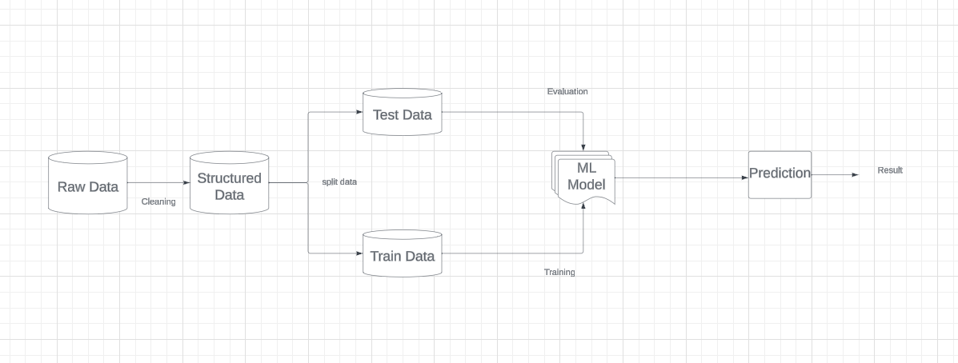

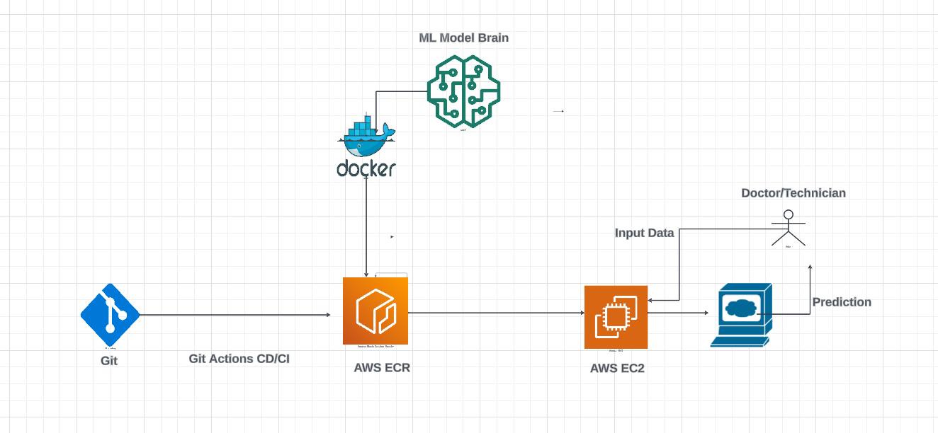

Process flow & architectural Diagram for data to deployment in AWS

## Data Description

The dataset is available in Kaggle website and it is in CSV format. This dataset contains 3773 patient record.

## Data Pre-processing

Data Pre-processing steps we could use are Null value handling, stop words removal, punctuation removal, Imbalanced data set handling, Handling columns with standard deviation zero or below a threshold, etc.

## Data Clustering

Many classification algorithm experimented like LogisticRegression, KNeighborsClassifier, DecisionTree,Random forest etc. Of which model with highest accuracy is selected for prediction.

## Model Building

After clusters are created, we will find the best model for each cluster. For each cluster, algorithms will be passed with the best parameters derived from Grid-Search. We will calculate the metric accuracy scores for models and select the model with the best score.

## Data from User

Here we will collect data from user such as age, sick, surgery, pregnant and other medical test parameters.

## Data Validation

Here Data Validation will be done, given by the user

## User Data in CSV

User data available in CSV format publicly in Kaggle website.

## Data Clustering

The model created during training will be loaded, and clusters for the user data will be predicted.

## Model Call for Specific Cluster

Based on the cluster number, the respective model will be loaded and will be used to predict/Recommend the data for that cluster.

## Thyroid disease Prediction

After calling high accuracy model the result is displayed in the web application console to the user.

## Deployment

We will be deploying the model to AWS.

This is a workflow diagram for the Thyroid Disease Prediction.

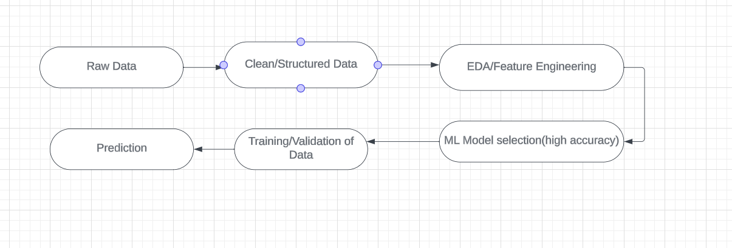

# Unit Test Cases

|  |  |  |
| --- | --- | --- |
| **Test Case Description** | **Pre-Requisite** | **Expected Result** |
| Verify whether the Application URL is  accessible to the user | 1. Application URL is accessible 2. 2.Application is deployed Cloud. | Application URL should be  accessible to the user |
| Verify whether the Application loads completely for the user when the URL is accessed | The Application should load completely for the user when the URL is accessed |
| Verify whether user is able to edit all input fields | User should be able to edit all input fields |
| Verify whether user gets Submit button to submit the inputs | User should get Submit button to submit the inputs |
| Verify whether user is presented with predicted results on clicking  submit | User should be presented with predicted results on clicking  submit |
| Verify whether the recommended results are in accordance to the selections user made | The recommended results should be in accordance to the selections user made |