*Thyroid Disease Prediction System*

***Wireframe Documentation***

**Homepage**

Thyroid Disease Prediction System Ui has two sections.

1. Home page shows as below as to expect user input for the personal & medical date of a patient:

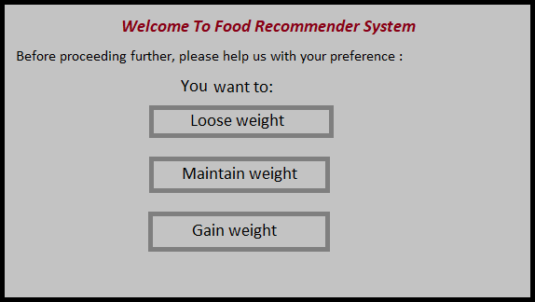

1. After entering the different parameters in the form, on click of submit the predicted result displayed as below

