ADBMS ASSIGNMENT REPORT
A case study related to Covid-19

Submitted to:

Dr.Shelly Sachdeva
HoD CSE Dept.
NIT Delhi

Submitted By:

G.D.V.Sujith Sagar
171210023
CSE Dept.
Btech 3rd year
NIT Delhi

Database used

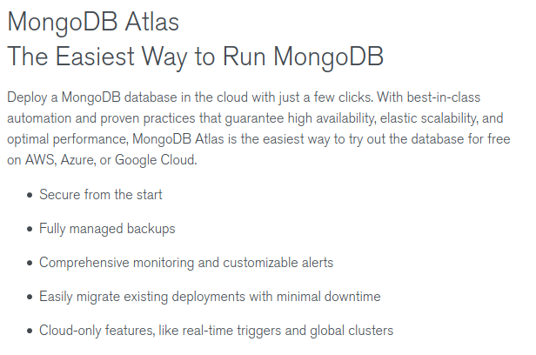
Start Mongo Server in Terminal

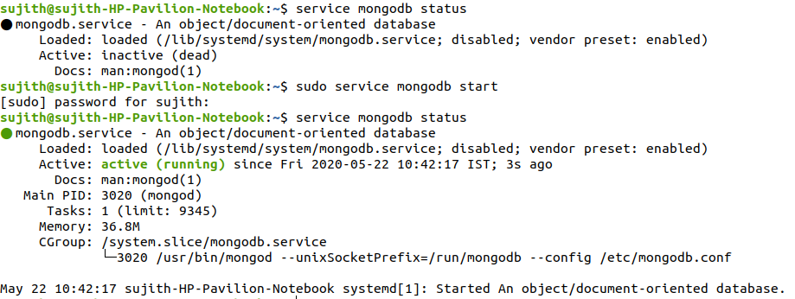

Start Mongo Shell

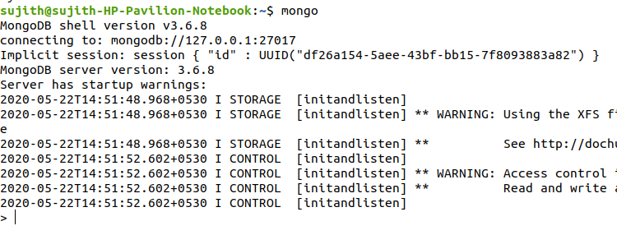
Database Status:

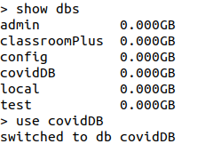

Collections:

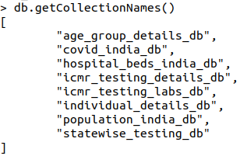

Converting CSV to DataFrame, Then DataFrame to Dictionaries, Then Dictionaries to JSON:

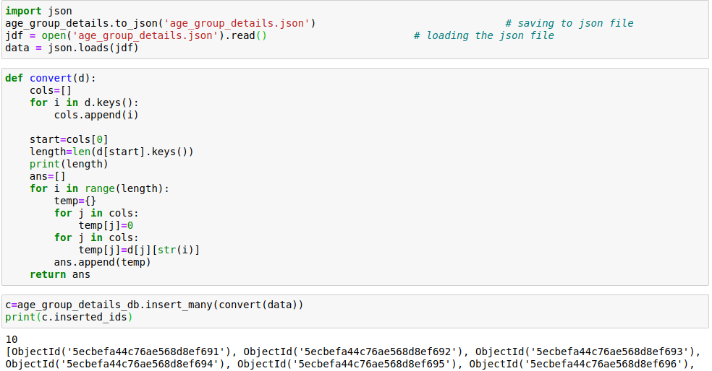
Analysis of Data

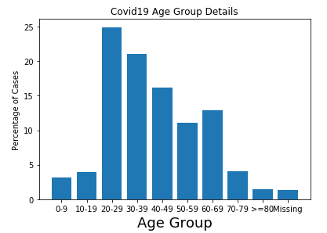

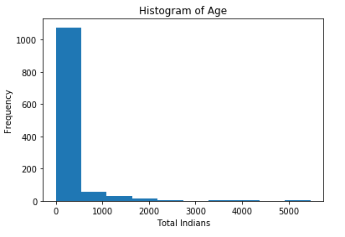

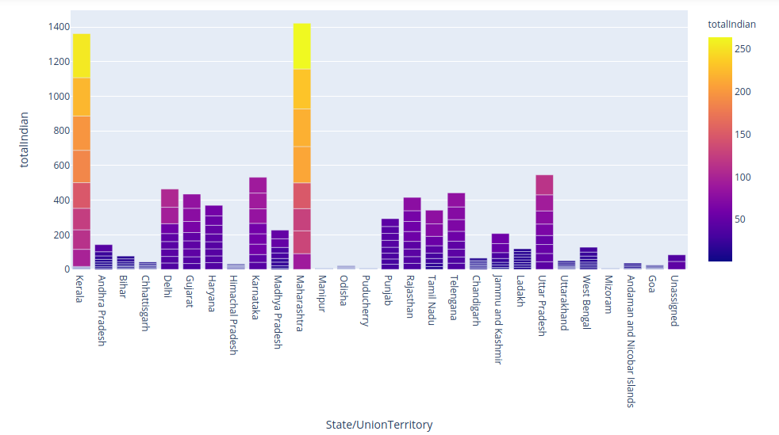

Querying Data from Database

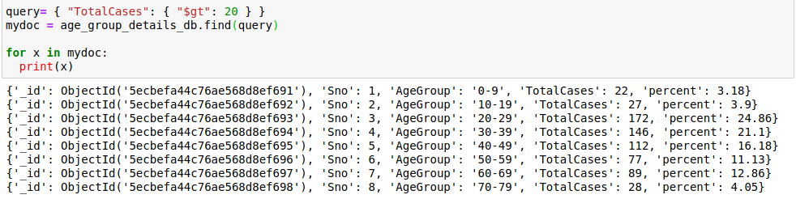

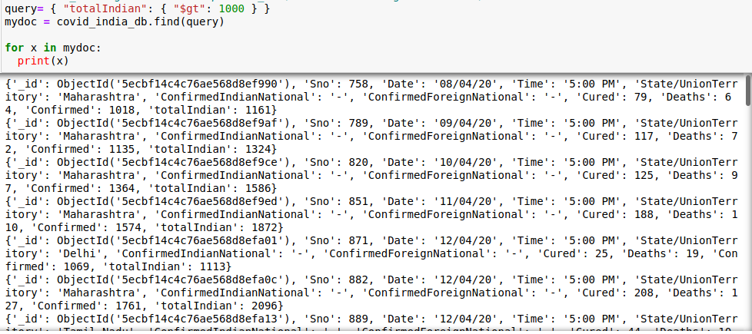

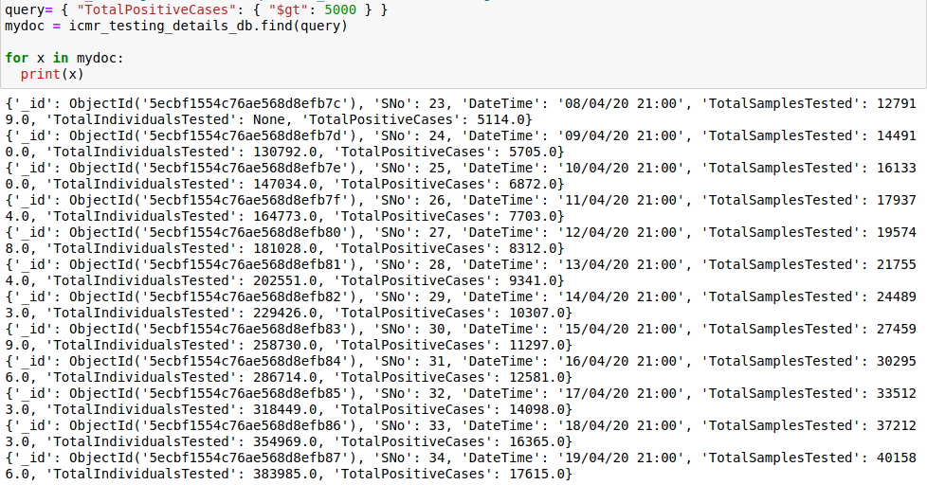

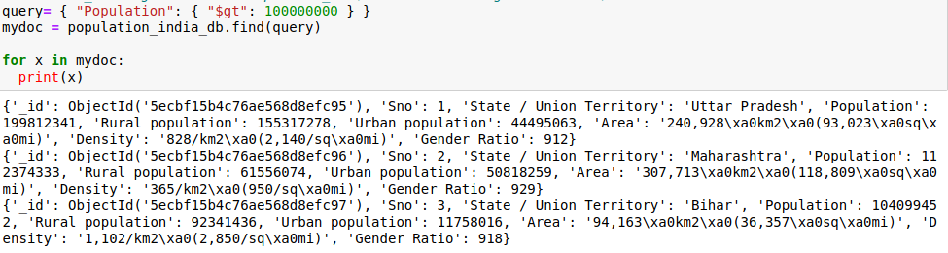

Program link: https://github.com/sujithsagar217/covid19_data_analysis/blob/master/Covid_Data_interpretation.ipynb

Github Repo Link: https://github.com/sujithsagar217/covid19_data_analysis

References

- https://specify.io/how-tos/find-documents-in-mongodb-using-the-mongo-shell
- https://www.w3schools.com/python/python_mongodb_getstarted.asp

