10. Develop a system using UML for Recruitment System, to recruit the applicant for a particular job in

the company. It was controlled by the central management system to manage the details of the

particular applicant who has to be recruited by a company.

State Diagram :

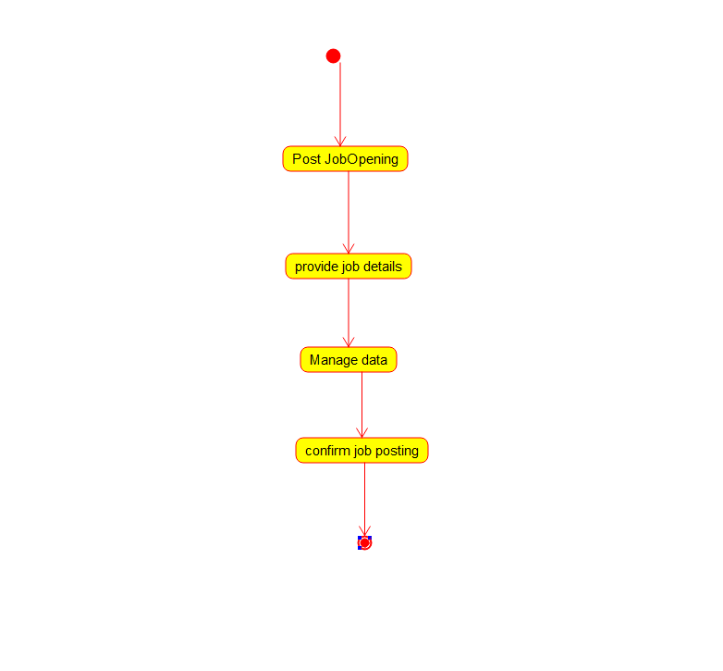

Package Diagram :

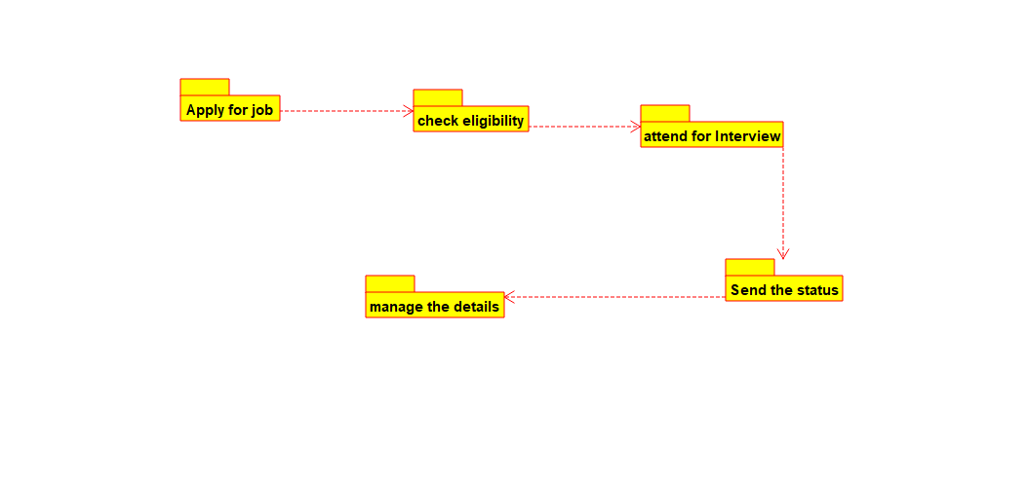

Sequence Diagram :

