3. Develop a system using UML for implementing the Exam Registration Portal. It should verify the

details of the candidate by the central computer. The details regarding the candidate will be

provided to the central computer through the administrator and the computer will verify the details

of the candidate and provide approval. Then the hall ticket will be issued from the office to the

candidate.

Class Diagram :

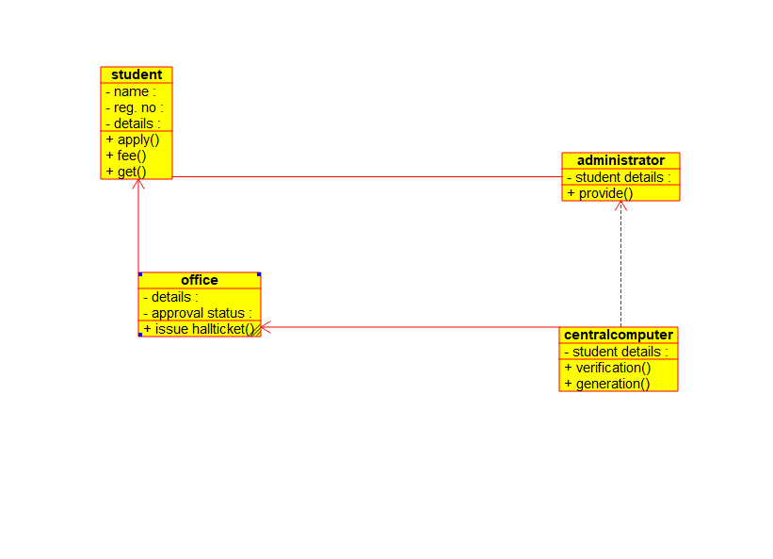

Figure 1Package

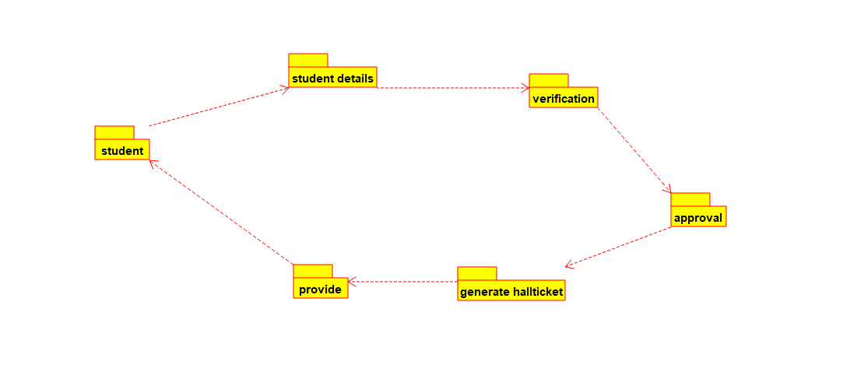

Figure 2USECASE

