**CP Project Proposal on**

**Dance Studio**

**Softwarica College of IT and E-Commerce**

**Kathmandu, Nepal**

**9th April 2019**



**Submitted by Submitted to**

**Sujit Khadgi Sudeep Lal Bajimaya**

**NCCID:** **00174623 Module Leader**

**Batch 22C L5DC**

Contents

**Chapter 1 – Introduction** 3

**1.1** **Introduction** 3

**1.2** **Background of project** 3

**1.3** **Problem statements** 3

**1.4 Description of the project** 3

**1.4.1 Features of the project** 3

**1.4** **Overview of the project** 3

**Chapter 2 – Scope of the project** 3

**2.1 Scope** 3

**2.2 Limitation** 4

**2.3 Aims** 4

**2.4 Objective** 4

**2.5 Overview of the scope** 4

**Chapter 3 – Development Methodology** 4

**3.1 Description of methodology chosen** 4

**3.2 Design pattern** 4

**3.3 Architecture** 4

**Chapter 4 – Project Planning** 4

**4.1 WBS (Work Breakdown structure)** 4

**4.2 Milestones** 4

**4.3 Gantt chart** 4

**Chapter 5 – Risk Management** 4

**Chapter 6 – Configuration Management** 4

**Chapter 7 – Conclusion** 4

**Chapter 8 – Reference and Bibliography** 4

**Table and figures.**

Figure 1: Waterfall Model 8

Figure 2: Model View Controller Pattern. 9

Figure 3: WBS (Work Breakdown Structure) 10

Figure 4: Gantt Chart schedule. 12

Figure 5: Gantt Chart. 12

Table 1: Milestones 11

Table 2: Risk consequence values 13

Table 3: Risk likelihood values 13

Table 4: Risk management table. 14

# **Chapter 1 – Introduction**

## **Introduction**

Dance Studio is an online website for dance studio where students or everyone can find out information about dance club. Information like faculty, facilities, coaches, records, achievement of club, events, etc. Guardian can surf the website for events that club is going to take part in from anywhere and decide if their children can take part in it. New members can first research about club in website and book desirable class from home.

Its purpose is to make advertising field for dance studio and for user to get what they want effortlessly.

## **Background of project**

Nowadays there are many dance studios available within small area and we don’t know if they are any good than any other dance studios. Students joins studios not because they know what that dance studio is capable of but they join them with information like their friends are attending that studios or they heard that the studios are great. Now in a developing country like our not many dance studios have their own websites to share the information about their facilities, achievement, marketing etc. In this busy schedule guardians need to visit every dance studio to provide their children good dance lesson.

## **Problem statements**

No matter what dance studio has achieved till now they can’t show everything to students and guardians every time they visit. People join because of achievement of studio and professor but showing them everything on one visit is impossible. With the help of this project dance studio can show off their achievement, facilities, faculty etc. through website.

People are getting busy day by day they don’t have time for directly visiting dance studios for research and admitting their children there. With less time and information, they may choose bad studio. To get to know what happening in dance studio they need to visit studio every time or contact them. This project makes easy access to information of studio, events, tickets etc.

## **Description of the project**

This project is being made for dance studios. In developing country like ours, not many dance studios have website so, people need to search from one place to another just to join one dance studio they want and again their guardians need to research about that studio by going there. In their busy schedule they can’t afford much time for choosing right studio for their children.

With this project parents can surf about studio from home it makes studio attractive, easy to get information can know about children’s event.

### **Features of the project**

Some feature available in this project are:

* Visit and surf the information about studio (not private information).
* Can sign up and get access to login and have privilege of using other functions.
* User can edit their own information.
* Users can research about lessons and decided then book the lesson they want to attend.
* Get detail information about events and show them to guardians.
* Ask questions in forum.
* Online ticket booking for events.

## **Overview of the project**

This project is about making website for dance studio which will help it to advertise itself. It will attract students. Students and guardian can get more information about studio from website than from face to face conversation. Making easy to choose studio.

# **Chapter 2 – Scope of the project**

## **2.1 Scope**

Project has its own scope. Scope of this project are:

* To make it easy enrollment in dance studio.
* Advertising of events and dance studio.
* To store detail information of students.
* Buy tickets of events online.

## **2.2 Limitation**

Limitation of this project are:

* Online email system is not available.
* Internet must be connected.

## **2.3 Aims**

The main aim of the project is to build website for dance studio showing all information about dance studio in one click. The project should consist of the following aims:

* To create website for dance studio which can keep students’ records.
* Easy access to information about dance club.

## **2.4 Objective**

This project will focus its attention on its main objectives in its operations. Some Objectives are:

* To complete this project, I need to learn more about php, JavaScript, and bootstrap.
* Easy sign up and login system for users.
* To perform design and create system user friendly.
* Detail analysis of the problem.
* Designing properly to meet the requirement.
* Deployment of the project
* They should be error free, easy to use.

## **2.5 Overview of the scope**

The scope of the project is to make online booking of class, advertising of the studio and events, to store information of students, and buy tickets online. Making interface which can make website attractive and easy to use for users.

# **Chapter 3 – Development Methodology**

## **3.1 Description of methodology chosen**

I will choose Waterfall Model for the development of project. It is very simple to understand and use. In a waterfall model, each phase must be completed before the next phase can begin and there is no overlapping in the phases.

**Waterfall Model**

Feasibility Study

Requirement Analysis

System Design

Implementation

Testing

Maintenance

Figure 1: Waterfall Model

## **3.2 Design pattern**

In this project I am going to use (MVC) Model View Controller Pattern as design pattern. This pattern is used to separate application's concerns.

* **Model** - It represents an object or JAVA POJO carrying data. It can also have logic to update controller if its data changes.
* **View** - It represents the visualization of the data that model contains.
* **Controller** - It acts on both model and view. It controls the data flow into model object and updates the view whenever data changes. It keeps view and model separate.

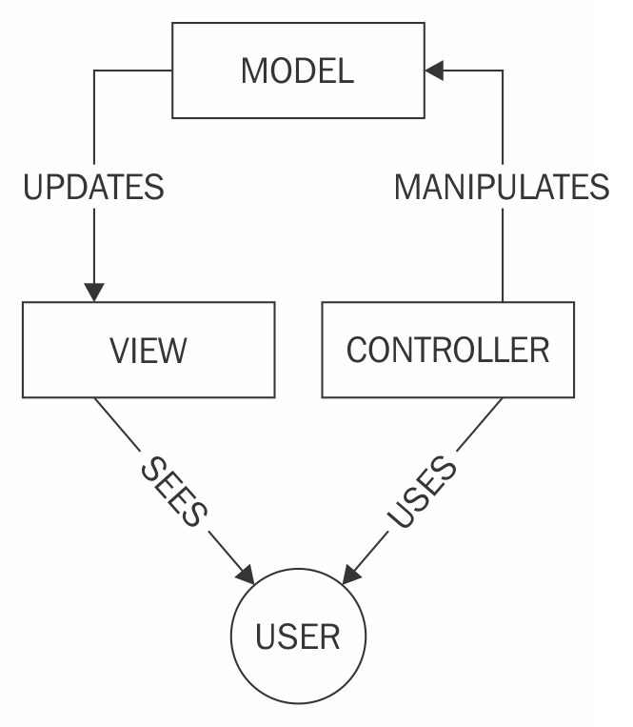

Figure 2: Model View Controller Pattern.

## **3.3 Architecture**

For network architecture I am using client server architecture. Client server architecture is a network architecture in which each computer on the network is either a client or a server. Clients rely on servers for resources. (Anon., n.d.)

You can add resources in the form of network segments, computers and servers to a client server network without major interruptions to the network. Access to any new resources can be administered from the centralized security database, stored on a single network server (Anon., n.d.)

# **Chapter 4 – Project Planning**

## **4.1 WBS (Work Breakdown structure)**

Work Breakdown Structure (WBS) is the process of Dividing complex projects to simpler and manageable tasks.

Usually, the project managers use this method for simplifying the project execution. In WBS, much larger tasks are broken down to manageable chunks of work. These chunks can be easily supervised and estimated.

WBS is not restricted to a specific field when it comes to application. This methodology can be used for any type of project management. (Anon., n.d.)

Dance Studio

Testing

Reporting

Implementation

Design

Analysis

Proposal

Unit Testing

Coding

Documentation

Structural model

Requirement analysis

Brain storming

Integration testing

Behavior model

Use case

scoping

Final report

UI design

Architecture

Planning

Presentation

Figure 3: WBS (Work Breakdown Structure)

## **4.2 Milestones**

Milestones are tools used in project management which is used to mark specific points and project timeline. These specific points may signal such as project start date and end date.

Milestones of the project given below:

|  |  |  |  |
| --- | --- | --- | --- |
| S. NO | Milestones | Start Date | Final Date |
| 1  1.1  1.2  1.3  1.4 | Proposal  Brain-Storming  Scoping  Planning  Configure management | 25th March  25th March  29th March  1st April  6th April | 9th April  24th March  31st March  5th April  9th April |
| 2  2.1  2.2  2.3 | Analysis  Requirement  Use case  Architecture | 10th April  10th April  21st April  30th April | 8th May  20th April  29th April  8th May |
| 3  3.1  3.2  3.3 | Design  Structural model  Behavior model  UI design | 9th May  9th May  17th May  25th May | 3rd June  16th May  24th May  3rd June |
| 4  4.1 | Implementation  Coding | 4th June  4th June | 24th June  24th June |
| 5  5.1  5.2 | Testing  Unit testing  Integration testing | 25th June  25th June  28th June | 1st July  27th June  1st July |
| 6  6.1  6.2  6.3 | Reporting  Documentation  Final report  Presentation | 2nd July  2nd July  5th July  8th July | 12th July  4th July  7th July  12th July |

Table 1: Milestones

In the above table five major accommodation of the project is mentioned and all the task date in the table are estimated according to my knowledge.

**Proposal:** Proposal is the deciding factor for starting the project so I allocated 16 days for proposal. For preparing proposal I have allocated 4 days for Brain - Storming cause it decides how it will start. For scoping I have allocated 3 days, 5days for planning and 4 days for Configure management.

**Analysis:** Analysis is the most important part of every project. With my knowledge in analysis I allocated 29 days for analysis. As for its sub phases 11 days for requirement, 9 days for Use case and 9 days for architecture.

**Design:** Design determine how my project will look like so its important to give the time it needed so I gave it 26 days. For its sub phases 8 days for structural model, 8 days for behavior model, and 11 days for UI design.

**Implementation:** For implementation I have Coding as sub phases. Since I have previous experience with coding, I allocated 21 days for Implementation.

**Testing:** Testing is the phase where project is tested if any problem got missed in this phase chances of project failure increases. So I allocated 7 days for testing and divided it in its sub phases like 3 days for Unit testing and 4 days for integration testing.

**Reporting**

Documentation

Final report

Presentation

## **4.3 Gantt chart**

A Gantt chart is one of the most popular and useful ways of showing activities like tasks or events displayed against time and it is commonly used in project management. List of activities are on the left side of chart and along the top is a suitable time scale. (Anon., n.d.)

Gantt chart of this project is given below:

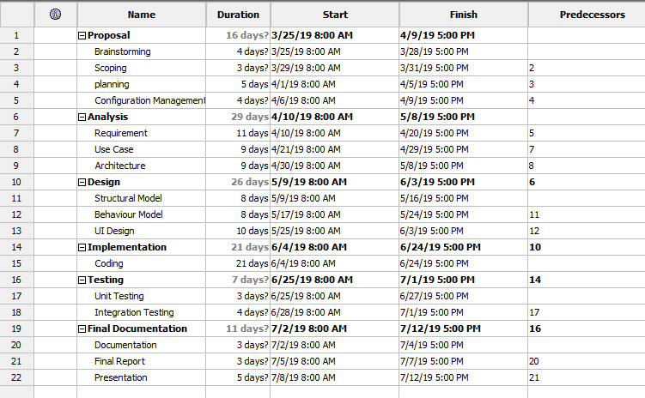

Figure 4: Gantt Chart schedule.

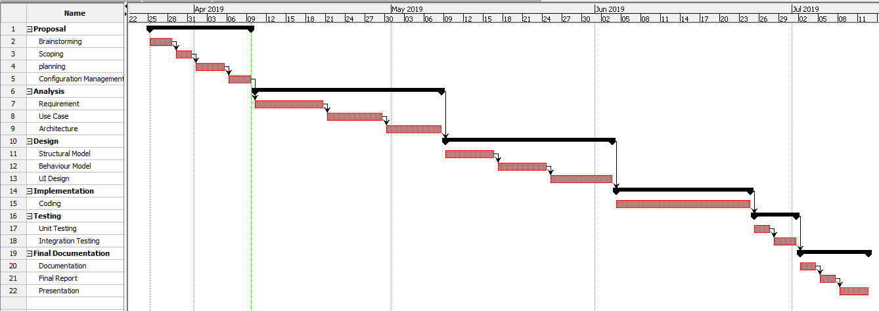

Figure 5: Gantt Chart.

# **Chapter 5 – Risk Management**

Risk management means risk containment and reduction of risk. First, you’ve got to identify and plan. Then be ready to act when a risk arises, drawing upon the experience and knowledge of the entire team to minimize the impact to the project.   
  
Risk management includes the following tasks:

* **Identify** risks and their triggers
* **Classify** and prioritize all risks
* Craft a **plan** that links each risk to a mitigation
* **Monitor** for risk triggers during the project
* Implement the **mitigating action** if any risk materializes
* **Communicate** risk status throughout project. (Anon., n.d.)

To estimate the impact of each identiﬁed risks we use

Impact = Likelihood × Consequence

The values of consequences of risk are shown in the table below:

|  |  |
| --- | --- |
| Consequences | Value |
| Very Low | 1 |
| Low | 2 |
| Medium | 3 |
| High | 4 |
| Very High | 5 |

Table 2: Risk consequence values

The values of consequences of risk are shown in the table below:

|  |  |
| --- | --- |
| Likelihood | Value |
| Low | 1 |
| Medium | 2 |
| High | 3 |

Table 3: Risk likelihood values

Every project has some kind of risk in it. Some of the risk that may occur in this project with its value of impact is given in the table below:

|  |  |  |  |  |  |
| --- | --- | --- | --- | --- | --- |
| S. No | Risk | Likelihood | Consequence | Impact | Remark |
| 1 | Hard disk failure | 2 | 4 | 8 | Make Backup data and store in online drive. |
| 2 | Data loss | 2 | 4 | 8 | Make Backup data and store in online drive. |
| 3 | Time limitation | 2 | 3 | 6 | Planning workable timetable and keep up with. |
| 4 | Natural disaster | 1 | 5 | 5 | Operating in low rate of disaster and creating policy for recovery. |
| 5 | Change in requirement | 2 | 3 | 6 | Getting in contact with client and users |
| 6 | Sickness | 1 | 3 | 3 | Maintaining health properly and have some backup plan |
| 7 | Code failure | 2 | 4 | 8 | Test properly |

Table 4: Risk management table.

# **Chapter 6 – Configuration Management**

Configuration management encompasses the administrative activities concerned with the creation, maintenance, controlled change and quality control of the scope of work. (Anon., n.d.)

it is process of managing the configuration of all of the key product and assets of the project.

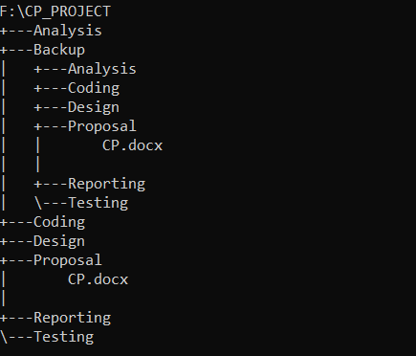

There are chances of data loss, hard disk crash which can hamper the whole project so I have backup my file in laptop and also in github. The project has been uploaded to my github.

**Account:**

<https://github.com/sujitkhadgi/>

<https://github.com/sujitkhadgi/proposal/blob/master/CP.docx>

# **Chapter 7 – Conclusion**

With completion of this project both dance studio and user of the website will benefit. Dance studio will get a platform for its own advertising, it will attract students, and in a developing country like our there are many dance studios but not many websites so, it can give more information about dance studio.

Likewise, people are busy and they want to choose best dance studio for their children but unable to because of their busy schedule. This project will help them to get easy access to information about dance studio which are needed for joining it. It makes them happy. They don’t have to walk from studio to studio.

# **Chapter 8 – Reference and Bibliography**

# References

Anon., n.d. *apm.* [Online]   
Available at: https://www.apm.org.uk/body-of-knowledge/delivery/scope-management/configuration-management/  
[Accessed 8 4 2019].

Anon., n.d. *Cast.* [Online]   
Available at: https://www.castsoftware.com/research-labs/risk-management-in-software-development-and-software-engineering-projects  
[Accessed 8 4 2019].

Anon., n.d. *Gantt.com.* [Online]   
Available at: https://www.gantt.com/  
[Accessed 6 4 2019].

Anon., n.d. *Teachwalla.* [Online]   
Available at: https://www.techwalla.com/articles/client-server-architecture-advantages-disadvantages  
[Accessed 8 4 2019].

Anon., n.d. *Tutorialspoint.* [Online]   
Available at: https://www.tutorialspoint.com/management_concepts/work_breakdown_structure.htm  
[Accessed 6 4 2019].

Anon., n.d. *Webopedia.* [Online]   
Available at: https://www.webopedia.com/TERM/C/client_server_architecture.html  
[Accessed 7 4 2019].