**STANDARD PRONUNCIATION FLOW:**

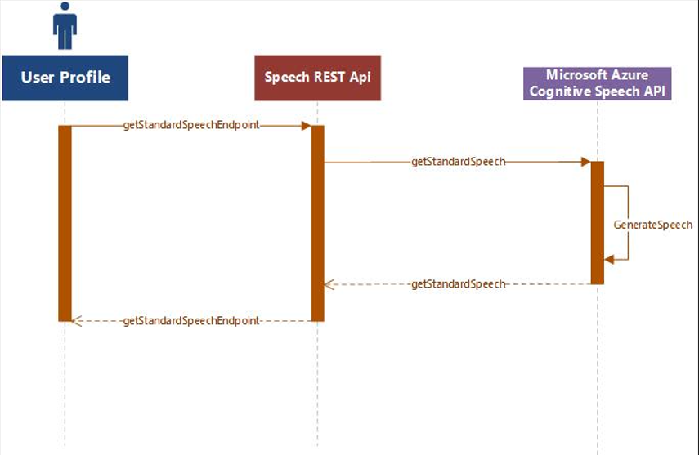

**CUSTOM PRONUNCIATION FLOW:**

