Smart Traffic Light Controller – Project Report

Objective
The objective of this project is to design a smart traffic light system that automatically changes signals based on vehicle density using AI logic.

Problem Statement
Traditional traffic lights which use fixed timing causes congestion and delays. This project provides dynamic signal timing based on traffic density.

Introduction
This project simulates a smart traffic management system using Python. The system analyzes vehicle count and gives priority to roads with more traffic.

Technologies Used
Technology | Purpose
Python | Programming Language
Random Module | Generate Vehicle Count
Time Module | Signal Timer Simulation
AI Logic | Decision Making

Working of the System
- Generate vehicle count.
- Analyze traffic density.
- Select busiest road.
- Give green signal.5. Switch signal automatically.

Algorithm
1: Start Program
Step 2: Generate Vehicle Count
Step 3: Analyze Traffic
Step 4: Give Green Signal
Step 5: Repeat Process Step

Source Code
import time import random signals = ["North", "South", "East", "West"]
def get_vehicle_count(): return random.randint(0, 50) while True:
traffic_data = {} print("\n===== Vehicle Density =====")
for signal in signals:
traffic_data[signal] = get_vehicle_count() print(signal, ":", traffic_data[signal], "vehicles") green_signal = max(traffic_data, key=traffic_data.get) print("\nGreen Signal:", green_signal) green_time = traffic_data[green_signal] // 5
if green_time < 5: green_time = 5 print("Green Light Duration:", green_time, "seconds")
for i in range(green_time, 0, -1): print("Remaining Time:", i) time.sleep(1)

Advantages
- Reduces congestion
- Saves time
- Automatic signal control
- Better traffic flow

Future Scope
- integration
- Real-time CCTV input
- Emergency vehicle priority
- Smart city integration

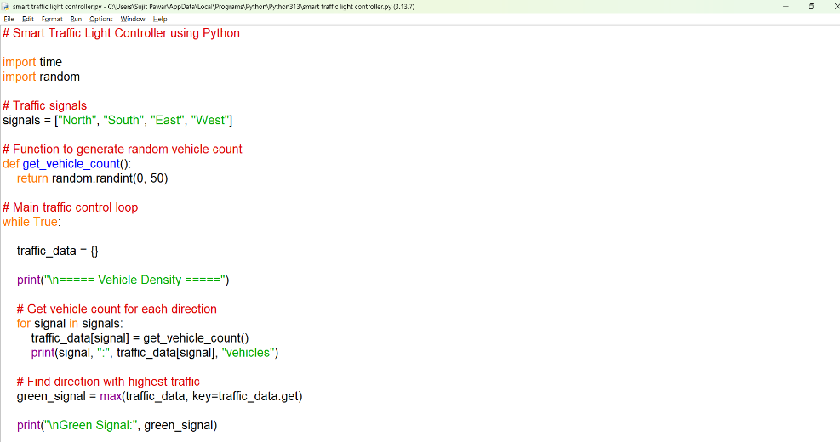
Code Screenshots

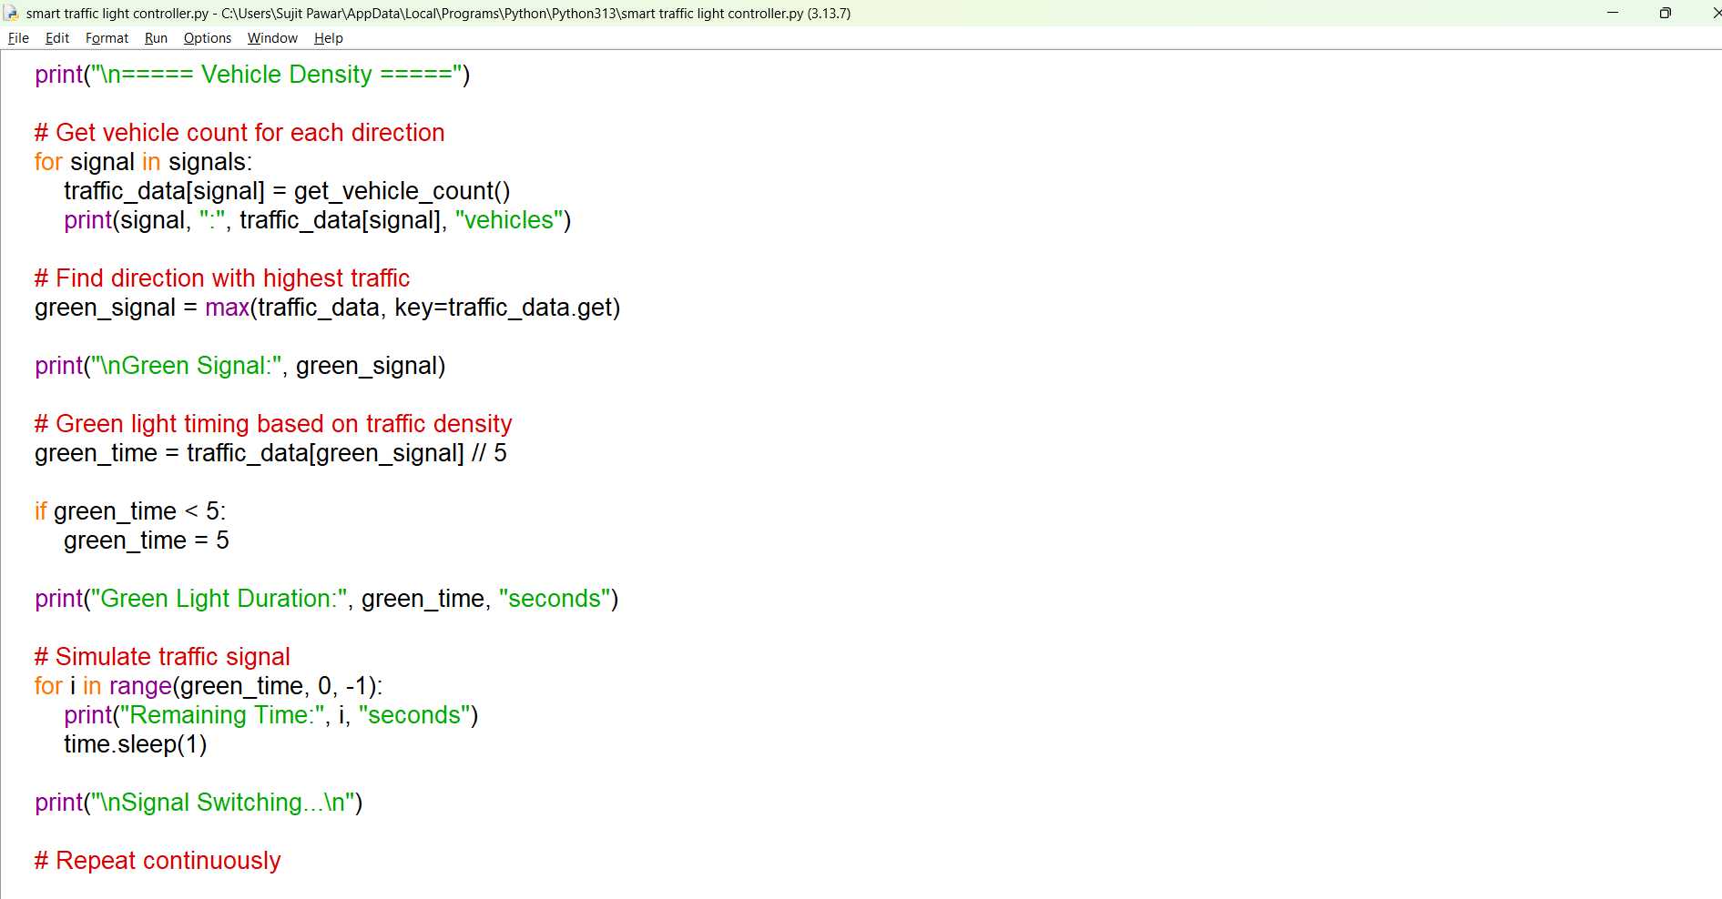

Output
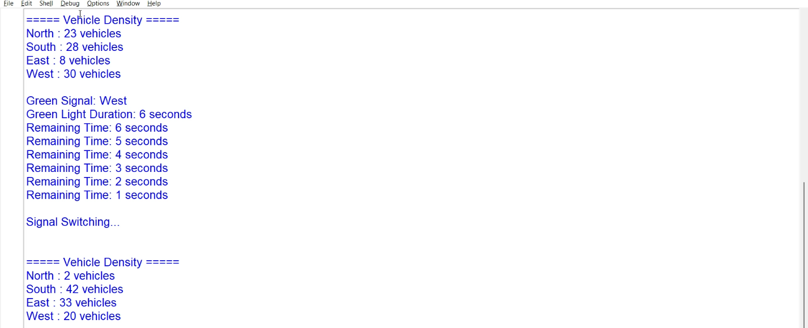
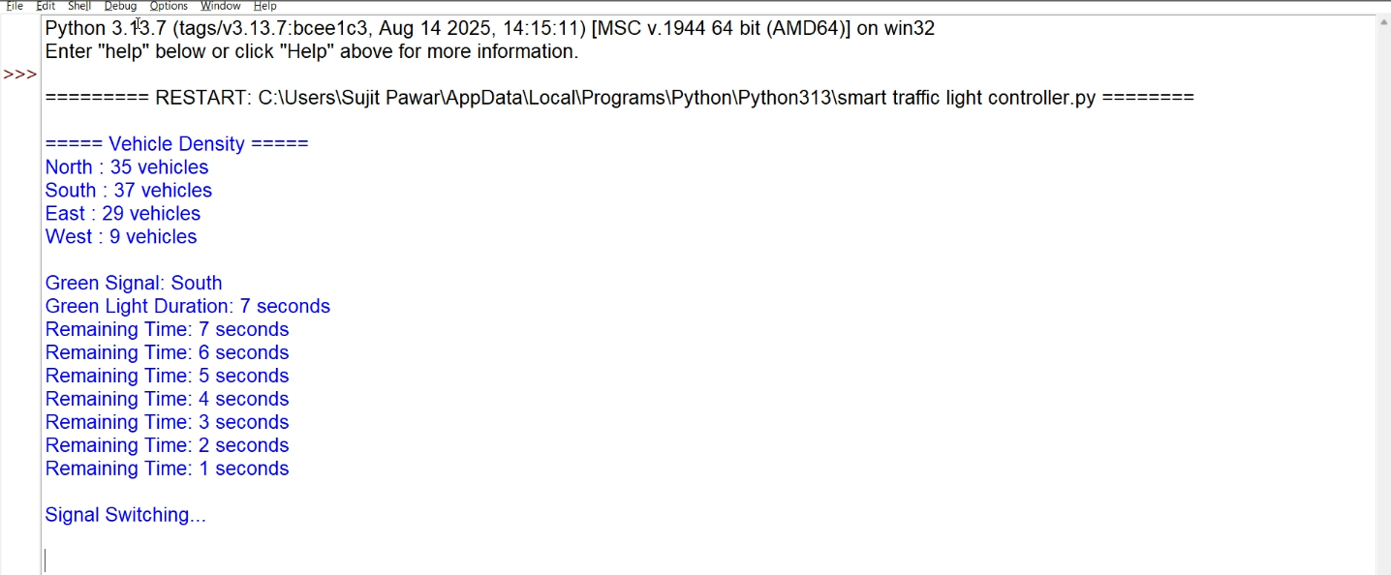

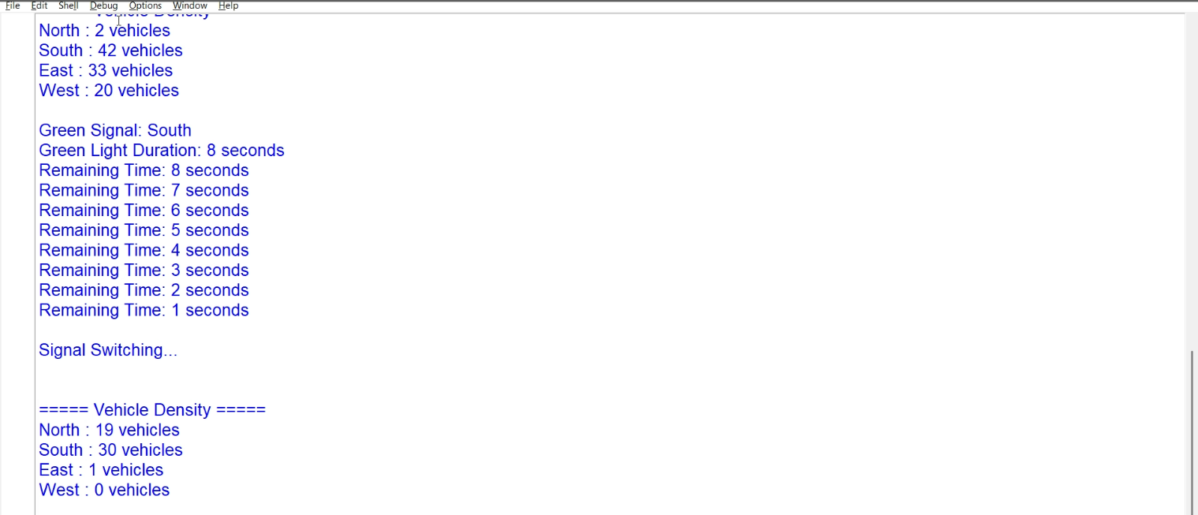
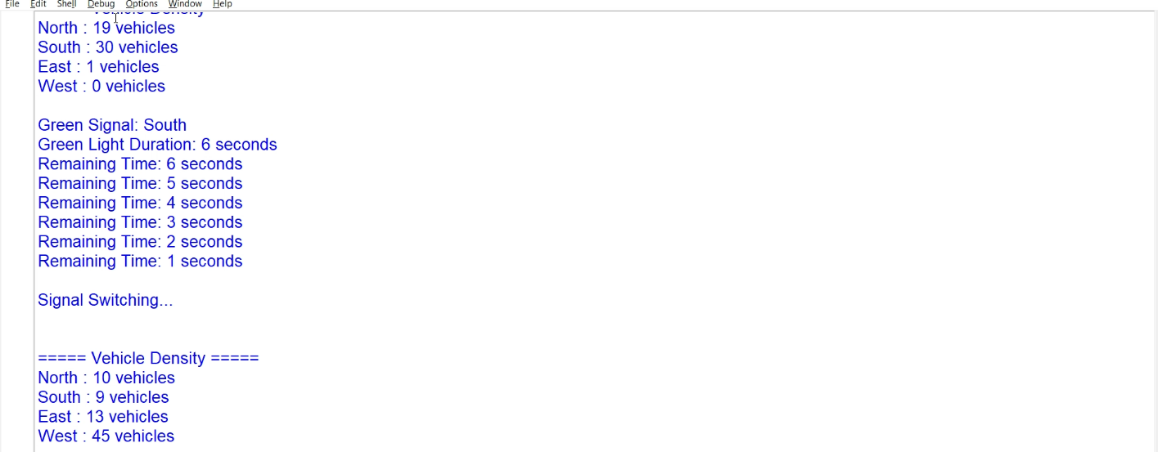


Conclusion
The Smart Traffic Light OpenCV Controller demonstrates AI-based automation for efficient traffic management and smart

