Mongo DB creation:

Trainer Path: <https://github.com/vinodh1988/capgemini>

Trainer mail: k.c.Vinodh@hotmail.com

<https://github.com/krishna-basvani/nodejsfullstack>

<https://github.com/krishna-basvani/mongoAPINew>

Client Side development (Angular, React, Ember,..)

Development:

1. Unit testing tools
2. Latest and advanced scripting technology(typescript,es6,JSX)
3. Vast set of supported libraries
4. Unit testing tools
5. Linking tools( to check the quality of the code)
6. Minifying tools(to remove spaces, newlines in the code)
7. Sass/less code

Browser

Css, HTML, and JS

SPA – Single page applications

100’s of functionalities concentrated in single html page

Transition:

Transpilation – process of converting one version of JS to other (ES5) (Babel).

Bundling – Bundling tool walks through to the code from an entry point… it utilizes a transpiler (babel) converts the code to target version (ES5). It walk multiple js files (source0 and libraries link only necessary code and skips the code that is never part of your project.

It Converts CSS specification in JS code. All files are bundled into a single file (sometimes two or more)

Bundler also minifies your code and removes unit testcode

Any code which configure to be skipped

Grunt, gulp – Were the task running frameworks and libraries where we do this tasks

Webpack – automates this bundling task with no code only configuration.

Production:

Development:

Setup Environmental variable in PC:

C:\Program Files\MongoDB 2.6 Standard Legacy\bin

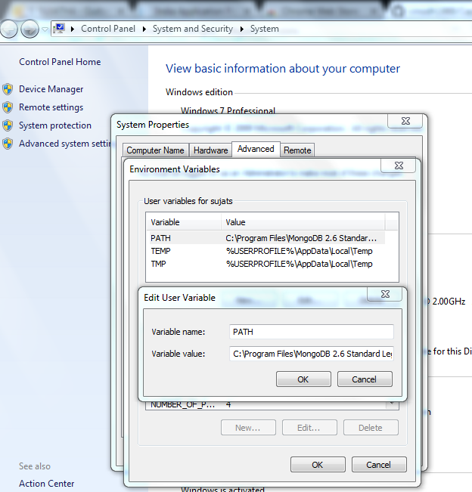

Run-> cmd – type below **bold** lines

**C:\Users\sujats>mongo**

2018-06-14T12:18:14.354+0530 Hotfix KB2731284 or later update is not installed,

will zero-out data files

MongoDB shell version: 2.6.9

connecting to: test

Welcome to the MongoDB shell.

For interactive help, type "help".

For more comprehensive documentation, see

http://docs.mongodb.org/

Questions? Try the support group

http://groups.google.com/group/mongodb-user

> **show dbs**

admin (empty)

local 0.078GB

> **use capgemini**

switched to db capgemini

>