Original data shape: (60000, 1, 28, 28)

Reshaped data shape: (60000, 784)

Number of features to retain for 75.0% variance: 34

PCA Reduced data shape: (60000, 34)

Starting t-SNE embedding on PCA reduced dataset...

[t-SNE] Computing 91 nearest neighbors...

[t-SNE] Indexed 60000 samples in 0.002s...

[t-SNE] Computed neighbors for 60000 samples in 30.740s...

[t-SNE] Computed conditional probabilities for sample 1000 / 60000

[t-SNE] Computed conditional probabilities for sample 2000 / 60000

[t-SNE] Computed conditional probabilities for sample 3000 / 60000

[t-SNE] Computed conditional probabilities for sample 4000 / 60000

[t-SNE] Computed conditional probabilities for sample 5000 / 60000

[t-SNE] Computed conditional probabilities for sample 6000 / 60000

[t-SNE] Computed conditional probabilities for sample 7000 / 60000

[t-SNE] Computed conditional probabilities for sample 8000 / 60000

[t-SNE] Computed conditional probabilities for sample 9000 / 60000

[t-SNE] Computed conditional probabilities for sample 10000 / 60000

[t-SNE] Computed conditional probabilities for sample 11000 / 60000

[t-SNE] Computed conditional probabilities for sample 12000 / 60000

[t-SNE] Computed conditional probabilities for sample 13000 / 60000

[t-SNE] Computed conditional probabilities for sample 14000 / 60000

[t-SNE] Computed conditional probabilities for sample 15000 / 60000

[t-SNE] Computed conditional probabilities for sample 16000 / 60000

[t-SNE] Computed conditional probabilities for sample 17000 / 60000

[t-SNE] Computed conditional probabilities for sample 18000 / 60000

[t-SNE] Computed conditional probabilities for sample 19000 / 60000

[t-SNE] Computed conditional probabilities for sample 20000 / 60000

[t-SNE] Computed conditional probabilities for sample 21000 / 60000

[t-SNE] Computed conditional probabilities for sample 22000 / 60000

[t-SNE] Computed conditional probabilities for sample 23000 / 60000

[t-SNE] Computed conditional probabilities for sample 24000 / 60000

[t-SNE] Computed conditional probabilities for sample 25000 / 60000

[t-SNE] Computed conditional probabilities for sample 26000 / 60000

[t-SNE] Computed conditional probabilities for sample 27000 / 60000

[t-SNE] Computed conditional probabilities for sample 28000 / 60000

[t-SNE] Computed conditional probabilities for sample 29000 / 60000

[t-SNE] Computed conditional probabilities for sample 30000 / 60000

[t-SNE] Computed conditional probabilities for sample 31000 / 60000

[t-SNE] Computed conditional probabilities for sample 32000 / 60000

[t-SNE] Computed conditional probabilities for sample 33000 / 60000

[t-SNE] Computed conditional probabilities for sample 34000 / 60000

[t-SNE] Computed conditional probabilities for sample 35000 / 60000

[t-SNE] Computed conditional probabilities for sample 36000 / 60000

[t-SNE] Computed conditional probabilities for sample 37000 / 60000

[t-SNE] Computed conditional probabilities for sample 38000 / 60000

[t-SNE] Computed conditional probabilities for sample 39000 / 60000

[t-SNE] Computed conditional probabilities for sample 40000 / 60000

[t-SNE] Computed conditional probabilities for sample 41000 / 60000

[t-SNE] Computed conditional probabilities for sample 42000 / 60000

[t-SNE] Computed conditional probabilities for sample 43000 / 60000

[t-SNE] Computed conditional probabilities for sample 44000 / 60000

[t-SNE] Computed conditional probabilities for sample 45000 / 60000

[t-SNE] Computed conditional probabilities for sample 46000 / 60000

[t-SNE] Computed conditional probabilities for sample 47000 / 60000

[t-SNE] Computed conditional probabilities for sample 48000 / 60000

[t-SNE] Computed conditional probabilities for sample 49000 / 60000

[t-SNE] Computed conditional probabilities for sample 50000 / 60000

[t-SNE] Computed conditional probabilities for sample 51000 / 60000

[t-SNE] Computed conditional probabilities for sample 52000 / 60000

[t-SNE] Computed conditional probabilities for sample 53000 / 60000

[t-SNE] Computed conditional probabilities for sample 54000 / 60000

[t-SNE] Computed conditional probabilities for sample 55000 / 60000

[t-SNE] Computed conditional probabilities for sample 56000 / 60000

[t-SNE] Computed conditional probabilities for sample 57000 / 60000

[t-SNE] Computed conditional probabilities for sample 58000 / 60000

[t-SNE] Computed conditional probabilities for sample 59000 / 60000

[t-SNE] Computed conditional probabilities for sample 60000 / 60000

[t-SNE] Mean sigma: 0.004584

[t-SNE] KL divergence after 250 iterations with early exaggeration: 95.103783

[t-SNE] KL divergence after 300 iterations: 4.257889

t-SNE embedding finished on PCA reduced dataset.

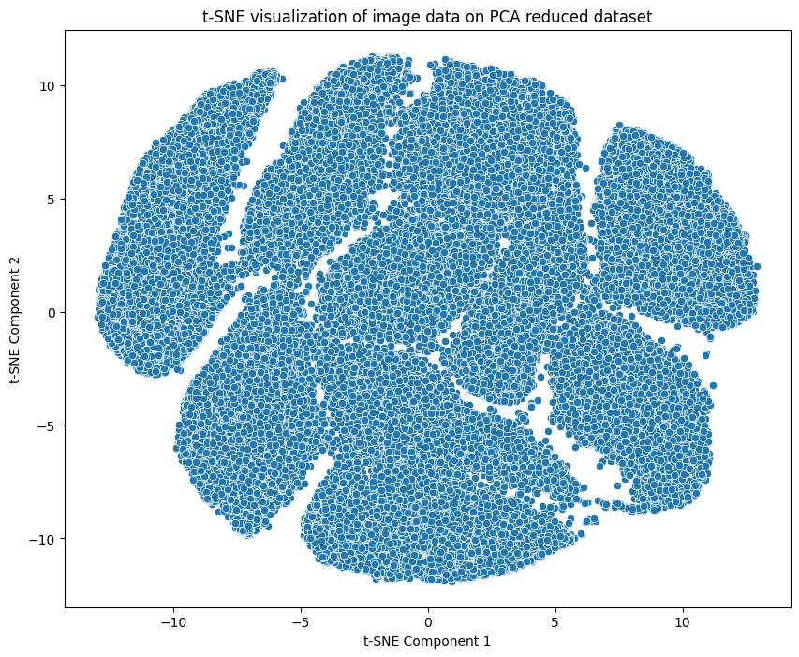

**Silhouette Score: 0.1099 for K 8 using KMEANS and Variance Coverage 75.0%**

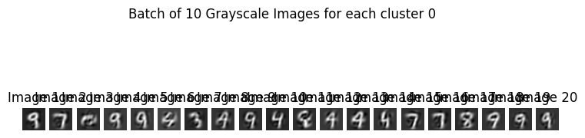

**Metrics for RandomForest classifier**

Training RandomForest classifier on reshaped full training set...

(RandomForest) Image Classifier - Train accuracy: 1.0000, Validation accuracy: 0.9340, Confidence: [0.83 1. 0.89 ... 0.78 1. 0.92]

**Metrics for KNearestNeighbour classifier**

Training KNearestNeighbour classifier on reshaped full training set...

(KNearestNeighbour) Image Classifier - Train accuracy: 0.9420, Validation accuracy: 0.9056, Confidence: [1. 1. 1. ... 0.6 1. 1. ]

