Original data shape: (60000, 1, 28, 28)

Reshaped data shape: (60000, 784)

Number of features to retain for 95.0% variance: 154

PCA Reduced data shape: (60000, 154)

Starting t-SNE embedding on PCA reduced dataset...

[t-SNE] Computing 91 nearest neighbors...

[t-SNE] Indexed 60000 samples in 0.016s...

[t-SNE] Computed neighbors for 60000 samples in 62.745s...

[t-SNE] Computed conditional probabilities for sample 1000 / 60000

[t-SNE] Computed conditional probabilities for sample 2000 / 60000

[t-SNE] Computed conditional probabilities for sample 3000 / 60000

[t-SNE] Computed conditional probabilities for sample 4000 / 60000

[t-SNE] Computed conditional probabilities for sample 5000 / 60000

[t-SNE] Computed conditional probabilities for sample 6000 / 60000

[t-SNE] Computed conditional probabilities for sample 7000 / 60000

[t-SNE] Computed conditional probabilities for sample 8000 / 60000

[t-SNE] Computed conditional probabilities for sample 9000 / 60000

[t-SNE] Computed conditional probabilities for sample 10000 / 60000

[t-SNE] Computed conditional probabilities for sample 11000 / 60000

[t-SNE] Computed conditional probabilities for sample 12000 / 60000

[t-SNE] Computed conditional probabilities for sample 13000 / 60000

[t-SNE] Computed conditional probabilities for sample 14000 / 60000

[t-SNE] Computed conditional probabilities for sample 15000 / 60000

[t-SNE] Computed conditional probabilities for sample 16000 / 60000

[t-SNE] Computed conditional probabilities for sample 17000 / 60000

[t-SNE] Computed conditional probabilities for sample 18000 / 60000

[t-SNE] Computed conditional probabilities for sample 19000 / 60000

[t-SNE] Computed conditional probabilities for sample 20000 / 60000

[t-SNE] Computed conditional probabilities for sample 21000 / 60000

[t-SNE] Computed conditional probabilities for sample 22000 / 60000

[t-SNE] Computed conditional probabilities for sample 23000 / 60000

[t-SNE] Computed conditional probabilities for sample 24000 / 60000

[t-SNE] Computed conditional probabilities for sample 25000 / 60000

[t-SNE] Computed conditional probabilities for sample 26000 / 60000

[t-SNE] Computed conditional probabilities for sample 27000 / 60000

[t-SNE] Computed conditional probabilities for sample 28000 / 60000

[t-SNE] Computed conditional probabilities for sample 29000 / 60000

[t-SNE] Computed conditional probabilities for sample 30000 / 60000

[t-SNE] Computed conditional probabilities for sample 31000 / 60000

[t-SNE] Computed conditional probabilities for sample 32000 / 60000

[t-SNE] Computed conditional probabilities for sample 33000 / 60000

[t-SNE] Computed conditional probabilities for sample 34000 / 60000

[t-SNE] Computed conditional probabilities for sample 35000 / 60000

[t-SNE] Computed conditional probabilities for sample 36000 / 60000

[t-SNE] Computed conditional probabilities for sample 37000 / 60000

[t-SNE] Computed conditional probabilities for sample 38000 / 60000

[t-SNE] Computed conditional probabilities for sample 39000 / 60000

[t-SNE] Computed conditional probabilities for sample 40000 / 60000

[t-SNE] Computed conditional probabilities for sample 41000 / 60000

[t-SNE] Computed conditional probabilities for sample 42000 / 60000

[t-SNE] Computed conditional probabilities for sample 43000 / 60000

[t-SNE] Computed conditional probabilities for sample 44000 / 60000

[t-SNE] Computed conditional probabilities for sample 45000 / 60000

[t-SNE] Computed conditional probabilities for sample 46000 / 60000

[t-SNE] Computed conditional probabilities for sample 47000 / 60000

[t-SNE] Computed conditional probabilities for sample 48000 / 60000

[t-SNE] Computed conditional probabilities for sample 49000 / 60000

[t-SNE] Computed conditional probabilities for sample 50000 / 60000

[t-SNE] Computed conditional probabilities for sample 51000 / 60000

[t-SNE] Computed conditional probabilities for sample 52000 / 60000

[t-SNE] Computed conditional probabilities for sample 53000 / 60000

[t-SNE] Computed conditional probabilities for sample 54000 / 60000

[t-SNE] Computed conditional probabilities for sample 55000 / 60000

[t-SNE] Computed conditional probabilities for sample 56000 / 60000

[t-SNE] Computed conditional probabilities for sample 57000 / 60000

[t-SNE] Computed conditional probabilities for sample 58000 / 60000

[t-SNE] Computed conditional probabilities for sample 59000 / 60000

[t-SNE] Computed conditional probabilities for sample 60000 / 60000

[t-SNE] Mean sigma: 0.006129

[t-SNE] KL divergence after 250 iterations with early exaggeration: 96.345726

[t-SNE] KL divergence after 300 iterations: 4.277635

t-SNE embedding finished on PCA reduced dataset.

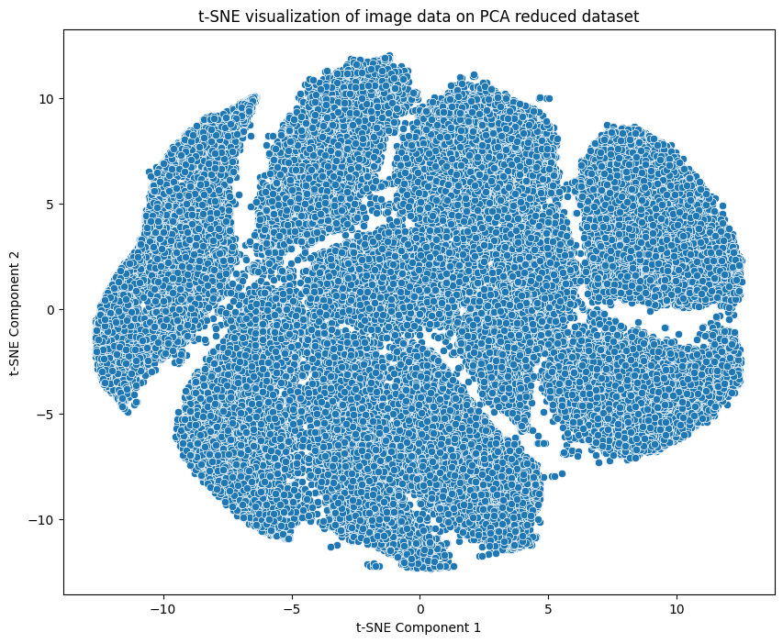

Silhouette Score: 0.0793 for K 8 and Variance Coverage 95.0%

