1. GET /logs:

Should return all log entries in a structured format (e.g., JSON).

Should support optional query parameters for filtering:

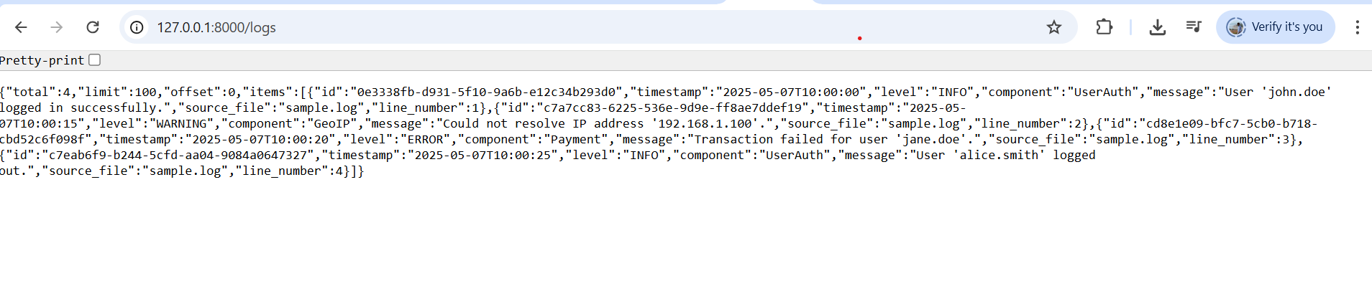

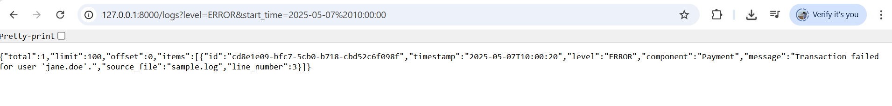

1. GET /logs/stats:

Should return statistics about the log data, including:

Total number of log entries.

Counts of log entries per level.

Counts of log entries per component.

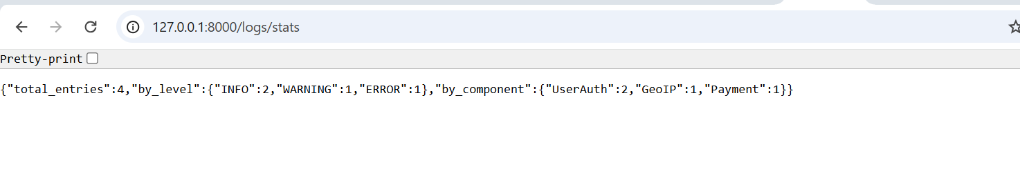

1. GET /logs/{log_id}:

Should return a specific log entry based on a unique log_id. You'll need to generate unique IDs for each log entry as you parse the files.

